ASSIGNMENT 2, WIND POWER

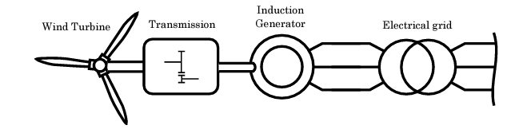

**TSAVALOS Anastasios, MUÑOZ SÁEZ Javier.**



Contents

Assignment description: 3

I – Developing the steady state model: 4

II – Developing the dynamic state model: 5

III – Studying results, comparing both static and dynamic models: 6

IV – Validating results with different grid conditions: 7

V – Pitch system and control for the dynamic model: 8

## Assignment description:

This Report provides a comprehensive overview of the second assignment for the Wind Power course, focusing on the analysis of a Type 1 wind turbine's steady-state and dynamic behavior.

The assignment involves the development of both steady-state and dynamic models, considering key variables such as mechanical power, torque, Cp coefficient, tip speed ratio, grid power, generator efficiency, slip, and more.

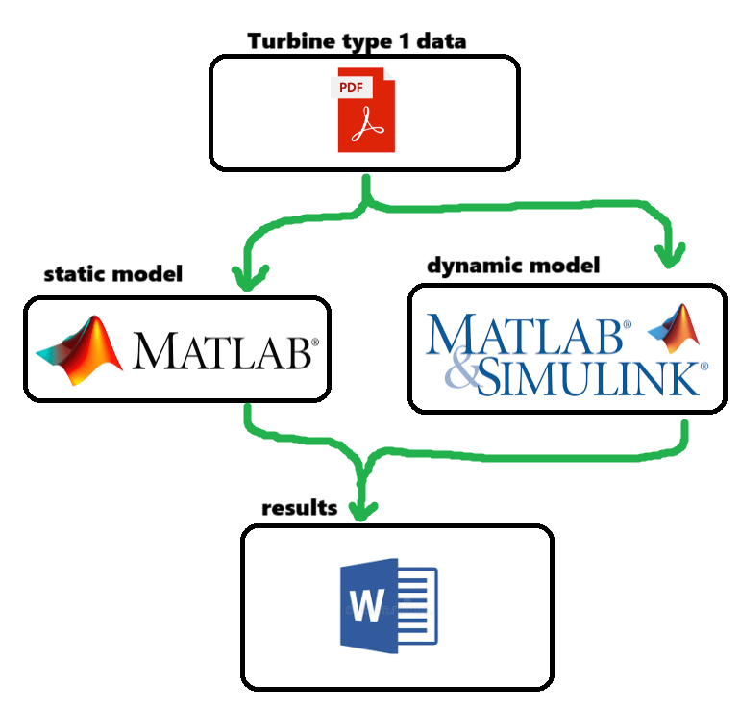

Figure 1, workflow of the assigment

## I – Developing the steady state model:

Recycling the simulations done in class, the turbine parameters were updated to our particular fixed blade turbine of the assignment.

We obtain the working points of our turbine: for 7 11 14m/s

We obtain the Cp curve and Cp points for 7 11 14m/s

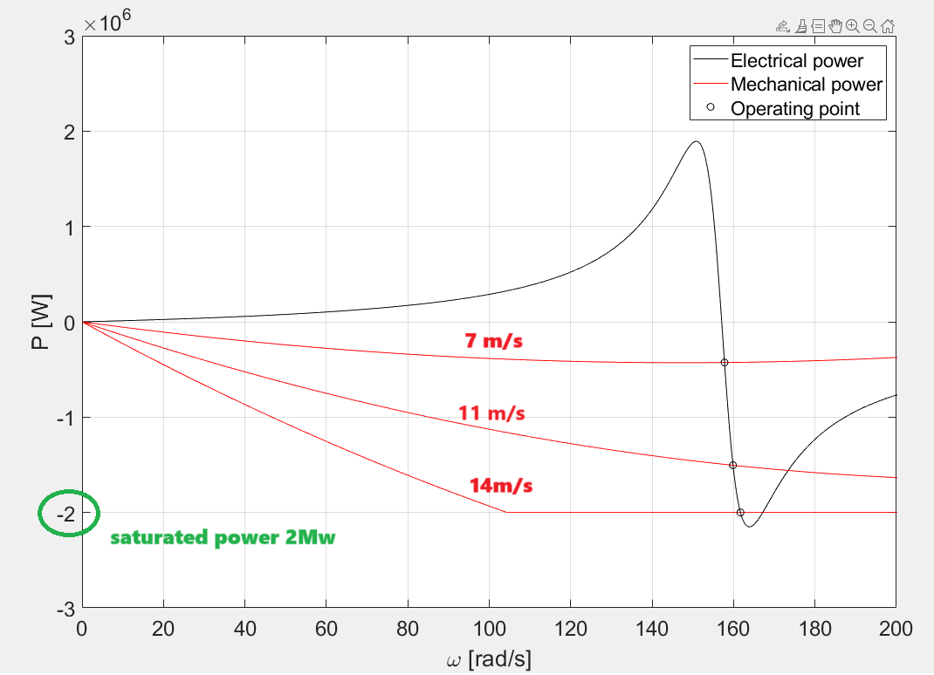

Figure 2, equilibrium power speed working points for each wind speed (saturated mechanical power)

Table 1, gridV 960 50Hz

|  |  |  |  |  |  |  |  |  |
| --- | --- | --- | --- | --- | --- | --- | --- | --- |
| Vind speed [m/s] | Cpp | Tip speed ratio | P [Mw] | slip | Losses [Mw] | S grid [Mva] | I grid [KA] | Wg [rpm] |
| 7 | 0.4478 | 10.7059 | 0.42674 | -0.0044 | 0.0093346 | 0.47932 | 0.2882675 | 1506.6 |
| 11 | 0.4068 | 6.9030 | 1.5046 | -0.0177 | 0.046892 | 1.6728 | 1.0060 | 1526.5 |
| 14 | 0.3657 | 0.3657 | 2 | -0.0641 | 0.19279 | 3.5808 | 2.1535 | 1544.1 |

Table 1, gridV 960 50Hz

|  |  |  |  |  |  |  |
| --- | --- | --- | --- | --- | --- | --- |
|  | P [w] | slip | Cpp | losses | S grid | I grid |
| V=7m/s | 4.2666e+05 | -0.0056 | 0.4477 | 8.7510e+03 | -4.1791e+05 + 2.0706e+05i | -2.8386e+02 - 1.4064e+02i |
| V=11m/s | 1.5375e+06 | -0.0675 | 0.4157 | 1.5545e+05 | -1.3821e+06 + 2.4907e+06i | -9.3877e+02 - 1.6917e+03i |
| V=14m/s |  |  |  |  |  |  |

## II – Developing the dynamic state model:

Following the instructions given in the assignment pdf, we built the model.

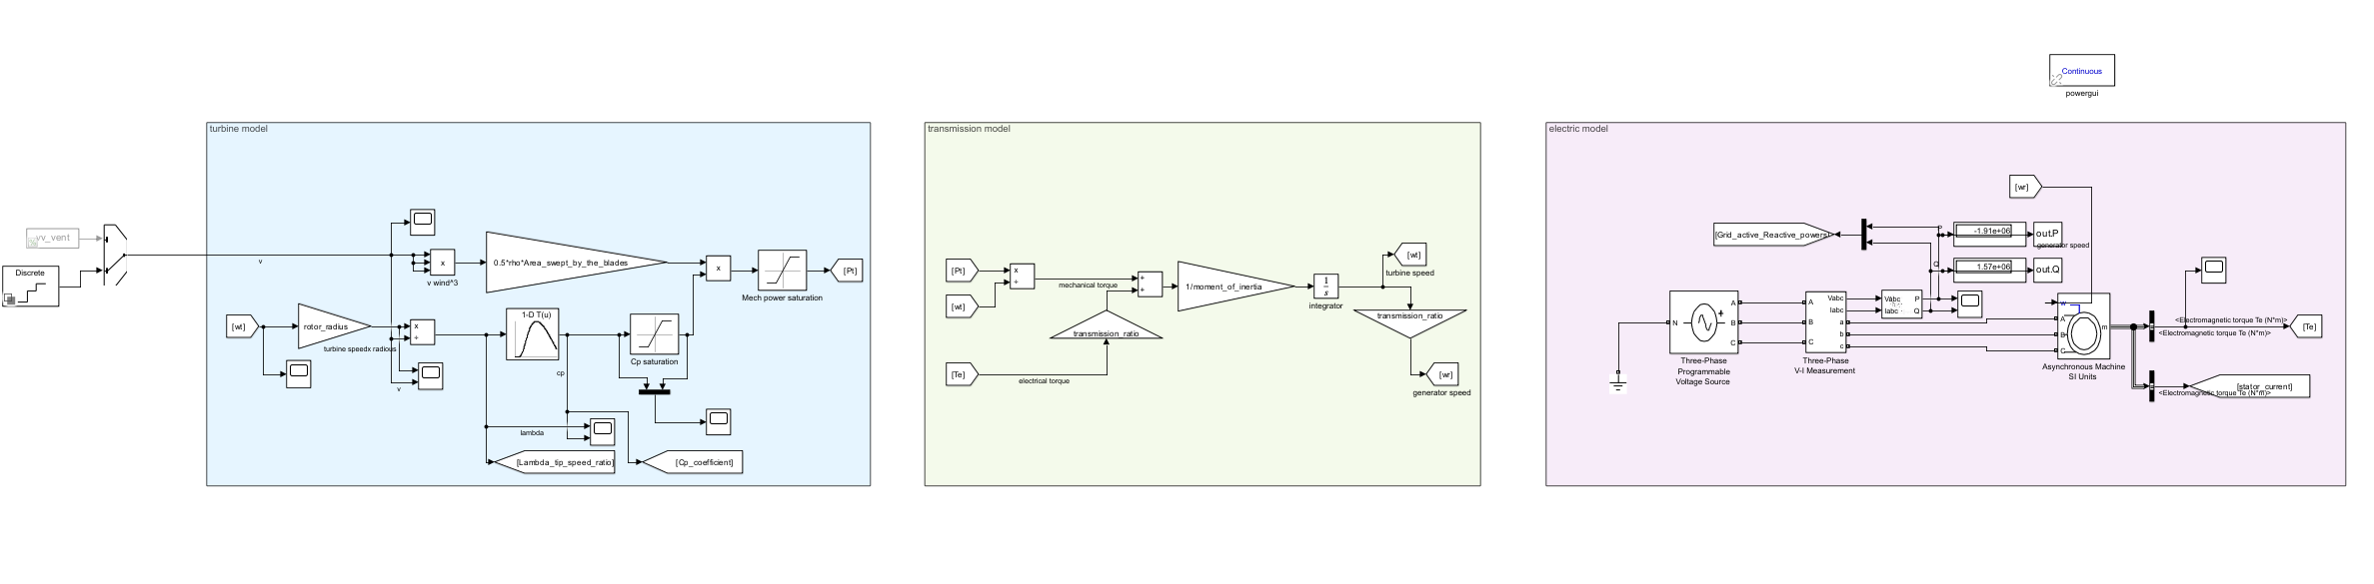

Figure 3, simulink dynamic model

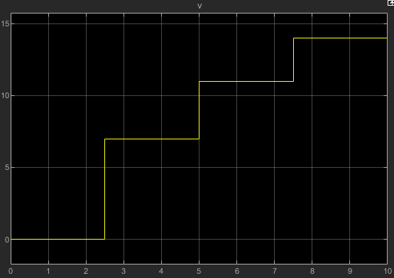

Figure 4, wind speed reference

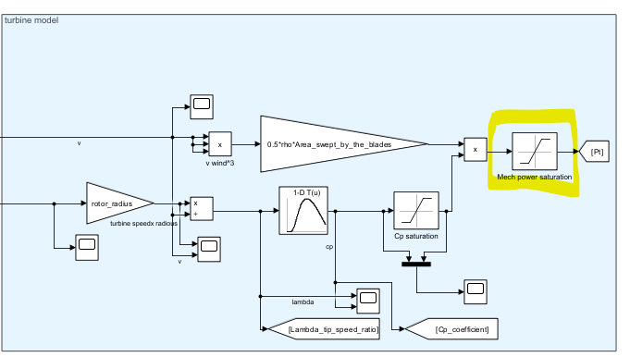

We obtain the working points of our turbine: for 7 11 14m/s

We obtain Cp points for 7 11 14m/s

## III – Studying results, comparing both static and dynamic models:

Illustrate graphically the results obtained, both for steady-state analysis using the mechanical and electrical characteristics, and for dynamic analysis using simulation results. For the dynamic case, show how the system reacts to changes in the wind speed, grid voltage or grid frequency. Highlight the convergence of steady-state and dynamic results.

## IV – Validating results with different grid conditions:

Discuss the results obtained. How the results change for different wind and grid conditions?

## V – Pitch system and control for the dynamic model:

Optional) For the dynamic model, implement the pitch system model and the pitch control to regulate the maximum mechanical power. For this purpose, consider different Cp parameters to enable the pitch system. Use the following Cp curve parameters: c1 = 0, 73 , c2 = 151, c3 = 0, 58, c4 = 0, 002, c5 = 2, 14, c6 = 13, 2, c7 = 18, 4, c8 = −0, 02, c9 = −0, 003. Take into account, that the look-up Table calculating Cp should be modified to include the dependency on both the tip speed ratio λ and the pitch angle β.

## 