

# Simulation:

Once I explored the simulation and understood the averaged model behaved the same as the commutated one, I used the averaged model to tune the PI closed loop control.

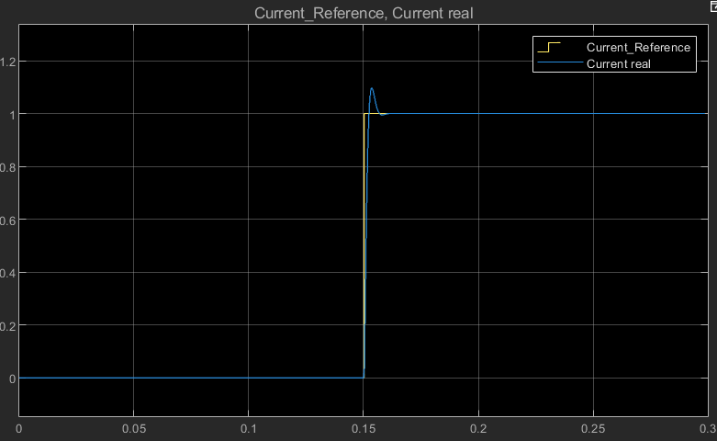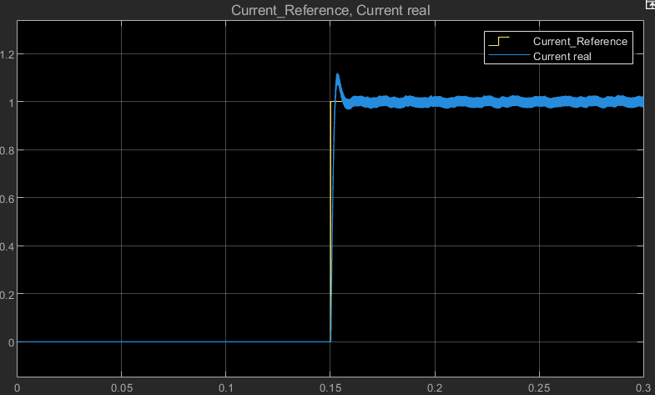

# Parameter Adjustment phase:

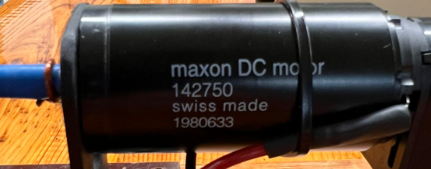

Figure , DC motor used in the lab

The motor resistance was measured with a multimeter, it read 2.4Ohms , 0.2 Ohms out of those 2.4 were from the multimeter cable resistance.

R=2.2Ohms

Comparing DC voltages measured from the DC supply and the ones in the simulation, they were quite similar (offset of 0.15V) so the results from Simulink HIL were used from this point forward.

|  |  |
| --- | --- |
| Simulink [V] | Multimeter[V] |
| 7.08 | 7.2 |
| 22.95 | 23.24 |
| 16.01 | 16.3 |
| 10.15 | 10.29 |
| 17.7 | 17.94 |

Using the current clamp with 4x windings of the DC power cable, we realized the measurements from the DC power source and simulink were off, specially in lower current values.

|  |  |  |
| --- | --- | --- |
| Simulink [A] | Lab DC power source [A] | Current clamp [A] |
| 0.1 | 0.38 | 0.325 |
| 0.76 | 1.55 | 1.78 |
| 1.92 | 1.96 | 1.9 |

From this point forward we used the Current clamp as I measurement.

To determine the inductance, we measured the current ripple on the real HIL with the switching 10Khz modulation.

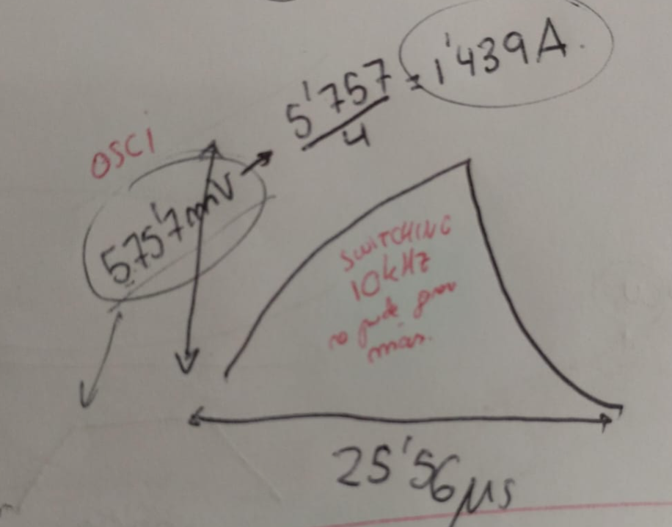

Following this formula  


We got 3.44uH inductance.

# Estimating remaining parameters from the real DC motor.

Using an optical tachometer, the DC voltage read in Simulink and the DC current measured with the current clamp we took two different measurements of K that are similar enough for us to be comfortable with the results.

Using the Formula:  


We got:

K=0.04233 [V/rad/s]

To estimate the inertia we spin the motor and disable all inverter mosfets, this shows the EMF to calculate inertia

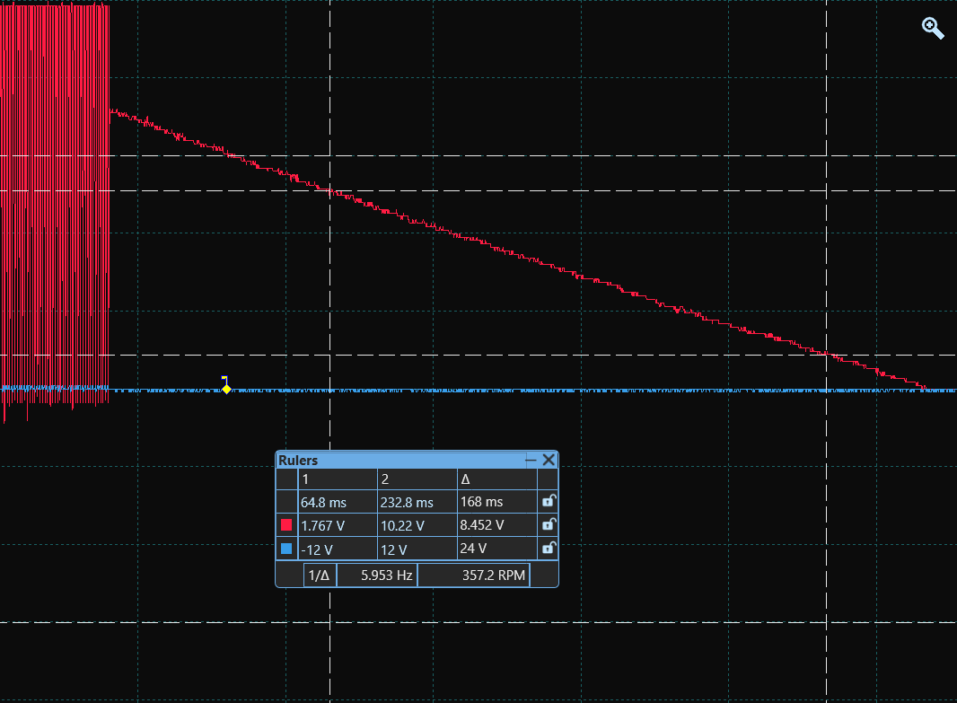

Figure , picoscope voltage sudden dissabling mosfets

From this formula  


We got :

J=0.000059 and J/b=166ms

# Controller integration:

As 3.44uH is a super low value, from this point we are going to use 344uH as Inductance value in all Simulink simulations plant’s parameter.

Heuristic tunning:

I just played with Kp and Ki until the system started being unstable and I settle before that.

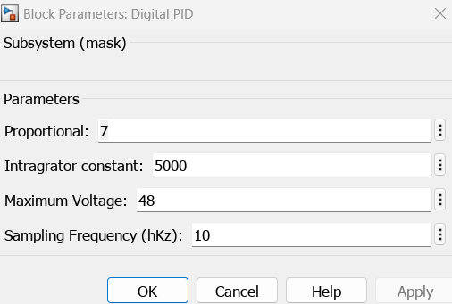

Figure , playfully chosen PI values

0.5ms fast rising time and overshoot of less than 10%  
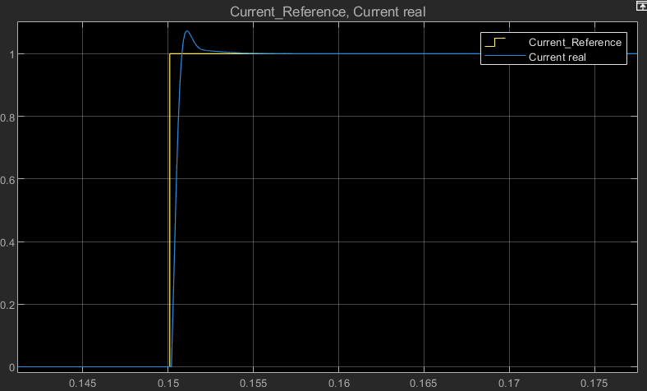

Figure , heuristic tunned PI current response

## Using Pole assignment method

The open loop plant with updated parameters behaved as follows (current step response), this will be used for plant characterization

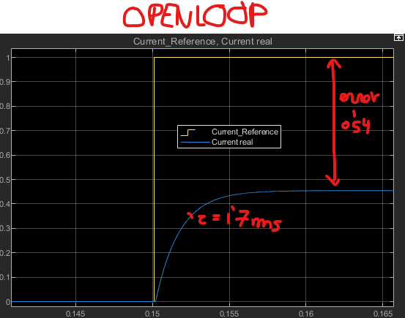

Figure , openloop response from the plant



Gp(s)= 0.54/((1.7e-3)s +1)

k =0.46

Tau =1.7ms

1.7ms is fast enough, we want our control response to be also 1,7ms.

K=1

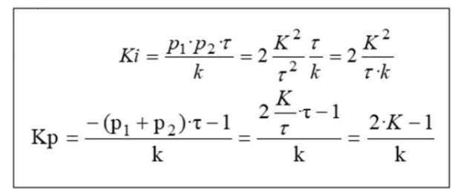

Ki=2/(0.46*1.7e-3)= 2557.54

Kp=(2-1)/0.46= 2.173

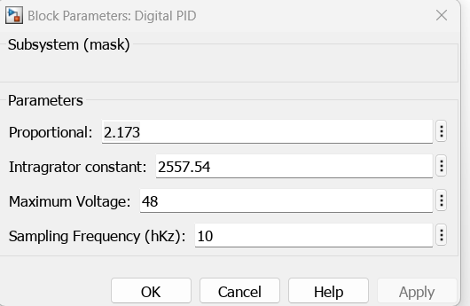

Figure , calculated PI values

No error in steady state , within 10% overshoot and still around 1,7ms of rising time

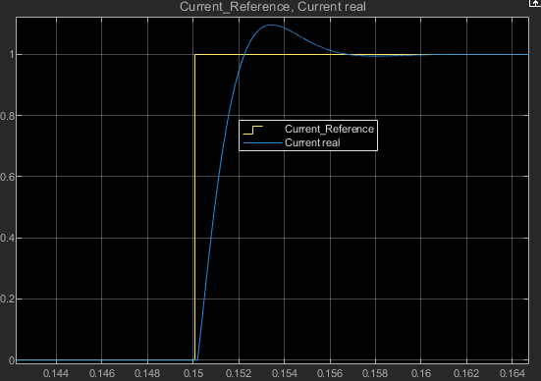

Figure , pole asigment tunned PI, current response

# Conclusion:

The Heuristically tunned PI Controller doesn’t have much room until it becomes unstable so it’s not a good option for a real world controller, but its results were much sharper.

Pole identification method process was very systematic so it could be programmed as an automatically PI tune method, the results were also satisfactory.