Intenté hacerlo en casa pero no lo consegui

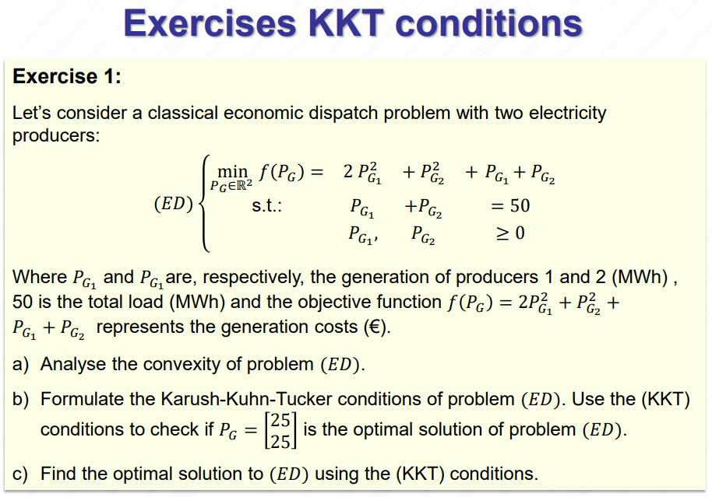
a)
(hessian) 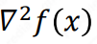>=0 so positive and semidefinit convex
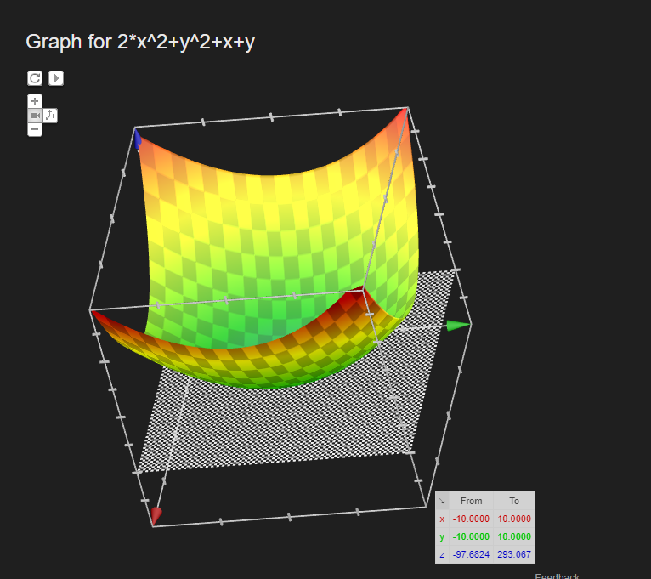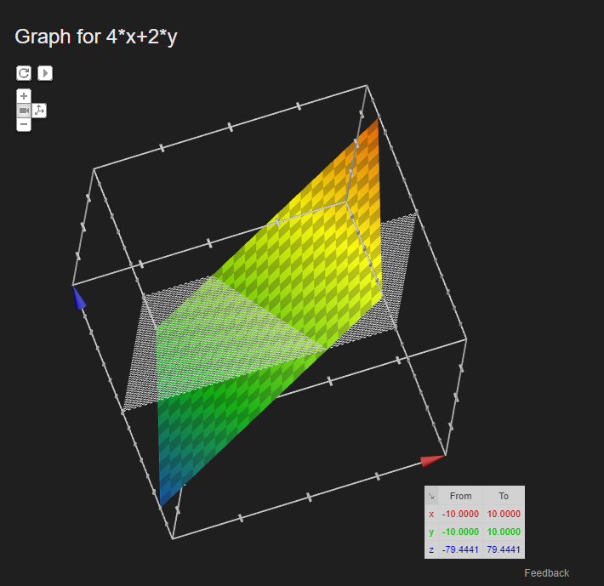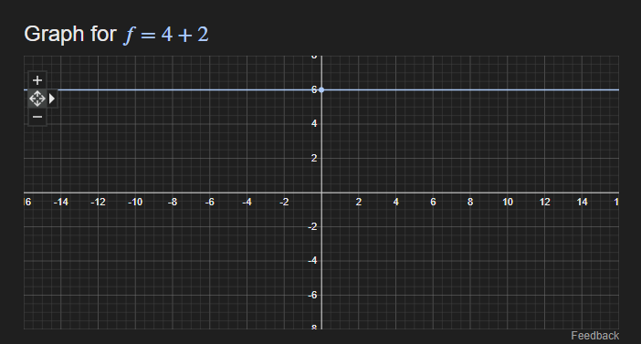
The feasible set ecuations are all linear, thus convex
Both the optimising function and the feasible set are convex
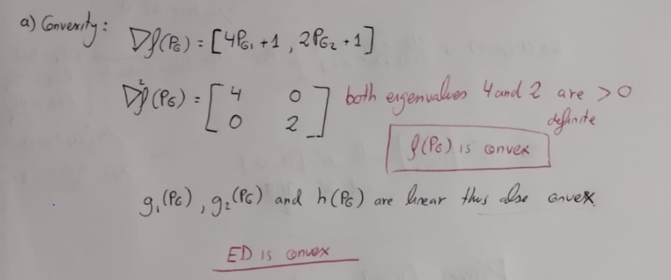
b)Checking if [25,25] is an optimal solution
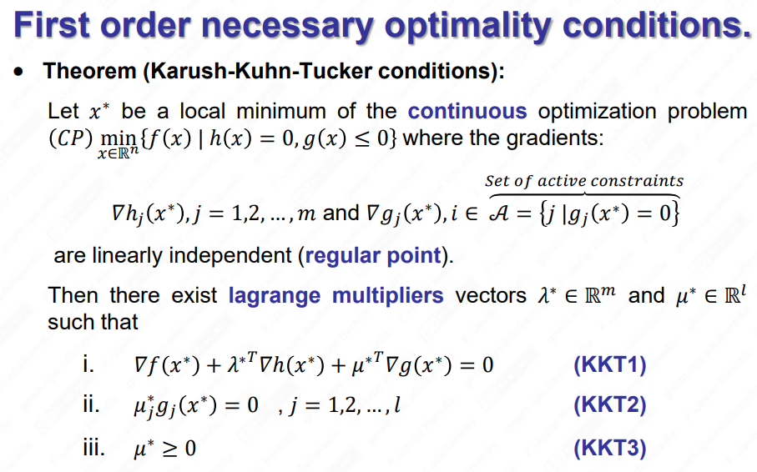
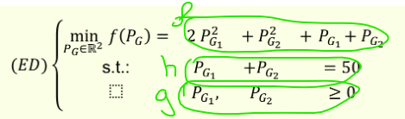
(KKT1) 4PG1 +1+lambda1 -mu1=0 . lambda1=mu1-101
(KKT1) 2PG2 +1 +lambda1 -mu2=0 . lambda1=mu2-51
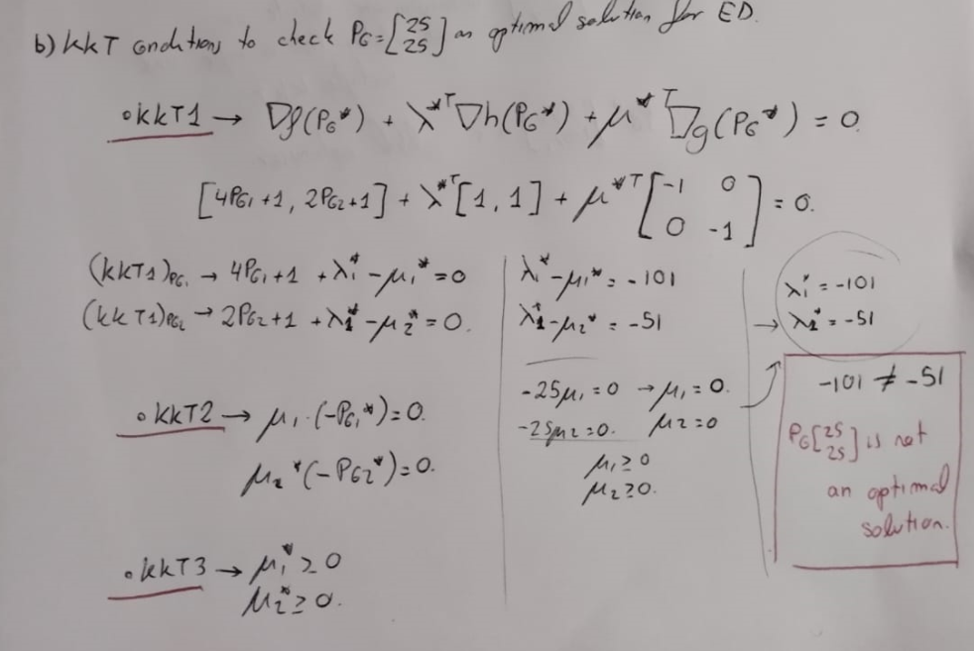

c)find the minimizer:
