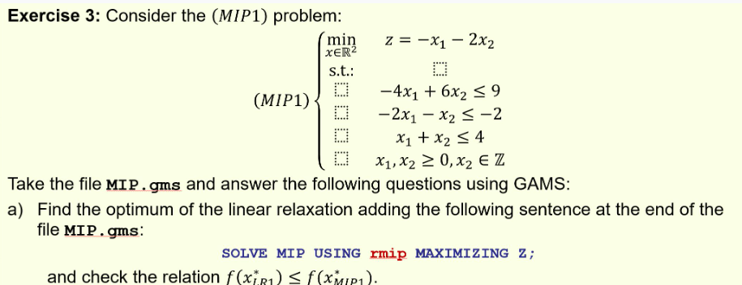
-6.5<-6 relation checked.
Linear relaxation solution:
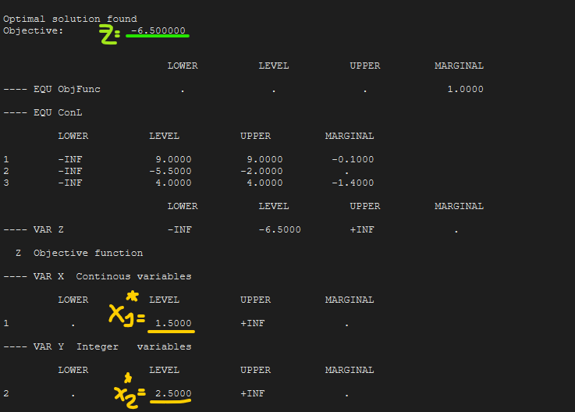
MIP solution:
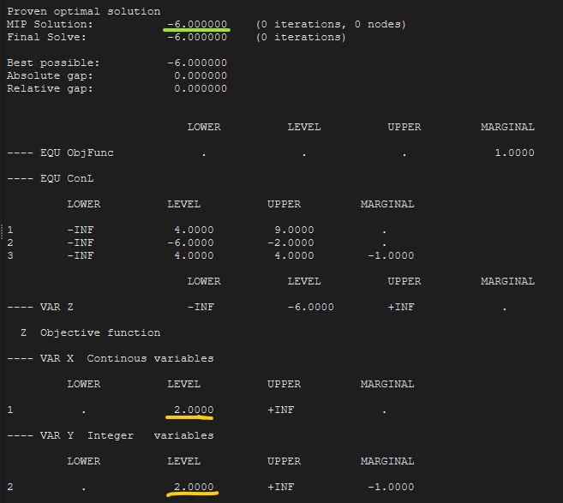
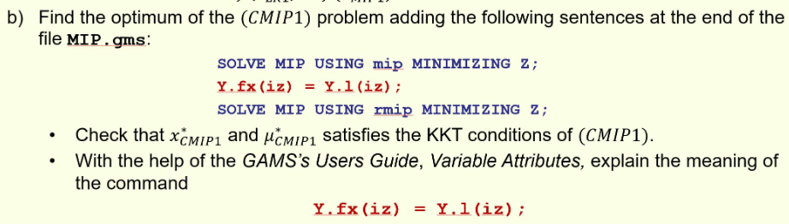

Solution of the continuous equivalent problem:
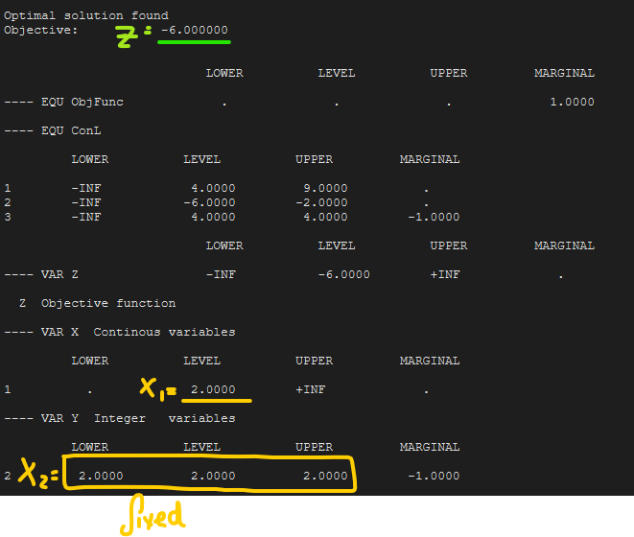
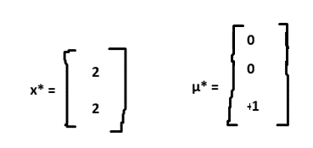
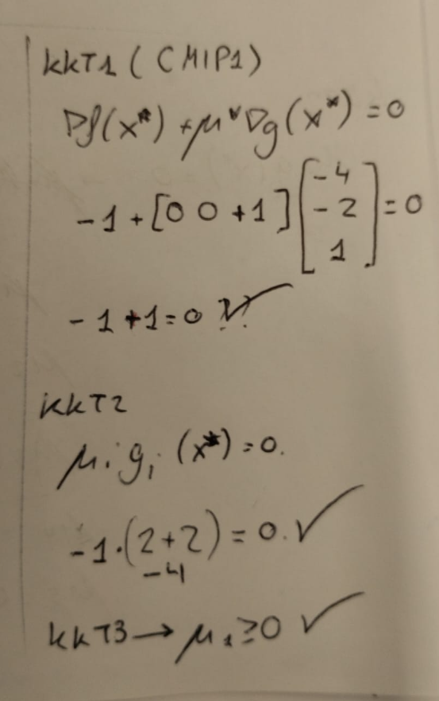
Previously having run the mip problem with the optimal solution already loaded into Y.l(iz) .
the line Y.fx(iz) = Y.l(iz) is effectively fixing Y (or X2) to the optimal value and rerunning the problem as a continuous problem.
