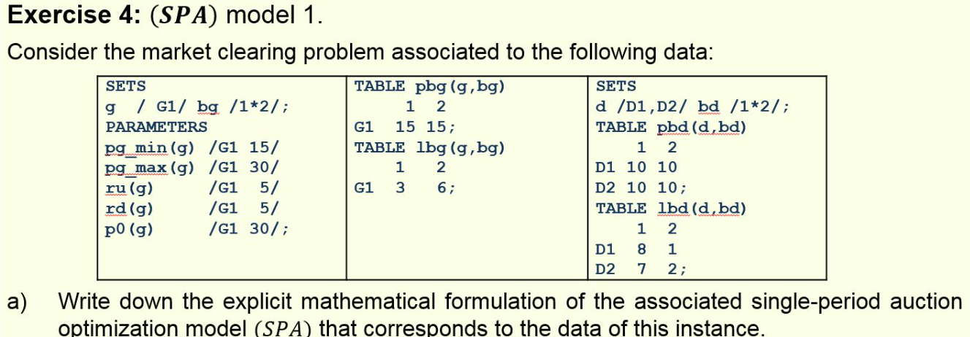
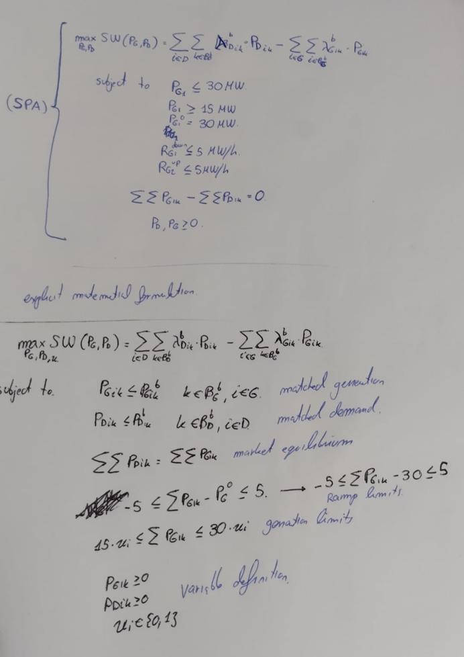

Choosing the real SPA solution, the one with constrains
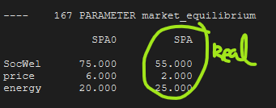
Equilibrium price of 2€
Matched power bids of 25Mw

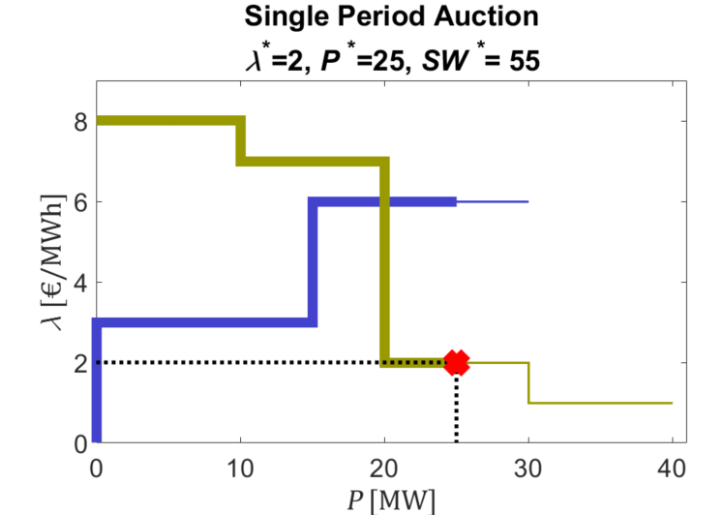

The generator already starts the bidding at its maximum power 30Mw, the ramp down limit is only 5Mw, this means the generator couldn’t reach the ideal 20Mw , it did just down to 30Mw and paid the price set by one of the cheap demand blocks of 2€.

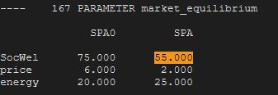
SW of 55

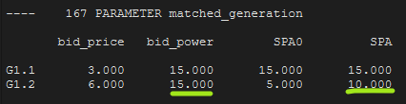
CS=5MW

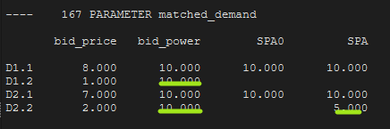
PS=15Mw

