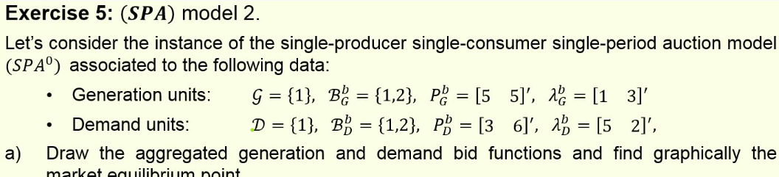
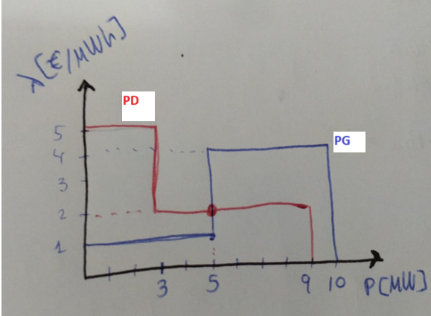
Equilibrium point at Price= 2€/MWh and Power=5MW
P11D= 3 MW (lleno)
P21D= 2 MW (medio lleno)
P11G= 5 MW ( lleno )
P21G= 0 MW (vacío)

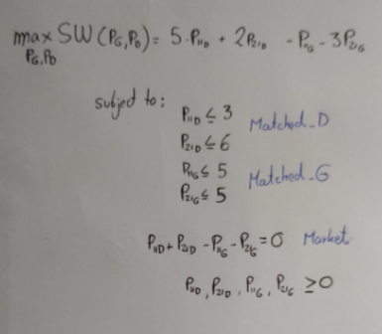
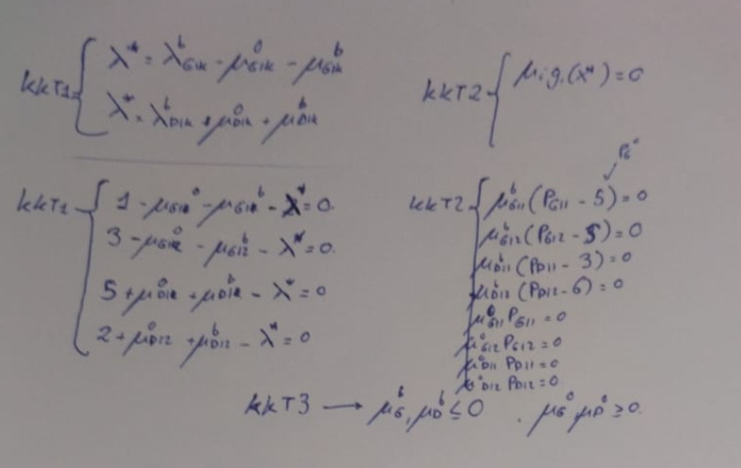

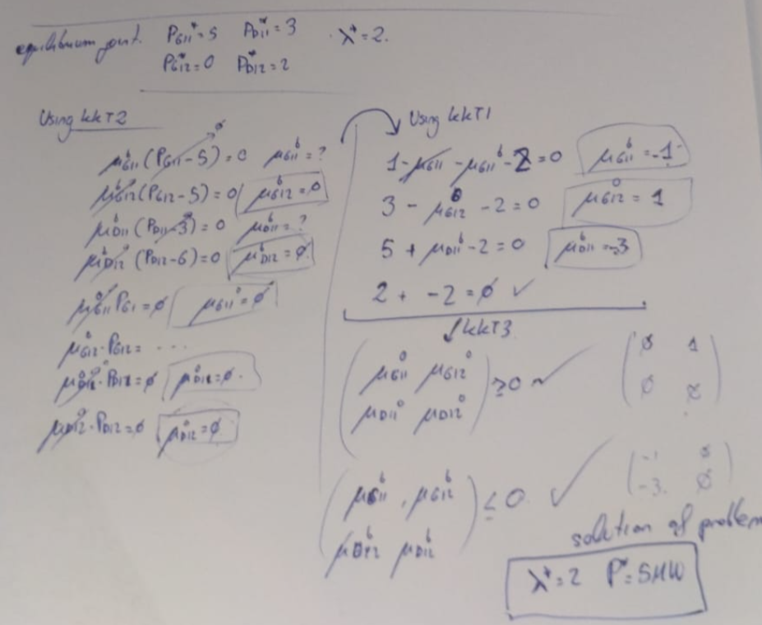

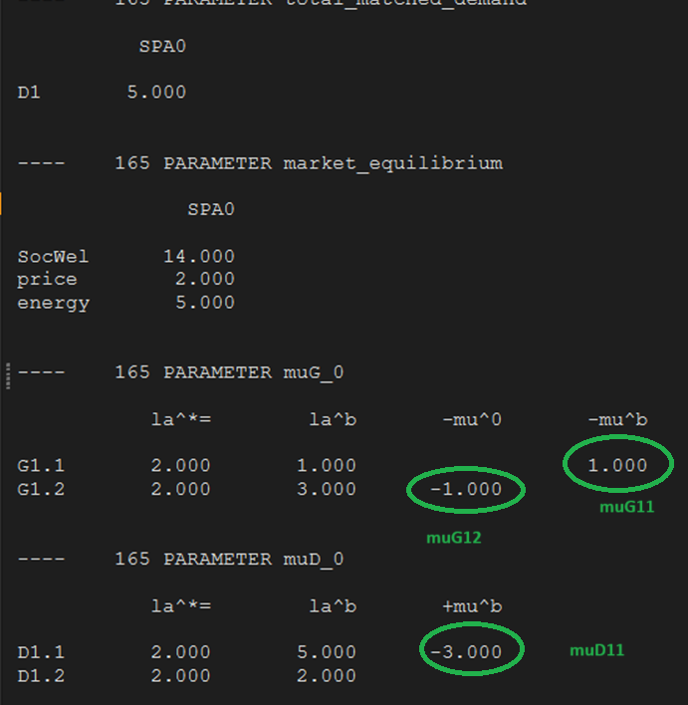

First market equilibrium condition ok,(3+2)-5=0
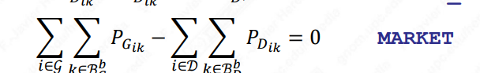
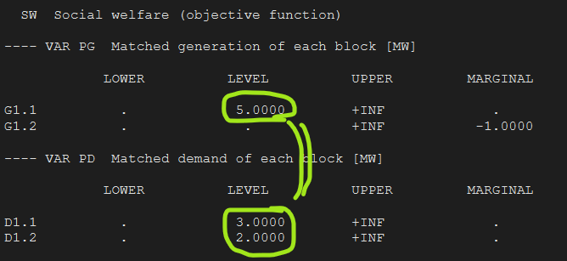

Second condition also check
