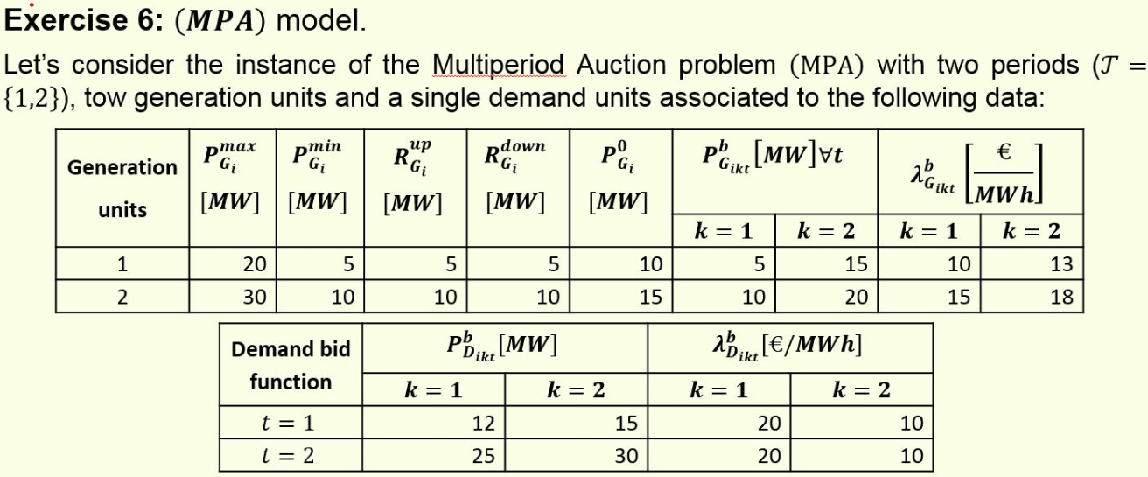

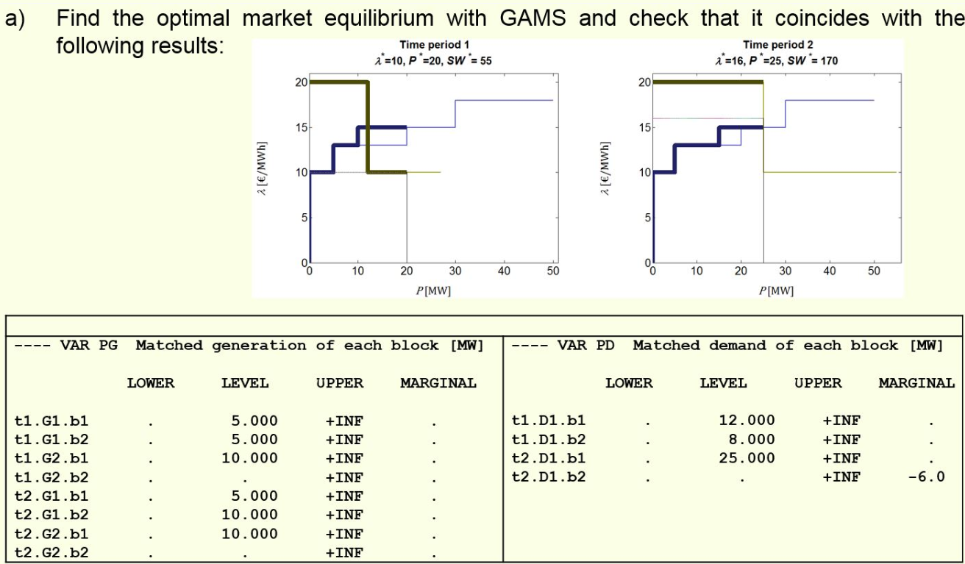
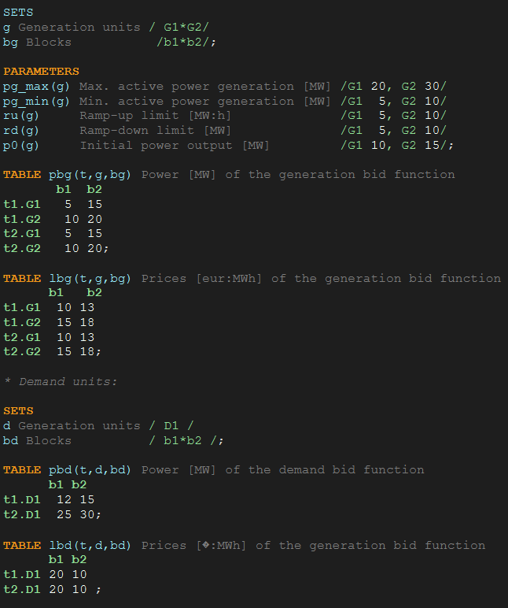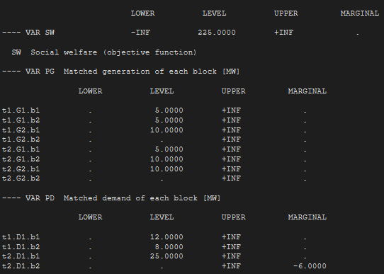

The rampup constraint of generator 1 is limited to 5MW, in t=2 the generator could only rampup from 10 to 15MW eventough more power was offered in the block.
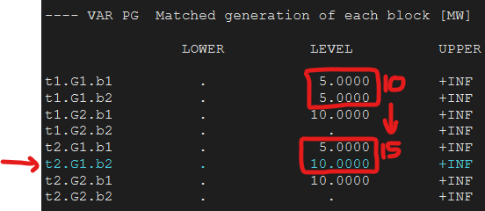

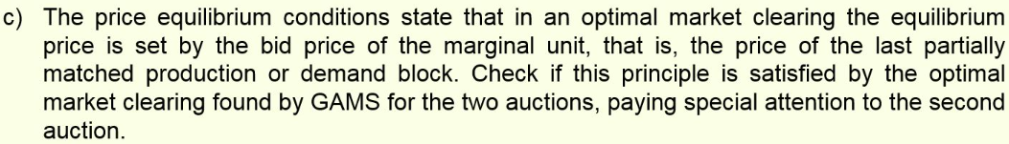
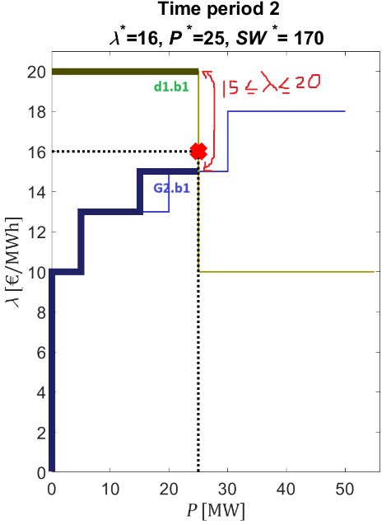
As both generation and demand blocks are filled there is not a marginal unit , the market price could be any integer value between 15 (block price of demand) and 20 (block price of generation).
SW would be the exact same area for any market clearing within those values.

GAMS chose 16.

The last block partially filled sets the market price, this time corresponds with a demand block instead of a generator block.

T1.D1.b2 sets the market price and not the fully filled block t1.g2.b1

