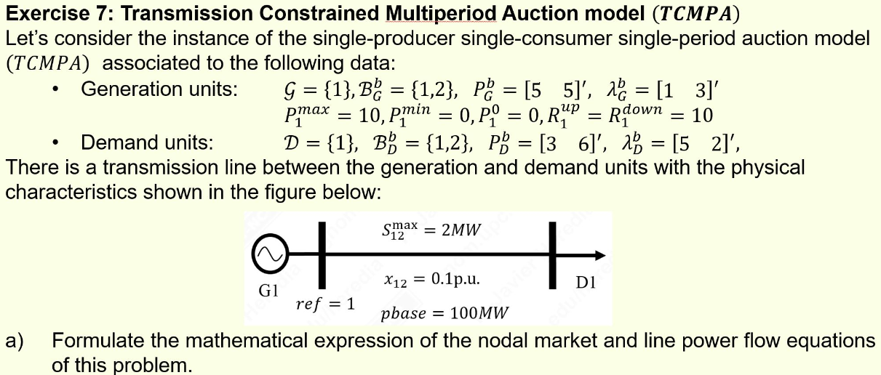
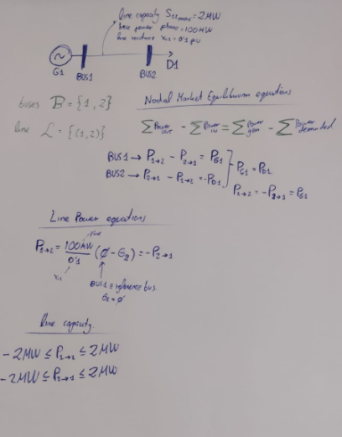

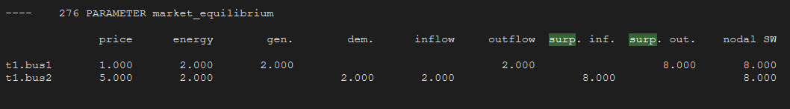
Producer surplus= Consumer surplus= merchandizing surplus = (5 €/MW – 1 €/MW) * 2MW= 8€
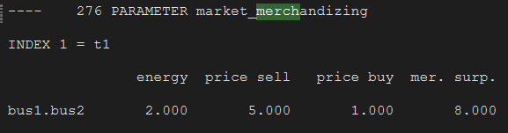

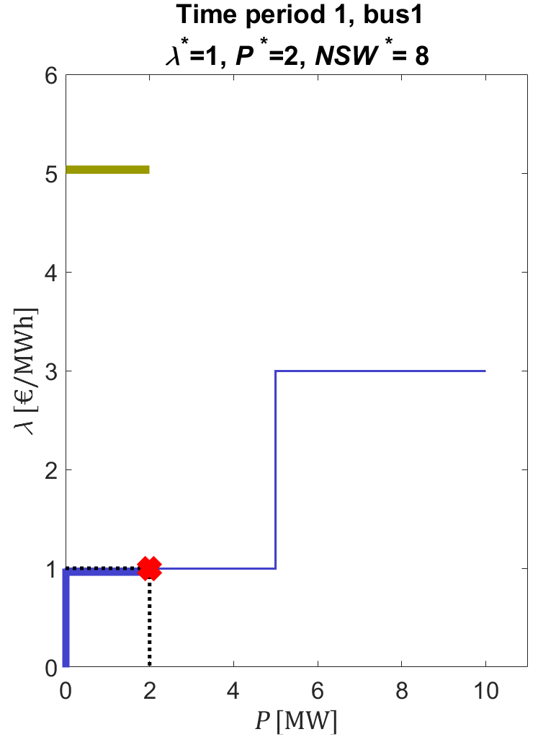

Transmission constrained SW= solutionSW + Merchandasing Surplus = 8+8??

