## Exercise 1 (lab1): How much power do we need to inject un bus 4 so that the voltage is between a valid range (+/- 10%)? Add increments of 10 MVAr and save it on a dataframe comparing with the bus 4 voltage.

Here is the meaty main loop to solve the exercise:

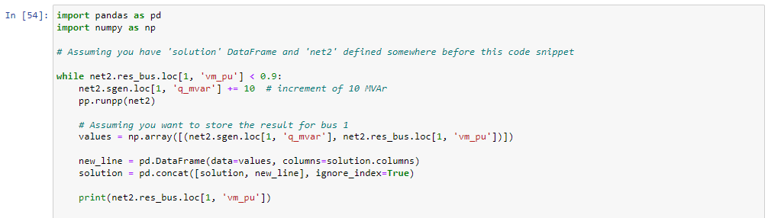

And Our solution, it seems like we need to inject right below 90MVar for our bus voltage to drop to 0.9pu’s

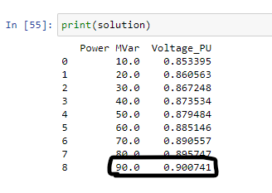

## Exercise 2 (lab1):

First some profile generation for generator and load (In pu’s):

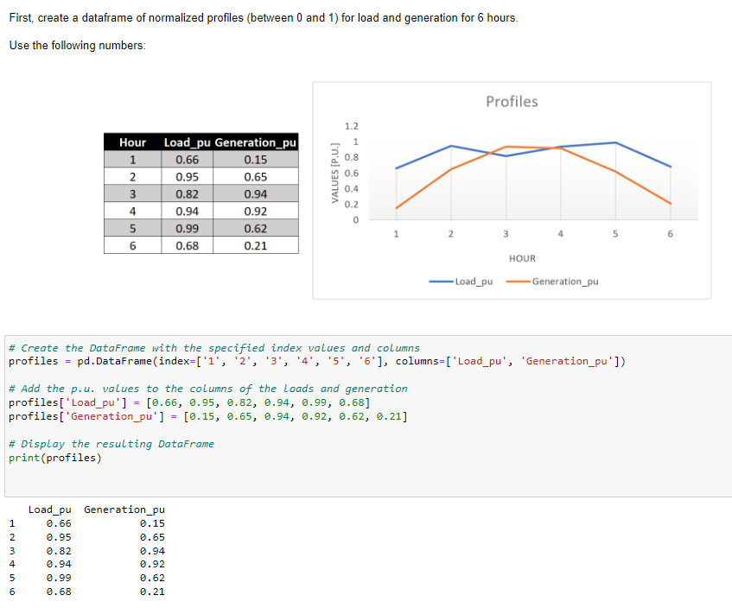

Then ,we create an empty dataframe as requested:  
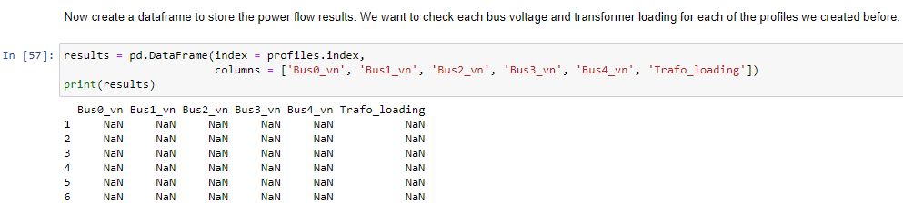

To finish we create the “pu transformation function” to be used in the next exercise.

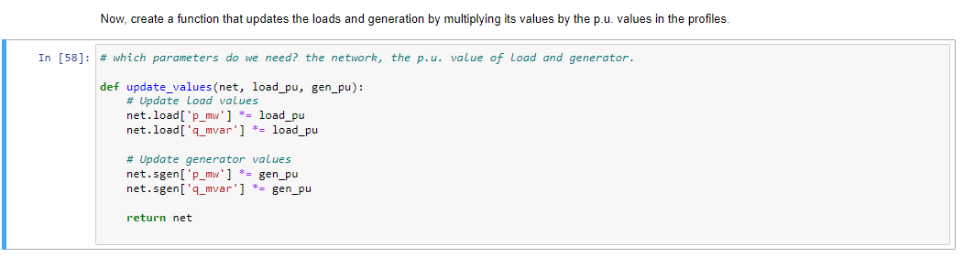

## Exercise 3 (lab1):

I created a for loop iterating over the exercise 2 profiles, it runs the powerflow for each hour and saves the result:

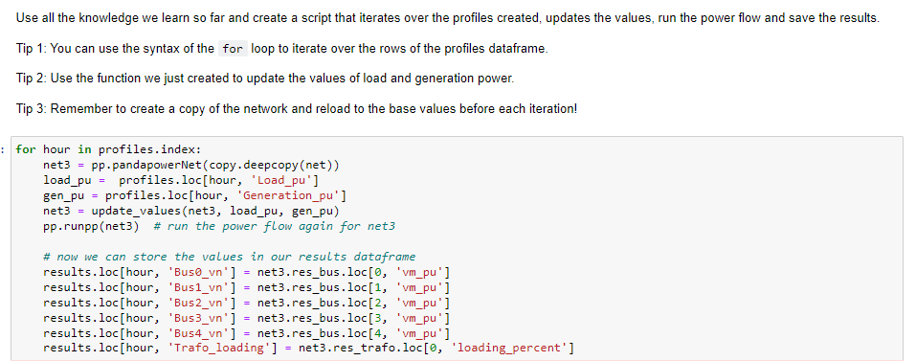

Our result is as follows, powerflow results for each hour: (hour 5 has the highest trafo loading)

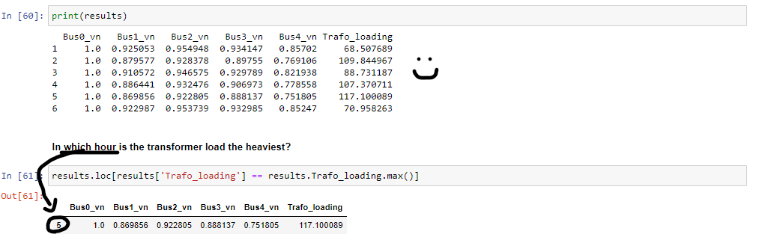

## Exercise 4 (lab2):

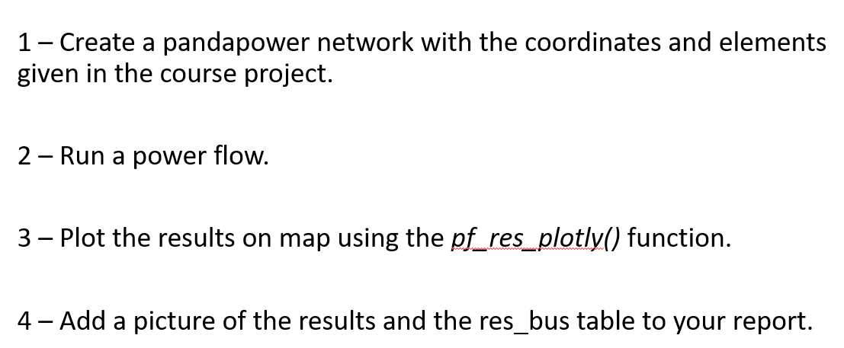

As this is a lot of code im going to jump straight to plotting the results:

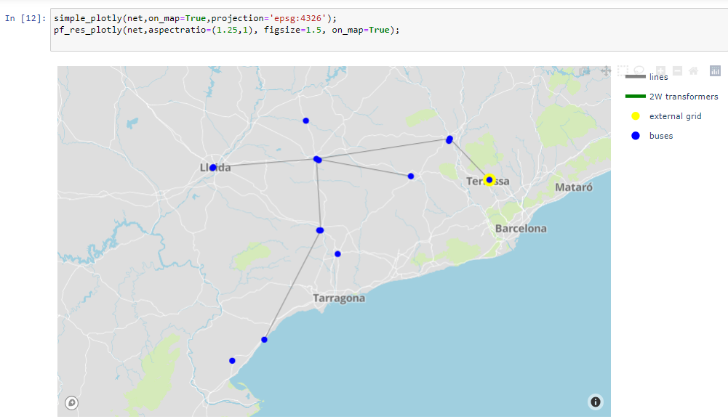

Oh no! ,it seems like Line0 from Manresa to Terrasa (external grid) is heavily loaded (75,452% of its capacity)

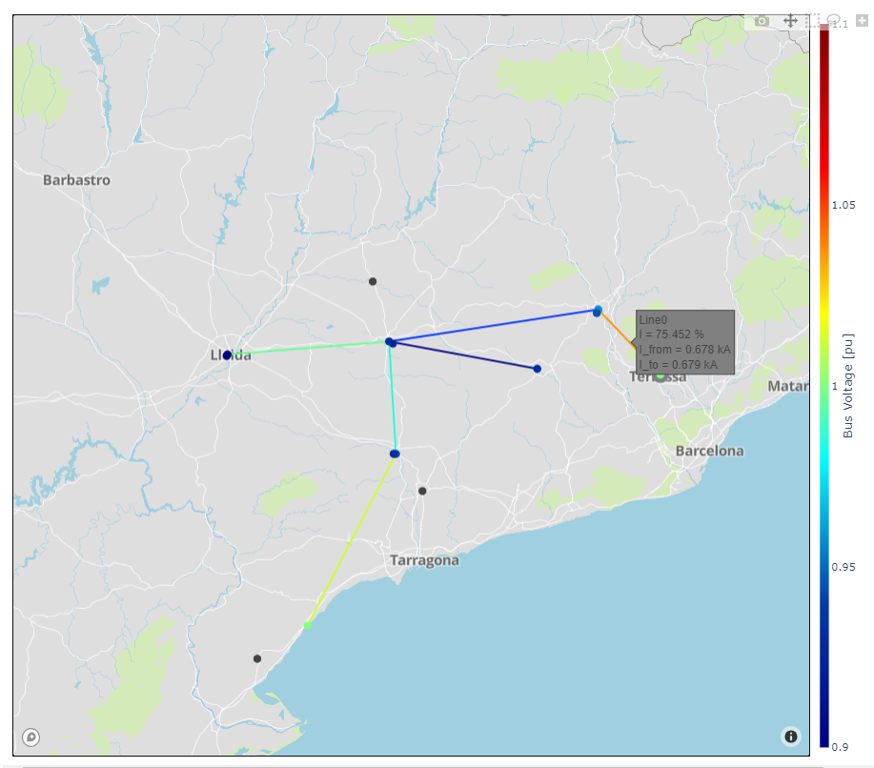

Looking at the powerflow results for each bus, it seems like we are a net negative system, we are greedily demanding active and reactive power from the external grid.

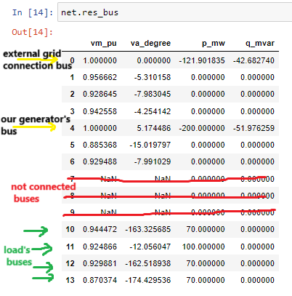

## Exercise 5 (lab3):

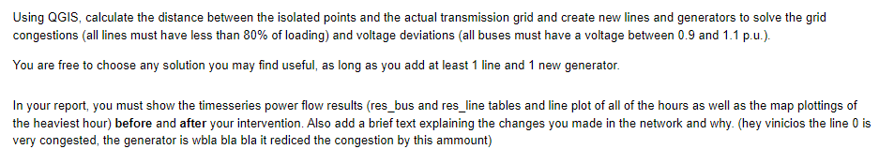

I decided to place my generator in argamut, because its closer to the overloaded line0, the generator 24h profile is the same as in gen_0.

I chose a double line for the connection of our new generator because a single line was also about to overload.  


Our new line loads are well under the 80% requirement, the busiest line would be now the line6, line6 happens to be the new line from argamut we just added. (figure2)

## Here some powerflow maps:

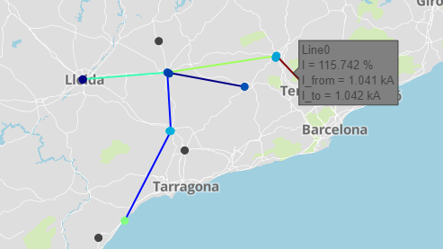

Figure 1, before connecting agramut, line0 is working above its rated capacity

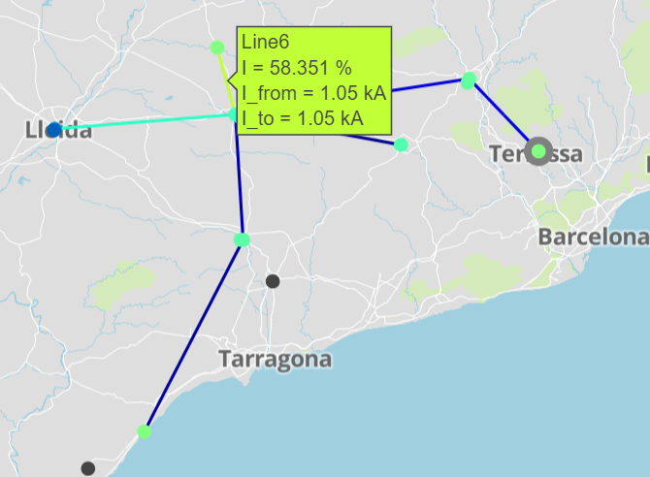

Figure 2, after connecting argamut, now all lines are working below 80%

## Here some tables of % line loading:

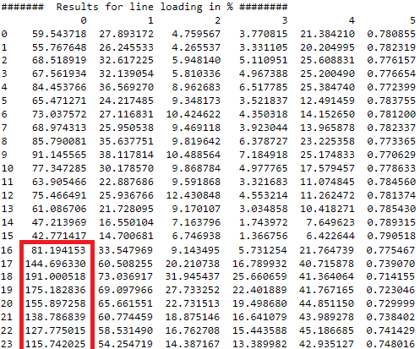

Figure 3, our net line load before connecting argamut’s generator, overload in line0

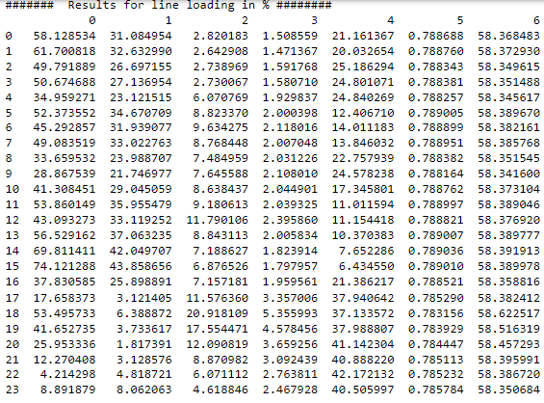

Figure 4,our net line load after connecting argamut’s generator, everything checks.

## And here some tables for voltage level in p.u’s:

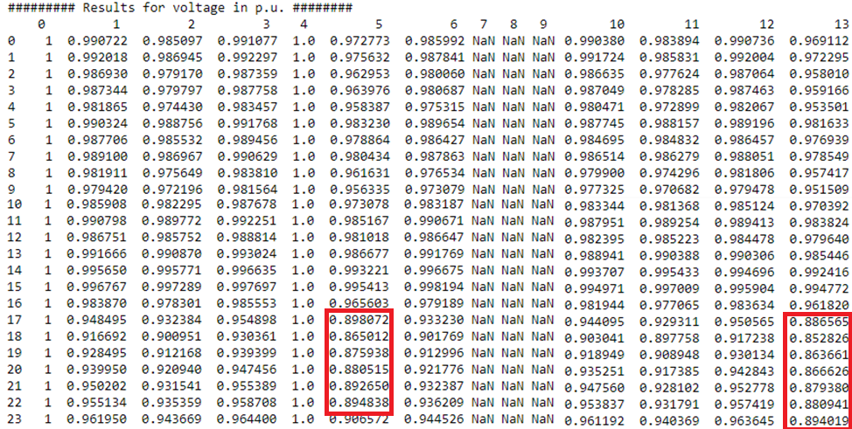

Figure 5, our line voltages before the inclusion of argamut, some voltages lower than out 0.9 requirement

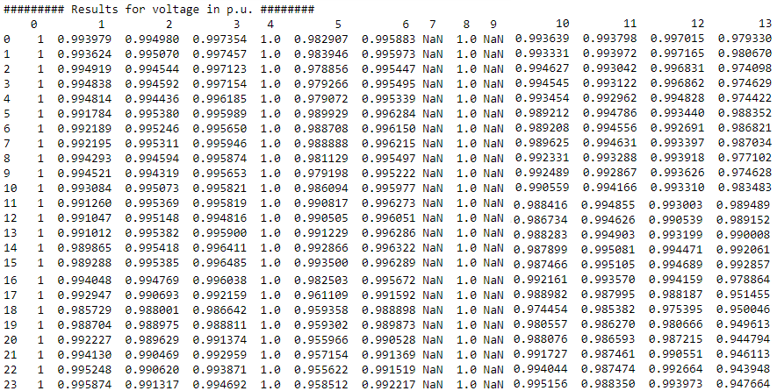

Figure 6, our line voltages after the conexion of argamut 's generator, everything checks