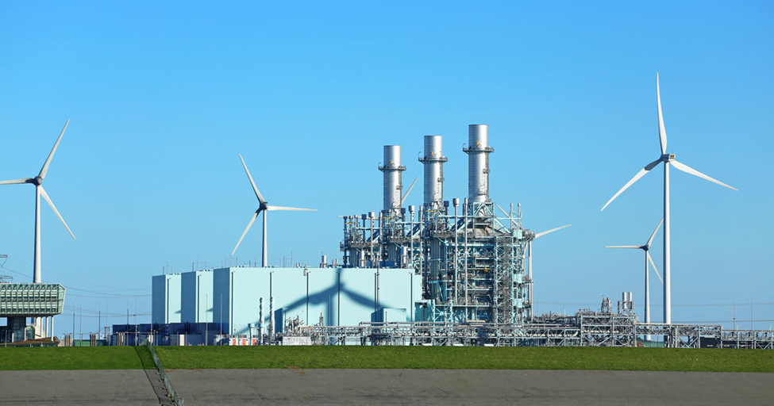

**BUILDING THE ENERGY GENERATION MIX   
FOR THE CITY OF BRIGHTON**

Engineering team:

* [Javier Muñoz Sáez](mailto:javier.munoz.saez@upc.edu)
* [Anastasios Tsavalos](mailto:anastasios.tsavalos@estudiantat.upc.edu)
* Hussein Mazeh
* Francisco Gaspar Martins

**Professor: Jordi Freixa Terradas**

Contents

1. Introduction 3

Key Objectives of the Project: 3

2. Country Overview 4

3. Existing power mix 4

4.Modeling & Optimization 5

Modeling 5

Constraints 6

Wind 6

Solar 7

Hydro Storage 7

Code layout 8

Results: 9

Optimization: 9

Investment: 10

Power mix: 11

Gas Capacity Utilization: 16

CO2 Emissions Analysis: 17

Conclusion 18

Hypothetical Scenario 19

Results from hypotetical scenario: 19

Anex I 23

# 1. Introduction

## Key Objectives of the Project:

The project carried out is an investment distribution problem. Our city Brighton (control area) seems to be stuck in time, as its electrical power production is only based on a small amount of Run of River hydro power and nuclear power and all the rest is produced by gas power plants. For this reason, a big investment is going to be carried out so that more renewable energy is integrated in the power mix of Brighton to minimize the CO2 emissions that result from the gas power plants.

The ministry of energy of England decided to invest in the most prominent renewable sources used currently around the world. These technologies are:

* Solar PV energy panels
* Wind energy turbines
* Nuclear energy SMR

In addition to the above investment, our city, Brighton, is equipped with a newly constructed hydro storage facility that will contribute to the better integration of the renewable energy produced.

To achieve that and to come up with the most efficient solution we used optimization techniques to find the perfect distribution of the above-mentioned variables to minimice Gas reliance. Specifically, for optimizing and presenting data we used python (3.7) with a Bayesian Gaussian numerical approach.

In this report the optimal solution is represented as well as the most relevant graphs and results that can adequately justify our solution.

The primary objective of the project is to determine the investment allocation among the three available technologies, aiming to achieve a sustainable energy mix and model the evolution of power. Additionally, the goals include reducing reliance on natural gas, optimizing investment distribution, minimizing CO2 emissions, evaluating economic viability, and providing recommendations for future action.

# 2. Country Overview

Brighton, located in the United Kingdom, serves as the control area for our investigation into an innovative electricity generation mix. The key details about Brighton are as follows:

* Geographical Location: Latitude: 50.81°N Longitude: 0.13°W
* Population: 14.691 million
* Area: 19,161 km²

These geographic and demographic characteristics will play a crucial role in shaping our energy generation strategy. Brighton's specific location will influence the effectiveness of solar and wind technologies, while its population size and area will determine the overall energy demand.

# 3. Existing power mix

As stated, the existing power mix of Brighton consists of the following:

* Run of River : 383.22 MW installed.
* Nuclear Plants : 2,203.65 MW installed.
* Gas Plant : An enough number of power plants that satisfies the power balance.

In addition to the existing facilities mentioned above, Brighton TSO can leverage the newly constructed hydro storage dam, which possesses the following characteristics: The hydro storage system has a generation capacity of 201.9 MW and a pumping capacity of 226.95 MW. Furthermore, the hydro storage reservoir has a capacity of 13,000,000 m³.

# 4.Modeling & Optimization

As stated before in our report our engineering team had the responsibility to carry out a study that will indicate how the total amount of investment will be divided into the available technologies ( SMRs, Wind Turbines, Solar PV panels). Also the main purpose of this was to minimize as possible the use of Natural Gas for the electricity generation as well as the resulting CO2 emissions happening from its use.

To achieve that our team formulated an optimization problem. First the raw data was preprocessed in matlab, then the system was modeled and then a Bayesian Gaussian numerical optimization was run in with Python (Jupyter), to solve the problem.

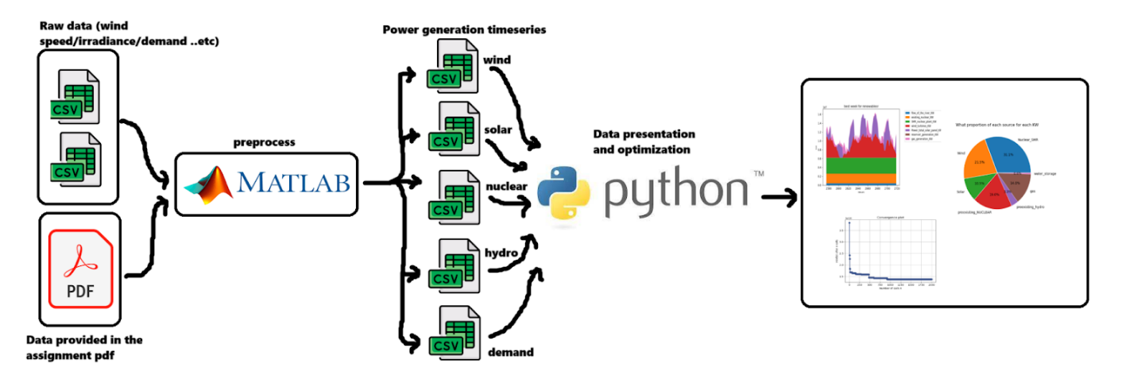

Figure 1, data adquisition, preprocessing, optimization and presentation flow

In the following part we briefly present the way we formulated the optimization problem, the constraints, the tool itself and the primary results of the optimization.

## Modeling

In this part we represent the way we formulated our problem. The main variables of our problem were as expected:

* ***Nsmr***: Number of SMR power plants
* ***Nwt***: Number of Wind Turbine
* ***Npanels***: Number of solar PV panels

Our main **objective function** is the following:

min f(Nsmr,Nwt,Npanels)=18760Pgas(h)

And the **main constraint** binding our variables is:

Nsmr*Csmr+Nwt*Cwt+Npanels*Cpanel=Total investment

Eventually though due to the complexity of the above statement we **modified the constraint** as follows:

Nsmr*Csmr+Nwt*Cwt<Total investment

And let the Npanels variable free to be decided by the other two variables.

## Constraints

### Wind

One of the constraints was the power generation of  a single WT in an hourly time step.

**h ∈ (1:8760) :**PperWT(h)

For this purpose we selected Turbine is an on-shore or close range off-shore [Gamesa G132-5.0MW](https://en.wind-turbine-models.com/turbines/768-gamesa-g132-5.0mw)

Figure 2, One close offshore Gamesa turbine

The process we followed to extract these values is the following:

1. Data Vw(h)were extracted from https://power.larc.nasa.gov/data-access-viewer/
2. Calculated the wind energy potential:  
   Pwind(h)=0.5*ρ*Awt*Vw3(h)
3. Using the given Power curve we extracted the Cps that correspond to each Vw
4. And evaluating the Vwwe created an array of 8760 Cp values:   
   Cp(h)
5. Finally we extracted the hourly power generation of  a single WT by

PperWT(h)=Pwind(h)*Cp(h)

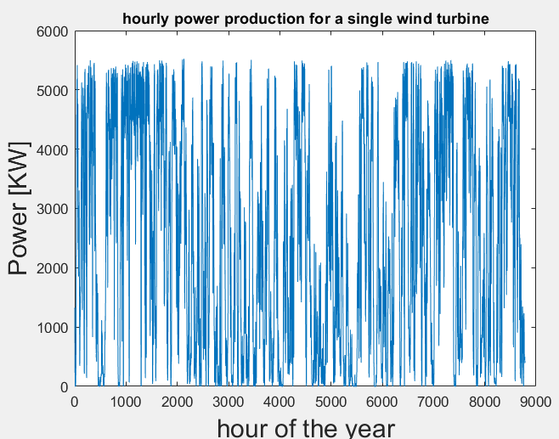

Figure 3, power generation for one of our turbines

### Solar

A similar process was used to calculate the hourly Solar PV panel generation that would constrain the total PV generation in our model.

**h ∈ (1:8760) :**PperPanel(h)

The process we followed to extract these values is the following:

1. Data  I(h)were extracted from <https://power.larc.nasa.gov/data-access-viewer/>. This irradiance data is the power potential of a m2 surface on ground’s level.
2. We decided to use dual axis trackers to maximize production so  
   Ipot(h)=I(h)/cos(Solar zenith angle)
3. Extracted the power of a single solar PV panel:  
    PperPanel(h)=Ipot(h)*npanel*ninverter*Apanel

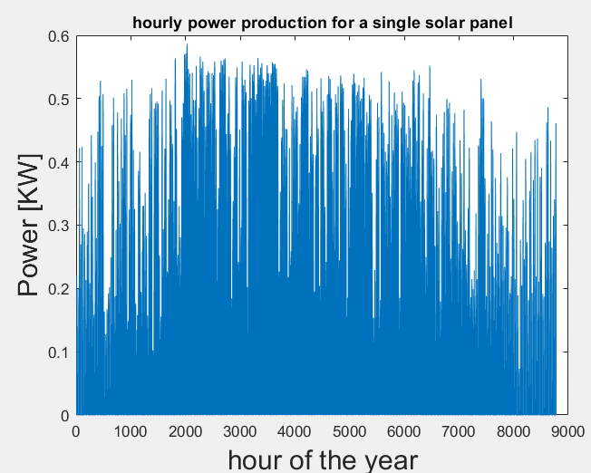

Figure 4, power generation for one of our pannels

### Hydro Storage

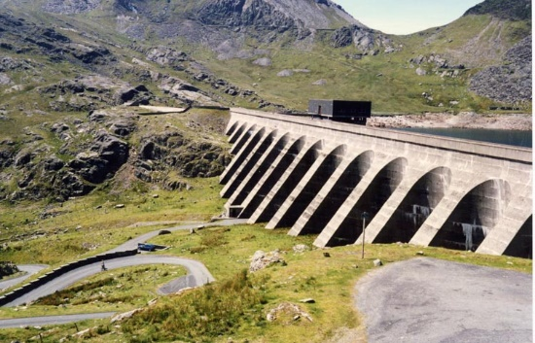

Figure 5, a Dam water torage in UK

Some useful numbers we used in our formulation bellow:

**Hydromax pumpMW=226.95 MW**

**Hydromax genMW=201.9 MW**

**Vw pumpper MW=(Wpumpper second*60*60)/Hydromax pumpMW**

**Vw lossperMW=(Wlossper second*60*60)/Hydromax genMW**

## Code layout

The basic idea of our script was, after assigning certain values for  Nsmr,Nwt,Npanels, to

1. Calculate the **available power** that could be pumped or generated by the **Hydro storage** facility depending on the difference between generation and demand
2. Decide the magnitude of the Gas power needed

You can find the Mathematical expressions of our model in ANEX I

# Results:

## Optimization:

After approximately 1250 interactions, the algorithm has converged to an optimized configuration with the aim of achieving the minimum gas usage throughout the entire year.

Figure , optimization of gas converging

The optimiced distribution (least gas) of energy plants is as follows:



Figure , our optimiced numbers

* Number of Small Modular Reactors (SMRs):
  + 36 units.
* Number of Wind Power Plants:
  + 1,011 turbines.
* Number of Solar Power Plants:
  + 8,017,500 panels.

This optimized configuration, resulting in a projected gas usage of 10650 GWh annually, reflects a significant achievement in meeting our goals of reducing reliance on natural gas and minimizing carbon emissions.

## Investment:

Our budget was numerically optimized to heavily invest in Nuclear SMR reactors as seen in the figure 4 below.

Figure , % of the budget spent in each clean source

It all makes sense when we calculate how much money is each resulting KW per source, Nuclear is a clear winner, each KW produced by nuclear is half the price than the one produced by wind.

Figure , price of KW per source

## Power mix:

These visual aids serve as powerful tools to communicate the success and efficacy of our chosen generation strategy for Brighton.

At this macro scale we get a general feeling of the importance and reliability of each generation source.

Figure , whole year power mix

By zooming in the strongest renewables week (mid april) we notice an abundance of both wind and solar generation.  
Our Gas combined cycle plants are working at very low load during this week

Figure , shows the week (mid-April) with the highest energy generated from renewable resources.

There is just one day from that week in which the water storage was drained due to demand being high. (brown)

By zooming again in the weakest renewables week (early January) we notice an almost complete lack of wind and only small solar production during the central hours of some days  
Our Gas combined cycle plants are working at nearly 100% load during this week

There is no generation coming from the water reservoir dam, previous weeks have demanded a lot of power generation from the dam, so it's by now mostly empty

Figure , shows the week (early-January) with the highest energy generated from gas power plants.

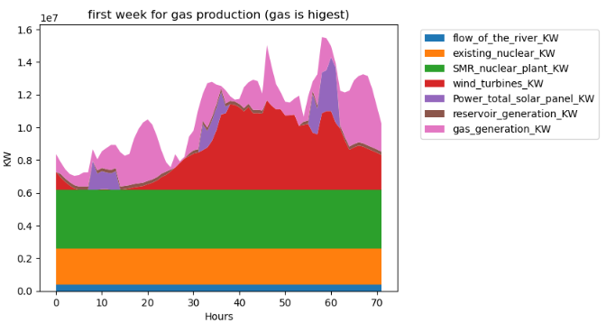

Figure , shows the first week of the year, notice the reservoir is being drained, (brown)

The water storage level for the whole year, it empties very rapidly due to the lack of renewables during the first month of the year but by the end of february it starts to fill again .

Figure , shows the variation of the water storage level throughout the entire year. (grid marks down months)

Our average KW generation contribution for each source results as follows:

Figure , pie chart of % generation for each source in the power mix (whole year averaged)

More than half of the mix comes from renewables, and more than 80% comes from “clean sources” (including nuclear)

At some hours of the year we will have excess of renewable generation, this would mean we would need to turn off turbines and solar plants or export excess energy.  
We have excess energy of 872GW/year

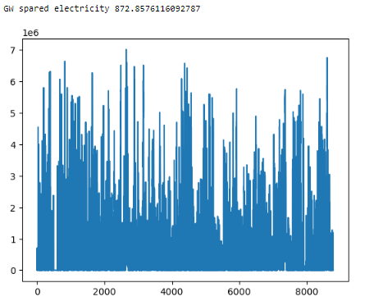

Figure , excess energy in the power mix in KW

## Gas Capacity Utilization:

With an installed gas capacity of **8,074 MW,** the optimization process ensures that the gas plants are utilized judiciously. The average annual usage of gas plant capacity at **22.3%** reflects a strategic balance, utilizing gas resources when necessary while maximizing the contribution of renewable energy sources.

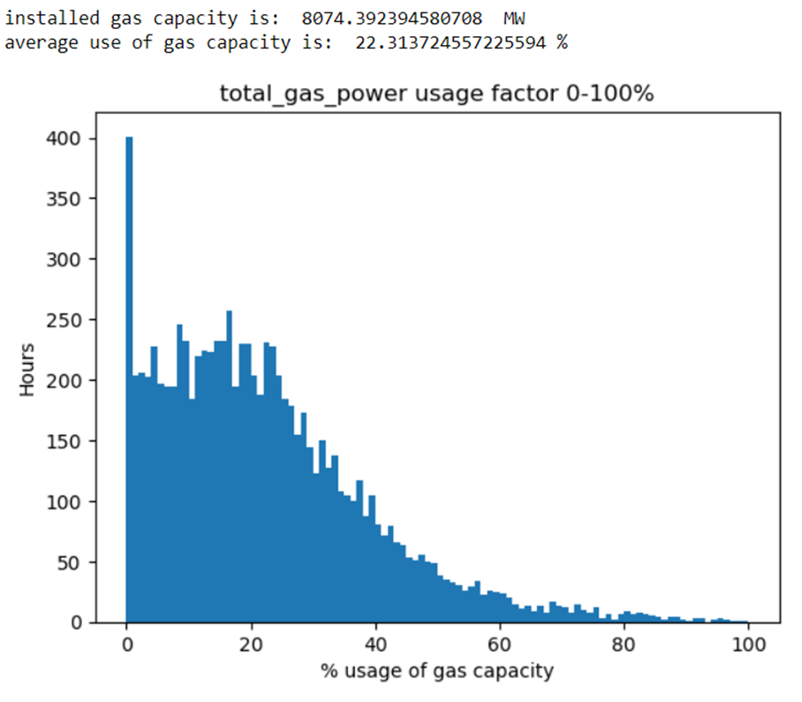

Figure , shows the percentage of usage of gas capacity throughout the year.

## 

## CO2 Emissions Analysis:

Looking at real UK data (2020), we have a very similar CO2 emission by source proportions.

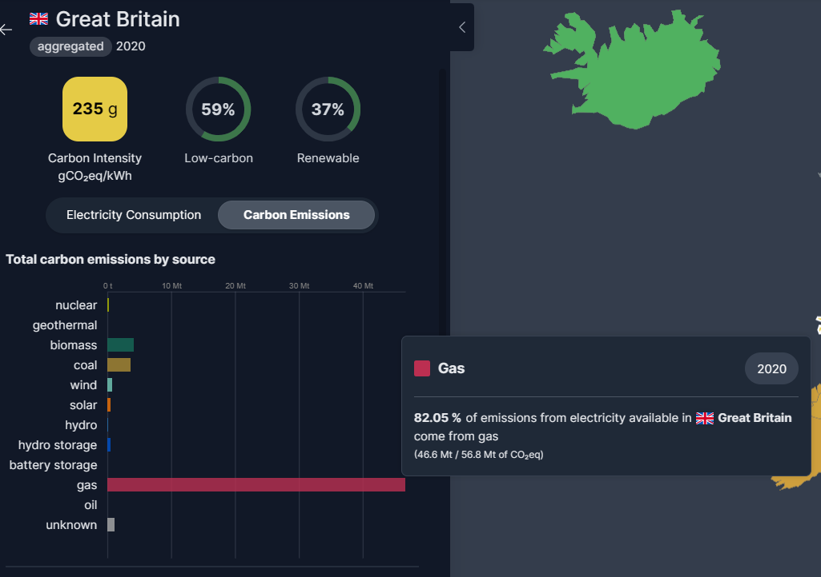

Figure , snap of real UK CO2 emissions

With our optimiced clean-energy power mix we would be cutting the current Brighton real CO2 emissions down to only a mere 33%

Figure , Pie chart of our optimized CO2 emissions by source

# Conclusion

In conclusion, the culmination of our efforts has yielded a diverse and sustainable energy mix for Brighton, effectively addressing the constraints outlined at the inception of this project.   
With 50% reliance on nuclear power, 21% from wind energy, 10% from solar energy, 14% from natural gas, and the remainder from hydropower, we have successfully crafted a well-balanced and resilient energy portfolio.

Our overall success is evident in achieving a harmonious blend of reliability, sustainability, and environmental responsibility. The 14% reliance on natural gas is a pragmatic compromise, striking a balance between stability in energy supply and the commitment to minimizing carbon emissions.

Recommendations for Future Improvements:

Technological Advancements:  
Stay abreast of technological advancements in renewable energy and storage solutions. As innovation progresses, incorporating cutting-edge technologies can further enhance the efficiency and sustainability of the energy mix.  
Maybe installation of offshore wind turbines would be in order.

Policy and Regulatory Framework:  
Advocate for supportive policies and regulatory frameworks that incentivize renewable energy adoption.   
Demonstrate that clean energy investment pays off.

In essence, our endeavor to minimize CO2 emissions, diversify the energy mix, and respect constraints has proven successful. The journey toward a greener and more sustainable future continues, and these recommendations serve as guideposts for ongoing improvement and innovation.

# Hypothetical Scenario

In response to the political agenda and electoral promises from the Environment Ministry and the Green  
Party, a hypothetical scenario unfolds where all small modular reactors (SMRs) are excluded from the energy mix budget for Brighton.  
 Instead, the budget initially allocated for SMRs is redirected towards bolstering the solar photovoltaic (PV) energy infrastructure.  
This strategic shift in the energy landscape is underpinned by local residents “NIMBY” movement, and public fear caused by poorly informed individuals about nuclear energy safety standards.

## Results from hypotetical scenario:

By diverting all the budget from SMR back to PV panels, we get a staggering number of 38 million pannels and the same number of turbines, nonetheless to say this mix won't be very optimized.  
  
Gas increases a lot defeating the purpose of clean energy the UK Green party had in their agenda.

Figure , our hypoteticall power mix source

The generation mix results as follows, huge spikes of solar and gas.

Figure ,shows the amount of energy generated from each technology throughout the entire year.

The best week for renewables looks

Figure ,shows the week (mid-April) with the highest energy generated from renewable resources.

Figure ,shows the week (mid-January) with the highest energy generated from gas power plants.

As we won’t have the luxury of continuous nuclear generation our power mix would sling between having too much energy and too little.  
This would result in more combined cycle capacity installed and more excess energy in total,

Figure , spared electricity trough the year

Our energy mix is lacking except in summer when there is enough renewables, this effect can be seen in the water storage fill level figure 21.

Figure ,shows the variation of the water storage level throughout the entire year.

The Combined cycle plants capacity needs to be much higher now but its load through the year is going to be lower than our optimiced mix.

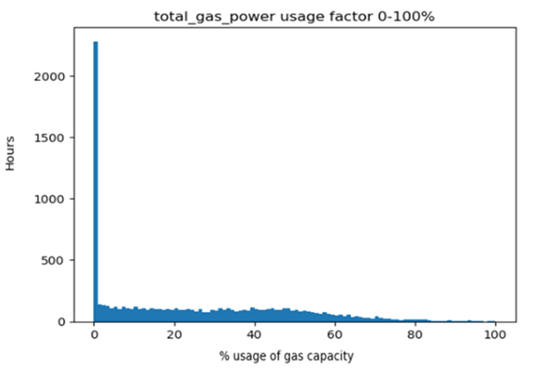

Figure ,shows the percentage of usage of gas capacity throughout the year.

# Anex I

**Step 1:** First we calculated the **total generation** (**Gen(h)**) in an hourly time step without taking into consideration the **Power produced or pumped** from the the Hydro storage facility (**Pstore**).

**h ∈ (1:8760) : Gen(h)= Pnucexist(h)+PRoRexist(h)+Pwind(h)+Psmr(h)+Ppv(h)**

**Pnucexist(h), PRoRexist(h)**                                                                       are both constant through the year

**Pwind(h)=**Nwt*PperWT(h)were PperWT(h)is the hourly generation of a single WT

**Psmr(h)=**Nwt*PperSMR(h)were PperSMR(h)is constant of 100 MW

**Ppv(h)=**Nwt*PperPanel(h)were PperPanel(h)is the hourly generation of a single PV Panel

**Step 2:** Then we calculated the **difference between Generation and Demand**

**h ∈ (1:8760) : Dif(h)=Gen(h)-Demand(h)**

**Step 3:** By Calculating the difference we could start working on the conditions on how to use the  **Hydro storage plant**.In this part the **hydro plant** was **considered a load** therefore if the

* **Dif(h)>0** we pump and the **Pstore(h)>0**
* **Dif(h)<0** we generate and the **Pstore(h)<0**

**h ∈ (1:8760) : Dif(h)=Gen(h)-Demand(h)**

1. In case **generation meets demand**, which translated into**Dif(h)=0**Then:
   * **Reslevel(h)=Reslevel(h-1)**
   * **Pstore(h)=0**
   * **Surplus(h)=0**
   * **Pgas(h)=0**

1. In case **generation exceeds demand** & **difference is less than the hydro can pump**   
    **Dif(h)>0** &        **Dif(h)<=Hydromax pumpMW**we have the following scenarios:
   * **Reslevel(h-1)+(Dif(h)*Vw pumpper MW)<=Resupper limit**
     + **Reslevel(h)=Reslevel(h-1)+(Dif(h)*Vw pumpper MW)**
     + **Pstore(h)=Dif(h)**
     + **Surplus(h)=0**
     + **Pgas(h)=0**
   * **Reslevel(h-1)+(Dif(h)*Vw pumpper MW)>Resupper limit**
     + **Reslevel(h)=Resupper limit**
     + **Pstore(h)=[Resupper limit-Reslevel(h-1)]/Vw pumpper MW**
     + **Surplus(h)=Dif(h)-Pstore(h)**
     + and **Pgas(h)=0**
2. In case **generation exceeds demand** &if the **difference is more than the hydro can pump**  **Dif(h)>0** &      **Dif(h)>Hydromax pumpMW**we have the following scenarios:
   * **Reslevel(h-1)+(Hydromax pumpMW*Vw pumpper MW)<=Resupper limit**
     + **Reslevel(h)=Reslevel(h-1)+(Hydromax pumpMW*Vw pumpper MW)**
     + **Pstore(h)=Hydromax pumpMW**
     + **Surplus(h)=Dif(h)-Hydromax pumpMW**
     + and **Pgas(h)=0**
   * **Reslevel(h-1)+(Hydromax pumpMW*Vw pumpper MW)>Resupper limit**
     + **Reslevel(h)=Resupper limit**
     + **Pstore(h)=[Resupper limit-Reslevel(h-1)]/Vw pumpper MW**
     + **Surplus(h)=Dif(h)-Pstore(h)**
     + and **Pgas(h)=0**
3. In case **demand is greater than generation** &if the **absolute values of difference is less than the hydro can generate   
   Dif(h)<0** & **abs[Dif(h)]<=Hydromax genMW**we have the following scenarios:
   * **Reslevel(h-1)-(abs[Dif(h)]*Vw lossperMW)>0**
     + **Reslevel(h)=Reslevel(h-1)-(abs[Dif(h)]*Vw lossperMW)**
     + **Pstore(h)=Dif(h)**
     + **Surplus(h)=0**
     + **Pgas(h)=0**
   * **Reslevel(h-1)-(abs[Dif(h)]*Vw lossperMW)<=0**
     + **Reslevel(h)=0**
     + **Pstore(h)=[-1 *Reslevel(h-1)]/Vw lossperMW**
     + **Surplus(h)=Dif(h)-Pstore(h)**
     + and **Pgas(h)=abs[Dif(h)]-Pstore(h)**
4. In case **demand is greater than generation** &if the **absolute values of difference is greater than the hydro can generate   
   Dif(h)<0** & **abs[Dif(h)]>Hydromax genMW**we have the following scenarios:
   * **Reslevel(h-1)-(Hydromax genMW*Vw lossperMW)>0**
     + **Reslevel(h)=Reslevel(h-1)-(Hydromax genMW*Vw lossperMW)**
     + **Pstore(h)=-Hydromax genMW**
     + **Surplus(h)=0**
     + **Pgas(h)=abs[Dif(h)]-Hydromax genMW**
   * **Reslevel(h-1)-(Hydromax genMW*Vw lossperMW)<=0**
     + **Reslevel(h)=0**
     + **Pstore(h)=[-1 *Reslevel(h-1)]/Vw lossperMW**
     + **Surplus(h)=0**
     + and **Pgas(h)=abs[Dif(h)]-Pstore(h)**

**Step 4:** Now exiting the conditional loop we sum the total energy generated by gas. This parameter is the value our solver minimized.

**Egastotal=18760  Pgas(h)**