mi primer documento rmarkdown

ricardogasku

21 de febrero de 2020

## R Markdown

This is an R Markdown document. Markdown is a simple formatting syntax for authoring HTML, PDF, and MS Word documents. For more details on using R Markdown see <http://rmarkdown.rstudio.com>.

When you click the **Knit** button a document will be generated that includes both content as well as the output of any embedded R code chunks within the document. You can embed an R code chunk like this:

summary(cars)

## speed dist   
## Min. : 4.0 Min. : 2.00   
## 1st Qu.:12.0 1st Qu.: 26.00   
## Median :15.0 Median : 36.00   
## Mean :15.4 Mean : 42.98   
## 3rd Qu.:19.0 3rd Qu.: 56.00   
## Max. :25.0 Max. :120.00

incluir otro fragmento de texto

summary(iris)

## Sepal.Length Sepal.Width Petal.Length Petal.Width   
## Min. :4.300 Min. :2.000 Min. :1.000 Min. :0.100   
## 1st Qu.:5.100 1st Qu.:2.800 1st Qu.:1.600 1st Qu.:0.300   
## Median :5.800 Median :3.000 Median :4.350 Median :1.300   
## Mean :5.843 Mean :3.057 Mean :3.758 Mean :1.199   
## 3rd Qu.:6.400 3rd Qu.:3.300 3rd Qu.:5.100 3rd Qu.:1.800   
## Max. :7.900 Max. :4.400 Max. :6.900 Max. :2.500   
## Species   
## setosa :50   
## versicolor:50   
## virginica :50   
##   
##   
##

boxplot(cars$speed)

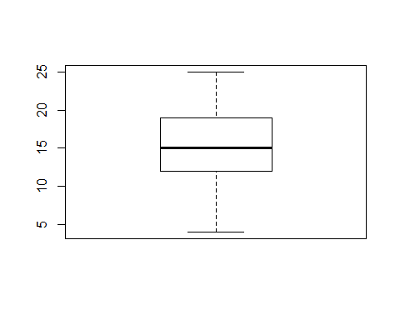

generamos un vector y le sacamos estadisticas

vect <- rep(1:20,200)  
summary(vect)

## Min. 1st Qu. Median Mean 3rd Qu. Max.   
## 1.00 5.75 10.50 10.50 15.25 20.00

boxplot(vect, main="my vector")

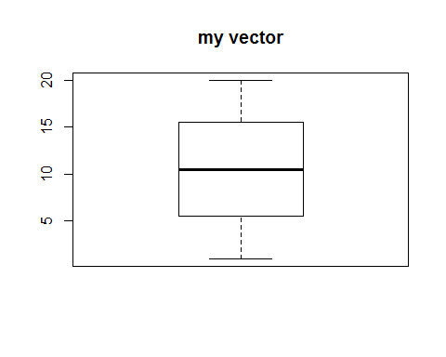

## Including Plots

You can also embed plots, for example:



Note that the echo = FALSE parameter was added to the code chunk to prevent printing of the R code that generated the plot.

diccionario de tipos de texto  
**negrita**  
*cursiva*  
~~tachado~~  
esto se escribe en markdown 10.5 $A=π*r^{2}$