**1-create new repository called chat in github**

**2-python –m venv venv**

**3- venv\Scripts\activate**

**4-pip install django**

**5-django-admin startprojet studybud .**

**6-python manage.py startapp base**

**7-add base app to installed_apps in settings.py**

**8-create template folder inside chat app and create another folder inside it called chat:**

**9-create lobby.html file inside chat folder:**

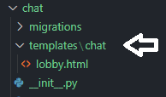

**10-lobby.html:**

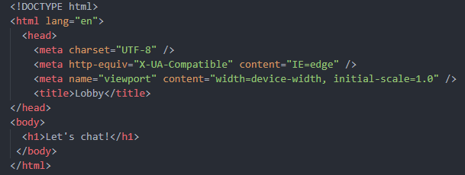

**11-views.py chat app:**



**12-urls.py chat app:**

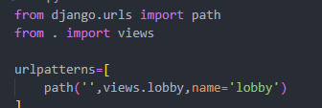

**13-urls.py project:**

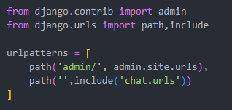

**14-runserver:**

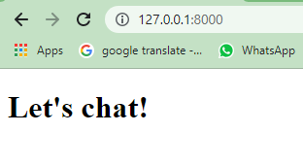

**Everything is good.**

**15-pip install channels**

**16-add channels to installed apps:**

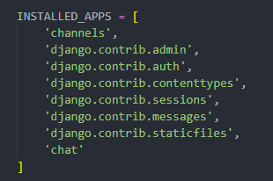

**now it's time to integrate channels so let's start by creating the routing configuration.**

**a channel's routing configuration is an asgi application that is similar to a django configuration in that it tells channels what code to run when an http request is received by a channel server.**

**17-asgi.py mywebsite project:**

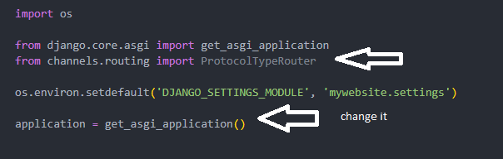



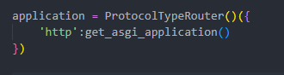

**18-settings.py:**



**let's ensure that the channel's development server is working correctly by starting up our server using the run server command if everything was done correctly you'll see something like this indicating that the channel's development server has taken over our django development server:**

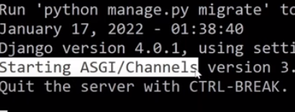

**19-lobby.html:**

**Now we work for client side to establish a websocket connection in our lobby.html:**