Name of structure to be created
Scale factor in angsroms
5.43

Size
4 4 4

Direct lattice vectors (Cartesian canonic coordinates)
0 0.5 0.5
0.5 0 0.5
0.5 0.5 0

Basis vectors
2
Si 0 0 0
Si 0.25 0.25 0.25

Planes
0

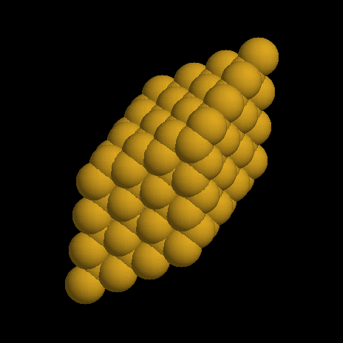
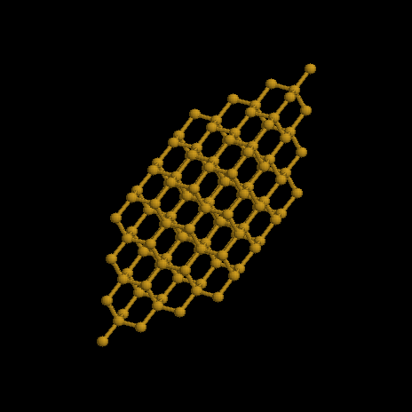

Name of structure to be created
Scale factor in angsroms
5.43

Size
15 15 15

Direct lattice vectors (Cartesian canonic coordinates)
0 0.5 0.5
0.5 0 0.5
0.5 0.5 0

Basis vectors
2
Si 0 0 0
Si 0.25 0.25 0.25

Planes
6
-1 0 0
6 6 6
1 0 0
10 10 10
0 -1 0
6 6 6
0 1 0
10 10 10
0 0 -1
6 6 6
0 0 1
10 10 10
1 2 4
7.5 7.5 7.5

