Table 1: Demographic Characteristics of Multiple Sclerosis Cases in Chile (2010–2023), Stratified by Healthcare System
Characteristic | FONASA | ISAPRE | FFAA | Total Cohort
Total Cases (N) | 2,119 | 1,878 | 121 | 4,118
Female (N, %) | 1,451 (68.5%) | 1,242 (66.1%) | 67 (55.4%) | 2,759 (67.0%)
Female-to-Male Ratio | 2.17:1 | 1.95:1 | 1.24:1 | 2.03:1
Mean Age at Diagnosis (yrs, SD) | 34.41 (±12.26) | 37.24 (±12.31) | 44.23 (±19.69) | 35.99 (±12.72)
Abbreviations: FFAA = Armed Forces and Police Healthcare System; FONASA = Public National Health Fund; ISAPRE = Private Health Insurance Institutions; SD = standard deviation.
Table 2: Crude and Age-Standardized Incidence of Multiple Sclerosis per 100,000 Population in Chile, 2010–2023
Year | Cases | Incidence per 100,000 | Age-Standardized Incidence per 100,000
2010 | 381 | 2.23 | 2.59
2011 | 325 | 1.88 | 2.02
2012 | 212 | 1.22 | 1.32
2013 | 241 | 1.37 | 1.50
2014 | 233 | 1.31 | 1.44
2015 | 223 | 1.24 | 1.32
2016 | 221 | 1.22 | 1.69
2017 | 335 | 1.82 | 2.00
2018 | 382 | 2.04 | 2.23
2019 | 287 | 1.50 | 1.59
2020 | 276 | 1.42 | 1.57
2021 | 362 | 1.84 | 2.27
2022 | 356 | 1.80 | 2.01
2023 | 284 | 1.42 | 1.42
Table 3: Comparison of Prevalence of Multiple Sclerosis per 100,000 Population Across Chilean Healthcare Systems, 2023
Healthcare System | Beneficiaries | MS Cases | Crude Prevalence | Age-Standardized Prevalence (95% CI)
FONASA (Public) | 16,229,898 | 2,042 † | 12.58 | 12.97 (12.41–13.5)
ISAPRE (Private) | 2,788,257 | 1,878 | 67.35 | 61.60 (58.69–64.5)
Abbreviations: CI = confidence interval; FONASA = Public National Health Fund; ISAPRE = Private Health Insurance Institutions; MS = multiple sclerosis. † Of the 2,119 FONASA cases in Table 1, 77 individuals died prior to 31 December 2023 and were excluded from the prevalence calculation.
Table 4: Mean Annual Incidence Rate of RRMS per 100,000 Inhabitants by Age Group and Sex, Chile 2011–2023
Age Group  (years) | Total  Cases (N) | Female  Cases (N) | Male  Cases (N) | Total Rate  (95% CI) | Female Rate  (95% CI) | Male Rate  (95% CI)
0–4 | 2 | 1 | 1 | 0.01 (0.00–0.05) | 0.01 (0.00–0.07) | 0.01 (0.00–0.07)
5–9 | 17 | 9 | 8 | 0.11 (0.06–0.17) | 0.11 (0.05–0.22) | 0.10 (0.04–0.19)
10–14 | 38 | 25 | 13 | 0.23 (0.16–0.32) | 0.31 (0.20–0.46) | 0.16 (0.08–0.27)
15–19 | 206 | 120 | 86 | 1.21 (1.05–1.38) | 1.43 (1.19–1.71) | 0.99 (0.79–1.22)
20–24 | 426 | 262 | 164 | 2.27 (2.06–2.49) | 2.83 (2.50–3.19) | 1.72 (1.46–2.00)
25–29 | 641 | 410 | 231 | 3.27 (3.02–3.54) | 4.24 (3.84–4.68) | 2.33 (2.04–2.65)
30–34 | 619 | 421 | 198 | 3.27 (3.02–3.54) | 4.50 (4.08–4.95) | 2.07 (1.79–2.38)
35–39 | 493 | 332 | 161 | 2.79 (2.55–3.05) | 3.78 (3.38–4.21) | 1.81 (1.54–2.11)
40–44 | 388 | 290 | 98 | 2.31 (2.09–2.55) | 3.45 (3.06–3.87) | 1.17 (0.95–1.42)
45–49 | 357 | 236 | 121 | 2.21 (1.99–2.45) | 2.89 (2.54–3.29) | 1.52 (1.26–1.81)
50–54 | 230 | 164 | 66 | 1.51 (1.32–1.72) | 2.11 (1.80–2.46) | 0.89 (0.69–1.13)
55–59 | 157 | 114 | 43 | 1.14 (0.97–1.33) | 1.60 (1.32–1.92) | 0.64 (0.47–0.87)
60–64 | 79 | 55 | 24 | 0.68 (0.54–0.84) | 0.90 (0.68–1.17) | 0.43 (0.28–0.64)
65–69 | 53 | 40 | 13 | 0.57 (0.43–0.75) | 0.81 (0.58–1.10) | 0.30 (0.16–0.52)
70–74 | 21 | 16 | 5 | 0.31 (0.19–0.47) | 0.42 (0.24–0.69) | 0.16 (0.05–0.38)
75–79 | 5 | 3 | 2 | 0.10 (0.03–0.24) | 0.11 (0.02–0.31) | 0.10 (0.01–0.35)
≥80 | 5 | 3 | 2 | 0.08 (0.03–0.18) | 0.07 (0.01–0.21) | 0.09 (0.01–0.31)
Rates per 100,000 person-years, pooled across 2011–2023. Year 2010 excluded (baseline; incorporates pre-existing FFAA cases consolidated from 2001–2009). Exact Poisson 95% confidence intervals. Abbreviations: CI = confidence interval; RRMS = relapsing-remitting multiple sclerosis.
Figure 5. Mean annual incidence rate of RRMS per 100,000 by five-year age group and sex, Chile 2011–2023. Error bars represent exact Poisson 95% confidence intervals. Abbreviations: RRMS = relapsing-remitting multiple sclerosis.
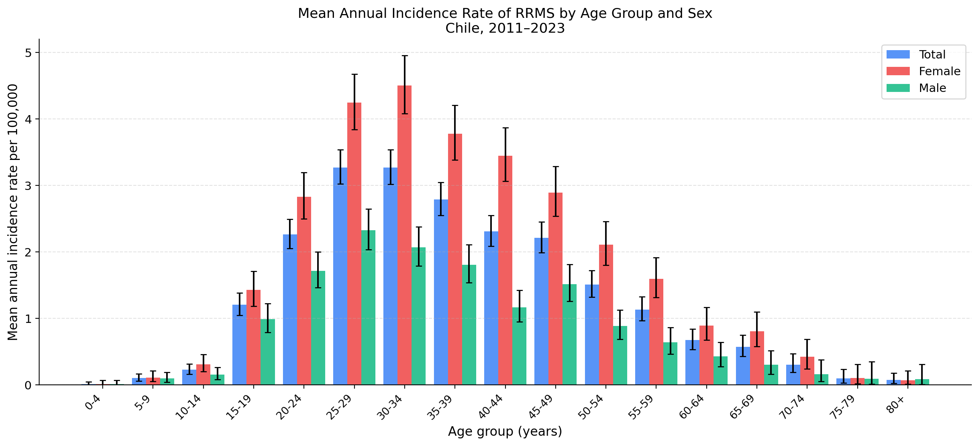
Table 5: Prevalence of RRMS per 100,000 Inhabitants by Age Group and Sex, Chile 2023
Age Group  (years) | Total  Cases (N) | Female  Cases (N) | Male  Cases (N) | Total Rate  (95% CI) | Female Rate  (95% CI) | Male Rate  (95% CI)
0–4 | 2 | 1 | 1 | 0.17 (0.02–0.61) | 0.17 (0.00–0.96) | 0.17 (0.00–0.93)
5–9 | 17 | 9 | 8 | 1.37 (0.80–2.19) | 1.48 (0.67–2.80) | 1.26 (0.55–2.49)
10–14 | 44 | 26 | 18 | 3.39 (2.46–4.55) | 4.08 (2.66–5.98) | 2.72 (1.61–4.31)
15–19 | 226 | 135 | 91 | 18.29 (15.99–20.84) | 22.24 (18.64–26.32) | 14.49 (11.66–17.78)
20–24 | 451 | 278 | 173 | 33.66 (30.63–36.92) | 42.15 (37.34–47.40) | 25.43 (21.78–29.52)
25–29 | 676 | 436 | 240 | 43.44 (40.23–46.85) | 56.85 (51.64–62.45) | 30.41 (26.69–34.51)
30–34 | 666 | 453 | 213 | 38.96 (36.06–42.03) | 53.76 (48.92–58.95) | 24.57 (21.38–28.10)
35–39 | 546 | 367 | 179 | 36.04 (33.08–39.19) | 49.06 (44.17–54.35) | 23.34 (20.04–27.02)
40–44 | 423 | 316 | 107 | 30.21 (27.40–33.23) | 45.42 (40.55–50.72) | 15.18 (12.44–18.35)
45–49 | 394 | 263 | 131 | 29.64 (26.78–32.72) | 39.44 (34.82–44.51) | 19.77 (16.53–23.46)
50–54 | 252 | 183 | 69 | 20.50 (18.05–23.20) | 29.35 (25.26–33.93) | 11.39 (8.86–14.42)
55–59 | 163 | 117 | 46 | 13.63 (11.62–15.89) | 19.05 (15.75–22.83) | 7.90 (5.79–10.54)
60–64 | 75 | 53 | 22 | 7.05 (5.55–8.84) | 9.55 (7.16–12.50) | 4.33 (2.71–6.55)
65–69 | 56 | 42 | 14 | 6.25 (4.72–8.11) | 8.80 (6.34–11.90) | 3.34 (1.83–5.60)
70–74 | 21 | 17 | 4 | 3.08 (1.90–4.70) | 4.56 (2.66–7.30) | 1.29 (0.35–3.30)
75–79 | 7 | 5 | 2 | 1.49 (0.60–3.06) | 1.87 (0.61–4.37) | 0.98 (0.12–3.54)
≥80 | 4 | 3 | 1 | 0.65 (0.18–1.67) | 0.77 (0.16–2.25) | 0.45 (0.01–2.48)
Rates per 100,000 inhabitants as of 31 December 2023. Exact Poisson 95% confidence intervals. Abbreviations: CI = confidence interval; RRMS = relapsing-remitting multiple sclerosis.
Figure 6. Prevalence of RRMS per 100,000 by five-year age group and sex, Chile 2023. Error bars represent exact Poisson 95% confidence intervals. Abbreviations: RRMS = relapsing-remitting multiple sclerosis.
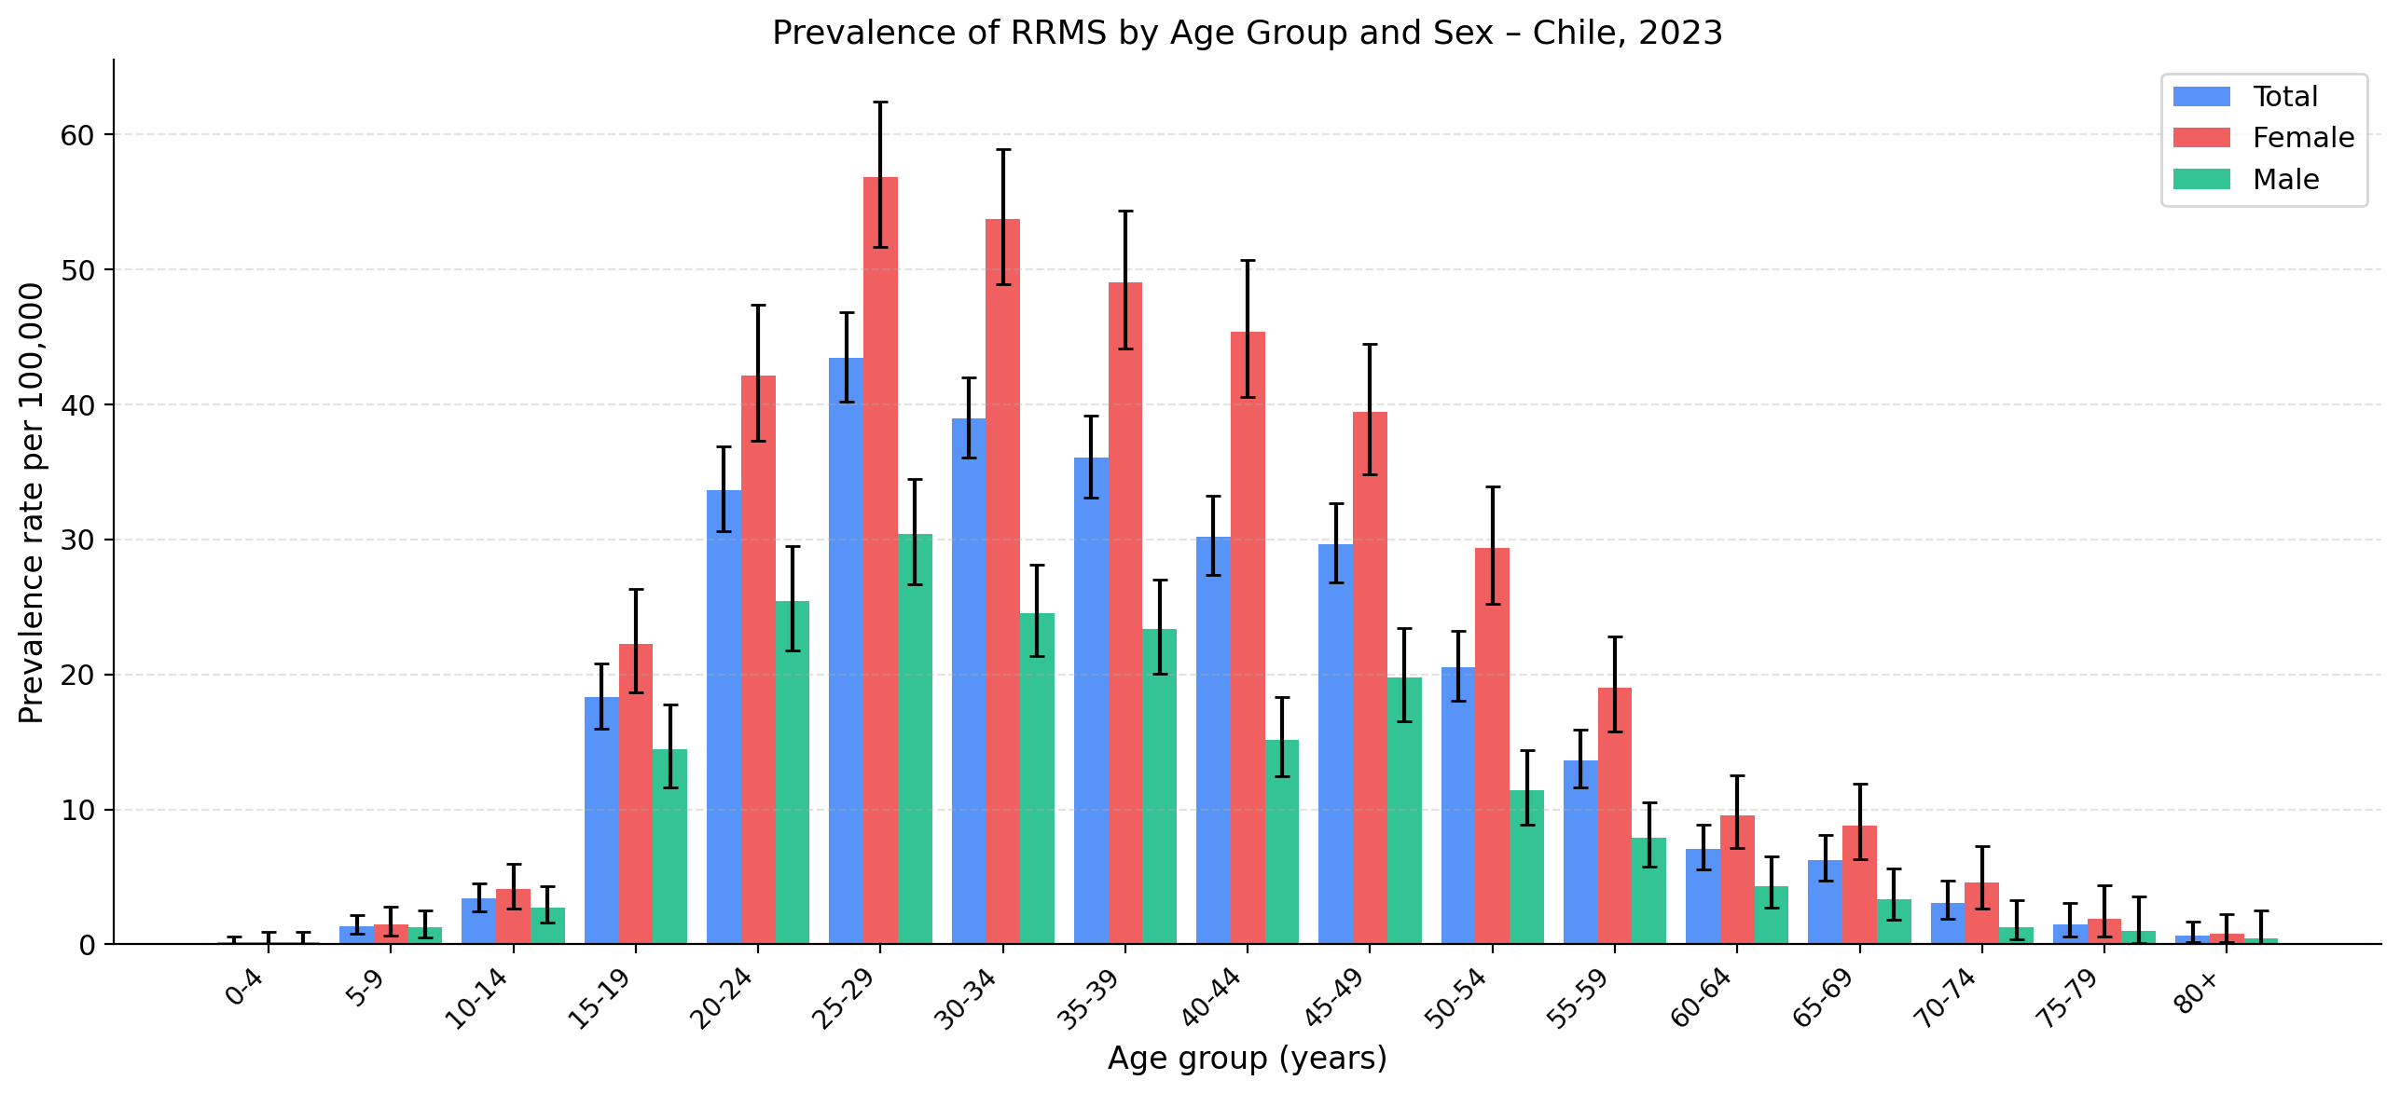
Table 6: Crude and Age-Standardized Prevalence of RRMS per 100,000 Inhabitants by Region, Chile 2023
Region | Crude Prevalence  (per 100,000) | Age-Standardized Prevalence  (per 100,000) | Latitude (°S)
De Arica y Parinacota | 2.31 | 8.00 | 18.5
De Tarapacá | 4.98 | 10.16 | 20.2
De Antofagasta | 11.06 | 12.18 | 23.6
De Atacama | 10.66 | 21.62 | 27.4
De Coquimbo | 9.55 | 12.79 | 30.0
De Valparaíso | 14.02 | 17.85 | 32.9
Metropolitana de Santiago | 30.08 | 30.91 | 33.5
Del Libertador B. O'Higgins | 11.20 | 15.73 | 34.6
Del Maule | 10.67 | 14.56 | 35.5
De Ñuble | 14.63 | 22.18 | 36.7
Del Bíobío | 15.70 | 23.47 | 37.4
De La Araucanía | 14.30 | 22.27 | 38.5
De Los Ríos | 16.29 | 23.15 | 40.0
De Los Lagos | 13.78 | 16.18 | 41.5
De Aisén del Gral. C. Ibáñez del Campo | 12.00 | 26.28 | 45.5
De Magallanes y de La Antártica Chilena | 39.51 | 50.93 | 53.2
Rates standardized to the WHO 2000–2025 World Standard Population using direct standardization. Regions ordered from north (lowest latitude) to south (highest latitude). Latitude corresponds to the regional capital (Coyhaique, 45.5°S for Aisén). Pearson correlation between WHO age-standardized prevalence and latitude: r = 0.784 (95% CI: 0.471–0.921; p<0.001; n = 16). Abbreviations: ASR = age-standardized rate; RRMS = relapsing-remitting multiple sclerosis.

