Diagrama_de_clases

Class Specification Report

Author: Author

Revision: 0.2

|  |  |
| --- | --- |
| No Magic |  |
| One Allen Center, 700 Central Expressway South, Suite 110 Allen, Texas 75013 USA | junio 02, 2020 |

**Approval**

|  |
| --- |
| The original of this document is approved and signed by:  Name:  Surname:  Title:  Date:  Signature: |

**Revision History**

|  |  |  |  |
| --- | --- | --- | --- |
| **Revision** | **Date** | **Description** | **Author** |
| 0.1 | <date 1> | <draft> | <Author name> |
| 0.2 | <date 2> | <release> | <Author name> |
|  |  |  |  |

| Table of Contents |
| --- |
| Microsoft Word users please click here and press F9 to create Table of Contents.  OpenOffice.org users please remove this text and select Insert Table of Content from menu. |

| Table of Figures |
| --- |
| Microsoft Word users please click here and press F9 to create Table of Contents.  OpenOffice.org users please remove this text and select Insert Table of Content from menu. |

# **Introduction**

## **Purpose**

This document provides class, interface, and enumeration specification. The specification provides the details of the types being modeled within the system

## **Scope**

This document is intended to define class specification for the {System Name}.

## **Overview**

This document provides a list of all packages with a summary for each. Each package has a section that contains a list of its classes, interfaces and enumeration type, with a summary for each. Class and Interface contains description, summary tables, detailed member descriptions, and relation table.

# **Appendix A: Diagram**

## **Model**

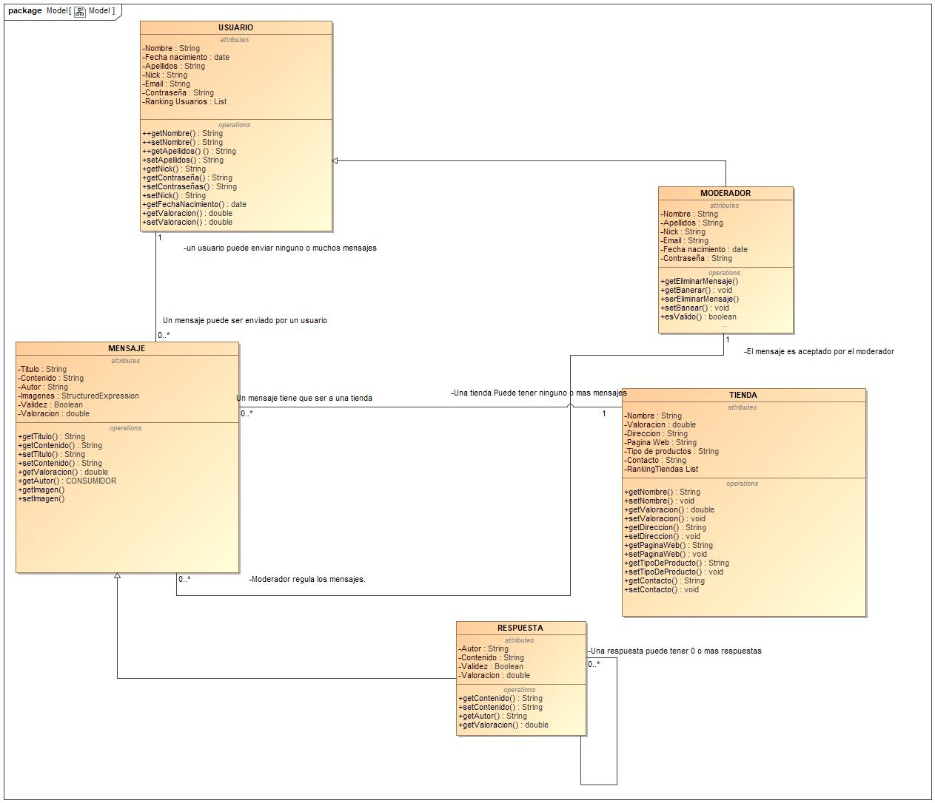

1. Model