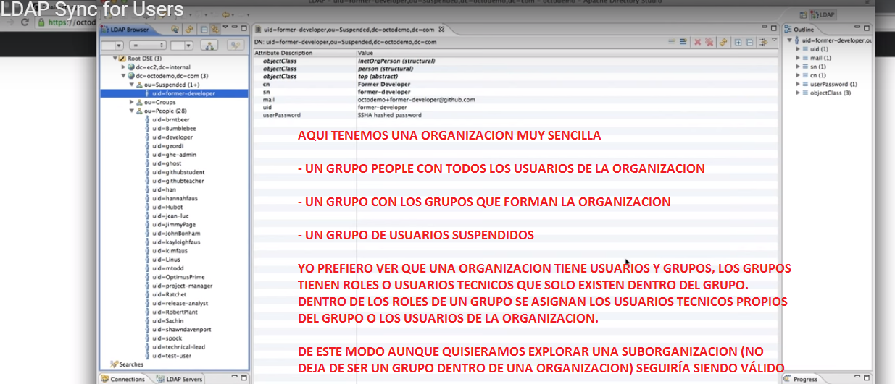

Una forma de gestionar diferentes organizaciones dentro de una empresa por países

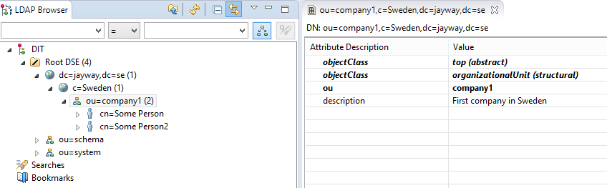

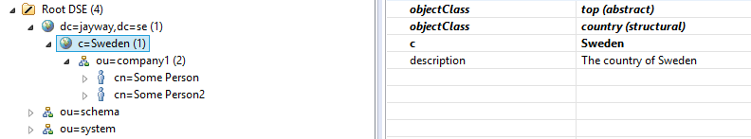

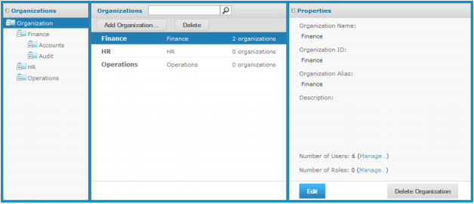

Figure 2-2 Organization Admin View of Manage Organizations Page  
2.1.1 Viewing Organization Properties  
1. Log in as a user with administrative privileges for the organization.  
2. Select Manage > Organizations.  
The organization management page appears, as shown in Figure 2-1 or Figure 2-2.  
3. To select an organization, click its parent in the left Organizations panel, then select the organization in the  
center panel. If there are many organizations, you can search for a specific organization, but the search will  
find only organization in the center Organizations panel.  
4. Once you select an organization, the Properties panel on the right shows information about it:  
• Name – Display name of the organization that appears on the organization’s top folder.  
• ID – Unique and permanent organization ID used for logging into it.  
• Alias – Unique but editable short organization name that can also be used when logging in.  
• Description – Optional description that appears only in this Properties panel.  
• Number of Users – Count of all users, including those in any suborganizations. Click Manage to see  
the list of users on the user management page.  
• Number of Roles – Count all roles, including those in any suborganizations. The number of roles does  
not include the system roles (such as ROLE_USER) that appear at every organization level but are  
defined at the root level. Click Manage to see the list of roles on the role management page.  
• For information about attributes on the organization, see 2.4.6, “Managing Organization Attributes,”  
on page 41.

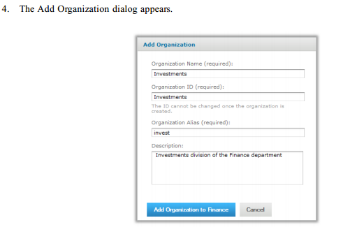

|  |
| --- |
| DIAGRAMA DE LA ORGANIZACION |
| SEGÚN LO QUE PINCHES EN EL DIAGRAMA, AQUÍ SE MOSTRARÁ EL FORMULARIO ASOCIADO, PARA EDITAR O AÑADIR UN HIJO, ETC. |
|  |

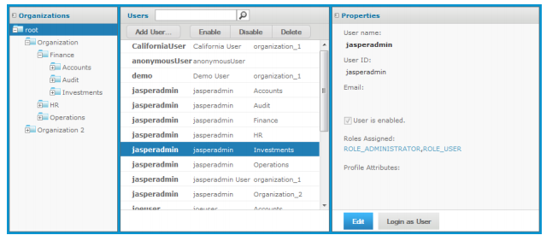

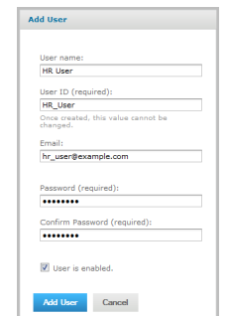

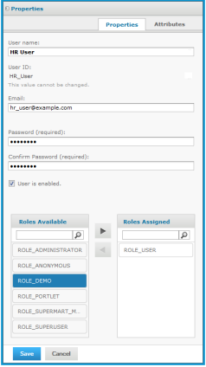

Table 2-2 Default Roles in JasperReports Server Installations  
32 TIBCO Software Inc.  
Chapter 2 Organization, User, and Role Management  
Role Description  
ROLE_ADMINISTRATOR This role determines organization admin privileges, as explained in 1.3.2,  
“Delegated Administration,” on page 17. This role is automatically  
assigned to the default jasperadmin user in every new organization. It's a  
special system-level role visible in every organization, and organization  
admins can assign to other users.  
Never delete this role, it's required for proper administration of the server.  
ROLE_USER Required to log in. This role is automatically assigned to every  
JasperReports Server user. It's a special system-level role visible in every  
organization.  
Never delete this role, it's required to create users and allow them to log in.  
ROLE_ANONYMOUS When anonymous access is enabled, this role is automatically assigned to  
any agent accessing the server without logging in. It's a special systemlevel role visible in every organization. This role is also assigned to the  
default anonymous user. By default, anonymous access is disabled and this  
role isn’t used. It's a system role that even the system admin can't delete.  
ROLE_PORTLET JasperReports Server assigns this role to users that are created  
automatically when a portal such as Liferay requests authentication for a  
connection. If the specified user name does not exist in the server, it is  
created, assigned the password of the user in the portal, and assigned the  
ROLE_PORTLET and ROLE_USER roles. If you do not use a portal server,  
you can delete this role.  
ROLE_DEMO This role grants access to the SuperMart demo Home page, reports, and if  
you implement Jaspersoft OLAP, OLAP views. This role is assigned to the  
demo user in the default organization. These objects are available only if  
you installed the sample data when you installed JasperReports Server. It is  
a special system-level role that is visible in every organization  
When you no longer need the sample data, this role can be deleted.  
ROLE_SUPERMART_  
MANAGER  
This role is used to assign permissions relative to the sample data. It is a  
special system-level role that is visible in every organization. It  
demonstrates data security features available in Jaspersoft OLAP. See the  
Jaspersoft OLAP Ultimate Guide for more information.  
When you no longer need the sample data, this role can be deleted.  
ROLE_ETL_ADMIN This role no longer governs any JasperReports Server permissions or  
functionality, unless your server is integrated with Talend Integration Suite  
Enterprise Edition (TIS EE). Otherwise, it does not appear in the server.

Except for the five special system-level roles visible in every organization, roles are defined within  
organizations. The same role ID can be defined in multiple organizations, as long as it is unique within eac

