1. Connection with GitLab

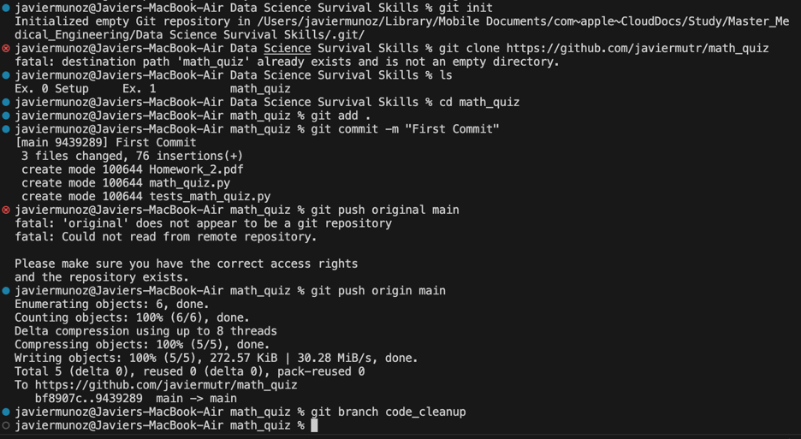

1. Math quiz file

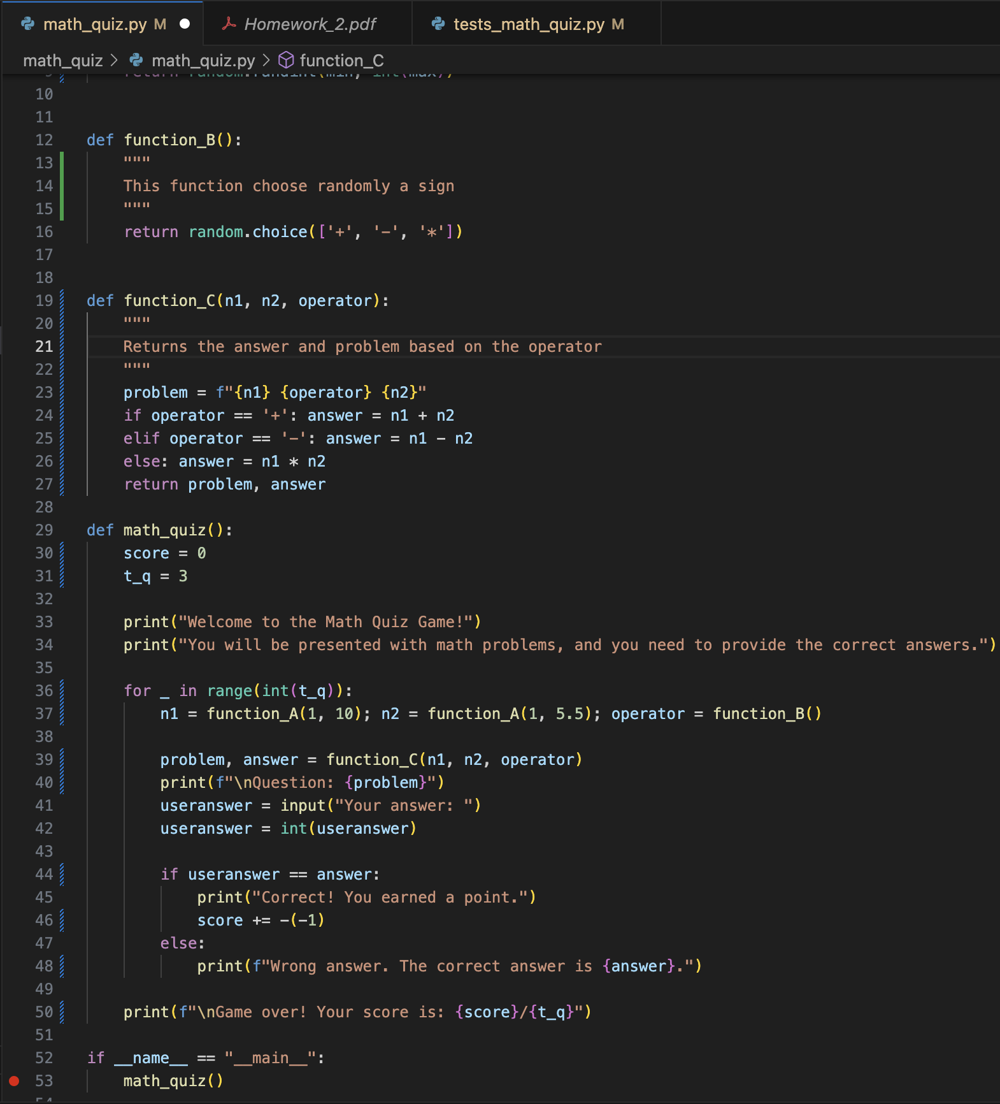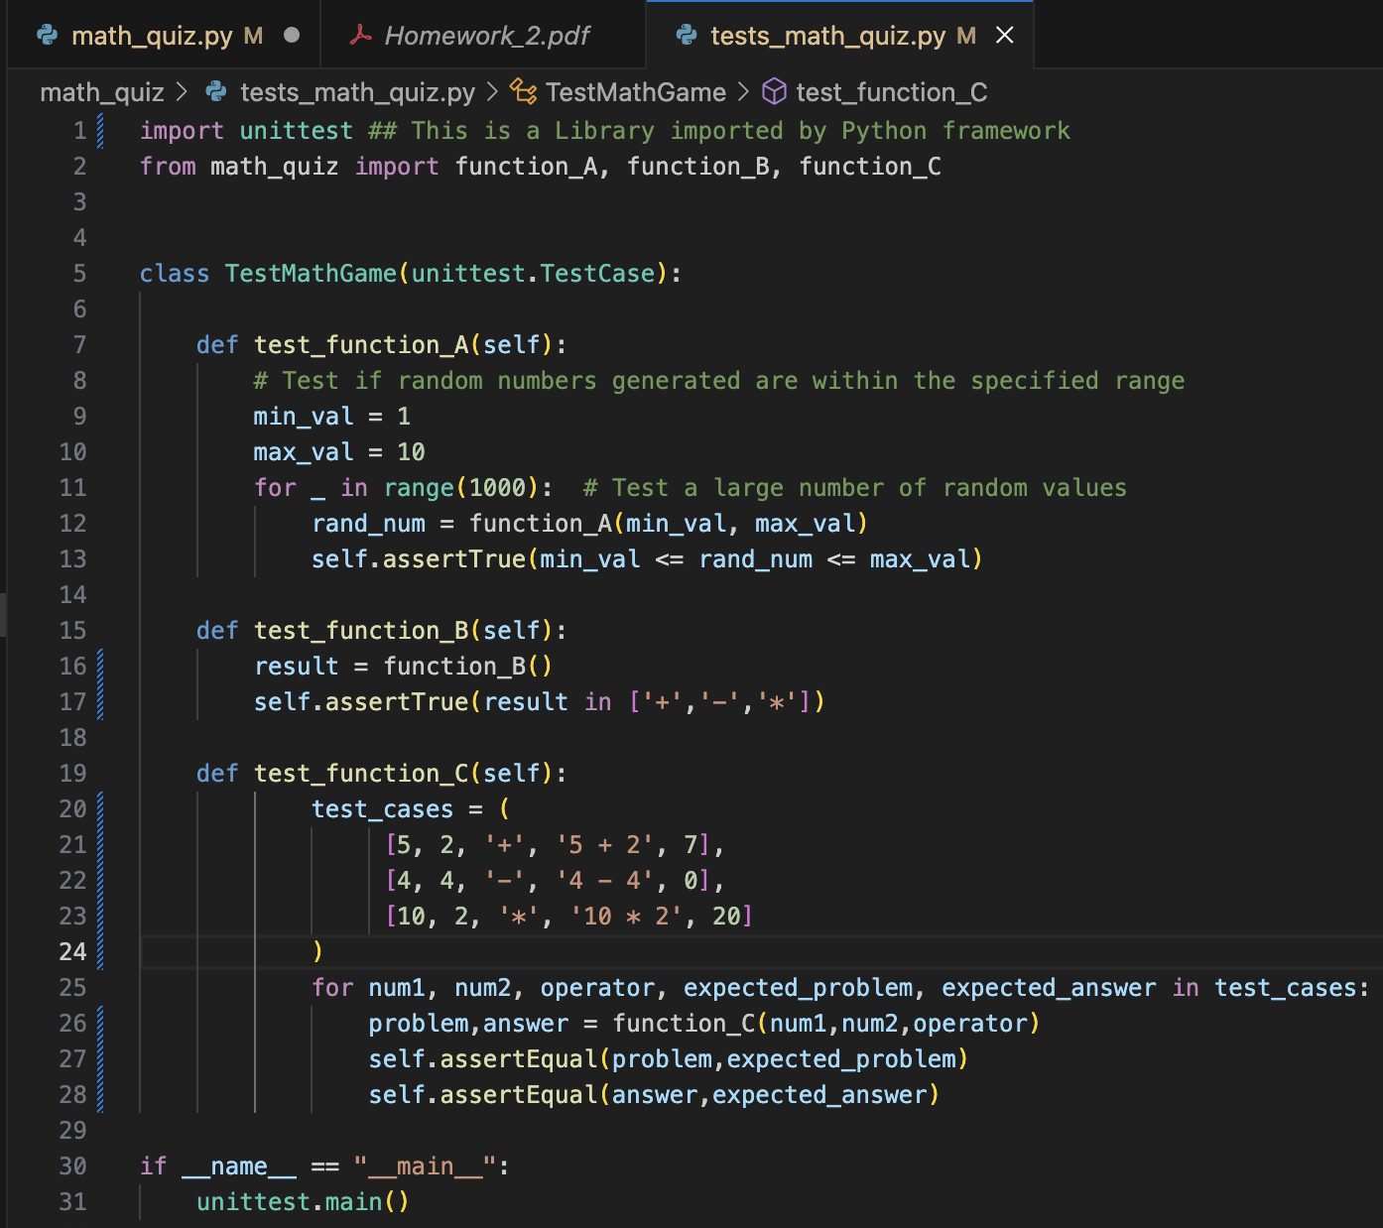

Link to the repository

<https://github.com/javiermutr/math_quiz>