17-9-2024

JAVIER RODRIGUEZ GARRIDO

Creation of a github page

Contenido

1. First we create the repository 2

2. Second we create de index 3

3. third we configure the github page 4

Access the page 4

# 1. First we create the repository

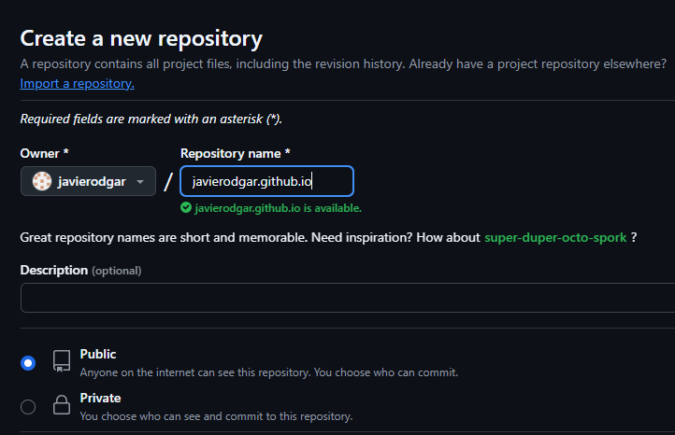

We need to use our name at the repository to this to work

Now we need to select the option of add a readme file



And click create repository at the bottom of the page

# 2. Second we create de index

We need to create an index page to git to open it, we can use html or php, in our case we are going to create it in html so we need to create a document called index.html

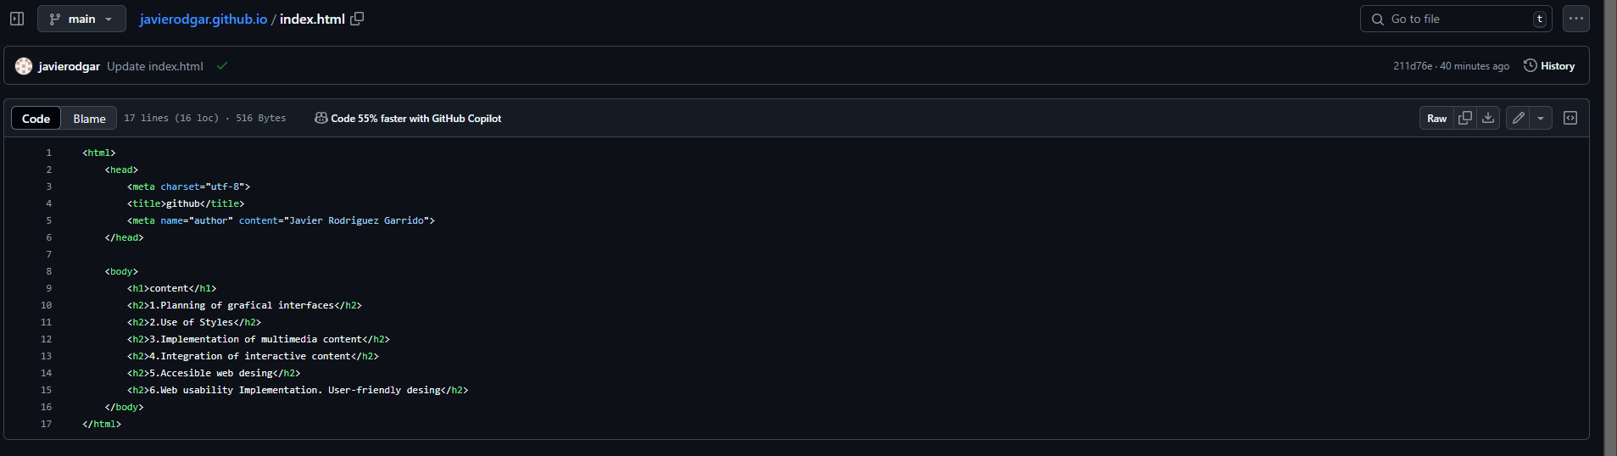

This is the document that is going to be shown when the user enters on the page

# 3. third we configure the github page

We access to the setting page and activate the github page, the https link that is going to be used to access our page

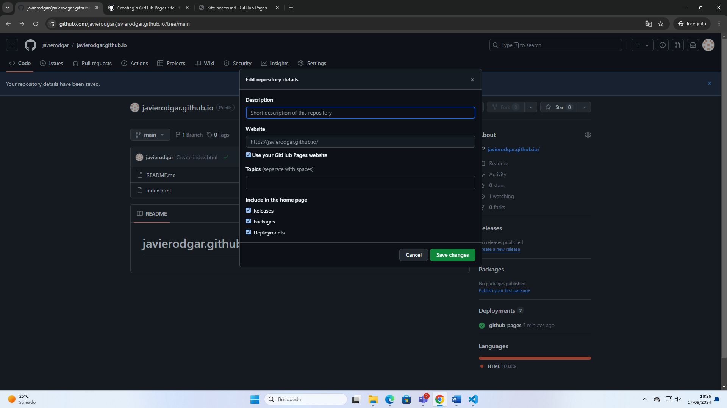

## Access the page

When we access the page the index is going to be shown

