Deploy Angular Application in Docker Container.

DESCRIPTION

Deploy the Angular application in Docker. The Angular application should be built with the Angular CLI along with Docker Compose for development and production.

Problem Statement Scenario:

HTQual Technology Solutions hired you as a MEAN Stack Developer. The organization decided to implement DevOps to develop and deliver the products. Since HTQual is an Agile organization, they follow Scrum methodology to develop the projects incrementally. The Company decided to develop their website on Mean stack. Since you are the MEAN stack developer, you have to demonstrate that deploying an Angular application on Docker is always a best approach to develop a project and test it incrementally. You agreed upon the following:

Setting up an image for code development

Build the application in Docker and host it in Docker Hub

List the advantages, disadvantages, and document the tasks involved

Your goal is to demonstrate the Angular application and run it in a Docker container.

You must use the following tools:

Docker – To package the application in a Docker container

Node.js – To support the Angular application with the required node modules.

Angular CLI – To execute and bundle the dependencies together.

Linux (Ubuntu) – As a base operating system to start and execute the project.

Following requirements should be met:

Document the step-by-step process from the initial installation to the final production.

Run the Angular application successfully in the Docker container.

Use Docker Compose to manage the Angular application running inside the Docker container.

REPORT

1) Install Docker, Docker Compose, Node.js, TypeScript and Angular:

curl -fsSL https://get.docker.com -o get-docker.sh

sudo sh get-docker.sh

sudo curl -L "https://github.com/docker/compose/releases/download/1.29.2/docker-compose-$(uname -s)-$(uname -m)" -o /usr/local/bin/docker-compose

sudo chmod +x /usr/local/bin/docker-compose

sudo ln -s /usr/local/bin/docker-compose /usr/bin/docker-compose

curl -fsSL https://deb.nodesource.com/setup_16.x | sudo -E bash -

sudo apt-get install -y nodejs

npm install typescript -g

npm install -g @angular/cli

2) Create the Angular application.

sudo ng new angular-application

ng serve --open

3) Create the Dockerfile

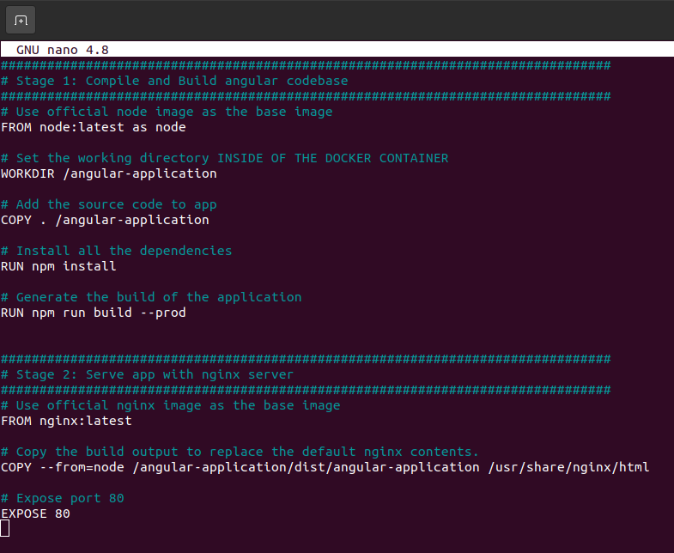
4) Create the Docker image with the Angular application

sudo docker image build .

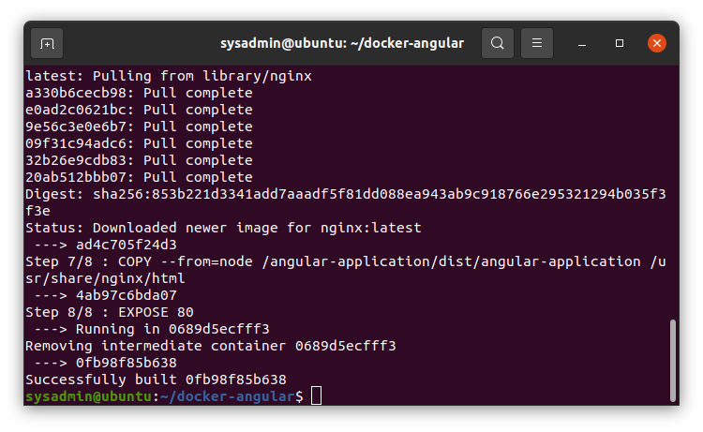
With that, now we know that the Dockerfile has a correct syntax and everything works.

5) Create the Docker Compose file for development and production
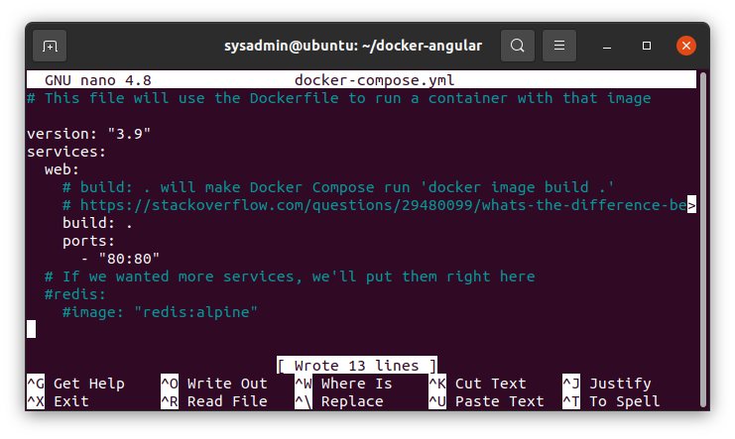

sudo docker-compose up

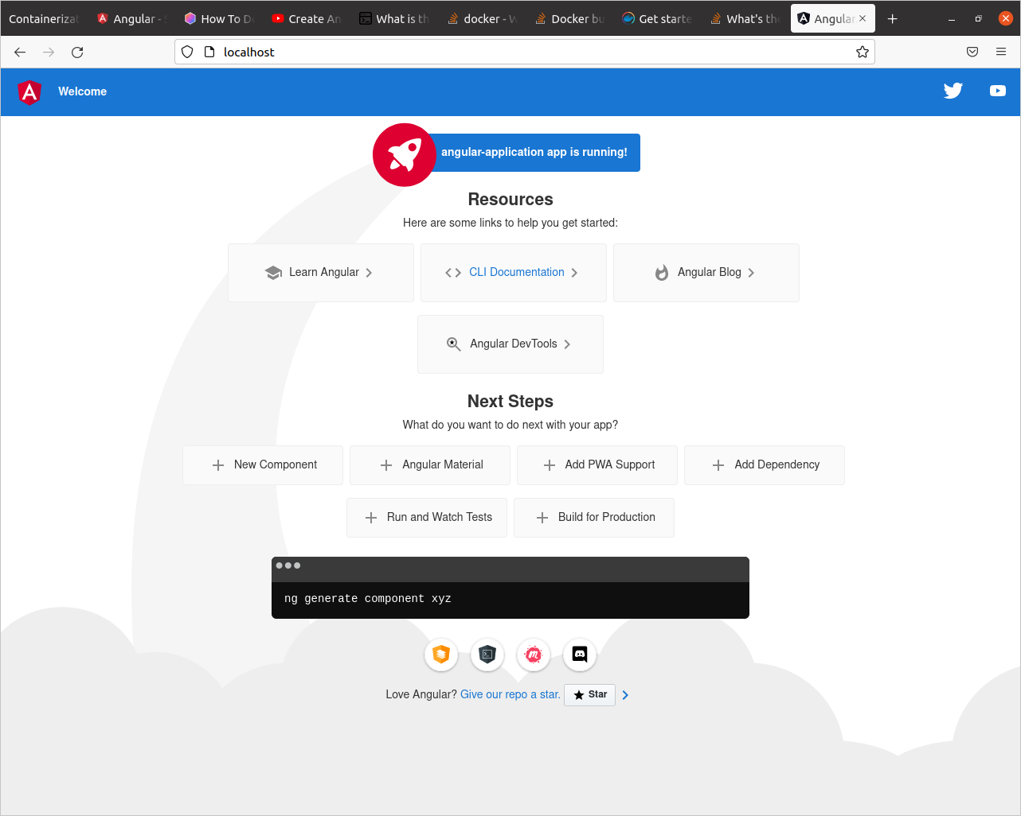

To run the service as a daemon, run sudo docker-compose up -d as -d stands for detached.

To stop the execution, press Ctrl+C or run sudo docker-compose stop .

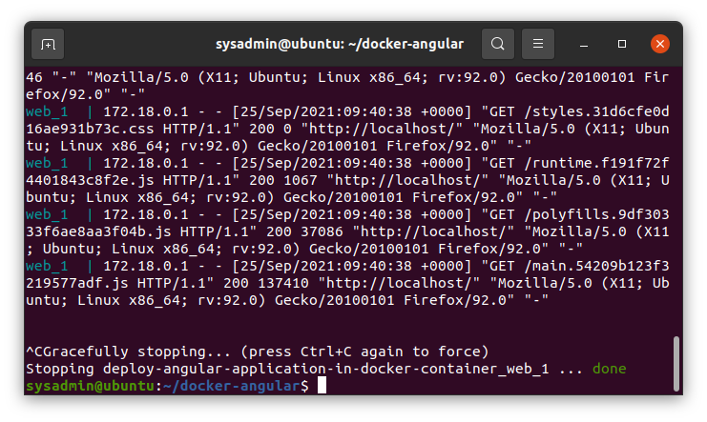

6) Host the application in DockerHub

First, we create the repository in DockerHub:
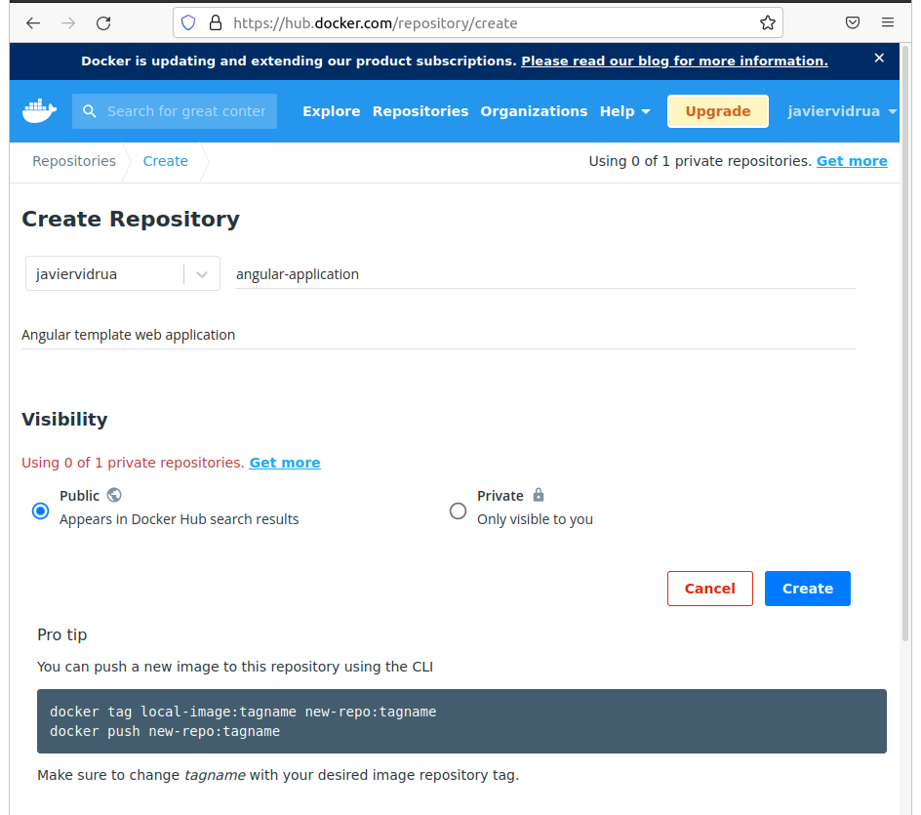

Then, we build the files:

sudo docker build -t javiervidrua/angular-application .

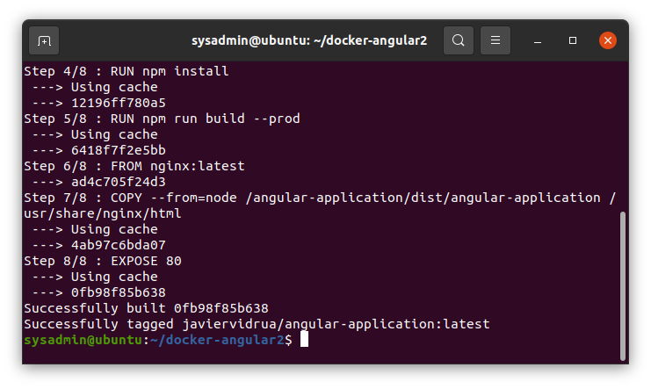

Then, we upload the files to the repository:

sudo docker login
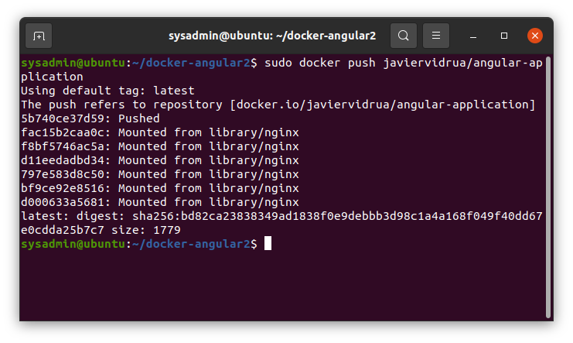
sudo docker push javiervidrua/angular-application

7) List the advantages, disadvantages and document the tasks involved

Advantages: Now the application is scalable and portable
Disadvantages: A little configuration is needed

All in all, it’s worth the effort!

