Notes on Using GCC IWMMXT Vector Class Header File
Table of Contents
Notes on Using GCC IWMMXT Vector Class Header File 1
1. Overview 3
2. Using GCC IWMMXT Vector Class in C++ sources 3
2.1. Include files and naming conventions 3
2.2. Rules for Operators 3
2.3. Example 4
3. Vector Classes details 5
3.1. Overview 5
3.2. Initialization and Data access 6
3.3. Assign Operators 7
3.4. Logical Operators 7
3.5. Arithmetic Operators 8
3.6. Multiplication Operators 8
3.7. Shift Operators 9
3.8. Pack/Unpack Operators 9
3.9. Comparison Operators 10
References 11

List of Figures and Tables
Figure 1 Vector Class Hierarchy 5

Table 1 Comparison among Inline ASM, Intrinsics, and Vector Class 4
Table 2 Vector Classes Data Types 5
Table 3 Operators Support Matrix 6
Table 4 Corresponding Intrinsics for Assign Operators 7
Table 5 Corresponding Intrinsics for Logical Operators 7
Table 6 Corresponding Intrinsics for Arithmetic Operators 8
Table 7 Corresponding Intrinsics for Multiplication Operators 8
Table 8 Corresponding Intrinsics for Shift Operators 9
Table 9 Corresponding Intrinsics for Pack/Unpack Operators 9
Table 10 Corresponding Intrinsics for Comparison Operators 10

Overview
The IWMMXT vector class header file contains functions abstracted from the IWMXMT instruction set. By providing a convenient interface to access the underlying IWMMXT instructions through intrinsics, the classes enable Single-Instruction, Multiple-Data (SIMD) operations. The objective is to improve application performance of complex and computation-intensive audio, video, and graphical data bit streams.
IWMMXT SIMD instructions can help improve efficiency of vector operations. These instructions can be implemented using inline asm, intrinsics or the C++ vector classes. The C++ vector class reuse the standard notation in C++, makes it much easier to implement SIMD operations over other methods.
This documentation is intended for programmers writing code for the IWMMXT coprocessor, particularly code that would benefit from the use of SIMD instructions. You should be familiar with C++ and the use of C++ classes.

Using GCC IWMMXT Vector Class in C++ sources

Include files and naming conventions
To use IWMMXT vector class, the <mmclass.h> file must be included.
The name of each class denotes the data type, signedness, bit size, number of elements using the following generic format:
<type> <signedness> <bits> vec <elements>
{ I } {s | u } {64 | 32 | 16 | 8 } {1 | 2 | 4 | 8}
For example:
Is32vec2 denotes the class supporting operations on two signed 32-bit integer vector.
Note that not all the combinations of signedness, bits and elements are supported. Please refer to Section 3 for more details.

Rules for Operators
To use operators with the Ivec classes you must use one of the following three syntax conventions:
[ Ivec_Class ] R = [ Ivec_Class ] A [ operator ][ Ivec_Class ] B
Example 1: I64vec1 R = I64vec1 A & I64vec1 B;
[ Ivec_Class ] R = [ operator ] ([ Ivec_Class ] A,[ Ivec_Class ] B)
Example 2: I64vec1 R = andnot(I64vec1 A, I64vec1 B);
[ Ivec_Class ] R [ operator ]= [ Ivec_Class ] A
Example 3: I64vec1 R &= I64vec1 A;

[ operator ] an operator (for example, &, |, or ^ )
[ Ivec_Class ] an Ivec class
R, A, B variables declared using the corresponding Ivec classes

Example
A simple example usage comparison is shown in Table 1. In the example, we add four 8-bit integer values twice, one with signed saturation the other with unsigned saturation. You can see how much easier it is to code with the vector class. Besides using fewer keystrokes and fewer lines of code, you can use standard C++ operators and don’t have to remember the different intrinsic names or complicated inline asm syntax.
Table 1 Comparison among Inline ASM, Intrinsics, and Vector Class
Inline ASM | 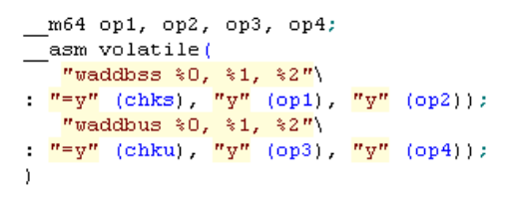
Intrinsics | 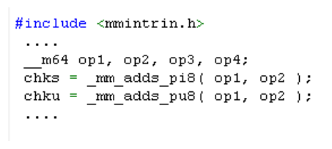
Vector Class | 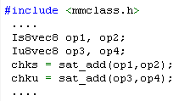

Vector Classes details

Overview
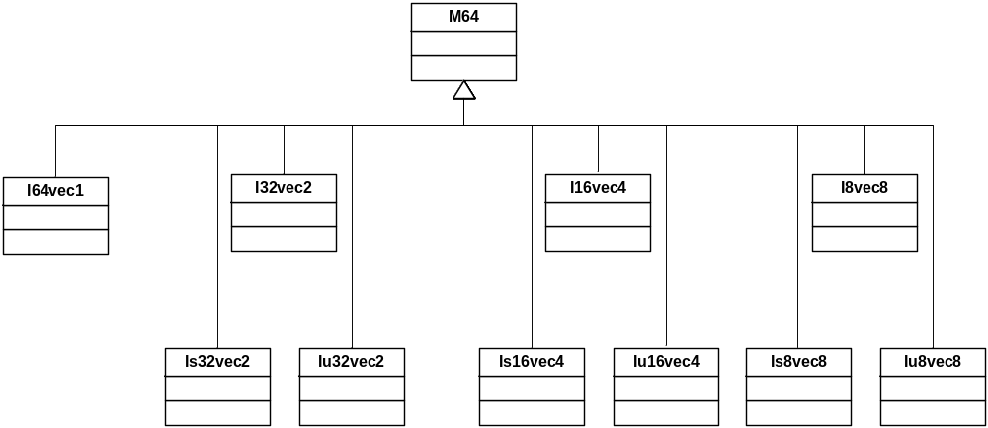
Figure 1 Vector Class Hierarchy
All supported vector classes are shown in Figure 1. The M64 class defines the __m64 data types from which the rest of the vector classes are derived. The first four child classes are derived based solely on bit sizes of 64, 32, 16 and 8 respectively for the I64vec1, I32vec2, I16vec4 and I8vec8 classes. The latter six of the classes require specification of signedness and saturation. Detail class names and their data type are listed in Table 2.
Table 2 Vector Classes Data Types
Class | Signedness | Data Type | Size | Elements
I64vec1 | unspecified | __m64 | 64 | 1
I32vec2 | unspecified | int | 32 | 2
Is32vec2 | signed | int | 32 | 2
Iu32vec2 | unsigned | int | 32 | 2
I16vec4 | unspecified | short | 16 | 4
Is16vec4 | signed | short | 16 | 4
Iu16vec4 | unsigned | short | 16 | 4
I8vec8 | unspecified | char | 8 | 8
Is8vec8 | signed | char | 8 | 8
Iu8vec8 | unsigned | char | 8 | 8

The vector class supports almost all the regular operators, but it varies a little for different class. The supported operators are: Assignment, Logical, Addition and Subtraction, Multiplication, Shift, Comparison. Details about the supported operators could be found in Table 3.
Table 3 Operators Support Matrix
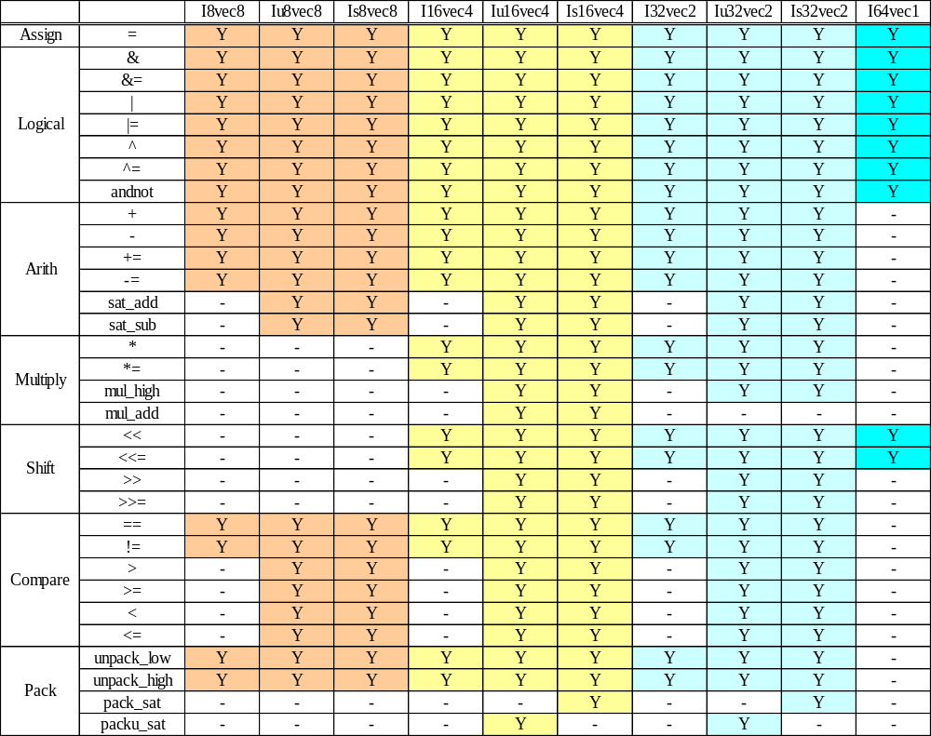
Note: All operators are restricted within same class only, except the assign operator.

Initialization and Data access
All vector classes could be initialized by three different values in examples below. All values are initialized with the most significant element on the left and the least significant to the right.

Example 1: __m64 initialization
I64vec1 A(__m64 m); Iu8vec8 A(__m64 m);
Example 2: __int64 initialization
I64vec1 A = __int64 m; Iu8vec8 A = __int64 m;
Example 2: Corresponding data type initialization
I32vec2 A (int A1, int A0);
Is32vec2 A (signed int A1, signed int A0);
Iu32vec2 A (unsigned int A1, unsigned int A0);
I16vec4 A (short A3, short A2, short A1, short A0);

The value of the class could be accessed by operator __m64().
For example, __m64 (I8vec8 A) would return the value of class A (of the type __m64).

Assign Operators
Any Ivec object can be assigned to any other Ivec object; conversion on assignment from one Ivec object to another is automatic. Table 4 shows the corresponding intrinsics used to implement the assign operator.
Table 4 Corresponding Intrinsics for Assign Operators
Assign
 | =
I8vec8 | _mm_set_pi32, _mm_cvtsi32_si64
Iu8vec8 | _mm_set_pi32, _mm_cvtsi32_si64
Is8vec8 | _mm_set_pi32, _mm_cvtsi32_si64
I16vec4 | _mm_set_pi32, _mm_cvtsi32_si64
Iu16vec4 | _mm_set_pi32, _mm_cvtsi32_si64
Is16vec4 | _mm_set_pi32, _mm_cvtsi32_si64
I32vec2 | _mm_set_pi32, _mm_cvtsi32_si64
Iu32vec2 | _mm_set_pi32, _mm_cvtsi32_si64
Is32vec2 | _mm_set_pi32, _mm_cvtsi32_si64
I64vec1 | _mm_set_pi32, _mm_cvtsi32_si64

Logical Operators
The logical operators use the intrinsics listed in Table 5.
Table 5 Corresponding Intrinsics for Logical Operators
Logicals
 | & | &= | | | |= | ^ | ^= | andnot
I8vec8 | _mm_and_si64 |  | _mm_or_si64 |  | _mm_xor_si64 |  | _mm_andnot_si64
Iu8vec8
Is8vec8
I16vec4
Iu16vec4
Is16vec4
I32vec2
Iu32vec2
Is32vec2
I64vec1

Arithmetic Operators
Default behavior is no saturation operation. The arithmetic operators use the intrinsics listed in Table 6.
Table 6 Corresponding Intrinsics for Arithmetic Operators
Arithmetic
 | + | += | sat_add | - | -= | sat_sub
I8vec8 | _mm_add_pi8 |  | - | _mm_sub_pi8 |  | -
Iu8vec8 |  |  | _mm_adds_pu8 |  |  | _mm_subs_pu8
Is8vec8 |  |  | _mm_adds_pi8 |  |  | _mm_subs_pi8
I16vec4 | _mm_add_pi16 |  | - | _mm_sub_pi16 |  | -
Iu16vec4 |  |  | _mm_adds_pu16 |  |  | _mm_subs_pu16
Is16vec4 |  |  | _mm_adds_pi16 |  |  | _mm_subs_pi16
I32vec2 | _mm_add_pi32 |  | - | _mm_sub_pi32 |  | -
Iu32vec2 |  |  | _mm_adds_pu32 |  |  | _mm_subs_pu32
Is32vec2 |  |  | _mm_adds_pi32 |  |  | _mm_subs_pi32
I64vec1 | - |  |  | -

Multiplication Operators
Default is to return the lower 32-bits of result. The multiplication operators use the intrinsics listed in Table 7.
Table 7 Corresponding Intrinsics for Multiplication Operators
Multiply
 | * | *= | mul_high | mul_add
I8vec8 | -
Iu8vec8
Is8vec8
I16vec4 | _mm_mullo_pi16 |  | - | -
Iu16vec4 |  |  | _mm_mulhi_pu16 | _mm_madd_pu16
Is16vec4 |  |  | _mm_mulhi_pi16 | _mm_madd_pi16
I32vec2 | _mm_mullo_pi32 |  | - | -
Iu32vec2 |  |  | _mm_mulhi_pu32 | -
Is32vec2 |  |  | _mm_mulhi_pi32 | -
I64vec1 | -

Shift Operators
The right shift argument can be any integer or Ivec value. The shift operators use the intrinsics listed in Table 8.
Table 8 Corresponding Intrinsics for Shift Operators
Shift
 | << | <<= | >> | >>=
I8vec8 | - | - | - | -
Iu8vec8 | - | - | - | -
Is8vec8 | - | - | - | -
I16vec4 | _mm_sll_pi16, _mm_slli_pi16 |  | -
Iu16vec4 |  |  | _mm_srl_pi16,_mm_srli_pi16
Is16vec4 |  |  | _mm_sra_pi16,_mm_srai_pi16
I32vec2 | _mm_sll_pi32, _mm_slli_pi32 |  | -
Iu32vec2 |  |  | _mm_srl_pi32,_mm_srli_pi32
Is32vec2 |  |  | _mm_sra_pi32,_mm_srai_pi32
I64vec1 | _mm_sll_pi64, _mm_slli_pi64 |  | -

Pack/Unpack Operators
The pack/unpack operators use the intrinsics listed in Table 9.
Table 9 Corresponding Intrinsics for Pack/Unpack Operators
Pack/Unpack
 | unpack_low | unpack_high | pack_sat | packu_sat
I8vec8 | _mm_unpacklo_pi8 | _mm_unpackhi_pi8 | - | -
Iu8vec8 | _mm_unpacklo_pi8 | _mm_unpackhi_pi8 | - | -
Is8vec8 | _mm_unpacklo_pi8 | _mm_unpackhi_pi8 | - | -
I16vec4 | _mm_unpacklo_pi16 | _mm_unpackhi_pi16 | - | -
Iu16vec4 | _mm_unpacklo_pi16 | _mm_unpackhi_pi16 | - | _mm_packs_pu16
Is16vec4 | _mm_unpacklo_pi16 | _mm_unpackhi_pi16 | _mm_packs_pi16 | -
I32vec2 | _mm_unpacklo_pi32 | _mm_unpackhi_pi32 | - | -
Iu32vec2 | _mm_unpacklo_pi32 | _mm_unpackhi_pi32 | - | _mm_packs_pu32
Is32vec2 | _mm_unpacklo_pi32 | _mm_unpackhi_pi32 | _mm_packs_pi32 | -
I64vec1 | -

Comparison Operators
The equality and inequality comparison operands can have mixed signedness, but they must be of the same size. The comparison operators for “less-than” and “greater-than” must be of the same sign and size. The comparison operators use the intrinsics listed in Table 10.
Table 10 Corresponding Intrinsics for Comparison Operators
Compare
 | == | != | > | < | >= | <=
I8vec8 | _mm_cmpeq_pi8 | _mm_andnot_si64,  _mm_cmpeq_pi8 | - |  | -
Iu8vec8 | _mm_cmpeq_pi8 | _mm_andnot_si64,  _mm_cmpeq_pi8 | _mm_cmpgt_pu8 |  | _mm_andnot_si64,  _mm_cmpgt_pu8
Is8vec8 | _mm_cmpeq_pi8 | _mm_andnot_si64,  _mm_cmpeq_pi8 | _mm_cmpgt_pi8 |  | _mm_andnot_si64,  _mm_cmpgt_pi8
I16vec4 | _mm_cmpeq_pi16 | _mm_andnot_si64,  _mm_cmpeq_pi16 | - |  | -
Iu16vec4 | _mm_cmpeq_pi16 | _mm_andnot_si64,  _mm_cmpeq_pi16 | _mm_cmpgt_pu16 |  | _mm_andnot_si64,  _mm_cmpgt_pu16
Is16vec4 | _mm_cmpeq_pi16 | _mm_andnot_si64,  _mm_cmpeq_pi16 | _mm_cmpgt_pi16 |  | _mm_andnot_si64,  _mm_cmpgt_pi16
I32vec2 | _mm_cmpeq_pi32 | _mm_andnot_si64,  _mm_cmpeq_pi16 | - |  | -
Iu32vec2 | _mm_cmpeq_pi32 | _mm_andnot_si64,  _mm_cmpeq_pi16 | _mm_cmpgt_pu32 |  | _mm_andnot_si64,  _mm_cmpgt_pu32
Is32vec2 | _mm_cmpeq_pi32 | _mm_andnot_si64,  _mm_cmpeq_pi16 | _mm_cmpgt_pi32 |  | _mm_andnot_si64,  _mm_cmpgt_pi32
I64vec1 | -

References
- Intel® C++ Compiler for Linux Compiler Reference (Document Number: 307777 - 002US), Intel
- Intel Wireless MMX Technology Intrinsic Support (Chapter 20 of Marvell C++ Compiler Users’ Manual ), Marvell, December, 2008

