Gasto cardíaco por ECOTT vs Fick

Parte 3: Análisis Índice Cardíaco

J. Mancilla Galindo, E. Garza Santiago, L.A. Fernández Urrutia

A. Kammar-García

2024-12-10

# Cardiac Index

The distribution of cardiac index values for both methods is skewed as shown bellow.

|  |  |
| --- | --- |
| TTE  TTE | Fick  Fick |

Thus, bootstrapping is used to calculate the mean with 95% CI:

The mean cardiac index for TTE is 3.47 L/min/m² (95% CI: 3.21 to 3.74), and for Fick, 4.33 L/min/m² (95% CI: 4.04 to 4.67).

However, the distribution of differences between the two methods is approximately normal.

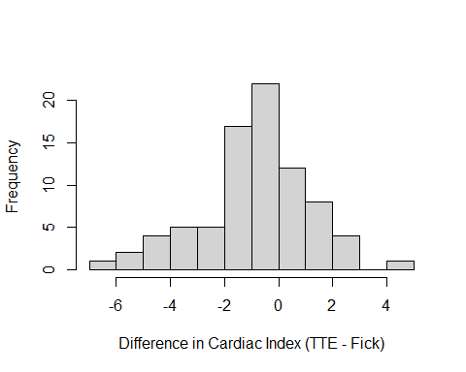

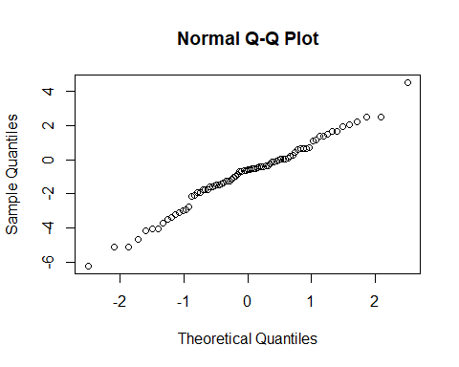

Assuming a linear and non-linear relationship

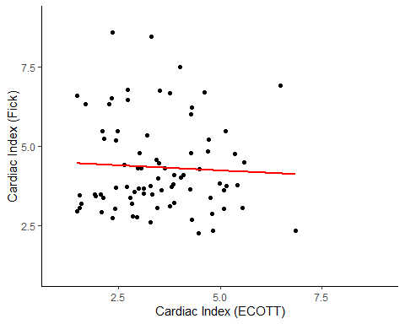

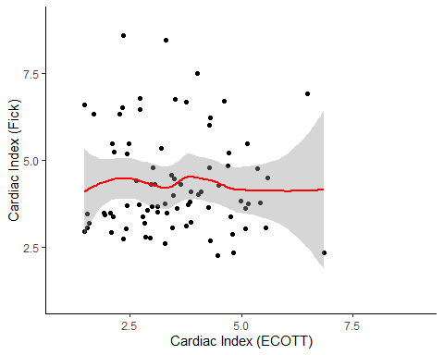

Examine if non-linear term is significantly better than linear term

Family: gaussian   
Link function: identity   
  
Formula:  
cardiac_index_Fick ~ s(cardiac_index_TTE)  
  
Parametric coefficients:  
 Estimate Std. Error t value Pr(>|t|)   
(Intercept) 4.3307 0.1621 26.72 <2e-16 ***  
---  
Signif. codes: 0 '***' 0.001 '**' 0.01 '*' 0.05 '.' 0.1 ' ' 1  
  
Approximate significance of smooth terms:  
 edf Ref.df F p-value  
s(cardiac_index_TTE) 1 1 0.225 0.637  
  
R-sq.(adj) = -0.00978 Deviance explained = 0.284%  
GCV = 2.1819 Scale est. = 2.128 n = 81

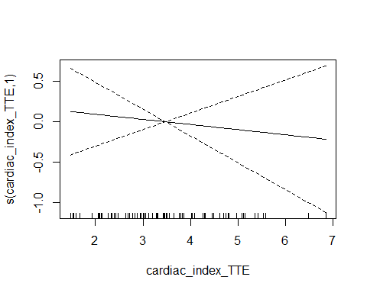

Non-linear relationship is not significantly better than linear relationship. Thus, I will model as linear relationship.

# Pearson correlation

Pearson's product-moment correlation  
  
data: data$cardiac_index_TTE and data$cardiac_index_Fick  
t = -0.47421, df = 79, p-value = 0.6367  
alternative hypothesis: true correlation is not equal to 0  
95 percent confidence interval:  
 -0.2685034 0.1670148  
sample estimates:  
 cor   
-0.05327754

# Linear regression

Call:  
lm(formula = cardiac_index_TTE ~ cardiac_index_Fick, data = data)  
  
Residuals:  
 Min 1Q Median 3Q Max   
-2.0591 -0.9323 -0.0813 0.8727 3.2967   
  
Coefficients:  
 Estimate Std. Error t value Pr(>|t|)   
(Intercept) 3.66720 0.42949 8.539 7.75e-13 ***  
cardiac_index_Fick -0.04462 0.09409 -0.474 0.637   
---  
Signif. codes: 0 '***' 0.001 '**' 0.01 '*' 0.05 '.' 0.1 ' ' 1  
  
Residual standard error: 1.222 on 79 degrees of freedom  
Multiple R-squared: 0.002838, Adjusted R-squared: -0.009784   
F-statistic: 0.2249 on 1 and 79 DF, p-value: 0.6367

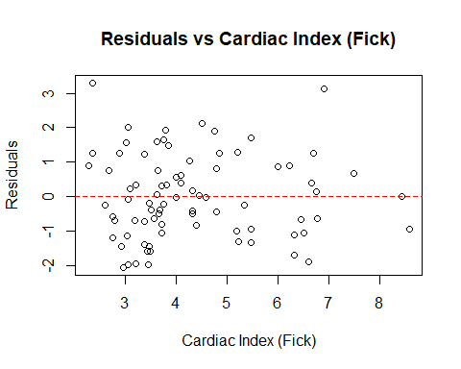

# Linear Mixed Effects Model

Linear mixed model fit by REML ['lmerMod']  
Formula: cardiac_index_Fick ~ cardiac_index_TTE + (1 | ID) + (1 | time_point)  
 Data: data  
  
REML criterion at convergence: 269.2  
  
Scaled residuals:   
 Min 1Q Median 3Q Max   
-1.6281 -0.3603 -0.1032 0.2624 2.4707   
  
Random effects:  
 Groups Name Variance Std.Dev.  
 ID (Intercept) 1.4125 1.1885   
 time_point (Intercept) 1.4002 1.1833   
 Residual 0.4453 0.6673   
Number of obs: 81, groups: ID, 52; time_point, 9  
  
Fixed effects:  
 Estimate Std. Error t value  
(Intercept) 5.10906 0.66721 7.657  
cardiac_index_TTE -0.02765 0.11350 -0.244  
  
Correlation of Fixed Effects:  
 (Intr)  
crdc_nd_TTE -0.649

# Intraclass correlation coefficient (ICC)

Average Score Intraclass Correlation  
  
 Model: twoway   
 Type : agreement   
  
 Subjects = 81   
 Raters = 2   
 ICC(A,2) = -0.0921  
  
 F-Test, H0: r0 = 0 ; H1: r0 > 0   
 F(80,65.7) = 0.9 , p = 0.675   
  
 95%-Confidence Interval for ICC Population Values:  
 -0.588 < ICC < 0.265

# Coefficient of variation (CV) and coefficient of error (CE)

The following calculation is the coefficient of variation (CV) for the overall averaged measurements, expressed as percentage:

Fick CV: 33.52%

TTE CV: 35%

Because there are multiple measurements that are averaged to produce the mean Cardiac Index for TTE, we can calculate the coefficient of error (CE) as suggested by Cecconi, et al.1 The following calculations reproduce the structure of the table in their review article:

| ID | CI 1 (TTE), L/min/m² | CI 2 (TTE), L/min/m² | CI 3 (TTE), L/min/m² | Mean CI TTE, L/min/m² | CV (%) | CE (%) | CI (Fick method), L/min/m² |
| --- | --- | --- | --- | --- | --- | --- | --- |
| 1 | 3.18 | 3.59 | 3.10 | 3.29 | 8.02 | 4.63 | 2.60 |
| 2 | 7.31 | 6.51 | 6.76 | 6.86 | 5.96 | 3.44 | 2.35 |
| 2 | 4.93 | 4.90 | 4.62 | 4.82 | 3.52 | 2.03 | 2.35 |
| 3 | 2.30 | 2.42 | 2.34 | 2.35 | 2.74 | 1.58 | 8.58 |
| 3 | 2.67 | 2.77 | 2.72 | 2.72 | 1.83 | 1.05 | 6.46 |
| 4 | 1.54 | 1.61 | 1.49 | 1.55 | 3.74 | 2.16 | 3.07 |
| CE: Coefficient of Error; CV: Coefficient of Variation; TTE: Transthoracic Echocardiography. | | | | | | | |

The mean CV of TTE for the repeated measurements per patient was 7.3% (95% CI: 6.2 to 8.7) and the CE was 4.2% (95% CI: 3.6 to 5), corresponding to a precision of 8.4% (95% CI: 7.2 to 10.1).

# Bland-Altman Plot

#### Bland Altman-single measure

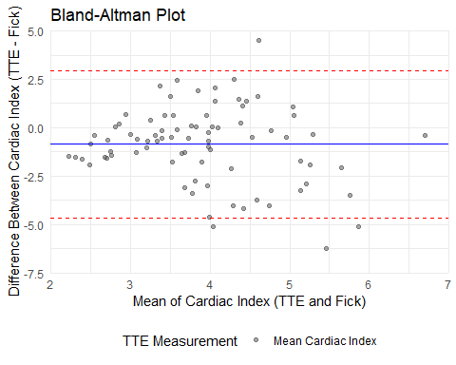

##### Systematic bias (Paired t-test)

Paired t-test  
  
data: data$cardiac_index_TTE and data$cardiac_index_Fick  
t = -3.9695, df = 80, p-value = 0.0001563  
alternative hypothesis: true mean difference is not equal to 0  
95 percent confidence interval:  
 -1.2863075 -0.4272454  
sample estimates:  
mean difference   
 -0.8567765

#### Bland Altman-repeated measures (random effects for between-subject variance)

Linear mixed model fit by REML ['lmerMod']  
Formula: differences ~ 1 + (1 | ID)  
 Data: data  
  
REML criterion at convergence: 319.4  
  
Scaled residuals:   
 Min 1Q Median 3Q Max   
-2.22339 -0.30675 -0.05103 0.31807 2.02571   
  
Random effects:  
 Groups Name Variance Std.Dev.  
 ID (Intercept) 2.301 1.517   
 Residual 1.433 1.197   
Number of obs: 81, groups: ID, 52  
  
Fixed effects:  
 Estimate Std. Error t value  
(Intercept) -0.9965 0.2570 -3.877

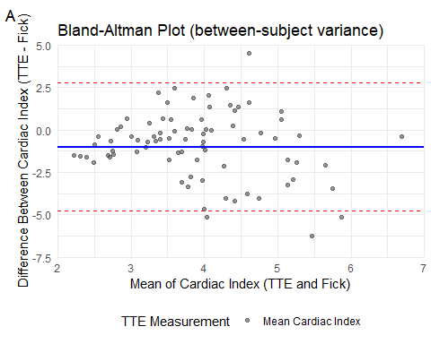

#### Bland Altman-repeated measures (random effects for between-subject variance and within-subject variance)

Linear mixed model fit by REML ['lmerMod']  
Formula:   
differences ~ 1 + (1 | ID) + (1 | ID:time_point) + (1 | TTE_measurement)  
 Data: data_long  
  
REML criterion at convergence: 476.3  
  
Scaled residuals:   
 Min 1Q Median 3Q Max   
-2.6307 -0.4333 -0.0181 0.3925 2.4684   
  
Random effects:  
 Groups Name Variance Std.Dev.  
 ID:time_point (Intercept) 1.40369 1.1848   
 ID (Intercept) 2.30131 1.5170   
 TTE_measurement (Intercept) 0.00000 0.0000   
 Residual 0.08906 0.2984   
Number of obs: 243, groups: ID:time_point, 81; ID, 52; TTE_measurement, 3  
  
Fixed effects:  
 Estimate Std. Error t value  
(Intercept) -0.9965 0.2570 -3.877  
optimizer (nloptwrap) convergence code: 0 (OK)  
boundary (singular) fit: see help('isSingular')

There was singularity in the prior model including a random effect for within-subject TTE measurements. Because this term is conceptually important to take into account the nested structure of the data, we will keep it in the model. Other alternatives would be to include it as a fixed effect, but this would not necessarily represent a meaningful variable to model.

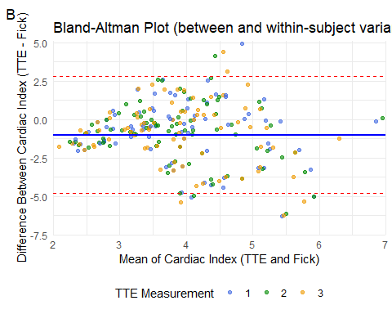

# Mean absolute difference (MAD)

The MAD for Cardiac Index is 1.6 (95% CI: 1.2 to 2).

# Mean absolute percentage error (MAPE) and precision of Fick method

Precisionb (point estimate): 56.84 %

Precisionb (95% CI): 44.34 - 74.22 %

# Summary

The mean cardiac index with the TTE method was 3.47 L/min/m² (95% CI: 3.21 to 3.74) and 4.33 L/min/m² (95% CI: 4.04 to 4.67) with the Fick method. The correlation between the two methods was rho = -0.05 (95% CI: -0.27 to 0.17, p=0.637). In a linear mixed model with random patient slopes, there was a change in Fick CI of -0.03 (95% CI: -0.26 to 0.2) L/min/m² for each unit change in mean TTE CI. The ICC between TCE and Fick CI -0.09 (95% CI: -0.59 to 0.26).

The mean absolute difference in CI between TTE and Fick was 1.59 (95% CI: 1.2 to 2) L/min/m². The coefficient of variation for an individual measurement of TTE was 35% and 33.52% for Fick. The mean CV of TTE for the repeated measurements per patient was 7.3% (95% CI: 6.2 to 8.7) and the CE was 4.2% (95% CI: 3.6 to 5), corresponding to a precision of 8.4% (95% CI: 7.2 to 10.1). The MAPE of the Fick method compared to TTE was 57.5% (95% CI: 45.5 - 74.6). The precision of the Fick method was 56.84% (95% CI: 44.34 to 74.22). The LSC was 11.9% (95% CI: 10.1 to 14.3) for TTE and 80.4% (95% CI: 62.7 to 105) for the Fick method.

**Figure 2** shows the Bland-Altman plot for the repeated measures model with random effects for between-subject variance (Figure2A) and within-subject variance (Figure2B). The mean difference (systematic bias) between TTE and Fick CI was -1 (95% CI: -1.5 to -0.49, p = 0) L/min/m², with 95% limits of agreement of -4.81 to 2.82 L/min/m².

# References

1. Cecconi M, Rhodes A, Poloniecki J, Della Rocca G, Grounds RM. Bench-to-bedside review: The importance of the precision of the reference technique in method comparison studies with specific reference to the measurement of cardiac output. *Critical Care*. 2009;13(1):201. doi:[10.1186/cc7129](https://doi.org/10.1186/cc7129)

# Package References

* Angelo Canty, B. D. Ripley (2024). *boot: Bootstrap R (S-Plus) Functions*. R package version 1.3-31. A. C. Davison, D. V. Hinkley (1997). *Bootstrap Methods and Their Applications*. Cambridge University Press, Cambridge. ISBN 0-521-57391-2, <doi:10.1017/CBO9780511802843>.
* Auguie B (2017). *gridExtra: Miscellaneous Functions for “Grid” Graphics*. R package version 2.3, <https://CRAN.R-project.org/package=gridExtra>.
* Bates D, Mächler M, Bolker B, Walker S (2015). “Fitting Linear Mixed-Effects Models Using lme4.” *Journal of Statistical Software*, *67*(1), 1-48. doi:10.18637/jss.v067.i01 <https://doi.org/10.18637/jss.v067.i01>.
* Bates D, Maechler M, Jagan M (2024). *Matrix: Sparse and Dense Matrix Classes and Methods*. R package version 1.7-0, <https://CRAN.R-project.org/package=Matrix>.
* Berkelaar M (2024). *lpSolve: Interface to ‘Lp_solve’ v. 5.5 to Solve Linear/Integer Programs*. R package version 5.6.22, <https://CRAN.R-project.org/package=lpSolve>.
* Gamer M, Lemon J, [puspendra.pusp22@gmail.com](mailto:puspendra.pusp22@gmail.com) IFPS (2019). *irr: Various Coefficients of Interrater Reliability and Agreement*. R package version 0.84.1, <https://CRAN.R-project.org/package=irr>.
* Grolemund G, Wickham H (2011). “Dates and Times Made Easy with lubridate.” *Journal of Statistical Software*, *40*(3), 1-25. <https://www.jstatsoft.org/v40/i03/>.
* Iannone R, Cheng J, Schloerke B, Hughes E, Lauer A, Seo J, Brevoort K, Roy O (2024). *gt: Easily Create Presentation-Ready Display Tables*. R package version 0.11.0, <https://CRAN.R-project.org/package=gt>.
* Makowski D, Lüdecke D, Patil I, Thériault R, Ben-Shachar M, Wiernik B (2023). “Automated Results Reporting as a Practical Tool to Improve Reproducibility and Methodological Best Practices Adoption.” *CRAN*. <https://easystats.github.io/report/>.
* Müller K, Wickham H (2023). *tibble: Simple Data Frames*. R package version 3.2.1, <https://CRAN.R-project.org/package=tibble>.
* Pinheiro J, Bates D, R Core Team (2023). *nlme: Linear and Nonlinear Mixed Effects Models*. R package version 3.1-164, <https://CRAN.R-project.org/package=nlme>. Pinheiro JC, Bates DM (2000). *Mixed-Effects Models in S and S-PLUS*. Springer, New York. doi:10.1007/b98882 <https://doi.org/10.1007/b98882>.
* R Core Team (2024). *R: A Language and Environment for Statistical Computing*. R Foundation for Statistical Computing, Vienna, Austria. <https://www.R-project.org/>.
* Rich B (2023). *table1: Tables of Descriptive Statistics in HTML*. R package version 1.4.3, <https://CRAN.R-project.org/package=table1>.
* Rinker TW, Kurkiewicz D (2018). *pacman: Package Management for R*. version 0.5.0, <http://github.com/trinker/pacman>.
* Wickham H (2016). *ggplot2: Elegant Graphics for Data Analysis*. Springer-Verlag New York. ISBN 978-3-319-24277-4, <https://ggplot2.tidyverse.org>.
* Wickham H (2023). *forcats: Tools for Working with Categorical Variables (Factors)*. R package version 1.0.0, <https://CRAN.R-project.org/package=forcats>.
* Wickham H (2023). *stringr: Simple, Consistent Wrappers for Common String Operations*. R package version 1.5.1, <https://CRAN.R-project.org/package=stringr>.
* Wickham H, Averick M, Bryan J, Chang W, McGowan LD, François R, Grolemund G, Hayes A, Henry L, Hester J, Kuhn M, Pedersen TL, Miller E, Bache SM, Müller K, Ooms J, Robinson D, Seidel DP, Spinu V, Takahashi K, Vaughan D, Wilke C, Woo K, Yutani H (2019). “Welcome to the tidyverse.” *Journal of Open Source Software*, *4*(43), 1686. doi:10.21105/joss.01686 <https://doi.org/10.21105/joss.01686>.
* Wickham H, François R, Henry L, Müller K, Vaughan D (2023). *dplyr: A Grammar of Data Manipulation*. R package version 1.1.4, <https://CRAN.R-project.org/package=dplyr>.
* Wickham H, Henry L (2023). *purrr: Functional Programming Tools*. R package version 1.0.2, <https://CRAN.R-project.org/package=purrr>.
* Wickham H, Hester J, Bryan J (2024). *readr: Read Rectangular Text Data*. R package version 2.1.5, <https://CRAN.R-project.org/package=readr>.
* Wickham H, Vaughan D, Girlich M (2024). *tidyr: Tidy Messy Data*. R package version 1.3.1, <https://CRAN.R-project.org/package=tidyr>.
* Wood SN (2011). “Fast stable restricted maximum likelihood and marginal likelihood estimation of semiparametric generalized linear models.” *Journal of the Royal Statistical Society (B)*, *73*(1), 3-36. Wood S, N., Pya, S”afken B (2016). “Smoothing parameter and model selection for general smooth models (with discussion).” *Journal of the American Statistical Association*, *111*, 1548-1575. Wood SN (2004). “Stable and efficient multiple smoothing parameter estimation for generalized additive models.” *Journal of the American Statistical Association*, *99*(467), 673-686. Wood S (2017). *Generalized Additive Models: An Introduction with R*, 2 edition. Chapman and Hall/CRC. Wood SN (2003). “Thin-plate regression splines.” *Journal of the Royal Statistical Society (B)*, *65*(1), 95-114.