**Preoperative atelectasis in patients with obesity undergoing bariatric surgery: a cross-sectional study**

Javier Mancilla-Galindo,1 Ashuin Kammar-García,2,*

1. Institute for Risk Assessment Sciences, Utrecht University, Utrecht, Netherlands.
2. Dirección de Investigación, Instituto Nacional de Geriatría, Mexico City, Mexico.

* Correspondence: aaa@hotmail.com

ORCiD

* Javier Mancilla-Galindo: 0000-0002-0718-467X
* Ashuin Kammar-García: 0000-0002-3875-0945

**Abstract**

**Background**: x.

**Objective**: x.

**Methods**: x.

**Results**: x.

**Conclusions**: x.

Keywords:

Disclosure: The authors report there are no competing interests to declare.

Data Availability: The data that support the findings of this study are openly available in Harvard Dataverse at <https://doi.org/10.7910/DVN/4JZZLB>.

Code Availability: The code documenting the analyses in this study is openly available in <https://github.com/javimangal/preoperative_atelectasis>.

**INTRODUCTION**

Bariatric surgery,

.

The objective of this study was to assess the prevalence and extension of preoperative atelectasis in patients with obesity undergoing bariatric surgery, and the extent to which atelectasis explained preoperative SpO2 values.

**METHODS**

**Study Design and Setting**

This was a single-center cross-sectional study conducted in a specialized center for laparoscopic bariatric surgery in Tijuana, Mexico mainly receiving patients from abroad. The study period was the month of June 2020. During this time, a joint initiative between Mexico, Canada and the United States (USA) restricted international non-essential travels due to the COVID-19 emergency,1 but travelling for elective surgeries was possible. American Society of Anesthesiologists (ASA) recommendations for elective surgeries included that patients were tested against SARS-CoV-2, screened for symptoms of COVID-19, and advised against surgery when symptoms were present.2 Rapid antigen tests against SARS-CoV-2 were not yet available in Mexico3 and it was not feasible to perform RT-PCR on patients before surgery due to long waiting times until the result was available. Thus, the hospital committee decided that patients were screened for COVID-19 by a sequential approach consisting of 1) patients were asked for sign and symptoms of COVID-19 prior to arriving to the hospital and advised not to present for surgery if these were present, 2) upon arrival at the hospital, a rapid SARS-CoV-2 antibody testing was performed. If IgM against SARS-CoV-2 was positive, the surgery was postponed. 3) If the antibody test was negative, a chest computed tomography (CT) was performed and a CO-RADS4 score ≥3 was considered suggestive of COVID-19, leading to cancellation of the surgery.

Since chest CT images were available as part of this screening process, we considered this a unique opportunity to study the prevalence and extent of preoperative atelectasis in patients with obesity undergoing bariatric surgery. Adult patients who presented for elective bariatric surgery who underwent chest CT scan screening for COVID-19 were eligible. Exclusion criteria were a CO-RADS score ≥3, positive antibody test against SARS-CoV-2, and a prior history of COVID-19, neuromuscular disease, or bronchiectasis.

This study was reviewed and approved by the ethics committee of Hospital General de Tijuana (CONBIOÉTICA-02-CEI-001-20170526, approval no. 001771).

**Outcomes**

The main outcome of interest was the prevalence of atelectasis. The degree of atelectasis coverage as a percentage of lung volume and the peripheral saturation of oxygen (SpO2) during the preanesthetic assessment were secondary outcomes.

High-resolution chest CT images (1mm slices, 120kV, 50mA, scan time: 0.5sec, FOV L: 240) were obtained with a Toshiba© Aquilion 16 Slice CT Scanner and archived in EvoView PACS (U.M.G. Inc.). A senior radiologist was blinded to the patient’s BMI and analyzed chest CT scans in OsiriX© viewer to assess the presence and extent of atelectasis by first measuring the total area of the lung⎯pixels with density values between –1000 and +100 Hounsfield Units (HU)⎯. Densities considered to indicate atelectasis were identified in dependent lung regions and calculated by including all pixels within these regions⎯HU between –100 and +100⎯.5 The location was expressed as unilateral or bilateral, whereas the percentage of coverage was registered by rounding to the lower 2.5% category (i.e. values <2.5% were rounded to 0%). Thus, all patients with an atelectasis percentage ≥2.5% were considered as having atelectasis.

SpO2 was determined during the preanesthetic assessment with the patient seating, at rest, and at room air (FiO2: 21%) with a pulse oximeter (Masimo SET®) with precision of 2% at rest in the range of 70-100%.

**Exposure**

Weight was measured in a 90x90 cm platform scale with a maximal capacity of 1,000 kg and a precision of 200 grams (Rhino© PLABA-9 model). For height determination patients are encouraged to stand with the heels together and buttocks, shoulders, and head in contact with a stadiometer (precision 0.1 mm). Body-mass index (kg/m2) was determined as the ratio of weight (kilograms) and squared height (meters2). Obesity class categories were created according to WHO criteria6 by classifying BMI values into class 1 [30,35), 2 [35,40), and 3 (≥40). Class 3 obesity subgroups were further defined as: [40,45), [45−50), and ≥50 kg/m2.

**Confounders**

All hypothesized relationships between the exposure, outcomes and confounders were defined a priori and drawn in a directed acyclic graph (DAG)7 (**Supplementary Figure 1**). The diagram was updated by testing implied conditional independencies as recommended by Ankan, et al.8 Age, sex and obstructive sleep apnea (OSA) constituted the minimal set of adjustment for the relationship between obesity class and atelectasis percentage. For the relationship between BMI and preoperative SpO2, atelectasis percentage was studied as the mediator of the effect, while the minimal set of confounders was the same as above. Blood serum hemoglobin was considered as an ancestor of the outcome. The mean altitude of the state of residence in meters above sea level (m.a.s.l.) was considered as potentially relevant determinant of SpO2. Due to overspread distribution and inability to model as a non-linear term, this variable was categorized into low (0-1000 m.a.s.l.) and moderate (1000-2500 m.a.s.l.) altitude as per Crocker ME, et al.9

Detailed descriptions of all other variables are provided in the supplementary dataset dictionary.10

**Sample Size**

We did not identify any prior studies reporting the prevalence of preoperative atelectasis in patients with obesity. Thus, we calculated the minimum sample size based on the following assumptions:

1. The PROBESE trial reported that 5.6% of patients in the high PEEP group (12 cmH2O) and 4.4% in the low PEEP group (4 cmH2O) had postoperative atelectasis.11 Assuming a linear relationship between PEEP and atelectasis, patients with no PEEP (0 cmH2O) could be expected to have a prevalence of atelectasis of 6%.
2. A deviation of 5% in the expected prevalence estimate was selected according to recommendations by Naing et al.12 for preliminary small-scale studies.
3. Confidence level of 95%.

The minimum sample size obtained was 241 patients.

**Statistical analysis**

Descriptive characteristics are presented as the mean and standard deviation (SD), median with interquartile range (IQR), and/or range (minimum−maximum) for numerical variables. For categorical variables, absolute frequencies and percentages were calculated. A map of the USA and Canada territories was plotted showing the absolute frequency of patients coming from different states. Categorical variables were summarized in frequency tables and compared through the chi-squared test. Relationships between categorical and numerical variables were assessed through stacked histograms, boxplots, and Q-Q plots and compared with unpaired t-tests or Wilcoxon’s test. Scatterplots were used to assess relationships between numeric variables and compared with Pearson’s or Spearman’s correlation test if monotonic. When relationships were non-linear, curvatures were first visualized through local regression smooth curves (loess), followed by determining an optimal smooth curvature in a general additive model by increasing the number of knots and comparing these against linear terms; if the non-linear term was significantly better than linear, the lowest k with a drop ≥2 in the Akaike information criterion (AIC), plus an adequate visual representation of the relationship, and optimal k-index was selected.

The prevalence of atelectasis and its 95% confidence interval (95%CI) were estimated with a one-sample proportion test with Wilson score intervals for the total sample and BMI categories. Due to zero-inflation and skewness, mean atelectasis percentage was determined by bootstrapping with 10,000 re-samples, and 95%CI with the bias-corrected and accelerated (BCa) method. Prevalence ratios of atelectasis per obesity class (reference category: class 1) were estimated through a modified Poisson regression model with robust errors as described by Yorlets, et al.13 and adjusted for age, sex, and OSA. Atelectasis percentage coverage was modeled in an ordinal logistic regression model; assumptions were checked with the nominal test for proportional odds and scale test for scaling effects. Due to problems in convergence when fitting nominal models to test the proportional odds assumption, non-integer atelectasis percentage categories (i.e., 2.5%, 7.5%) were collapsed against the immediate lower category, resulting in 5% jumps (0-5%, 5-10%, 10-15%, and ≥15%). The relative frequencies of atelectasis percentage category by obesity classes and class 3 subgroups (40−45, 45−50, and ≥50 kg/m2) are shown in a barplot. Partial proportional odds models were fitted to model nominal effects of variables not meeting the proportional odds assumption. Estimates are summarized as the unadjusted and adjusted odds ratio (OR) with their Wald 95%CI.

Mean SpO2 was assessed in a fractional regression model by building generalized additive models with a quasibinomial logit link function to assess the extent to which BMI, OSA, atelectasis percentage, and additional covariates (age, sex, altitude, and hemoglobin) explained the variability in SpO2. A smooth BMI term (k=5) was modelled, and the partial effect of this term was plotted with its 95%CI to assess the extent to which the effect of BMI on SpO2 changed when adjusting for other variables. OR for the mean SpO2 value with their 95%CI were calculated for all linear and categorical terms. Models were compared by their explained deviance.

Complete-case analysis was performed since missing data was <3% for all variables. Statistical significance was defined as p<0.05. P-values are shown rounded to 3 decimals. All analyses and figures were created with R version 4.3.2. All packages used are listed and referenced in the supplementary material. The dataset10 and code documenting these analyses are also publicly available at: <https://github.com/javimangal/preoperative_atelectasis>.

**RESULTS**

Out of 281 scheduled surgeries, 35 (12.4%) patients decided not to present to the hospital, 3 (1.1%) had a positive antigen test, and the remaining 243 (86.5%) underwent chest CT screening. After exclusion of 7 patients due to CO-RADS ≥3 (n=4) and who reported prior COVID-19 (n=3), 236 were included for analysis.

All participants were residents of the USA and Canada (**Supplementary Figure 2**). The mean age of participants was 40.3 (SD: 9.87) years and 90.7% were women (n=214). Most patients had a CO-RADS score of 1 (n=230, 97.5%), while the remaining 2.5% (n=6) had CO-RADS 2. Patients with a diagnosis of OSA constituted 7.6% (n=18) of the sample. The median BMI was 40.3 (IQR: 34.6−46.0) and the distribution was right-skewed (range: 30−77.3). Most patients were in the class 3 obesity category (n=121, 51.3%), followed by class 1 (n=62, 26.3%) and 2 (n=53, 22.5%). Characteristics of the sample stratified by obesity class are shown in **Table 1**.

Age had a weak negative correlation with BMI (rho= -0.155, p=0.017). The median BMI was not significantly different between men (43, IQR: 37.9−46.2) and women (39.9, IQR: 34.5−45.5) (p=0.154). The median BMI was significantly higher in participants with OSA (44, IQR: 40.1−49.2) than those without (39.8, IQR: 34.5−45.1) (p=0.014). OSA was more frequent among men than women (p<0.001).

***Preoperative atelectasis***

The overall prevalence of preoperative atelectasis was 32.63% (95%CI: 26.97−38.85), being greater in higher obesity classes (p<0.001): class 1 (n=8/62), 12.9% (95%CI: 6.13−24.4); class 2 (n=15/53), 28.3% (95%CI: 17.2−42.56); and class 3 (n=54/121), 44.63% (95%CI: 35.68−53.92). Of those who had atelectasis, the most frequent presentation was unilateral n=53 (68.83%), compared to bilateral n=24 (31.17%). When examining this by obesity class, laterality was not significantly different for those with class 1, 2, and 3 obesity categories: n=7 (87.5%), n=10 (66.67%), and n=36 (66.67%), respectively (p=0.484). Atelectasis percentage showed a non-monotonic non-linear relationship with BMI (**Figure 1A**). A marked increase in atelectasis percentage occurred at BMI higher than ~42 kg/m2. The mean atelectasis percentage coverage in the sample was 2.66% (95%CI:2.08-3.26) and according to WHO categories: class 1 (0.92%, 95%CI:0.36-1.77), class 2 (1.55%, 95%CI:0.8-2.45), and class 3 (4.02%, 95%CI:3.06-5.04). Within class 3 subgroups, the mean atelectasis percentage was 0.7% (95%CI:0.22-1.27) in the 40−45 kg/m2 group; 3.63% (95%CI:2.26-5.16), in 45−50 kg/m2, and 10.48% (95%CI:8.75-12.34), in the ≥50 kg/m2 subgroup. The relative frequencies of the extent of coverage expressed in 5% jumps were significantly higher with increasing obesity class (p<0.001) (**Figure 2A**), with greater heterogeneity and increasing percentage coverage within class 3 obesity subgroups (**Figure 2B**).

Age was similarly distributed among patients without atelectasis (40.6, SD:10.1) and those with atelectasis (39.6, SD:9.3) (p=0.498). There were no significant differences in atelectasis occurrence between men (45.5%) and women (31.3%) (p=0.178). Patients with a diagnosis of OSA had atelectasis more frequently (94.4%, n=17/18) than those without (27.5%, n=60/218) (p<0.001). The location of atelectasis was not different among patients with and without OSA (p=0.313). Unadjusted and adjusted prevalence ratios of atelectasis by obesity class are shown in **Table 2**.

Ordinal logistic regression models were fit to assess the relationship between explanatory variables and 5% increases in the extent of CT lung atelectasis percentage. The results of univariable and multivariable models for obesity class and confounder variables are shown in **Table 3**. Compared to class 1 obesity, class 2 obesity was not significantly associated with a greater atelectasis percentage coverage (aOR=1.48, 95%CI: 0.51−4.28), whereas class 3 obesity was associated with a 5-fold increase in the odds of a greater extent of atelectasis percentage (aOR=5.12, 95%CI: 2.17−12.09). The proportional odds assumption did not hold (p=0.021); a model with nominal effects had lower AIC (360.05) than the ordinal model (363.66) for the obesity class variable, reason why a partial proportional odds model was built to allow modelling nominal effects only for obesity class (**Supplementary Table S1**). Within the class 2 obesity category, the aOR tended to increase (range: 1.26−2.65) for every 5% jump in atelectasis percentage (all non-significant, p>0.05), whereas in the class 3 obesity category, increases were higher in magnitude (range: 5.00−8.69) and statistically significant, except for the jump from 10% to ≥15% (aOR=5.00, 95%CI: 0.55−45.22).

Due to the heterogeneity observed in atelectasis percentage in the class 3 category, post-hoc analyses were conducted to assess differences in the subgroups shown in **Figure 2B**. The prevalence of atelectasis in the 40−45, 45−50, and ≥50 kg/m2 subgroups was 12.3% (95%CI: 5.49−24.29), 48.4% (95%CI: 30.56−66.60), and 68.75% (95%CI: 86.66−100.00), respectively. Prevalence ratios are shown in **Table 2**. Ordinal logistic regression analyses showed that compared to the 30−35 kg/m2 category, the odds of a higher atelectasis percentage did not increase in the 40−45 kg/m2 group (aOR=0.77, 95%CI: 0.50−4.20), whereas the odds of higher atelectasis affection increased in several orders of magnitude in the 45−50 (aOR=6.20, 95%CI: 2.32−16.57), and ≥50 kg/m2 (aOR=54.85, 95%CI: 18.46−162.94) groups (**Supplementary Table S2**). The partial proportional odds model led to unreliable estimates due to the Hauck-Donner effect and is thus not reported.

***SpO2 during the pre-anesthetic assessment***

The median SpO2 was 96% (IQR: 93−97), with a minimum value of 88%. A total n=146 (61.9%) had normal SpO2 (above 94%), whereas n=75 (31.8%) had a value in the 90−94% range, and n=15 (6.4%) had ≤90%. BMI exhibited a negative non-linear non-monotonic relationship with SpO2 (**Figure 1B**). SpO2 was significantly lower in patients with atelectasis (92, IQR: 91−93) compared to those without (97, IQR: 96−98) (p<0.001), and lower in patients with bilateral atelectasis (91.5, IQR: 90−92) compared to those with unilateral atelectasis (92, IQR: 92−93) (p=0.006). There was a decreasing trend in SpO2 with higher atelectasis percentage extension (**Figure 1C**). Patients with sleep apnea had a lower median SpO2 (92, IQR: 91−93) than those without (96, IQR: 93−97) (p<0.001). SpO2 was not correlated (rho= -0.065, p=0.32) with the values of hemoglobin (mean:14.5, SD:1.21 g/dL) observed in this study. Similarly, mean altitude of the place of residence (range: 31−1861 m.a.s.l.), age (rho= 0.022, p=0.74), and sex (p=0.413) were not associated with SpO2.

Generalized additive models were created to model the non-linear relationship between BMI and SpO2, allowing the incorporation of additional linear and categorical terms (**Supplementary Table S3**). A non-linear term of BMI alone explained 32.9% of the variability in SpO2 (**Figure 3A)**, whereas OSA alone explained 10.3%, and atelectasis percent alone accounted for 62.6% of the variation in SpO2. When combining the smoothed BMI term with OSA (**Figure 3B**), the explained deviance increased to 38.8% but the partial effect of BMI on SpO2 was not significantly altered. However, when modelling BMI plus atelectasis percent (**Figure 3C**), this model explained 62.9% of deviance, with a large attenuation in the partial effect of BMI on SpO2, rendering BMI non-significantly associated with SpO2 (p=0.2). A combined model of these three variables explained 63.1% of deviance, whilst the model adjusted for these variables plus sex, age, and hemoglobin (**Figure 3D**) led to an explained deviance of 63.8% but no further attenuation in the partial effect of BMI. In all models, atelectasis percent was significantly associated with a reduction in the odds of having high SpO2 values. Noteworthy, there was heteroskedasticity in the residuals of adjusted models, with very low error at SpO2 ≤95% and increasing error at higher SpO2 values, possibly reflecting that explanation of low SpO2 values with these variables was very good, but that SpO2 values >95% were not well explained by these terms.

**DISCUSSION**

Altogether, these results show that the effect of BMI on low SpO2 was largely explained by atelectasis percentage alone.

A high response rate was achieved (84%).

**CONCLUSION**

Table 1. Clinical characteristics of patients, according to obesity class.

|  | **Total** (n=236) | **Class 1 Obesity** (n=62) | **Class 2 Obesity** (n=53) | **Class 3 Obesity** (n=121) |
| --- | --- | --- | --- | --- |
| **Sex** |  |  |  |  |
| Woman | 214 (90.7%) | 60 (96.8%) | 48 (90.6%) | 106 (87.6%) |
| Man | 22 (9.3%) | 2 (3.2%) | 5 (9.4%) | 15 (12.4%) |
| **Age (years)** |  |  |  |  |
| Mean (SD) | 40.3 (9.87) | 42.1 (10.3) | 40.8 (9.25) | 39.1 (9.82) |
| **Weight (kilograms, kg)** |  |  |  |  |
| Median [Q1, Q3] | 111 [97.4, 130] | 88.8 [84.2, 95.7] | 107 [102, 112] | 128 [114, 142] |
| **Height (meters, m)** |  |  |  |  |
| Mean (SD) | 1.67 (0.08) | 1.66 (0.06) | 1.69 (0.09) | 1.67 (0.09) |
| **BMI (kg/m2)** |  |  |  |  |
| Median [Q1, Q3] | 40.3 [34.6, 46.0] | 33.0 [31.5, 33.8] | 38.3 [36.6, 39.1] | 45.6 [42.2, 51.1] |
| **Surgical procedure** |  |  |  |  |
| SG | 189 (80.1%) | 52 (83.9%) | 41 (77.4%) | 96 (79.3%) |
| RYGB | 6 (2.5%) | 1 (1.6%) | 1 (1.9%) | 4 (3.3%) |
| OAGB | 5 (2.1%) | 1 (1.6%) | 1 (1.9%) | 3 (2.5%) |
| LBGS | 31 (13.1%) | 5 (8.1%) | 9 (17.0%) | 17 (14.0%) |
| **ARISCAT risk group** |  |  |  |  |
| Low Risk | 175 (74.2%) | 44 (71.0%) | 41 (77.4%) | 90 (74.4%) |
| Intermediate Risk | 61 (25.8%) | 18 (29.0%) | 12 (22.6%) | 31 (25.6%) |
| High Risk | 0 (0%) | 0 (0%) | 0 (0%) | 0 (0%) |
| **SpO2 (%)** |  |  |  |  |
| Median [Q1, Q3] | 96.0 [93.0, 97.0] | 97.0 [95.0, 97.8] | 96.0 [94.0, 97.0] | 94.0 [92.0, 97.0] |
| **Mean altitude (meters)1** |  |  |  |  |
| Median [Q1, Q3] | 519 [519, 806] | 519 [313, 806] | 519 [519, 885] | 519 [519, 806] |
| **Hypertension** |  |  |  |  |
| No | 177 (75.0%) | 52 (83.9%) | 40 (75.5%) | 85 (70.2%) |
| Yes | 59 (25.0%) | 10 (16.1%) | 13 (24.5%) | 36 (29.8%) |
| **Diabetes** |  |  |  |  |
| No | 211 (89.4%) | 58 (93.5%) | 48 (90.6%) | 105 (86.8%) |
| Yes | 25 (10.6%) | 4 (6.5%) | 5 (9.4%) | 16 (13.2%) |
| **Obstructive sleep apnea** |  |  |  |  |
| No | 218 (92.4%) | 60 (96.8%) | 50 (94.3%) | 108 (89.3%) |
| Yes | 18 (7.6%) | 2 (3.2%) | 3 (5.7%) | 13 (10.7%) |
| **Hypothyroidism** |  |  |  |  |
| No | 213 (90.3%) | 55 (88.7%) | 50 (94.3%) | 108 (89.3%) |
| Yes | 23 (9.7%) | 7 (11.3%) | 3 (5.7%) | 13 (10.7%) |
| **Dyslipidemia** |  |  |  |  |
| No | 218 (92.4%) | 58 (93.5%) | 48 (90.6%) | 112 (92.6%) |
| Yes | 18 (7.6%) | 4 (6.5%) | 5 (9.4%) | 9 (7.4%) |
| **Use of antidepressants** |  |  |  |  |
| No | 142 (60.2%) | 36 (58.1%) | 33 (62.3%) | 73 (60.3%) |
| Yes | 94 (39.8%) | 26 (41.9%) | 20 (37.7%) | 48 (39.7%) |
| **CO-RADS** |  |  |  |  |
| CO-RADS 1 | 230 (97.5%) | 61 (98.4%) | 51 (96.2%) | 118 (97.5%) |
| CO-RADS 2 | 6 (2.5%) | 1 (1.6%) | 2 (3.8%) | 3 (2.5%) |
| **Glucose (mg/dL)** |  |  |  |  |
| Median [Q1, Q3] | 83.0 [74.0, 92.0] | 83.0 [77.0, 90.0] | 81.0 [70.0, 92.0] | 83.0 [74.0, 92.0] |
| **Creatinine (mg/dL)** |  |  |  |  |
| Mean (SD) | 0.758 (0.146) | 0.773 (0.115) | 0.744 (0.144) | 0.757 (0.160) |
| **Urea (mg/dL)** |  |  |  |  |
| Mean (SD) | 21.4 (6.70) | 22.9 (6.08) | 20.5 (6.77) | 21.1 (6.89) |
| **Hemoglobin (g/dL)** |  |  |  |  |
| Mean (SD) | 14.5 (1.21) | 14.5 (1.20) | 14.5 (1.17) | 14.6 (1.24) |
| **Hematocrit (%)** |  |  |  |  |
| Mean (SD) | 42.8 (3.33) | 42.6 (3.32) | 42.6 (3.22) | 42.9 (3.41) |
| **WBC count (10³/µL)** |  |  |  |  |
| Mean (SD) | 7.83 (1.76) | 7.81 (1.74) | 7.71 (1.76) | 7.89 (1.78) |
| **Neutrophils (10³/µL)** |  |  |  |  |
| Mean (SD) | 4.97 (1.42) | 4.94 (1.39) | 4.83 (1.39) | 5.04 (1.46) |
| **Lymphocytes (10³/µL)** |  |  |  |  |
| Mean (SD) | 2.70 (0.811) | 2.71 (0.802) | 2.70 (0.920) | 2.69 (0.771) |
| **Monocytes (10³/µL)** |  |  |  |  |
| Mean (SD) | 2.70 (0.811) | 2.71 (0.802) | 2.70 (0.920) | 2.69 (0.771) |
| **Platelets (cells/µL)** |  |  |  |  |
| Mean (SD) | 316 (64.4) | 307 (67.6) | 319 (63.2) | 320 (63.2) |

Abbreviations: Assess Respiratory Risk in Surgical Patients in Catalonia (ARISCAT), body-mass index (BMI), coronavirus disease (COVID-19) Reporting and Data System (CO-RADS), lap-band to gastric sleeve (LBGS), one anastomosis gastric bypass (OAGB), peripheral saturation of oxygen (SpO2), roux-en-Y gastric bypass (RYGB), sleeve gastrectomy (SG), white blood cell (WBC), 25th percentile (Q1), 75th percentile (Q3), percentage (%), standard deviation (SD).

1Mean altitude of the state of residence.

**Table 2**. Crude and adjusted prevalence ratio of atelectasis according to obesity class category.

| **Category** | **PR** | **SE** | **95%CI** | | **aPR1** | **SE** | **95%CI** | |
| --- | --- | --- | --- | --- | --- | --- | --- | --- |
| Class 1 Obesity | Reference | | | Reference | | | |
| Class 2 Obesity | 2.19 | 0.40 | 1.01 - 4.76 | | 2.13 | 0.37 | 1.03 - 4.41 | |
| Class 3 Obesity | 3.46 | 0.35 | 1.76 - 6.8 | | 3.10 | 0.33 | 1.63 - 5.9 | |
| Subgroups (Class 3 Obesity) | | | | | | | | |
| [40,45) | 0.97 | 0.48 | 0.37 - 2.5 | | 0.91 | 0.45 | 0.38 - 2.18 | |
| [45,50) | 3.81 | 0.38 | 1.81 - 8.01 | | 3.35 | 0.37 | 1.63 - 6.87 | |
| ≥50 | 7.88 | 0.33 | 4.12 - 15.05 | | 7.01 | 0.32 | 3.72 - 13.22 | |

1Adjusted for age, sex, and obstructive sleep apnea.

Abbreviations: 95% confidence interval (95%CI), adjusted prevalence ratio (aPR), prevalence ratio (PR), standard error (SE).

**Table 3**. Univariable and multivariable ordinal logistic regression models of lung atelectasis percentage coverage.

| **Characteristic** | **OR** | **95%CI** | **aOR** | **95%CI** |
| --- | --- | --- | --- | --- |
| **Obesity category1** |  |  |  |  |
| Class 1 | Reference | | Reference | |
| Class 2 | 1.61 | 0.56—4.65 | 1.48 | 0.51—4.28 |
| Class 3 | 5.55 | 2.38—12.94 | 5.12 | 2.17—12.09 |
| **Age** | 0.99 | 0.97—1.01 | 1.00 | 0.97—1.02 |
| **Sex** |  |  |  |  |
| Woman | Reference | | Reference | |
| Man | 1.70 | 0.84—3.44 | 0.62 | 0.27—1.43 |
| **Obstructive sleep apnea** |  |  |  |  |
| No | Reference | | Reference | |
| Yes | 5.39 | 2.92—9.93 | 5.46 | 2.64—11.29 |

1Proportional odds assumption not met for obesity category. However, models are presented to show first-order effects.

Abbreviations: 95% confidence interval (95%CI), adjusted odds ratio (aOR), odds ratio (OR)

**Figure 1**. Pairwise non-linear relationships between body mass index, preoperative SpO2, and preoperative atelectasis percentage coverage in chest CT scan.

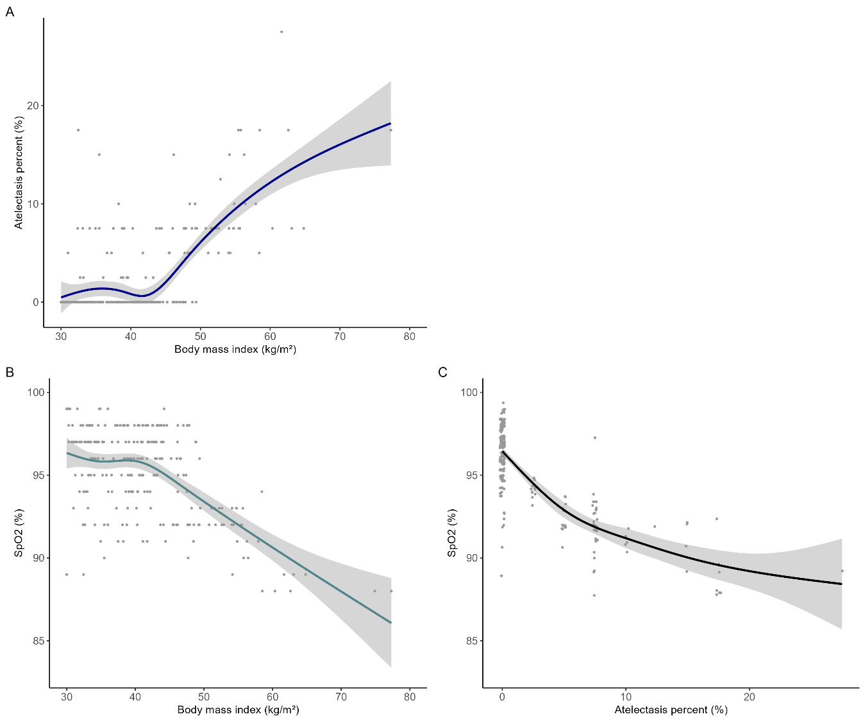

**Figure 2**. Relative frequency of atelectasis percentage coverage by BMI categories.

**Figure 3**. Partial effect of body mass index (BMI) on mean SpO2.

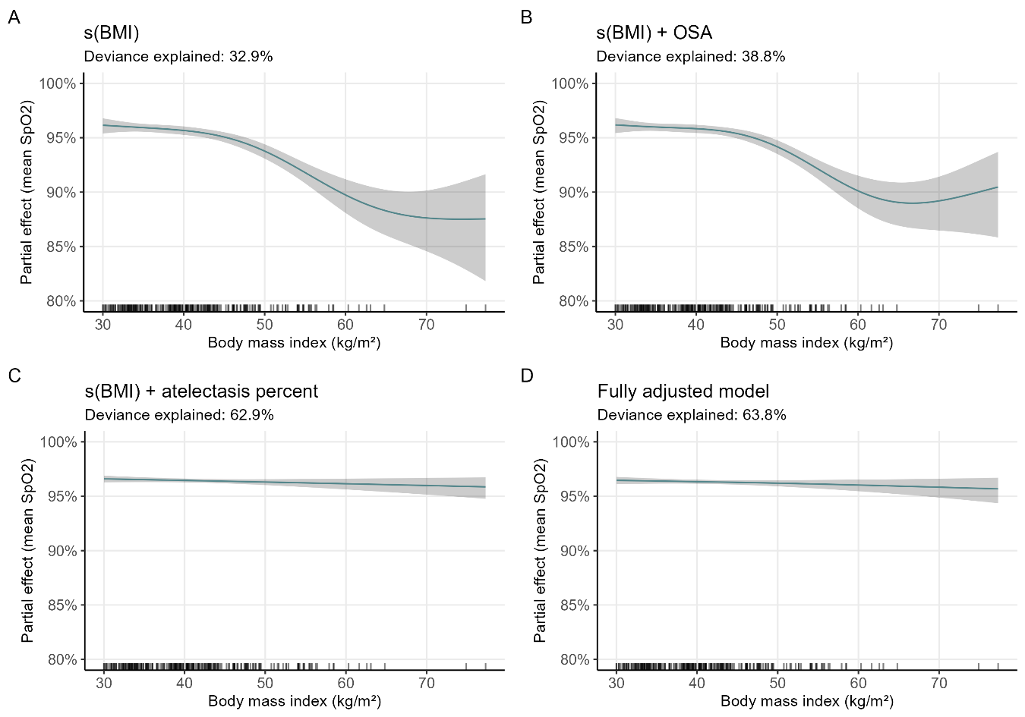

The green-blue line represents the mean SpO2 across increasing values of BMI, with its 95% confidence interval (shaded area). **A)** Model including only a smoothed term for BMI⎯s(BMI)⎯(p<0.001). **B)** Model including terms for s(BMI) (p<0.001) and obstructive sleep apnea (OSA). **C)** Model including s(BMI) (p=0.2) and atelectasis percent as predictors. **D)** Model including s(BMI) (p=0.3) adjusted for age, sex, OSA, mean altitude at the place of residence, hemoglobin, and atelectasis percentage.

**Supplementary Figure 1**. Directed acyclic graph (DAG).

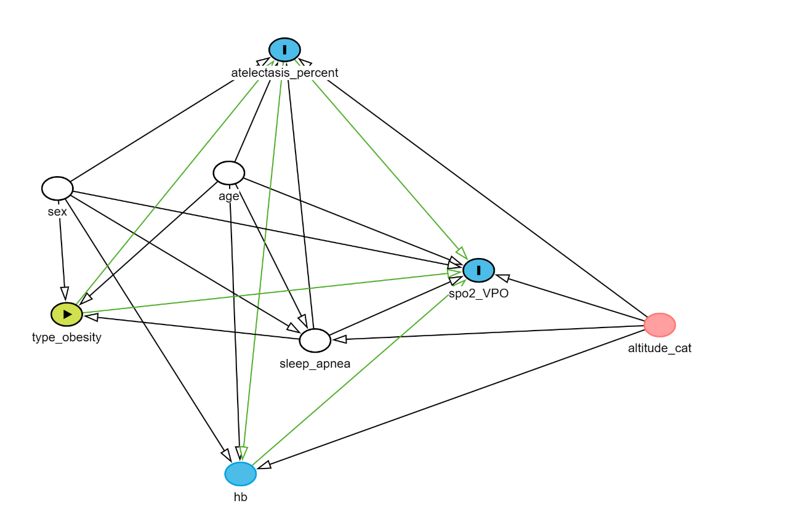

Each circle (node) is used to present a variable. The node in green with an arrowhead inside is the exposure of interest (obesity class), while nodes filled in blue with an “I” inside are the outcomes of interest (atelectasis and SpO2 during the preoperative assessment). White nodes (age, sex, and sleep apnea) correspond to the minimal set of confounders needed to adjust for to remove biasing pathways. The blue node (hemoglobin) is an ancestor of the Spo2 outcome. The pink node (altitude category) is a covariate for which no biasing pathways are latent.

Black arrows show the direction of association between variables, while green arrows present the potential causal paths between exposure and outcome variables.

This figure was generated in <https://www.dagitty.net/dags.html>; the model code is available at <https://github.com/javimangal/preoperative_atelectasis>.

**Supplementary Figure 2**. State of residence of participants.

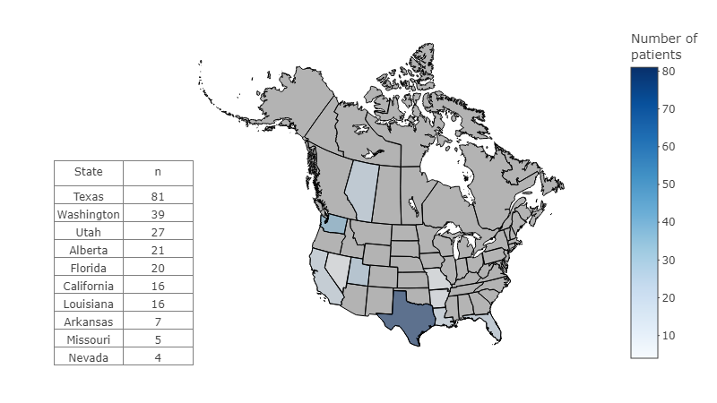

Absolute frequency of patients per state of residence in the USA and Canada.