ECOLOGICAL CONSEQUENCES OF INDIVIDUAL VARIATION IN ANIMAL MOVEMENT: A MODELING APPROACH

By

FRANCISCA JAVIERA RUDOLPH

A DISSERTATION PRESENTED TO THE GRADUATE SCHOOL  
OF THE UNIVERSITY OF FLORIDA IN PARTIAL FULFILLMENT  
OF THE REQUIREMENTS FOR THE DEGREE OF  
DOCTOR OF PHILOSOPHY

UNIVERSITY OF FLORIDA

2022

© 2022 Francisca Javiera Rudolph

To Julián y Adriana

ACKNOWLEDGMENTS

This dissertation is the result of my family’s efforts and sacrificies over two generations to provide me the education they hoped for. As a first-generation college student, and the only person in my family to receive a doctorate, this is a great accomplishment to us all. I would like to thank my parents for all their love and encouragement, their sacrifices, and for showing me strength. I would also like to thank my husband, Arthur Rudolph, my biggest cheerleader. I love you! The support offered by fellow science moms, RLadies, and our group of academic parents was indispensable. Special thanks to my closest friends, Kristen and Laura, for providing a space to vent and a friendly face when life was too much.

I would also like to specially thank Colette St. Mary, who is not only one of my committee members, but I am happy to be able to call a friend and part of our family. Your support, encouragement, feedback, and endless optimism were crucial for me to write this dissertation. I would like to acknowledge my colleage and friend, Mathew Leibold, who provided mentorship and support during this process, and I am honored to be an unofficial member of the Leibold lab. I would also like to thank my advisors, José Miguel and Bette, for their unwavering support, and my committee members, Miguel and Bob, for their feedback. Last but not least, I would not have finished this dissertation if it weren’t for Amanda Subalusky. You have showed me so much empathy and support, as a mother and a scientist. The motivation and excitement to work with you and your team has truly been the final push I needed to get this dissertation out of the way!

TABLE OF CONTENTS

page

ACKNOWLEDGMENTS 4

LIST OF TABLES 7

LIST OF FIGURES 8

LIST OF OBJECTS 9

LIST OF ABBREVIATIONS 10

ABSTRACT 11

CHAPTER

1 TITLE OF CHAPTER ONE 12

First Level Subheading 12

First Level Subheading 13

Second Level Subheading 14

Third level subheading 14

Third level subheading 15

Second Level Subheading 15

2 TITLE OF CHAPTER TWO 21

First Level Subheading 21

First Level Subheading 22

Second Level Subheading 23

Third level subheading 23

Third level subheading 24

Second Level Subheading 24

3 TITLE OF CHAPTER THREE 30

First Level Subheading 30

First Level Subheading 31

Second Level Subheading 32

Third level subheading 32

Third level subheading 33

Second Level Subheading 33

APPENDIX

A TITLE PAGE SAMPLE 39

B COPYRIGHT PAGE SAMPLE 40

C TABLE OF CONTENTS SAMPLES 41

Sample Table of Contents for Numbered Chapters 41

Sample Table of Contents for Numbered Chapters and Subdivisions 42

Sample Table of Contents for Theses and Dissertations without Chapter Numbers 43

Sample Table of Contents for Creative Writing 44

NOTE: This page is an example of how to request permission to use copyrighted material and is not to be included in the Thesis or Dissertation. If you use material from another author you must submit this completed form to the Graduate Editorial Office prior to receiving Final Clearance. 45

Permission to Reproduce Copyrighted Material 45

LIST OF REFERENCES 46

BIOGRAPHICAL SKETCH 48

LIST OF TABLES

Table page

1-1 Table captions go at the top of the table but should not be part of the table itself. 16

1-2 The best practice is to place Tables and Figures at the end of the Chapter. 17

1-3 Tables that can’t fit on a single page must be split across two of more pages. 19

2-1 Table captions go at the top of the table but should not be part of the table itself. 25

2-2 The best practice is to place Tables and Figures at the end of the Chapter. 26

2-3 Tables that can’t fit on a single page must be split across two of more pages. 28

3-1 Table captions go at the top of the table but should not be part of the table itself. 34

3-2 The best practice is to place Tables and Figures at the end of the Chapter. 35

3-3 Tables that can’t fit on a single page must be split across two of more pages. 37

LIST OF FIGURES

Figure page

1-1 Figure numbers take the form of Chapter number-Figure number and the figure caption uses the style 014 Figure Caption. 16

1-2 Multi-part figures should be clearly labeled, without punctuation. And have a description of the whole figure as the first part of the caption. 17

1-3 There should be a space between a figure and the figure caption, while the Table caption sits right on top of the Table. 20

2-1 Figure numbers take the form of Chapter number-Figure number and the figure caption uses the style 014 Figure Caption. 25

2-2 Multi-part figures should be clearly labeled, without punctuation. And have a description of the whole figure as the first part of the caption. 26

2-3 There should be a space between a figure and the figure caption, while the Table caption sits right on top of the Table. 29

3-1 Figure numbers take the form of Chapter number-Figure number and the figure caption uses the style 014 Figure Caption. 34

3-2 Multi-part figures should be clearly labeled, without punctuation. And have a description of the whole figure as the first part of the caption. 35

3-3 There should be a space between a figure and the figure caption, while the Table caption sits right on top of the Table. 38

LIST OF OBJECTS

Object page

1-1 An Audio, Video, or large chunk of data you wish to make available to the reader. Tell the reader the type and size of the file 15

1-2 Objects are numbered the same way that Tables and Figures are numbered. You would make these captions the hyperlinks to your Object Files. 15

2-1 An Audio, Video, or large chunk of data you wish to make available to the reader. Tell the reader the type and size of the file 24

2-2 Objects are numbered the same way that Tables and Figures are numbered. You would make these captions the hyperlinks to your Object Files. 24

3-1 An Audio, Video, or large chunk of data you wish to make available to the reader. Tell the reader the type and size of the file 33

3-2 Objects are numbered the same way that Tables and Figures are numbered. You would make these captions the hyperlinks to your Object Files. 33

LIST OF ABBREVIATIONS

|  |  |
| --- | --- |
| Word to be defined | Write the definition here. Do not put any hard carriage returns in the definition and it will wrap like this automatically. When you are done with the definition, press the “Tab” key once and you will advance to the next cell |
| Next word | And the list continues. This is actually a table with no boarders and gives the effect of two separate columns so the definitions can wrap in their column and the words (or phrases) to be defined can wrap in their column as well. |
| Another word | Remember to use a tab between the abbreviations and the definitions. A Tab will also advance you to the next line of the Table and will generate a new line if you hit “Tab” in the last cell of the table. Use the “Borders” button in the “Paragraph” section of the “Home” tab to show the cells of the table available, just remember to turn them off when you’re done. |

Abstract of Dissertation Presented to the Graduate School  
of the University of Florida in Partial Fulfillment of the  
Requirements for the Degree of Doctor of Philosophy

ECOLOGICAL CONSEQUENCES OF INDIVIDUAL VARIATION IN ANIMAL MOVEMENT: A MODELING APPROACH

By

Francisca Javiera Rudolph

May 2022

Chair: José Miguel Ponciano

Cochair: Bette Loiselle

Major: Zoology

Seed dispersal is a fundamental process in plant ecology and due to its importance in shaping plant distribution and communities, various modelling approaches have been developed to predict seed movement and dispersal mechanisms. Frugivore-generated seed dispersal patterns are largely influenced by animal movement patterns, and the intraspecific variation in animal movement and behaviors. In particular, long-distance seed dispersal (LDD) plays a significant role in determining genetic diversity and range expansion in plants. As frugivores can travel long distances and transport seeds with them, animal-mediated seed dispersal is a key component of LDD events. In this study we seek to understand the implications of individual variation in animal movement and how these can impact estimates of long-distance seed dispersal. We use a simulation approach to explore the effects of intraspecific variation in animal movement rates on seed dispersal distances and apply these methods to empirical data for the araçari, *Pteroglossus pluricintus*, one of the primary frugivores for the Amazonian canopy tree *Virola flexuosa*. We combine animal movement data and gut retention time to simulate *Virola* seed dispersal with an individual-based model on a homogeneous landscape. This approach showed that variation in individual araçari movement directly influences the estimated number of long-distance dispersal events for *Virola* seeds. Additionally, we include an approach using statistics of extremes to characterize the tail behavior of generated seed dispersal kernels under varying levels of intraspecific variation of animal movement. We found that models ignoring underlying variation in individual animal movement, underestimate long-distance seed dispersal events and maximum seed dispersal distances.

CHAPTER 1

TITLE

There does not have to be a heading at the beginning of each Chapter– which is, by definition, the introduction to the chapter.[1]* Any Chapter Title should not be used as a subheading in any other Chapter. The organization and order of your Chapters is up to you and your Committee. There are some basic requirements. If you are writing a “Three Paper Dissertation,” there must be a separate introductory Chapter and a separate conclusion Chapter. There should be only one Abstract for the entire document, and one list of References as well. Most of the time a review of the current literature on the subject is included, again, whether it is a stand alone chapter or a section of the introduction is between you and your Committee.

Many Dissertations contain mathematical equations or formulae. These can be troublesum if you try to place them within the text. We find that placing an equation within a one line table often solves the problem:

|  |  |
| --- | --- |
|  | (1-1) |

Turning off the border makes it appear as if it was simply inserted in the text. Note the equation label is aligned with the right hand margin and is keyed to the chapter just like Tables and Figures but the word “equation” is not used in the label. Use 007 Body Text No Indent to continue in the same paragraph after the equation, and 006 Body Text to start a new subject.

First Level Subheading

First Level Subheadings are in Title Case (every principal word is capitalized, except, prepositions, conjunctions, and articles. 006 Body Text comprises the majority of the text in the document. Each of the styles are presented in every chapter of the template. You only need to keep one chapter in your document until the document is fully formatted. Once you are finished with the formatting you can delete the Template Text. If, for some reason, you find you need a style not included in your finished document.[2] All you have to do is copy one chapter from the template, paste it to the end of your file and the missing style will be available again.

008 Block Text-Block Quote. Any quote that is more than three lines long (approximately 40 words) should be set as a block quote. Block quotes are single-spaced and indented one-half inch on both the left and right margins. No quotes are needed in a block quote, unless the person your are quoting is quoting someone else.

More than one paragraph can be used in a block quote. They are indicated by a line space that is built into the style. Just press return once at the end of the paragraph or quote to move on to another subject.

007 Body Text-No Indent. (used to continue a paragraph after a quote or list) Nulla vel volutpat enim. Curabitur molestie ut enim non bibendum.[3] Praesent id justo posuere, vestibulum lectus tempor, tempus libero. Nunc dictum, arcu sodales fringilla ornare,

First Level Subheading

006 Body Text. neque dui pulvinar nulla, et consequat velit arcu quis eros. Quisque massa diam, tempor eget arcu egestas, consectetur sollicitudin neque.

* 009 Short List - Bullets
* Used when no item in the list is longer
* Than a single line.

A short list is any list where no item is longer than a single line. The list is single-spaced with a space before and after the list. 006 Body Text provides the space before, but you must provide the space after. Press return to move to the next line and “Clear All” to make that new line empty space. 010 Short List – Numbers works the same way but enumerates the list instead of using bullets. The problem with the 010 Short List Numbers is that if you have a second numbered list, Word will continue the numbering from the previous list. If you attempt to make the list start over at 1, the formatting of the list will need to be manually adjusted.

Second Level Subheading

Second Level headings are also in Title Case, but are left-aligned instead of centered. O11 Long List – Bullets style is used if any of the lines in the list wrap to a second line. In that case the items are single-spaced but there is a space between each item.

* Proin vehicula diam non
* faucibus imperdiet. Fusce mattis
* tortor et velit viverra, sit amet blandit ipsum finibus.
* Vivamus vehicula sed elit
* vitae finibus. Sed egestas nunc in mi pretium, in rhoncus tellus facilisis. Class aptent taciti sociosqu ad litora torquent per conubia nostra,
* per inceptos himenaeos.
* Phasellus fermentum

With a long list the space at the end of the list is built in and does not have to be added. The biggest problem with 012 Long List – Numbers (or numbered lists in general) is that the second time you use the style it will continue the numbers from the first list. When you change it to re-start at 1, the formatting will revert to the default numbered list format. So you will have to re-set the hanging indent to 0.5” and set the left indent back to 0.

Third level subheading

Third level headings are left-aligned, but are in sentence case (The first word and any proper nouns are capitalized). 016 Transcribed dialog is used to quote participants in a study:

Name1: Dialog test presented in the dialog

Name2: Response to the first speaker. It’s not necessary to have two speakers, you’re just presenting comments from a study for the reader’s benefit.

007 Body Text – No Indent would be used to continue in the same train of thought, where regular 006 Body Text would start a new paragraph.

Third level subheading

Large amounts of data, audio, or video files can be stored in the UF Library System in the Institutional Repository Digital Collections. These files are called “Objects” and are accessed via a URL that is provided after you upload the file (Contact the Library for instructions on uploading). In your document, where you are discussing the Object File you should place the link to the file as an 015 Object Caption.

Object 1-1. An Audio, Video, or large chunk of data you wish to make available to the reader. Tell the reader the type and size of the file

Object 1-2. Objects are numbered the same way that Tables and Figures are numbered. You would make these captions the hyperlinks to your Object Files.

If you don’t have any objects (and most will not) feel free to delete the List of Objects page.

Second Level Subheading

There must be a second, second level subheading in this section to correctly follow the rules of outlining. Any section that is divided must be divided by two or more sections

**Paragraph headings.** The only exception is a paragraph heading, which is still formatted as 006 Body Text. It appears at the beginning of the sentence, ends with a period or colon, is in sentence case, and in bold. It can appear at any level and does not have to be paired as do the First, Second and Third level subheadings.

Table 1-1. Table captions go at the top of the table but should not be part of the table itself. The table numbers are keyed to the chapter (chapter number-table number) and the captions have the style 013 Table Caption. The table number should hang outside of the table caption

|  |  |  |  |  |
| --- | --- | --- | --- | --- |
|  | This heading covers 2 & 3 | | This heading covers 4 & 5 | |
| Heading1 | Heading 2 | Heading 3 | Heading 4a | Heading 5 |
| Row heading | Data | Data | 0.002 | Data |
| Row subheading | Data | Data | 43.4 | Data |
| Subheading | Data | Data | 100.456 | Data |
| Row heading | Data | Data | 2.5 | Data |

Notes go below the table but are not part of the table. The best practice is to make them in paragraph style, not as a list. a Numerical data should be aligned on a decimal tab. Select the column and place the tab using the Ruler. Notes are usually made in 10 pt. type. Tables should not have ANY vertical lines and only the minimum horizontal lines. Most tables are best when they are the full width of the text (6.5 in.)



Figure 1-1. Figure numbers take the form of Chapter number-Figure number and the figure caption uses the style 014 Figure Caption. The caption is left-aligned with a hanging indent and goes at the bottom of the figure. There should be one line of space between the figure and the caption.

Table 1-2. The best practice is to place Tables and Figures at the end of the Chapter. Once the paragraph text has ended, the requirement to make the pages full ends as well giving more freedom in your spacing.

|  |  |  |
| --- | --- | --- |
| Heading1 | Heading 2 | Heading 3 |
| Data | Data | Data |
| Data | Data | Data |
| Data | Data | Data |
| Data | Data | Data |
| Data | Data | Data |
| Data | Data | Data |
| Data | Data | Data |
| Data | Data | Data |

Even small tables generally look best when set to the full width of the text (6.5”)

A 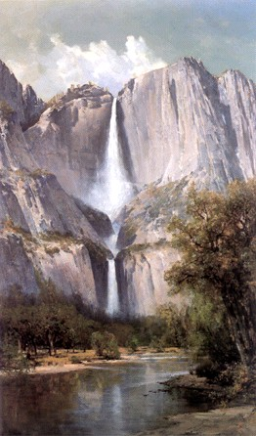 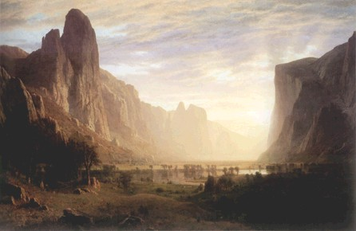 B

Figure 1-2. Multi-part figures should be clearly labeled, without punctuation. And have a description of the whole figure as the first part of the caption. Then you can describe A) the waterfall, B) the canyon, C) the Montana poster and D) the waterfall poster. These sub-captions can be removed in the actual List of Figures to make it much cleaner and compact. If the figure continues to a second page, the entire caption should appear on the first page of the figure and the following pages should be labeled as “Figure X-W. Continued” – do not apply the Figure Caption Style to the continued notation and it should not appear in the List of Figures.

C   D

Figure 1-2. Continued

Table 1-3. Tables that can’t fit on a single page must be split across two of more pages. When this happens, you actually split the table into a new table starting on the next page without a table caption – just the table number and the word “Continued” at the top of the Table. You also have to repeat the headings at the top of the second (and subsequent) page(s). Table text can be reduced from 12 pts. to 10 pts. to fit more data on the page if desired.

|  |  |  |  |  |
| --- | --- | --- | --- | --- |
| Category | Heading 1 | Heading 2 | Heading 3 | Heading 4 |
| Row heading | Data | Data | Data | Data |
| Row heading | Data | Data | Data | Data |
| Row heading | Data | Data | Data | Data |
| Row heading | Data | Data | Data | Data |
| Row heading | Data | Data | Data | Data |
| Row heading | Data | Data | Data | Data |
| Row heading | Data | Data | Data | Data |
| Row heading | Data | Data | Data | Data |
| Row heading | Data | Data | Data | Data |
| Row heading | Data | Data | Data | Data |
| Row heading | Data | Data | Data | Data |
| Row heading | Data | Data | Data | Data |
| Row heading | Data | Data | Data | Data |
| Row heading | Data | Data | Data | Data |
| Row heading | Data | Data | Data | Data |
| Row heading | Data | Data | Data | Data |
| Row heading | Data | Data | Data | Data |
| Row heading | Data | Data | Data | Data |
| Row heading | Data | Data | Data | Data |
| Row heading | Data | Data | Data | Data |
| Row heading | Data | Data | Data | Data |
| Row heading | Data | Data | Data | Data |
| Row heading | Data | Data | Data | Data |
| Row heading | Data | Data | Data | Data |
| Row heading | Data | Data | Data | Data |
| Row heading | Data | Data | Data | Data |
| Row heading | Data | Data | Data | Data |
| Row heading | Data | Data | Data | Data |
| Row heading | Data | Data | Data | Data |
| Row heading | Data | Data | Data | Data |
| Row heading | Data | Data | Data | Data |
| Row heading | Data | Data | Data | Data |
| Row heading | Data | Data | Data | Data |
| Row heading | Data | Data | Data | Data |
| Row heading | Data | Data | Data | Data |
| Row heading | Data | Data | Data | Data |
| Row heading | Data | Data | Data | Data |
| Row heading | Data | Data | Data | Data |

Table 1-3. Continued

|  |  |  |  |  |
| --- | --- | --- | --- | --- |
| Category | Heading 1 | Heading 2 | Heading 3 | Heading 4 |
| Row heading | Data | Data | Data | Data |
| Row heading | Data | Data | Data | Data |
| Row heading | Data | Data | Data | Data |
| Row heading | Data | Data | Data | Data |
| Row heading | Data | Data | Data | Data |
| Row heading | Data | Data | Data | Data |
| Row heading | Data | Data | Data | Data |
| Row heading | Data | Data | Data | Data |
| Row heading | Data | Data | Data | Data |
| Row heading | Data | Data | Data | Data |

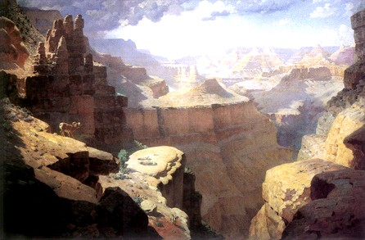

Figure 1-3. There should be a space between a figure and the figure caption, while the Table caption sits right on top of the Table. If the image has white space included at the bottom that can be used to be the needed space but make sure there is a return between the figure and the caption to keep the figure from becoming part of the List of Figures/Tables. My preference is for figures to be centered, but left aligned is OK – just be consistent.

CHAPTER 2

INDIVIDUAL VARIATION IN MOVEMENT RATES OF FRUGIVORES AND THEIR EFFECT OVER SEED DISPERSAL PATTERNS

This should be the introduction. In this chapter we are trying to answer the question, Does variation in animal movement rates have an impact in seed dispersal patterns? We characterize these patters with average dispersal measures, a measure of dispersion, and the percentage of long-distance seed dispersal events. We also fit a Weibull distribution to the data, to get the seed dispersal kernel, and use the fitted parameters as a measure of comparison between the dispersal kernels generated by the different movement rates.

Why is this important? Simulated based work in the past has mostly focused on using one distribution for movement rates or using a single movement rate that describes the whole population’s movement. We argue here that the variability between individuals is important to consider, specially when some animals are characteristically more adventurous and thus have greater movement rates. Movement rate variation also comes up with different seasons, such as breeding or nesting, and might be size or age related.

In this study we consider two traits, a movement distance and gut retention time to simulate seeds dispersed by animals, and try to link animal movement to properties of seed dispersal kernels. The dispersal kernels are the distance the seeds are moved by the animals, and calculate the mean and kurtosis.

Methods

We focused our study using a simulation-based approach that would allows us to explore different levels of variation across individuals and populations.

Simulation model

To study the effects of individual variation in animal movement on final dispersal distances of foraged seeds, we developed a spatially-explicit individual-based model in a homogenous landscape consisting of a single source tree. We incorporated animal movement as a random walk, focusing on two characteristics, a movement distance (MD) sampled from a probability density distribution, and a movement angle (MA) sampled from a uniform distribution. In addition to this, we included gut retention time (GRT), the time that ingested seeds stay inside the frugivore until they are dropped, as a random variable sampled from a gamma distribution (Morales & Carlo 2006). At the beginning of the simulation run, the animal was given 20 seeds, and allowed to move freely within the landscape, and GRT determined when the animal would drop a seed. Once a seed was dropped, its location was recorded, and once the animal dispersed all seeds, the simulation run stopped.

Simulation Experiments

Describe the different experiments you did theoretically: using three populations with same mean, but different variance, describing average movement rate of individuals. Then comparing the dispersal kernels between these populations.

An empirical example with data from the aracari and virola seeds

This is basically what I had done before, using the actual movement rates of the 12 individuals, and the gut retention time probability distribution done from field trials.

Results

Describing the results here

Simulation Experiments Results

We see that populations with higher variance also generate dispersal kernels with fatter tails. So, the variation among individuals within that population is important.

And, we can include the other measures here as well: mean, kurtosis, dispersion.

Results with parameters from aracari

Stuff that I had done before.

Discussion

CHAPTER 3

INCORPORATING INDIVIDUAL VARIATION IN ANIMAL MOVEMENT IN A STATE-SPACE MODELING FRAMEWORK USING RADIOTELEMETRY DATA

There does not have to be a heading at the beginning of each Chapter– which is, by definition, the introduction to the chapter. Any Chapter Title should not be used as a subheading in any other Chapter. The organization and order of your Chapters is up to you and your Committee. There are some basic requirements. If you are writing a “Three Paper Dissertation,” there must be a separate introductory Chapter and a separate conclusion Chapter. There should be only one Abstract for the entire document, and one list of References as well. Most of the time a review of the current literature on the subject is included, again, whether it is a stand alone chapter or a section of the introduction is between you and your Committee.

Many Dissertations contain mathematical equations or formulae. These can be troublesum if you try to place them within the text. We find that placing an equation within a one line table often solves the problem:

|  |  |
| --- | --- |
| $${\left(x+a\right)}^{n}=\sum_{k=0}^{n}{\left({n \atop k}\right)x^{k}a^{n-k}}$$ | (3-1) |

Turning off the border makes it appear as if it was simply inserted in the text. Note the equation label is aligned with the right hand margin and is keyed to the chapter just like Tables and Figures but the word “equation” is not used in the label. Use 007 Body Text No Indent to continue in the same paragraph after the equation, and 006 Body Text to start a new subject.

First Level Subheading

First Level Subheadings are in Title Case (every principal word is capitalized, except, prepositions, conjunctions, and articles.[4]* 006 Body Text comprises the majority of the text in the document. Each of the styles are presented in every chapter of the template. You only need to keep one chapter in your document until the document is fully formatted. Once you are finished with the formatting you can delete the Template Text. If, for some reason, you find you need a style not included in your finished document.[5] All you have to do is copy one chapter from the template, paste it to the end of your file and the missing style will be available again.

008 Block Text-Block Quote. Any quote that is more than three lines long (approximately 40 words) should be set as a block quote. Block quotes are single-spaced and indented one-half inch on both the left and right margins. No quotes are needed in a block quote, unless the person your are quoting is quoting someone else.

More than one paragraph can be used in a block quote. They are indicated by a line space that is built into the style. Just press return once at the end of the paragraph or quote to move on to another subject.

007 Body Text-No Indent. (used to continue a paragraph after a quote or list) Nulla vel volutpat enim. Curabitur molestie ut enim non bibendum.[6] Praesent id justo posuere, vestibulum lectus tempor, tempus libero. Nunc dictum, arcu sodales fringilla ornare,

First Level Subheading

006 Body Text. neque dui pulvinar nulla, et consequat velit arcu quis eros. Quisque massa diam, tempor eget arcu egestas, consectetur sollicitudin neque.

* 009 Short List - Bullets
* Used when no item in the list is longer
* Than a single line.

A short list is any list where no item is longer than a single line. The list is single-spaced with a space before and after the list. 006 Body Text provides the space before, but you must provide the space after. Press return to move to the next line and “Clear All” to make that new line empty space. 010 Short List – Numbers works the same way but enumerates the list instead of using bullets. The problem with the 010 Short List Numbers is that if you have a second numbered list, Word will continue the numbering from the previous list. If you attempt to make the list start over at 1, the formatting of the list will need to be manually adjusted.

Second Level Subheading

Second Level headings are also in Title Case, but are left-aligned instead of centered. O11 Long List – Bullets style is used if any of the lines in the list wrap to a second line. In that case the items are single-spaced but there is a space between each item.

* Proin vehicula diam non
* faucibus imperdiet. Fusce mattis
* tortor et velit viverra, sit amet blandit ipsum finibus.
* Vivamus vehicula sed elit
* vitae finibus. Sed egestas nunc in mi pretium, in rhoncus tellus facilisis. Class aptent taciti sociosqu ad litora torquent per conubia nostra,
* per inceptos himenaeos.
* Phasellus fermentum

With a long list the space at the end of the list is built in and does not have to be added. The biggest problem with 012 Long List – Numbers is that the second time you use the style it will continue the numbers from the first list. When you change it to re-start at 1, the formatting will revert to the default numbered list format. So you will have to re-set the hanging indent to 0.5” and set the left indent back to 0.

Third level subheading

Third level headings are left-aligned, but are in sentence case (The first word and any proper nouns are capitalized). 016 Transcribed dialog is used to quote participants in a study:

Name1: Dialog test presented in the dialog

Name2: Response to the first speaker. It’s not necessary to have two speakers, you’re just presenting comments from a study for the reader’s benefit.

007 Body Text – No Indent would be used to continue in the same train of thought, where regular 006 Body Text would start a new paragraph.

Third level subheading

Large amounts of data, audio, or video files can be stored in the UF Library System in the Institutional Repository Digital Collections. These files are called “Objects” and are accessed via a URL that is provided after you upload the file (Contact the Library for instructions on uploading). In your document, where you are discussing the Object File you should place the link to the file as an 015 Object Caption.

Object 3-1. An Audio, Video, or large chunk of data you wish to make available to the reader. Tell the reader the type and size of the file

Object 3-2. Objects are numbered the same way that Tables and Figures are numbered. You would make these captions the hyperlinks to your Object Files.

If you don’t have any objects (and most will not) feel free to delete the List of Objects page.

Second Level Subheading

There must be a second, second level subheading in this section to correctly follow the rules of outlining. Any section that is divided must be divided by two or more sections

**Paragraph headings.** The only exception is a paragraph heading, which is still formatted as 006 Body Text. It appears at the beginning of the sentence, ends with a period or colon, is in sentence case, and in bold. It can appear at any level and does not have to be paired as do the First, Second and Third level subheadings.

Table 3-1. Table captions go at the top of the table but should not be part of the table itself. The table numbers are keyed to the chapter (chapter number-table number) and the captions have the style 013 Table Caption. The table number should hang outside of the table caption

|  |  |  |  |  |
| --- | --- | --- | --- | --- |
|  | This heading covers 2 & 3 | | This heading covers 4 & 5 | |
| Heading1 | Heading 2 | Heading 3 | Heading 4a | Heading 5 |
| Row heading | Data | Data | 0.002 | Data |
| Row subheading | Data | Data | 43.4 | Data |
| Subheading | Data | Data | 100.456 | Data |
| Row heading | Data | Data | 2.5 | Data |

Notes go below the table but are not part of the table. The best practice is to make them in paragraph style, not as a list. a Numerical data should be aligned on a decimal tab. Select the column and place the tab using the Ruler. Notes are usually made in 10 pt. type. Tables should not have ANY vertical lines and only the minimum horizontal lines. Most tables are best when they are the full width of the text (6.5 in.)



Figure 3-1. Figure numbers take the form of Chapter number-Figure number and the figure caption uses the style 014 Figure Caption. The caption is left-aligned with a hanging indent and goes at the bottom of the figure. There should be one line of space between the figure and the caption.

Table 3-2. The best practice is to place Tables and Figures at the end of the Chapter. Once the paragraph text has ended, the requirement to make the pages full ends as well giving more freedom in your spacing.

|  |  |  |
| --- | --- | --- |
| Heading1 | Heading 2 | Heading 3 |
| Data | Data | Data |
| Data | Data | Data |
| Data | Data | Data |
| Data | Data | Data |
| Data | Data | Data |
| Data | Data | Data |
| Data | Data | Data |
| Data | Data | Data |

Even small tables generally look best when set to the full width of the text (6.5”)

A   B

Figure 3-2. Multi-part figures should be clearly labeled, without punctuation. And have a description of the whole figure as the first part of the caption. Then you can describe A) the waterfall, B) the canyon, C) the Montana poster and D) the waterfall poster. These sub-captions can be removed in the actual List of Figures to make it much cleaner and compact. If the figure continues to a second page, the entire caption should appear on the first page of the figure and the following pages should be labeled as “Figure X-Y. Continued” – do not apply the Figure Caption Style to the continued notation and it should not appear in the List of Figures.

C   D

Figure 3-2. Continued

Table 3-3. Tables that can’t fit on a single page must be split across two of more pages. When this happens, you actually split the table into a new table starting on the next page without a table caption – just the table number and the word “Continued” at the top of the Table. You also have to repeat the headings at the top of the second (and subsequent) page(s). Table text can be reduced from 12 pts. to 10 pts. to fit more data on the page if desired.

|  |  |  |  |  |
| --- | --- | --- | --- | --- |
| Category | Heading 1 | Heading 2 | Heading 3 | Heading 4 |
| Row heading | Data | Data | Data | Data |
| Row heading | Data | Data | Data | Data |
| Row heading | Data | Data | Data | Data |
| Row heading | Data | Data | Data | Data |
| Row heading | Data | Data | Data | Data |
| Row heading | Data | Data | Data | Data |
| Row heading | Data | Data | Data | Data |
| Row heading | Data | Data | Data | Data |
| Row heading | Data | Data | Data | Data |
| Row heading | Data | Data | Data | Data |
| Row heading | Data | Data | Data | Data |
| Row heading | Data | Data | Data | Data |
| Row heading | Data | Data | Data | Data |
| Row heading | Data | Data | Data | Data |
| Row heading | Data | Data | Data | Data |
| Row heading | Data | Data | Data | Data |
| Row heading | Data | Data | Data | Data |
| Row heading | Data | Data | Data | Data |
| Row heading | Data | Data | Data | Data |
| Row heading | Data | Data | Data | Data |
| Row heading | Data | Data | Data | Data |
| Row heading | Data | Data | Data | Data |
| Row heading | Data | Data | Data | Data |
| Row heading | Data | Data | Data | Data |
| Row heading | Data | Data | Data | Data |
| Row heading | Data | Data | Data | Data |
| Row heading | Data | Data | Data | Data |
| Row heading | Data | Data | Data | Data |
| Row heading | Data | Data | Data | Data |
| Row heading | Data | Data | Data | Data |
| Row heading | Data | Data | Data | Data |
| Row heading | Data | Data | Data | Data |
| Row heading | Data | Data | Data | Data |
| Row heading | Data | Data | Data | Data |
| Row heading | Data | Data | Data | Data |
| Row heading | Data | Data | Data | Data |
| Row heading | Data | Data | Data | Data |
| Row heading | Data | Data | Data | Data |

Table 3-3. Continued

|  |  |  |  |  |
| --- | --- | --- | --- | --- |
| Category | Heading 1 | Heading 2 | Heading 3 | Heading 4 |
| Row heading | Data | Data | Data | Data |
| Row heading | Data | Data | Data | Data |
| Row heading | Data | Data | Data | Data |
| Row heading | Data | Data | Data | Data |
| Row heading | Data | Data | Data | Data |
| Row heading | Data | Data | Data | Data |
| Row heading | Data | Data | Data | Data |
| Row heading | Data | Data | Data | Data |
| Row heading | Data | Data | Data | Data |
| Row heading | Data | Data | Data | Data |



Figure 3-3. There should be a space between a figure and the figure caption, while the Table caption sits right on top of the Table. If the image has white space included at the bottom that can be used to be the needed space but make sure there is a return between the figure and the caption to keep the figure from becoming part of the List of Tables. My preference is for figures to be centered, but left aligned is OK – just be consistent.

CHAPTER 1

WHERE ARE WE AT WITH SEED DISPERSAL MODELING AND FRUGIVORE MOVEMENT?

There does not have to be a heading at the beginning of each Chapter– which is, by definition, the introduction to the chapter.[7]* Any Chapter Title should not be used as a subheading in any other Chapter. The organization and order of your Chapters is up to you and your Committee. There are some basic requirements. If you are writing a “Three Paper Dissertation,” there must be a separate introductory Chapter and a separate conclusion Chapter. There should be only one Abstract for the entire document, and one list of References as well. Most of the time a review of the current literature on the subject is included, again, whether it is a stand alone chapter or a section of the introduction is between you and your Committee.

Many Dissertations contain mathematical equations or formulae. These can be troublesum if you try to place them within the text. We find that placing an equation within a one line table often solves the problem:

|  |  |
| --- | --- |
|  | (1-1) |

Turning off the border makes it appear as if it was simply inserted in the text. Note the equation label is aligned with the right hand margin and is keyed to the chapter just like Tables and Figures but the word “equation” is not used in the label. Use 007 Body Text No Indent to continue in the same paragraph after the equation, and 006 Body Text to start a new subject.

First Level Subheading

First Level Subheadings are in Title Case (every principal word is capitalized, except, prepositions, conjunctions, and articles. 006 Body Text comprises the majority of the text in the document. Each of the styles are presented in every chapter of the template. You only need to keep one chapter in your document until the document is fully formatted. Once you are finished with the formatting you can delete the Template Text. If, for some reason, you find you need a style not included in your finished document.[8] All you have to do is copy one chapter from the template, paste it to the end of your file and the missing style will be available again.

008 Block Text-Block Quote. Any quote that is more than three lines long (approximately 40 words) should be set as a block quote. Block quotes are single-spaced and indented one-half inch on both the left and right margins. No quotes are needed in a block quote, unless the person your are quoting is quoting someone else.

More than one paragraph can be used in a block quote. They are indicated by a line space that is built into the style. Just press return once at the end of the paragraph or quote to move on to another subject.

007 Body Text-No Indent. (used to continue a paragraph after a quote or list) Nulla vel volutpat enim. Curabitur molestie ut enim non bibendum.[9] Praesent id justo posuere, vestibulum lectus tempor, tempus libero. Nunc dictum, arcu sodales fringilla ornare,

First Level Subheading

006 Body Text. neque dui pulvinar nulla, et consequat velit arcu quis eros. Quisque massa diam, tempor eget arcu egestas, consectetur sollicitudin neque.

* 009 Short List - Bullets
* Used when no item in the list is longer
* Than a single line.

A short list is any list where no item is longer than a single line. The list is single-spaced with a space before and after the list. 006 Body Text provides the space before, but you must provide the space after. Press return to move to the next line and “Clear All” to make that new line empty space. 010 Short List – Numbers works the same way but enumerates the list instead of using bullets. The problem with the 010 Short List Numbers is that if you have a second numbered list, Word will continue the numbering from the previous list. If you attempt to make the list start over at 1, the formatting of the list will need to be manually adjusted.

Second Level Subheading

Second Level headings are also in Title Case, but are left-aligned instead of centered. O11 Long List – Bullets style is used if any of the lines in the list wrap to a second line. In that case the items are single-spaced but there is a space between each item.

* Proin vehicula diam non
* faucibus imperdiet. Fusce mattis
* tortor et velit viverra, sit amet blandit ipsum finibus.
* Vivamus vehicula sed elit
* vitae finibus. Sed egestas nunc in mi pretium, in rhoncus tellus facilisis. Class aptent taciti sociosqu ad litora torquent per conubia nostra,
* per inceptos himenaeos.
* Phasellus fermentum

With a long list the space at the end of the list is built in and does not have to be added. The biggest problem with 012 Long List – Numbers (or numbered lists in general) is that the second time you use the style it will continue the numbers from the first list. When you change it to re-start at 1, the formatting will revert to the default numbered list format. So you will have to re-set the hanging indent to 0.5” and set the left indent back to 0.

Third level subheading

Third level headings are left-aligned, but are in sentence case (The first word and any proper nouns are capitalized). 016 Transcribed dialog is used to quote participants in a study:

Name1: Dialog test presented in the dialog

Name2: Response to the first speaker. It’s not necessary to have two speakers, you’re just presenting comments from a study for the reader’s benefit.

007 Body Text – No Indent would be used to continue in the same train of thought, where regular 006 Body Text would start a new paragraph.

Third level subheading

Large amounts of data, audio, or video files can be stored in the UF Library System in the Institutional Repository Digital Collections. These files are called “Objects” and are accessed via a URL that is provided after you upload the file (Contact the Library for instructions on uploading). In your document, where you are discussing the Object File you should place the link to the file as an 015 Object Caption.

Object 1-1. An Audio, Video, or large chunk of data you wish to make available to the reader. Tell the reader the type and size of the file

Object 1-2. Objects are numbered the same way that Tables and Figures are numbered. You would make these captions the hyperlinks to your Object Files.

If you don’t have any objects (and most will not) feel free to delete the List of Objects page.

Second Level Subheading

There must be a second, second level subheading in this section to correctly follow the rules of outlining. Any section that is divided must be divided by two or more sections

**Paragraph headings.** The only exception is a paragraph heading, which is still formatted as 006 Body Text. It appears at the beginning of the sentence, ends with a period or colon, is in sentence case, and in bold. It can appear at any level and does not have to be paired as do the First, Second and Third level subheadings.

Table 1-1. Table captions go at the top of the table but should not be part of the table itself. The table numbers are keyed to the chapter (chapter number-table number) and the captions have the style 013 Table Caption. The table number should hang outside of the table caption

|  |  |  |  |  |
| --- | --- | --- | --- | --- |
|  | This heading covers 2 & 3 | | This heading covers 4 & 5 | |
| Heading1 | Heading 2 | Heading 3 | Heading 4a | Heading 5 |
| Row heading | Data | Data | 0.002 | Data |
| Row subheading | Data | Data | 43.4 | Data |
| Subheading | Data | Data | 100.456 | Data |
| Row heading | Data | Data | 2.5 | Data |

Notes go below the table but are not part of the table. The best practice is to make them in paragraph style, not as a list. a Numerical data should be aligned on a decimal tab. Select the column and place the tab using the Ruler. Notes are usually made in 10 pt. type. Tables should not have ANY vertical lines and only the minimum horizontal lines. Most tables are best when they are the full width of the text (6.5 in.)



Figure 1-1. Figure numbers take the form of Chapter number-Figure number and the figure caption uses the style 014 Figure Caption. The caption is left-aligned with a hanging indent and goes at the bottom of the figure. There should be one line of space between the figure and the caption.

Table 1-2. The best practice is to place Tables and Figures at the end of the Chapter. Once the paragraph text has ended, the requirement to make the pages full ends as well giving more freedom in your spacing.

|  |  |  |
| --- | --- | --- |
| Heading1 | Heading 2 | Heading 3 |
| Data | Data | Data |
| Data | Data | Data |
| Data | Data | Data |
| Data | Data | Data |
| Data | Data | Data |
| Data | Data | Data |
| Data | Data | Data |
| Data | Data | Data |

Even small tables generally look best when set to the full width of the text (6.5”)

A   B

Figure 1-2. Multi-part figures should be clearly labeled, without punctuation. And have a description of the whole figure as the first part of the caption. Then you can describe A) the waterfall, B) the canyon, C) the Montana poster and D) the waterfall poster. These sub-captions can be removed in the actual List of Figures to make it much cleaner and compact. If the figure continues to a second page, the entire caption should appear on the first page of the figure and the following pages should be labeled as “Figure X-W. Continued” – do not apply the Figure Caption Style to the continued notation and it should not appear in the List of Figures.

C   D

Figure 1-2. Continued

Table 1-3. Tables that can’t fit on a single page must be split across two of more pages. When this happens, you actually split the table into a new table starting on the next page without a table caption – just the table number and the word “Continued” at the top of the Table. You also have to repeat the headings at the top of the second (and subsequent) page(s). Table text can be reduced from 12 pts. to 10 pts. to fit more data on the page if desired.

|  |  |  |  |  |
| --- | --- | --- | --- | --- |
| Category | Heading 1 | Heading 2 | Heading 3 | Heading 4 |
| Row heading | Data | Data | Data | Data |
| Row heading | Data | Data | Data | Data |
| Row heading | Data | Data | Data | Data |
| Row heading | Data | Data | Data | Data |
| Row heading | Data | Data | Data | Data |
| Row heading | Data | Data | Data | Data |
| Row heading | Data | Data | Data | Data |
| Row heading | Data | Data | Data | Data |
| Row heading | Data | Data | Data | Data |
| Row heading | Data | Data | Data | Data |
| Row heading | Data | Data | Data | Data |
| Row heading | Data | Data | Data | Data |
| Row heading | Data | Data | Data | Data |
| Row heading | Data | Data | Data | Data |
| Row heading | Data | Data | Data | Data |
| Row heading | Data | Data | Data | Data |
| Row heading | Data | Data | Data | Data |
| Row heading | Data | Data | Data | Data |
| Row heading | Data | Data | Data | Data |
| Row heading | Data | Data | Data | Data |
| Row heading | Data | Data | Data | Data |
| Row heading | Data | Data | Data | Data |
| Row heading | Data | Data | Data | Data |
| Row heading | Data | Data | Data | Data |
| Row heading | Data | Data | Data | Data |
| Row heading | Data | Data | Data | Data |
| Row heading | Data | Data | Data | Data |
| Row heading | Data | Data | Data | Data |
| Row heading | Data | Data | Data | Data |
| Row heading | Data | Data | Data | Data |
| Row heading | Data | Data | Data | Data |
| Row heading | Data | Data | Data | Data |
| Row heading | Data | Data | Data | Data |
| Row heading | Data | Data | Data | Data |
| Row heading | Data | Data | Data | Data |
| Row heading | Data | Data | Data | Data |
| Row heading | Data | Data | Data | Data |
| Row heading | Data | Data | Data | Data |

Table 1-3. Continued

|  |  |  |  |  |
| --- | --- | --- | --- | --- |
| Category | Heading 1 | Heading 2 | Heading 3 | Heading 4 |
| Row heading | Data | Data | Data | Data |
| Row heading | Data | Data | Data | Data |
| Row heading | Data | Data | Data | Data |
| Row heading | Data | Data | Data | Data |
| Row heading | Data | Data | Data | Data |
| Row heading | Data | Data | Data | Data |
| Row heading | Data | Data | Data | Data |
| Row heading | Data | Data | Data | Data |
| Row heading | Data | Data | Data | Data |
| Row heading | Data | Data | Data | Data |



Figure 1-3. There should be a space between a figure and the figure caption, while the Table caption sits right on top of the Table. If the image has white space included at the bottom that can be used to be the needed space but make sure there is a return between the figure and the caption to keep the figure from becoming part of the List of Figures/Tables. My preference is for figures to be centered, but left aligned is OK – just be consistent.

CHAPTER 4

UNDERSTANDING THE EFFECTS OF INDIVIDUAL VARIATION IN FRUGIVORE MOVEMENT ON THE FREQUENCY OF LONG-DISTANCE SEED DISPERSAL USING STATISTICS OF EXTREMES

There does not have to be a heading at the beginning of each Chapter– which is, by definition, the introduction to the chapter.[10]* Any Chapter Title should not be used as a subheading in any other Chapter. The organization and order of your Chapters is up to you and your Committee. There are some basic requirements. If you are writing a “Three Paper Dissertation,” there must be a separate introductory Chapter and a separate conclusion Chapter. There should be only one Abstract for the entire document, and one list of References as well. Most of the time a review of the current literature on the subject is included, again, whether it is a stand alone chapter or a section of the introduction is between you and your Committee.

Many Dissertations contain mathematical equations or formulae. These can be troublesum if you try to place them within the text. We find that placing an equation within a one line table often solves the problem:

|  |  |
| --- | --- |
|  | (1-1) |

Turning off the border makes it appear as if it was simply inserted in the text. Note the equation label is aligned with the right hand margin and is keyed to the chapter just like Tables and Figures but the word “equation” is not used in the label. Use 007 Body Text No Indent to continue in the same paragraph after the equation, and 006 Body Text to start a new subject.

First Level Subheading

First Level Subheadings are in Title Case (every principal word is capitalized, except, prepositions, conjunctions, and articles. 006 Body Text comprises the majority of the text in the document. Each of the styles are presented in every chapter of the template. You only need to keep one chapter in your document until the document is fully formatted. Once you are finished with the formatting you can delete the Template Text. If, for some reason, you find you need a style not included in your finished document.[11] All you have to do is copy one chapter from the template, paste it to the end of your file and the missing style will be available again.

008 Block Text-Block Quote. Any quote that is more than three lines long (approximately 40 words) should be set as a block quote. Block quotes are single-spaced and indented one-half inch on both the left and right margins. No quotes are needed in a block quote, unless the person your are quoting is quoting someone else.

More than one paragraph can be used in a block quote. They are indicated by a line space that is built into the style. Just press return once at the end of the paragraph or quote to move on to another subject.

007 Body Text-No Indent. (used to continue a paragraph after a quote or list) Nulla vel volutpat enim. Curabitur molestie ut enim non bibendum.[12] Praesent id justo posuere, vestibulum lectus tempor, tempus libero. Nunc dictum, arcu sodales fringilla ornare,

First Level Subheading

006 Body Text. neque dui pulvinar nulla, et consequat velit arcu quis eros. Quisque massa diam, tempor eget arcu egestas, consectetur sollicitudin neque.

* 009 Short List - Bullets
* Used when no item in the list is longer
* Than a single line.

A short list is any list where no item is longer than a single line. The list is single-spaced with a space before and after the list. 006 Body Text provides the space before, but you must provide the space after. Press return to move to the next line and “Clear All” to make that new line empty space. 010 Short List – Numbers works the same way but enumerates the list instead of using bullets. The problem with the 010 Short List Numbers is that if you have a second numbered list, Word will continue the numbering from the previous list. If you attempt to make the list start over at 1, the formatting of the list will need to be manually adjusted.

Second Level Subheading

Second Level headings are also in Title Case, but are left-aligned instead of centered. O11 Long List – Bullets style is used if any of the lines in the list wrap to a second line. In that case the items are single-spaced but there is a space between each item.

* Proin vehicula diam non
* faucibus imperdiet. Fusce mattis
* tortor et velit viverra, sit amet blandit ipsum finibus.
* Vivamus vehicula sed elit
* vitae finibus. Sed egestas nunc in mi pretium, in rhoncus tellus facilisis. Class aptent taciti sociosqu ad litora torquent per conubia nostra,
* per inceptos himenaeos.
* Phasellus fermentum

With a long list the space at the end of the list is built in and does not have to be added. The biggest problem with 012 Long List – Numbers (or numbered lists in general) is that the second time you use the style it will continue the numbers from the first list. When you change it to re-start at 1, the formatting will revert to the default numbered list format. So you will have to re-set the hanging indent to 0.5” and set the left indent back to 0.

Third level subheading

Third level headings are left-aligned, but are in sentence case (The first word and any proper nouns are capitalized). 016 Transcribed dialog is used to quote participants in a study:

Name1: Dialog test presented in the dialog

Name2: Response to the first speaker. It’s not necessary to have two speakers, you’re just presenting comments from a study for the reader’s benefit.

007 Body Text – No Indent would be used to continue in the same train of thought, where regular 006 Body Text would start a new paragraph.

Third level subheading

Large amounts of data, audio, or video files can be stored in the UF Library System in the Institutional Repository Digital Collections. These files are called “Objects” and are accessed via a URL that is provided after you upload the file (Contact the Library for instructions on uploading). In your document, where you are discussing the Object File you should place the link to the file as an 015 Object Caption.

Object 1-1. An Audio, Video, or large chunk of data you wish to make available to the reader. Tell the reader the type and size of the file

Object 1-2. Objects are numbered the same way that Tables and Figures are numbered. You would make these captions the hyperlinks to your Object Files.

If you don’t have any objects (and most will not) feel free to delete the List of Objects page.

Second Level Subheading

There must be a second, second level subheading in this section to correctly follow the rules of outlining. Any section that is divided must be divided by two or more sections

**Paragraph headings.** The only exception is a paragraph heading, which is still formatted as 006 Body Text. It appears at the beginning of the sentence, ends with a period or colon, is in sentence case, and in bold. It can appear at any level and does not have to be paired as do the First, Second and Third level subheadings.

Table 1-1. Table captions go at the top of the table but should not be part of the table itself. The table numbers are keyed to the chapter (chapter number-table number) and the captions have the style 013 Table Caption. The table number should hang outside of the table caption

|  |  |  |  |  |
| --- | --- | --- | --- | --- |
|  | This heading covers 2 & 3 | | This heading covers 4 & 5 | |
| Heading1 | Heading 2 | Heading 3 | Heading 4a | Heading 5 |
| Row heading | Data | Data | 0.002 | Data |
| Row subheading | Data | Data | 43.4 | Data |
| Subheading | Data | Data | 100.456 | Data |
| Row heading | Data | Data | 2.5 | Data |

Notes go below the table but are not part of the table. The best practice is to make them in paragraph style, not as a list. a Numerical data should be aligned on a decimal tab. Select the column and place the tab using the Ruler. Notes are usually made in 10 pt. type. Tables should not have ANY vertical lines and only the minimum horizontal lines. Most tables are best when they are the full width of the text (6.5 in.)



Figure 1-1. Figure numbers take the form of Chapter number-Figure number and the figure caption uses the style 014 Figure Caption. The caption is left-aligned with a hanging indent and goes at the bottom of the figure. There should be one line of space between the figure and the caption.

Table 1-2. The best practice is to place Tables and Figures at the end of the Chapter. Once the paragraph text has ended, the requirement to make the pages full ends as well giving more freedom in your spacing.

|  |  |  |
| --- | --- | --- |
| Heading1 | Heading 2 | Heading 3 |
| Data | Data | Data |
| Data | Data | Data |
| Data | Data | Data |
| Data | Data | Data |
| Data | Data | Data |
| Data | Data | Data |
| Data | Data | Data |
| Data | Data | Data |

Even small tables generally look best when set to the full width of the text (6.5”)

A   B

Figure 1-2. Multi-part figures should be clearly labeled, without punctuation. And have a description of the whole figure as the first part of the caption. Then you can describe A) the waterfall, B) the canyon, C) the Montana poster and D) the waterfall poster. These sub-captions can be removed in the actual List of Figures to make it much cleaner and compact. If the figure continues to a second page, the entire caption should appear on the first page of the figure and the following pages should be labeled as “Figure X-W. Continued” – do not apply the Figure Caption Style to the continued notation and it should not appear in the List of Figures.

D

Figure 1-2. Continued

CHAPTER 5

A CALL FOR THE STUDY OF THE CONSEQUENCES OF INDIVIDUAL VARIATION IN MOVEMENT OF SEED DISPERSER COMMUNITIES

There does not have to be a heading at the beginning of each Chapter– which is, by definition, the introduction to the chapter.[13]* Any Chapter Title should not be used as a subheading in any other Chapter. The organization and order of your Chapters is up to you and your Committee. There are some basic requirements. If you are writing a “Three Paper Dissertation,” there must be a separate introductory Chapter and a separate conclusion Chapter. There should be only one Abstract for the entire document, and one list of References as well. Most of the time a review of the current literature on the subject is included, again, whether it is a stand alone chapter or a section of the introduction is between you and your Committee.

Many Dissertations contain mathematical equations or formulae. These can be troublesum if you try to place them within the text. We find that placing an equation within a one line table often solves the problem:

|  |  |
| --- | --- |
|  | (1-1) |

Turning off the border makes it appear as if it was simply inserted in the text. Note the equation label is aligned with the right hand margin and is keyed to the chapter just like Tables and Figures but the word “equation” is not used in the label. Use 007 Body Text No Indent to continue in the same paragraph after the equation, and 006 Body Text to start a new subject.

First Level Subheading

First Level Subheadings are in Title Case (every principal word is capitalized, except, prepositions, conjunctions, and articles. 006 Body Text comprises the majority of the text in the document. Each of the styles are presented in every chapter of the template. You only need to keep one chapter in your document until the document is fully formatted. Once you are finished with the formatting you can delete the Template Text. If, for some reason, you find you need a style not included in your finished document.[14] All you have to do is copy one chapter from the template, paste it to the end of your file and the missing style will be available again.

008 Block Text-Block Quote. Any quote that is more than three lines long (approximately 40 words) should be set as a block quote. Block quotes are single-spaced and indented one-half inch on both the left and right margins. No quotes are needed in a block quote, unless the person your are quoting is quoting someone else.

More than one paragraph can be used in a block quote. They are indicated by a line space that is built into the style. Just press return once at the end of the paragraph or quote to move on to another subject.

007 Body Text-No Indent. (used to continue a paragraph after a quote or list) Nulla vel volutpat enim. Curabitur molestie ut enim non bibendum.[15] Praesent id justo posuere, vestibulum lectus tempor, tempus libero. Nunc dictum, arcu sodales fringilla ornare,

First Level Subheading

006 Body Text. neque dui pulvinar nulla, et consequat velit arcu quis eros. Quisque massa diam, tempor eget arcu egestas, consectetur sollicitudin neque.

* 009 Short List - Bullets
* Used when no item in the list is longer
* Than a single line.

A short list is any list where no item is longer than a single line. The list is single-spaced with a space before and after the list. 006 Body Text provides the space before, but you must provide the space after. Press return to move to the next line and “Clear All” to make that new line empty space. 010 Short List – Numbers works the same way but enumerates the list instead of using bullets. The problem with the 010 Short List Numbers is that if you have a second numbered list, Word will continue the numbering from the previous list. If you attempt to make the list start over at 1, the formatting of the list will need to be manually adjusted.

Second Level Subheading

Second Level headings are also in Title Case, but are left-aligned instead of centered. O11 Long List – Bullets style is used if any of the lines in the list wrap to a second line. In that case the items are single-spaced but there is a space between each item.

* Proin vehicula diam non
* faucibus imperdiet. Fusce mattis
* tortor et velit viverra, sit amet blandit ipsum finibus.
* Vivamus vehicula sed elit
* vitae finibus. Sed egestas nunc in mi pretium, in rhoncus tellus facilisis. Class aptent taciti sociosqu ad litora torquent per conubia nostra,
* per inceptos himenaeos.
* Phasellus fermentum

With a long list the space at the end of the list is built in and does not have to be added. The biggest problem with 012 Long List – Numbers (or numbered lists in general) is that the second time you use the style it will continue the numbers from the first list. When you change it to re-start at 1, the formatting will revert to the default numbered list format. So you will have to re-set the hanging indent to 0.5” and set the left indent back to 0.

Third level subheading

Third level headings are left-aligned, but are in sentence case (The first word and any proper nouns are capitalized). 016 Transcribed dialog is used to quote participants in a study:

Name1: Dialog test presented in the dialog

Name2: Response to the first speaker. It’s not necessary to have two speakers, you’re just presenting comments from a study for the reader’s benefit.

007 Body Text – No Indent would be used to continue in the same train of thought, where regular 006 Body Text would start a new paragraph.

Third level subheading

Large amounts of data, audio, or video files can be stored in the UF Library System in the Institutional Repository Digital Collections. These files are called “Objects” and are accessed via a URL that is provided after you upload the file (Contact the Library for instructions on uploading). In your document, where you are discussing the Object File you should place the link to the file as an 015 Object Caption.

Object 1-1. An Audio, Video, or large chunk of data you wish to make available to the reader. Tell the reader the type and size of the file

Object 1-2. Objects are numbered the same way that Tables and Figures are numbered. You would make these captions the hyperlinks to your Object Files.

If you don’t have any objects (and most will not) feel free to delete the List of Objects page.

Second Level Subheading

There must be a second, second level subheading in this section to correctly follow the rules of outlining. Any section that is divided must be divided by two or more sections

**Paragraph headings.** The only exception is a paragraph heading, which is still formatted as 006 Body Text. It appears at the beginning of the sentence, ends with a period or colon, is in sentence case, and in bold. It can appear at any level and does not have to be paired as do the First, Second and Third level subheadings.

Table 1-1. Table captions go at the top of the table but should not be part of the table itself. The table numbers are keyed to the chapter (chapter number-table number) and the captions have the style 013 Table Caption. The table number should hang outside of the table caption

|  |  |  |  |  |
| --- | --- | --- | --- | --- |
|  | This heading covers 2 & 3 | | This heading covers 4 & 5 | |
| Heading1 | Heading 2 | Heading 3 | Heading 4a | Heading 5 |
| Row heading | Data | Data | 0.002 | Data |
| Row subheading | Data | Data | 43.4 | Data |
| Subheading | Data | Data | 100.456 | Data |
| Row heading | Data | Data | 2.5 | Data |

Notes go below the table but are not part of the table. The best practice is to make them in paragraph style, not as a list. a Numerical data should be aligned on a decimal tab. Select the column and place the tab using the Ruler. Notes are usually made in 10 pt. type. Tables should not have ANY vertical lines and only the minimum horizontal lines. Most tables are best when they are the full width of the text (6.5 in.)

Figure 1-1. Figure numbers take the form of Chapter number-Figure number and the figure caption uses the style 014 Figure Caption. The caption is left-aligned with a hanging indent and goes at the bottom of the figure. There should be one line of space between the figure and the caption.

Table 1-2. The best practice is to place Tables and Figures at the end of the Chapter. Once the paragraph text has ended, the requirement to make the pages full ends as well giving more freedom in your spacing.

|  |  |  |
| --- | --- | --- |
| Heading1 | Heading 2 | Heading 3 |
| Data | Data | Data |
| Data | Data | Data |
| Data | Data | Data |
| Data | Data | Data |
| Data | Data | Data |
| Data | Data | Data |
| Data | Data | Data |
| Data | Data | Data |

Even small tables generally look best when set to the full width of the text (6.5”)

B

Figure 1-2. Multi-part figures should be clearly labeled, without punctuation. And have a description of the whole figure as the first part of the caption. Then you can describe A) the waterfall, B) the canyon, C) the Montana poster and D) the waterfall poster. These sub-captions can be removed in the actual List of Figures to make it much cleaner and compact. If the figure continues to a second page, the entire caption should appear on the first page of the figure and the following pages should be labeled as “Figure X-W. Continued” – do not apply the Figure Caption Style to the continued notation and it should not appear in the List of Figures.

D

Figure 1-2. Continued

Table 1-3. Tables that can’t fit on a single page must be split across two of more pages. When this happens, you actually split the table into a new table starting on the next page without a table caption – just the table number and the word “Continued” at the top of the Table. You also have to repeat the headings at the top of the second (and subsequent) page(s). Table text can be reduced from 12 pts. to 10 pts. to fit more data on the page if desired.

|  |  |  |  |  |
| --- | --- | --- | --- | --- |
| Category | Heading 1 | Heading 2 | Heading 3 | Heading 4 |
| Row heading | Data | Data | Data | Data |
| Row heading | Data | Data | Data | Data |
| Row heading | Data | Data | Data | Data |
| Row heading | Data | Data | Data | Data |
| Row heading | Data | Data | Data | Data |
| Row heading | Data | Data | Data | Data |
| Row heading | Data | Data | Data | Data |
| Row heading | Data | Data | Data | Data |
| Row heading | Data | Data | Data | Data |
| Row heading | Data | Data | Data | Data |
| Row heading | Data | Data | Data | Data |
| Row heading | Data | Data | Data | Data |
| Row heading | Data | Data | Data | Data |
| Row heading | Data | Data | Data | Data |
| Row heading | Data | Data | Data | Data |
| Row heading | Data | Data | Data | Data |
| Row heading | Data | Data | Data | Data |
| Row heading | Data | Data | Data | Data |
| Row heading | Data | Data | Data | Data |
| Row heading | Data | Data | Data | Data |
| Row heading | Data | Data | Data | Data |
| Row heading | Data | Data | Data | Data |
| Row heading | Data | Data | Data | Data |
| Row heading | Data | Data | Data | Data |
| Row heading | Data | Data | Data | Data |
| Row heading | Data | Data | Data | Data |
| Row heading | Data | Data | Data | Data |
| Row heading | Data | Data | Data | Data |
| Row heading | Data | Data | Data | Data |
| Row heading | Data | Data | Data | Data |
| Row heading | Data | Data | Data | Data |
| Row heading | Data | Data | Data | Data |
| Row heading | Data | Data | Data | Data |
| Row heading | Data | Data | Data | Data |
| Row heading | Data | Data | Data | Data |
| Row heading | Data | Data | Data | Data |
| Row heading | Data | Data | Data | Data |
| Row heading | Data | Data | Data | Data |

Table 1-3. Continued

|  |  |  |  |  |
| --- | --- | --- | --- | --- |
| Category | Heading 1 | Heading 2 | Heading 3 | Heading 4 |
| Row heading | Data | Data | Data | Data |
| Row heading | Data | Data | Data | Data |
| Row heading | Data | Data | Data | Data |
| Row heading | Data | Data | Data | Data |
| Row heading | Data | Data | Data | Data |
| Row heading | Data | Data | Data | Data |
| Row heading | Data | Data | Data | Data |
| Row heading | Data | Data | Data | Data |
| Row heading | Data | Data | Data | Data |
| Row heading | Data | Data | Data | Data |

Figure 1-3. There should be a space between a figure and the figure caption, while the Table caption sits right on top of the Table. If the image has white space included at the bottom that can be used to be the needed space but make sure there is a return between the figure and the caption to keep the figure from becoming part of the List of Figures/Tables. My preference is for figures to be centered, but left aligned is OK – just be consistent.

Table 1-3. Tables that can’t fit on a single page must be split across two of more pages. When this happens, you actually split the table into a new table starting on the next page without a table caption – just the table number and the word “Continued” at the top of the Table. You also have to repeat the headings at the top of the second (and subsequent) page(s). Table text can be reduced from 12 pts. to 10 pts. to fit more data on the page if desired.

|  |  |  |  |  |
| --- | --- | --- | --- | --- |
| Category | Heading 1 | Heading 2 | Heading 3 | Heading 4 |
| Row heading | Data | Data | Data | Data |
| Row heading | Data | Data | Data | Data |
| Row heading | Data | Data | Data | Data |
| Row heading | Data | Data | Data | Data |
| Row heading | Data | Data | Data | Data |
| Row heading | Data | Data | Data | Data |
| Row heading | Data | Data | Data | Data |
| Row heading | Data | Data | Data | Data |
| Row heading | Data | Data | Data | Data |
| Row heading | Data | Data | Data | Data |
| Row heading | Data | Data | Data | Data |
| Row heading | Data | Data | Data | Data |
| Row heading | Data | Data | Data | Data |
| Row heading | Data | Data | Data | Data |
| Row heading | Data | Data | Data | Data |
| Row heading | Data | Data | Data | Data |
| Row heading | Data | Data | Data | Data |
| Row heading | Data | Data | Data | Data |
| Row heading | Data | Data | Data | Data |
| Row heading | Data | Data | Data | Data |
| Row heading | Data | Data | Data | Data |
| Row heading | Data | Data | Data | Data |
| Row heading | Data | Data | Data | Data |
| Row heading | Data | Data | Data | Data |
| Row heading | Data | Data | Data | Data |
| Row heading | Data | Data | Data | Data |
| Row heading | Data | Data | Data | Data |
| Row heading | Data | Data | Data | Data |
| Row heading | Data | Data | Data | Data |
| Row heading | Data | Data | Data | Data |
| Row heading | Data | Data | Data | Data |
| Row heading | Data | Data | Data | Data |
| Row heading | Data | Data | Data | Data |
| Row heading | Data | Data | Data | Data |
| Row heading | Data | Data | Data | Data |
| Row heading | Data | Data | Data | Data |
| Row heading | Data | Data | Data | Data |
| Row heading | Data | Data | Data | Data |

Table 1-3. Continued

|  |  |  |  |  |
| --- | --- | --- | --- | --- |
| Category | Heading 1 | Heading 2 | Heading 3 | Heading 4 |
| Row heading | Data | Data | Data | Data |
| Row heading | Data | Data | Data | Data |
| Row heading | Data | Data | Data | Data |
| Row heading | Data | Data | Data | Data |
| Row heading | Data | Data | Data | Data |
| Row heading | Data | Data | Data | Data |
| Row heading | Data | Data | Data | Data |
| Row heading | Data | Data | Data | Data |
| Row heading | Data | Data | Data | Data |
| Row heading | Data | Data | Data | Data |



Figure 1-3. There should be a space between a figure and the figure caption, while the Table caption sits right on top of the Table. If the image has white space included at the bottom that can be used to be the needed space but make sure there is a return between the figure and the caption to keep the figure from becoming part of the List of Figures/Tables. My preference is for figures to be centered, but left aligned is OK – just be consistent.

APPENDIX A

TITLE PAGE SAMPLE

Consult [GIMS](http://graduateschool.ufl.edu/student-life-and-support/gims) for the correct title of the degree. Substitute the correct designation (thesis or dissertation) and the correct degree (Master of . . . or Doctor of . . .).

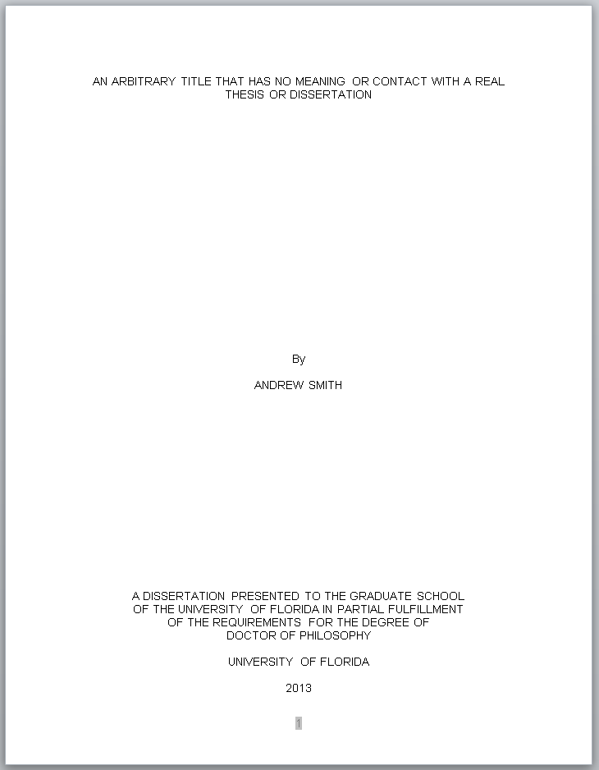

The title page should be in all capital letters. Title and statements should be typed single-spaced. Bottom and top margins should be only 1 inch.

APPENDIX B

COPYRIGHT PAGE SAMPLE

A copyright page is required for all ETDs. The author of the thesis or dissertation is automatically the copyright holder. Candidates who plan to register copyright must include a copyright page in their dissertation. The copyright page is the first page after the title page; it is counted as page 2 but it is not listed in the table of contents.



Same name as on the Title Page, only typed in upper and lower case here

APPENDIX C

TABLE OF CONTENTS SAMPLES

Sample Table of Contents for Numbered Chapters

These samples show capitalization, spacing, and format. Use the appropriate sample, depending on the organization of your manuscript.

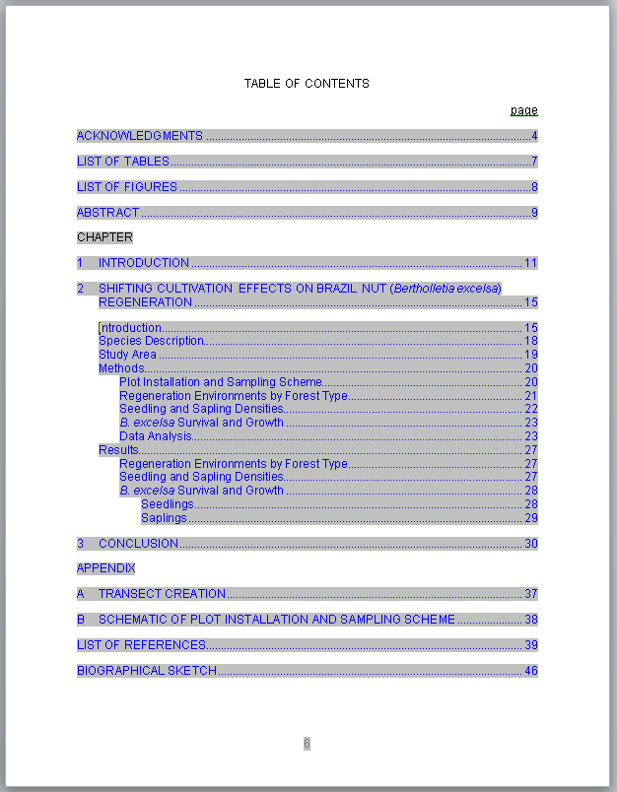

Sample Table of Contents for Numbered Chapters and Subdivisions

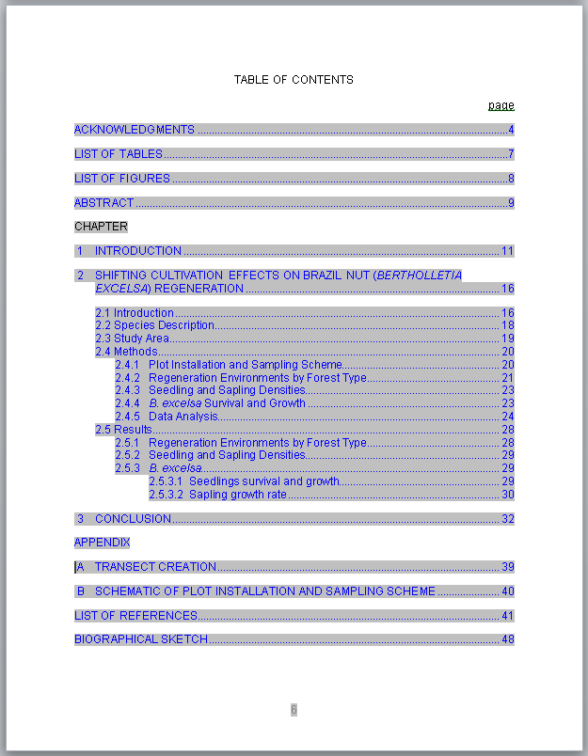

Sample Table of Contents for Theses and Dissertations without Chapter Numbers

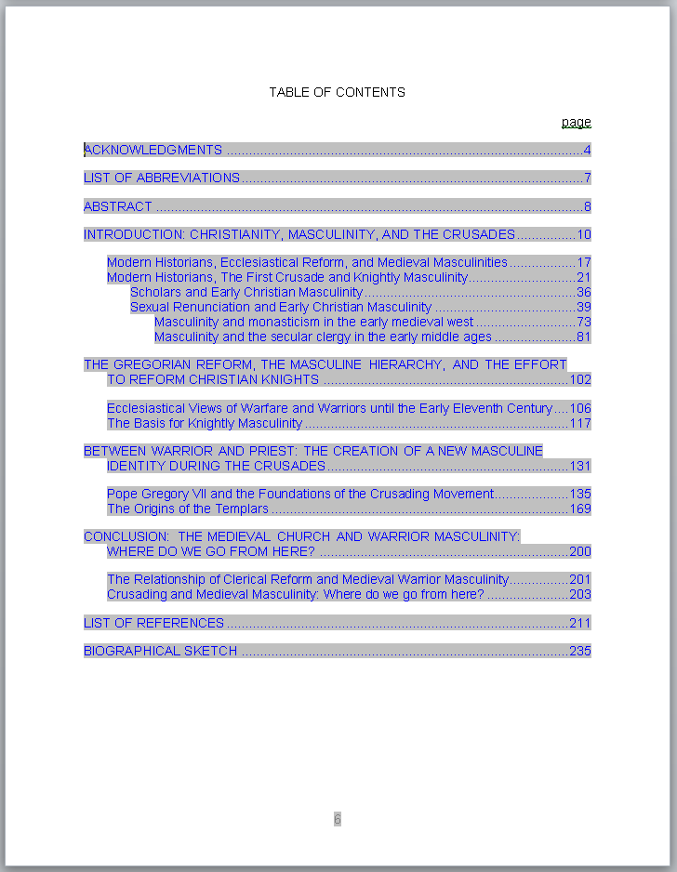

**Note: Do not use this format if you refer to your chapters by number.**

Sample Table of Contents for Creative Writing

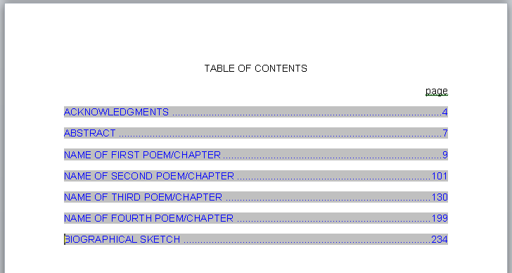

**Note: Should further subdivisions be desired, follow the formatting guidelines set for all headings and subheadings as shown in this guide for theses and dissertations.**

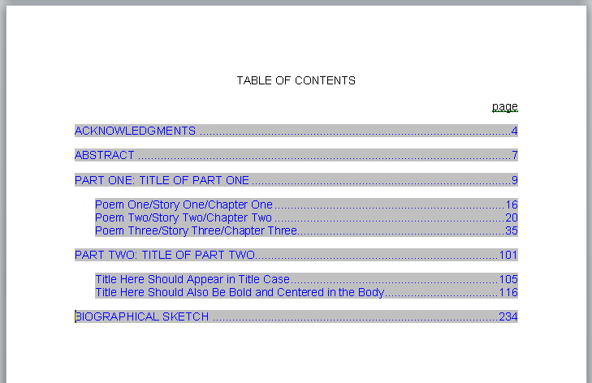

NOTE: This page is an example of how to request permission to use copyrighted material and is not to be included in the Thesis or Dissertation. If you use material from another author you must submit this completed form to the Graduate Editorial Office prior to receiving Final Clearance.

Permission to Reproduce Copyrighted Material

Any candidate who intends to quote or reproduce material beyond the limits of "fair use" from a copyrighted source must have written permission from the copyright holder. A copy of this written approval must be submitted to the Graduate School Editorial Office no later than the final submission date of the term the candidate graduates.

The form below is intended to aid the candidate in fulfilling his or her responsibility.

_______________________________________________________________________.

PERMISSION TO QUOTE/REPRODUCE COPYRIGHTED MATERIAL

I (We),_______________________________________, owners(s) of the copyright of the work known as _______________________________________________________  
________________________________________________________________________

________________________________________________________________________

hereby authorize _________________________________ to use the following material as part of his/her thesis/dissertation to be submitted to the University of Florida.

Page Inclusive Line Numbers Passages to be Quoted/Reproduced

**The following should be added for doctoral students:**

I (We) further extend this authorization to ProQuest Information and Learning Company (PQIL), Ann Arbor, Michigan, for the purposes of reproducing and distributing microfilmed copies of the dissertation.

_______________________________________

Signature of Copyright Holder

_______________________________________

Date

LIST OF REFERENCES

Reference styles will vary widely from discipline to discipline. The only constant is that all references should be single-spaced, with a space between each reference. No Reference should split across pages. This is an example of 018 Reference Hanging.

Beland, J. (2004). NCAA board approves athletics reform. *Academe, 90*(5), 13.

Benson, K. F. (2000). Constructing academic inadequacy: African American athletes’ stories of schooling. *Journal of Higher Education, 71,* 223-246.

Brewer D. J., Eide, E. R., & Ehrenberg, R. G. (1999). Does it pay to attend an elite private college? Cross-cohort evidence on the effects of college type on earnings. *The Journal of Human Resources, 34*(1), 104-123.

Cuyjet, M. J. (1997). African American men on college campuses: Their needs and perceptions. *New Directions for Student Services, 80,* 5-16.

Diprete, T. A., & Buchman, C. (2006). Gender-specific trends in the value of education and the emerging gender gap in college completion. *Demography, 43*(1), 1-24.

Edwards, H. (2000). Crisis in Black athletes on the eve of the 21st century. *Society 37*(3),9.

Fountain, J. J., & Finley, P. S. (2009). Academic majors of upperclassmen football players in the Atlantic Coast Conference: An analysis of academic clustering comparing White and minority players. *Journal of Issues in Intercollegiate Athletics, 2,* 1-13.

Gill, E., & Goff, A. (2008). The role of academic advisors in National Collegiate Athletic Association academic reform. [Monograph]. *National Academic Advising Association, 18,* 37-41.

Harrison, C. K. (2002). Scholar or baller in American higher education: A visual elicitation and qualitative assessment of the student-athlete’s mindset. *NASPA Journal, 8*(1), 66-81.

Jameson, M., Diehl, R., & Danso, H. (2007). Stereotype threat impacts college athletes’ academic performance. Current Research in Social Psychology 12(5), 68-76.

Kuh, G. D., Cruce, T. M., Shoup, R., Kinzie, J., & Gonyea, R. M. (2008). Unmasking the effects of student engagement on first-year college grades and persistence. *The Journal of Higher Education, 79*(5), 540-563.

Lotkowski, V. A., Robbins, S. B., & Noeth, R. J. (2004). *The role of academic and non-academic factors in improving college retention*. Iowa City, IA: ACT Policy Report.

Martin, B. E. & Harris III, F. (2006). Examining productive conceptions of masculinities: Lessons learned from academically driven African American male student athletes. *Journal of Men’s Studies, 14*(3), 359-378.

National Center for Educational Statistics. (1996). *See who can play? An examination of NCAA’s Proposition 16.* Retrieved June 10, 2010 from <http://nces.ed.gov/pubs95/95763.pdf>

On the other hand, some people prefer the block style for their reference list. In that case you shold use 017 Reference Block Style

Owens, S. J. (2011, January 10). College season tainted by scandal. *Orlando Sentinel*, C1, C6.

Pascarella, E. T., Edison, M., Hagedorn, L. S. , Nora, A., & Terenzini, P. (1996). Influences of students’ internal locus of attribution for academic success in the first year of college. *Research in Higher Education, 37*, 731-753.

Rishe, P. J. (2003). A reexamination of how athletic success impacts graduation rates: Comparing student-athletes to all other undergraduates. *American Journal of Economics and Sociology 62*(2), 407-427.

Sedlacek, W. E. (1999). Black students on White campuses: 20 years of research. *Journal of College Student Development, 40*(5), 538-549.

Tucker, I. B. (2004). A reexamination of the effect of big-time football and basketball success on graduation rates and alumni giving rates. *Economics of Education Review, 23*(6), 655-661.

Valentine, J. J., & Taub, D. J. (1999). Responding to the developmental needs of student athletes. *Journal of College Counseling, 3*, 164-178.

Waller, J. M. (2003). A necessary evil: Proposition 16 and its impact on academics and athletics in the NCAA. *DePaul Journal of Sports Law & Contemporary Problems, 1*(2), 189-207.

BIOGRAPHICAL SKETCH

Francisca Javiera Rudolph is a Chilean scientist, who completed her undergraduate education at Universidad San Francisco de Quito (USFQ), Ecuador, receiving a B.S. in biology with a concentration in microbiology in June 2015. While at her undergraduate institution, Javiera worked at various research labs investigating the use of sulfate-reducing bacteria for acid mine drainage remediation, given the mining industry in Ecuador, and the use of methane-producing bacteria for managing agricultural waste. During her undergraduate program, she also completed four years of training in veterinary medicine, leading to her interests in zoonotic diseases. She co-organized spay-neuter campaigns in the Galápagos Islands, recognizing the negative impacts of domestic cats and dogs on wildlife, while also assessing sea lion health and working on the first island-wide sea lion census. During the academic year 2013-2014, she completed a semester abroad at the University of Georgia, developing her quantitative skills in disease ecology modeling working in a Leptospirosis system. During her final year at USFQ, she collaborated with the GEOcenter on an individual-based model for human malaria in Peru, further developing her quantitive skills. Right before starting her PhD, Javiera had the opportunity to work with researchers from the University of Manchester at Timburicocha in Ecuador, assessing primate conservation challenges using qualitative methods. Javiera started her PhD at the University of Florida in 2015, focused on modeling avian malaria dynamics with metacommunity theory, but finished with an investigation of individual variation in animal movement and its role on seed dispersal in tropical forests. During her time at UF, she coorganized RLadies, and was also an advocate for student parents, becoming the president of PhD moms in 2018. Javiera received her Ph.D. in May 2022.

1. * This chapter is reprinted with permission from Adelman, C. (1983). The major seventh: Standards as a leading tone in higher education. *New Directions for Higher Education, 43,* 39-54
2. Footnotes must restart at 1 at the beginning of each chapter. The exception is the un-numbered footnote that credits the publishing journal of a previously published chapter.
3. In most instances you need only to change the numbering to restart each section and apply changes to the whole document. Then, end each chapter with a section break – next page.
4. * This chapter is reprinted with permission from Adelman, C. (1983). The major seventh: Standards as a leading tone in higher education. *New Directions for Higher Education, 43,* 39-54
5. Footnotes must restart at 1 at the beginning of each chapter. The exception is the un-numbered footnote that credits the publishing journal of a previously published chapter.
6. In most instances you need only to change the numbering to restart each section and apply changes to the whole document. Then, end each chapter with a section break – next page.
7. * This chapter is reprinted with permission from Adelman, C. (1983). The major seventh: Standards as a leading tone in higher education. *New Directions for Higher Education, 43,* 39-54
8. Footnotes must restart at 1 at the beginning of each chapter. The exception is the un-numbered footnote that credits the publishing journal of a previously published chapter.
9. In most instances you need only to change the numbering to restart each section and apply changes to the whole document. Then, end each chapter with a section break – next page.
10. * This chapter is reprinted with permission from Adelman, C. (1983). The major seventh: Standards as a leading tone in higher education. *New Directions for Higher Education, 43,* 39-54
11. Footnotes must restart at 1 at the beginning of each chapter. The exception is the un-numbered footnote that credits the publishing journal of a previously published chapter.
12. In most instances you need only to change the numbering to restart each section and apply changes to the whole document. Then, end each chapter with a section break – next page.
13. * This chapter is reprinted with permission from Adelman, C. (1983). The major seventh: Standards as a leading tone in higher education. *New Directions for Higher Education, 43,* 39-54
14. Footnotes must restart at 1 at the beginning of each chapter. The exception is the un-numbered footnote that credits the publishing journal of a previously published chapter.
15. In most instances you need only to change the numbering to restart each section and apply changes to the whole document. Then, end each chapter with a section break – next page.