Figures and Tables

Table of Contents

## Figure 1.

Density distributions from which we sample gut retention time (GRT) and movement distance (MD).

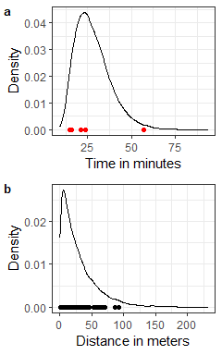

## Figure 2.

Simulation example where animal movement determines location for seeds dropped. Calculations for seed dispersal distance from the parent tree and seed distance to the mean seed location as a measure of aggregation.

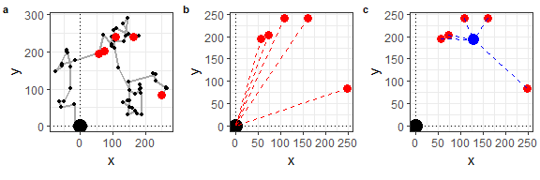

## Figure 3.

Variation in Weibull distributions determined by the value of the shape parameter. The scale parameter is defined as , and the shape parameters are defined as follows: solid line shows an exponential decay tail, dashed line shows a thin tail, and describes a fat tail with the dotted line.

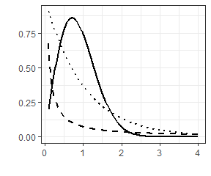

## Figure 4.

Box plots to show the distribution of mean seed dispersal distance and seed dispersion per simulation run. In this case, we are looking at the data per simulation run, since we calculate seed dispersion in relation to the mean seed location, and this is done for each simulation run with five seeds each. Here, we consider mean seed dispersal as the distance from the origin to the mean seed location for each simulation run.

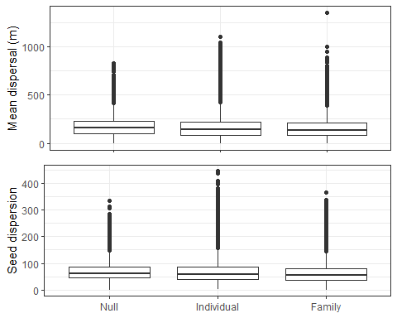

# Table 1.