Task.txt:
&#128345;&#128338;| &#128336;&#128339;&#128342;| &#128336;&#128336;&#128336;| &#128336;&#128339;&#128345;| &#128346;&#128344;| &#128339;&#128339;| &#128344;&#128340;| &#128336;&#128341;&#128345;| &#128345;&#128343;| &#128336;&#128338;&#128345;| &#128339;&#128347;| &#128344;&#128344;| &#128336;&#128341;&#128345; &#128345;&#128343;| &#128336;&#128338;&#128345;| &#128339;&#128338;| &#128336;&#128339;&#128341;| &#128345;&#128346;| &#128339;&#128336;| &#128344;&#128344;| &#128345;&#128340;| &#128341;&#128340;| &#128336;&#128342;&#128341;| &#128336;&#128347;&#128338;| &#128336;&#128337;&#128340;| &#128341;&#128340;

After some research we found that these are “Code with HTML special escaping characters”. First we remove “|” signs then decode. After decoding them we get these clock emotes:

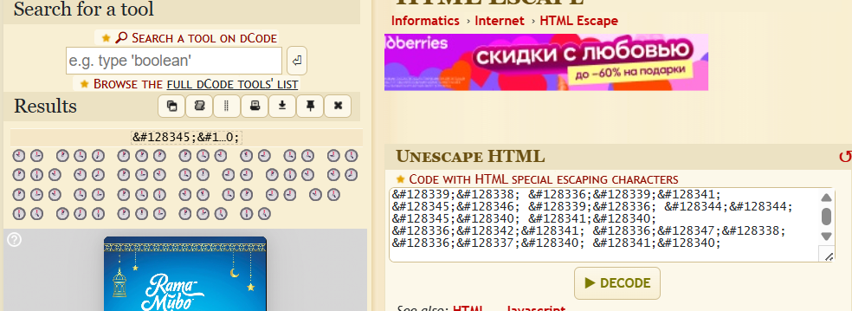

Lets write down each number we got from emotes with putting spaces where “|” is found in the task.txt (we mark 10 as “A”, 11 as “B”):
A3 147 111 14A B9 44 95 16A A8 13A 40 99 16A A8 13A 43 146 AB 41 99 A5 65 176 103 125 65

Lets convert it to text from ascii:

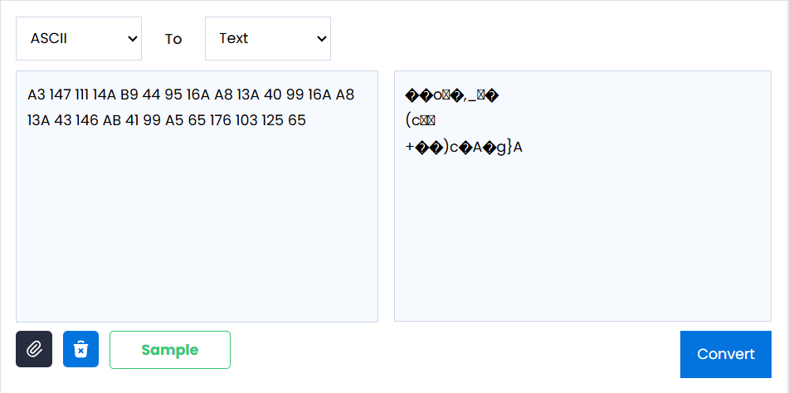

This didn’t work. The clock system is in base 12 system so lets decode it to decimal:
123 199 157 202 141 52 113 226 128 190 48 117 226 128 190 51 198 131 49 117 125 77 234 147 173 77

Now try again to convert to text:

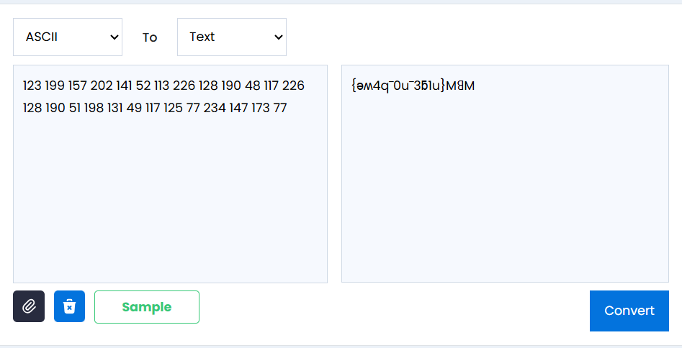

Here we got something, looks like upside-down:
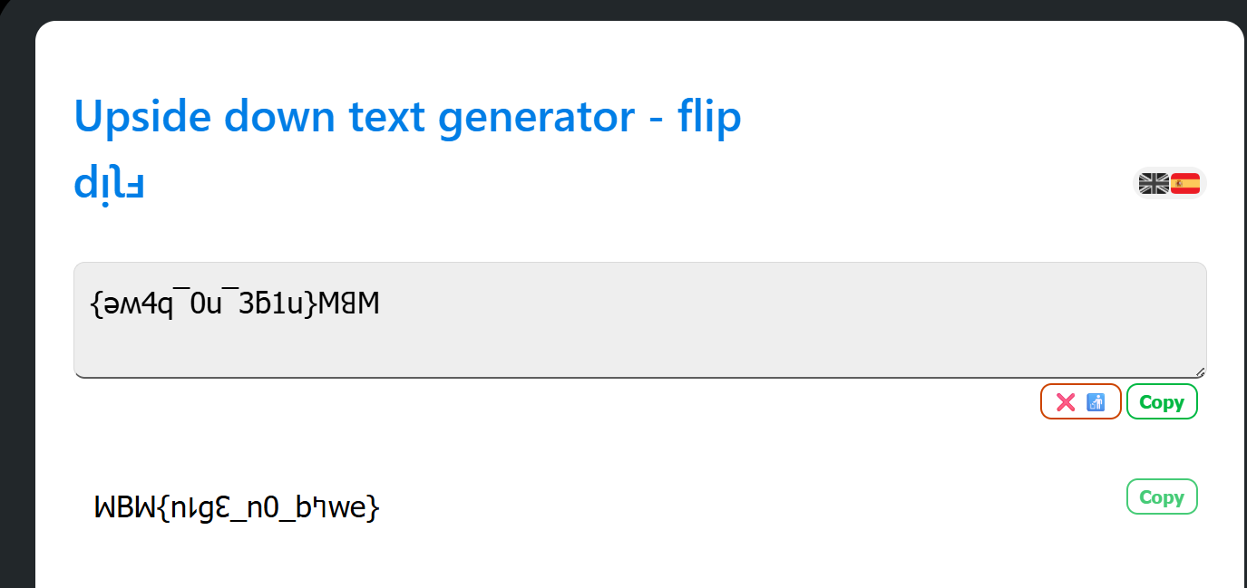

Lets modify it little by making numbers upside-down manually: WBW{n1g3_n0_b4we}

Now it looks like some fomr of rotation:

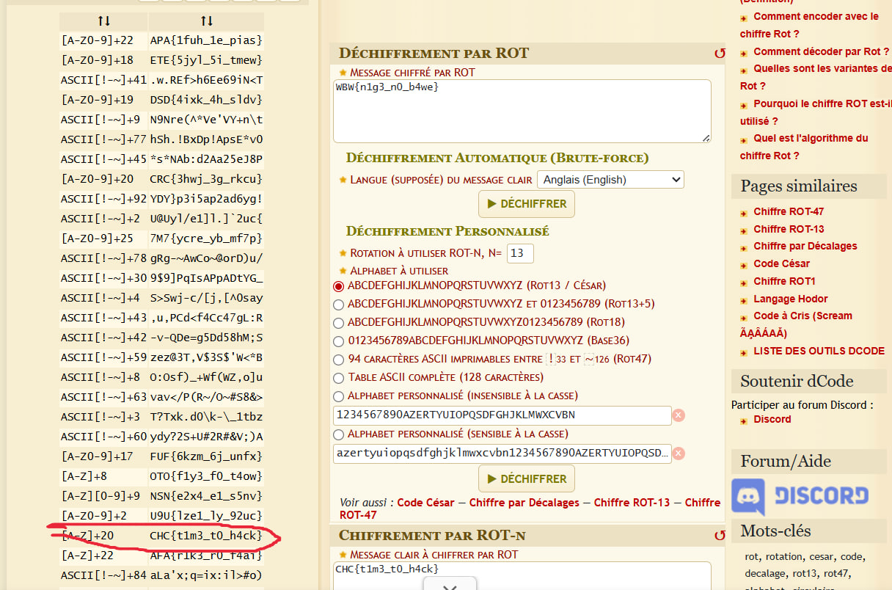

Flag: CHC{t1m3_t0_h4ck}

