

DATABASE

SPECIFICATIONS

Online Student Registration System for Gotham University
Ja’ Vonn Liner
javonn19@gmail.com

School of Graduate Professional Studies
Information Science Department
IN SC 521 - Introduction to Database Concepts

January, 2018

Document Control

Work carried out by:
Name | Email Address
Ja’ Vonn Liner | Javonn19@gmail.com

Revision Sheet

Release No. | Date | Revision Description
1.0 | Jan 11, 2019 | Draft
2.0 | Jan 15, 2019 | ERD Model, Assumptions and Constraints
3.0 | Jan 27, 2019 | ERD Model (Crow Foot Notation), Assumptions and Constraints
4.0 | Feb 03, 2019 | Normalization
5.0 | Feb 08, 2019 | Physical Design
6.0 | Feb 17, 2019 | SQL Queries AND

DATABASE SPECIFICATIONS

TABLE OF CONTENTS

Document Control i
Work carried out by: i
Revision Sheet i
Milestone 1: Data Requirements 1
Purpose 1
Outcomes 1
Student contribution 1
System Name or Title 1
Core requirements 1
Milestone 2: Conceptual Design 2
Purpose 2
Outcomes 2
Student contribution 2
Entity Relationship Diagram 2
Assumptions and Constraints 3
Milestone 3: Logical Design 4
Purpose 4
Outcomes 4
Student contribution 4
Entity Relationship Diagram 4
Assumptions and Constraints 5
Milestone 4: Normalization 6 Milestone 5: Physical Design 7
Purpose 7
Outcomes 7
Student contribution 7
Assumptions and Constraints 8
Naming Conventions 8
Tables 9
Examples of values 9
Notes 9

Milestone 6: SQL queries and 8
Purpose 8
Outcomes 8
Student contribution 8

Milestone 1: Data Requirements

Purpose
The university online registration system for Gotham University is incapable to maintain the massive demand of registration and is starting to be a nuisance. An online registration system is needed for in-state, out of state, and off campus students so they can easily register for classes or anything related to registration.

Outcomes
The university online registration system will provide the interface of the database. It will handle the high, transactional, and numerous demands of students. The system will have back-up systems installed just in case the main interface shuts down. It will be the main registration tool for all students trying to get into classes or anything else related to registration.

Student Contribution
Read the provided Software Requirements Specification and filled in the rubric

System Name or Title
Online registration system for Gotham University

Core requirements

No. | Requirement | Referenced page in SRS | Referenced Section in SRS | Referenced Paragraph in Section
1 | The capability to search, view, drop, and register course offerings online | 4 | 2.1 | 1
2 | Provide unofficial transcripts online | 5 | 2.2 | 1
3 | Provide prerequisites for necessary courses | 6 | 2.3 | 3
4 | Alert students of registration halts and provide solutions to register in classes | 7 | 2.4 | 5
5 | Provide all-access to the registrar | 8 | 2.5 | 4
6 | Provide application for graduation | 9 | 2.6 | 1

Milestone 2: Conceptual Design

Purpose
Produce an Entity-Relationship Diagram using Chen notation.

Outcomes
An Entity-Relationship Diagram in Chen notation is generated from the core requirements that were gathered in previous milestones.

Student Contribution
Implemented all the core requirements that were elicited in the previous milestone and created an Entity-Relationship Diagram in chen notation that were specified for this course.

Diagram

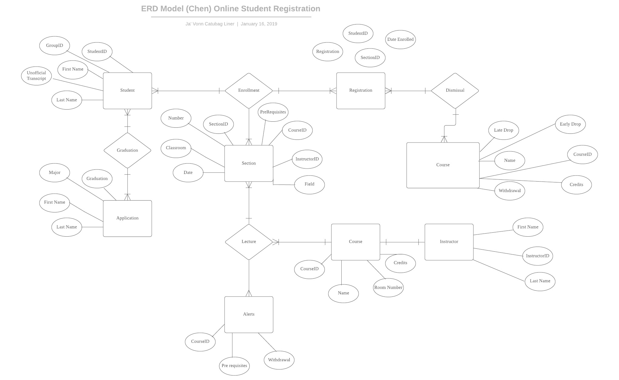

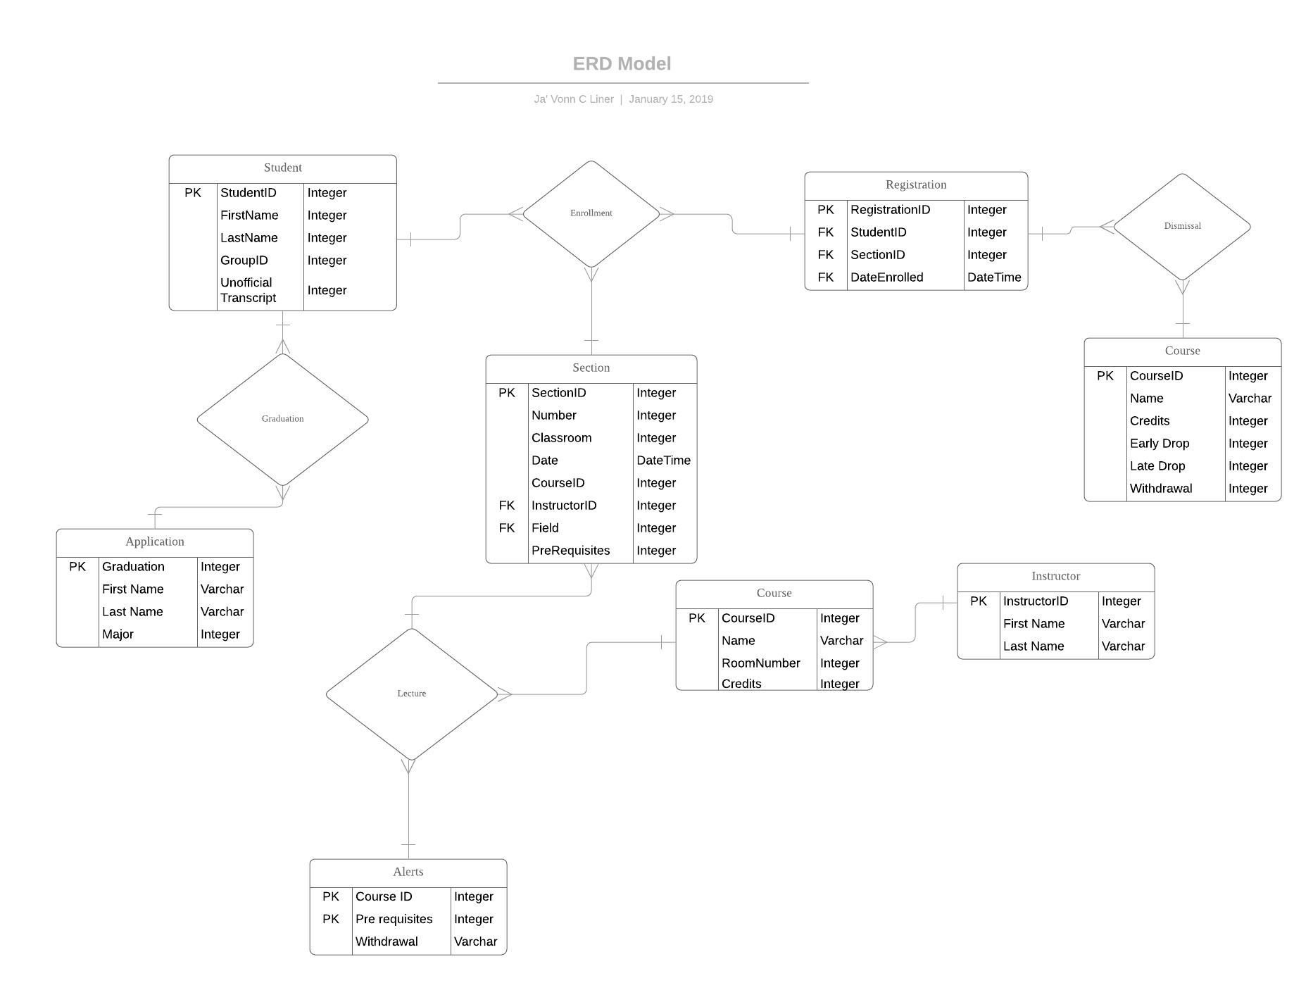

Assumptions and Constraints
Not able to show all-access to the registrar through the entity relationship diagram. The entity of the registrar would either mislead or be misinterpreted of relationships between other attributes or entities. Attributes that weren’t shown involves the following: Age, Student Year Classification, Address, Graduation Date and Enrollment Date and Time

Milestone 3: Logical Design

Purpose
Produce an Entity-Relationship Diagram in Crow-Foot notation.

Outcomes
An Entity-Relationship Diagram in Crow-Foot notation is generated from the conceptual model that was generated in previous milestone.

Student Contribution
Converted the conceptual model generated in the previous milestone to a logical model using one of tools that were specified for this course. For each entity, I ensure that the functional dependencies and unique keys are determined, using the template below.

Entity name: Student
Attributes: StudentID, FirstName, LastName, GroupID
Keys: StudentID
Functional dependencies:
Attributes not in FD | Attributes on the left | Attributes on both sides | Attributes on the right side
 | StudentID |  | StudentID
 | StudentID |  | FirstName
 | StudentID |  | LastName
 | StudentID |  | GroupID
 | StudentID |  | GroupID

Attribute closures (if any): StudentID---> (StudentID, FirstName, LastName, GroupID)
Unique keys: the key for this table is StudentID

Entity name: Application
Attributes: Graduation, FirstName, LastName, Major
Keys: Graduation
Functional dependencies:
Attributes not in FD | Attributes on the left | Attributes on both sides | Attributes on the right side
 | Graduation |  | Graduation
 | Graduation |  | FirstName
 | Graduation |  | LastName
 | Graduation |  | Major

Attribute closures (if any): Graduation--->(Graduation, FirstName, LastName, Major)
Unique keys: the key for this table is Graduation

Entity name: Section
Attributes: SectionID, Number, Classroom, Date, CourseID, InstructorID, Field, Prerequsites
Keys: SectionID
Functional dependencies:
Attributes not in FD | Attributes on the left | Attributes on both sides | Attributes on the right side
 | SectionID |  | SectionID
 | SectionID |  | Number
 | SectionID |  | Classroom
 | SectionID |  | Date
 | SectionID |  | CourseID
 | SectionID |  | InstructorID
 | SectionID |  | Field
 | SectionID |  | Prerequsites

Attribute closures (if any): SectionID--->( SectionID, Number, Classroom, Date, CourseID, InstructorID, Field, Prerequsites)
Unique keys: the key for this table is SectionID
Entity name: Registration
Attributes: RegistrationID, StudentID, SectionID, DateEnrolled
Keys: RegistrationID
Functional dependencies:
Attributes not in FD | Attributes on the left | Attributes on both sides | Attributes on the right side
 | RegistrationID |  | RegistrationID
 | RegistrationID |  | StudentID
 | RegistrationID |  | SectionID
 | RegistrationID |  | DateEnrolled

Attribute closures (if any): RegistrationID--->( RegistrationID, StudentID, SectionID, DateEnrolled)
Unique keys: the key for this table is RegistrationID

Entity name: Course
Attributes: Graduation, FirstName, LastName, Major
Keys: Graduation
Functional dependencies:
Attributes not in FD | Attributes on the left | Attributes on both sides | Attributes on the right side
 | Graduation |  | Graduation
 | Graduation |  | FirstName
 | Graduation |  | LastName
 | Graduation |  | Major

Attribute closures (if any): Graduation--->( Graduation, FirstName, LastName, Major)
Unique keys: the key for this table is Graduation
Entity name: Instructor
Attributes: InstructorID, FirstName, LastName
Keys: InstructorID
Functional dependencies:
Attributes not in FD | Attributes on the left | Attributes on both sides | Attributes on the right side
 | InstructorID |  | InstructorID
 | InstructorID |  | FirstName
 | InstructorID |  | LastName

Attribute closures (if any): InstructorID--->( InstructorID, FirstName, LastName)
Unique keys: the key for this table is InstructorID

Entity name: Alerts
Attributes: CourseID, Prerequisites, Withdrawal
Keys: CourseID
Functional dependencies:
Attributes not in FD | Attributes on the left | Attributes on both sides | Attributes on the right side
 | CourseID |  | CourseID
 | CourseID |  | Prerequsites
 | CourseID |  | Withdrawal

Attribute closures (if any): CourseID--->( CourseID, Prerequisites, Withdrawal)
Unique keys: the key for this table is CourseID
Entity name: Course
Attributes: CourseID, Name, RoomNumber, Credit
Keys: CourseID
Functional dependencies:
Attributes not in FD | Attributes on the left | Attributes on both sides | Attributes on the right side
 | CourseID |  | CourseID
 | CourseID |  | Name
 | CourseID |  | RoomNumber
 | CourseID |  | Credit

Attribute closures (if any): CourseID---> (CourseID, Name, RoomNumber, Credit)
Unique keys: the key for this table is CourseID

Entity Relationship Diagram
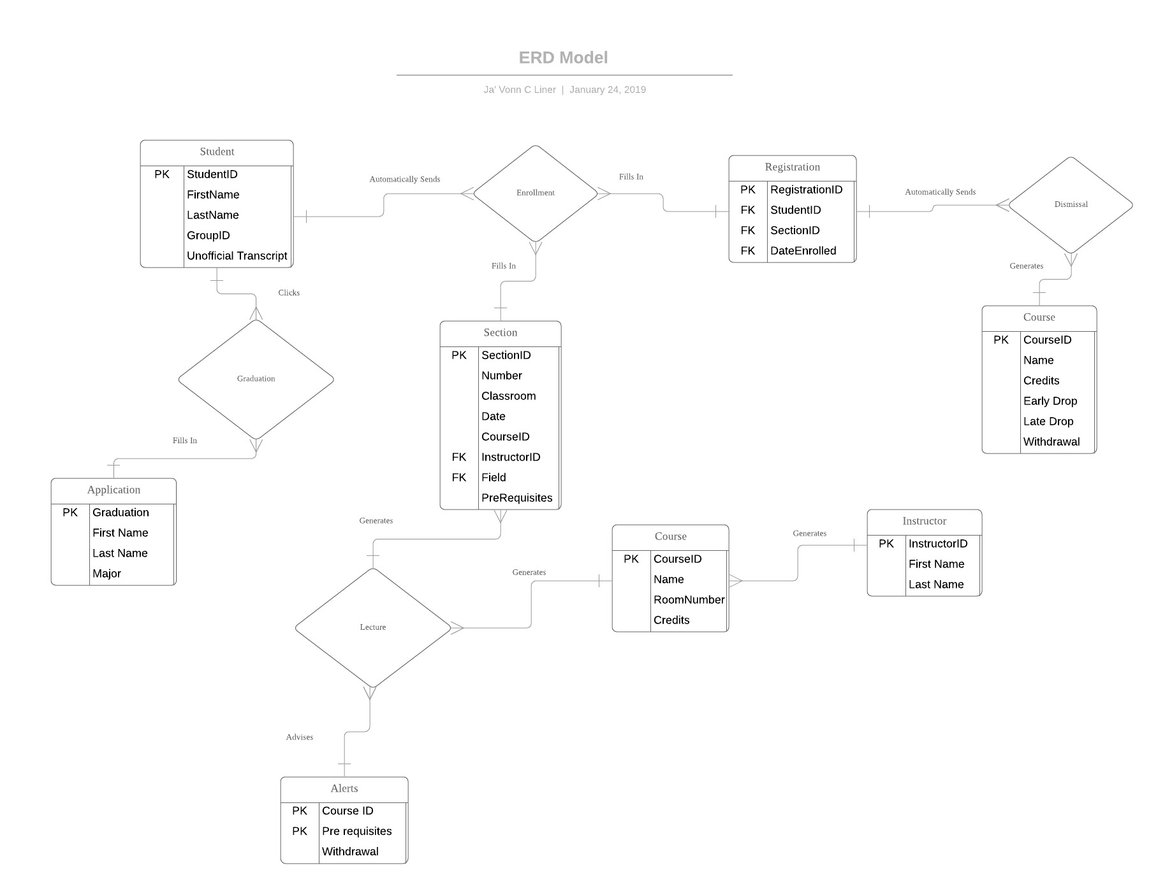

Assumptions and Constraints
No assumptions or constraints found in the ERD model.

Milestone 4: Normalization and

Name of the table | Student
Description | A student is a person that attends the university.
Attribute | Description |  | Type | Examples of values | Notes
StudentID, | Id of a student |  | integer | Between 1 and 99999999
FirstName, | First name of student |  | integer | Steve | Cannot be null
LastName, | Last name of student |  | integer | Johnson | Cannot be null
GroupID | Id of the group |  | integer | Between 1 and 99999999
Functional Dependencies and Keys
Functional dependencies | StudentID-→ FirstName  StudentID → LastName  StudentID → GroupID
Normalization
1NF | Yes | all cells contain a unique value
2NF | Yes | all the non-key attributes depend on the entire key
3NF | Yes | all the non-key attributes depend only on the key
BCNF | Yes | all the attributes depend only on the key

Name of the table | Application
Description | a formal request to graduate from the university
Attribute | Description |  | Type | Examples of values | Notes
Graduation, | Confirmation of graduation |  | integer | Confirm | Accept/Confirm
FirstName, | First name of student |  | varchar | Adam | Cannot be null
LastName, | Last name of student |  | varchar | Jones | Cannot be null
Major | Subject of graduation |  | integer | Basket Weaving | Cannot be null
Functional Dependencies and Keys
Functional dependencies | Graduation→ FirstName  Graduation→ LastName  Graduation→ Major
Normalization
1NF | Yes | all cells contain a unique value
2NF | Yes | all the non-key attributes depend on the entire key
3NF | Yes | all the non-key attributes depend only on the key
BCNF | Yes | all the attributes depend only on the key

Name of the table | Section
Description | A specific class at the university
Attribute | Description |  | Type | Examples of values | Notes
SectionID, | Id of a section |  | integer | Between 1 and 99999999
Number, | Number of a section |  | integer | Between 1 and 99999999
Classroom, | Room number |  | integer | Between 1 and 99999999
Date | Date of class |  | DateTime | 02OCT19 | Must be bigger than 01JAN2019
CourseID | Id of a course |  | integer | Between 1 and 99999999
InstructorID | Id of the instructor |  | integer | Between 1 and 99999999
Field | Subject |  | integer | Art | Cannot be null
Prerequsites | Classes needed to register for class |  | integer | Math 101
Functional Dependencies and Keys
Functional dependencies | SectionID → Number  SectionID → Classroom  SectionID →Date  SectionID →CourseID  SectionID →InstructorID  SectionID → Field  SectionID → Prerequsites
Normalization
1NF | Yes | all cells contain a unique value
2NF | Yes | all the non-key attributes depend on the entire key
3NF | Yes | all the non-key attributes depend only on the key
BCNF | Yes | all the attributes depend only on the key

Name of the table | Registrtion
Description | Registering the student for the university
Attribute | Description |  | Type | Examples of values | Notes
RegistrationID, | Id of registration |  | integer | Between 1 and 99999999
StudentID | Id of a student |  | integer | Between 1 and 99999999
SectionID | Id of a section |  | integer | Between 1 and 99999999
DateEnrolled | Date of Enrollment |  | DateTime | 02OCT19 | Must be bigger than 01JAN2019
Functional Dependencies and Keys
Functional dependencies | RegistrationID→ StudentID  RegistrationID→ SectionID  RegistrationID→ DateEnrolled
Normalization
1NF | Yes | all cells contain a unique value
2NF | Yes | all the non-key attributes depend on the entire key
3NF | Yes | all the non-key attributes depend only on the key
BCNF | Yes | all the attributes depend only on the key

Name of the table | Courses
Description | A specific subject of class
Attribute | Description |  | Type | Examples of values | Notes
Graduation, | Confirmation of graduation |  | Integer | Confirm | Accept/Confirm
FirstName, | First name of student |  | varchar | Adam | Cannot be null
LastName, | Last name of student |  | integer | Jones | Cannot be null
Major | Subject of graduation |  | integer | Basket Weaving | Cannot be null
Functional Dependencies and Keys
Functional dependencies | Graduation→ FirstName  Graduation→ LastName  Graduation→ Major
Normalization
1NF | Yes | all cells contain a unique value
2NF | Yes | all the non-key attributes depend on the entire key
3NF | Yes | all the non-key attributes depend only on the key
BCNF | Yes | all the attributes depend only on the key

Name of the table | Instructor
Description | an employee who teaches the classes in the university
Attribute | Description |  | Type | Examples of values | Notes
InstructorID, | Id of an instructor |  | Integer | Between 1 and 99999999
FirstName, | First name of student |  | Varchar | Steve | Cannot be null
LastName, | Last name of student |  | varchar | Mcdonald | Cannot be null
Functional Dependencies and Keys
Functional dependencies | InstructorID→FirstName  InstructorID→LastName
Normalization
1NF | Yes | all cells contain a unique value
2NF | Yes | all the non-key attributes depend on the entire key
3NF | Yes | all the non-key attributes depend only on the key
BCNF | Yes | all the attributes depend only on the key

Name of the table | Alerts
Description | Warning on an error made in registering for classes
Attribute | Description |  | Type | Examples of values | Notes
CourseID, | Id of a course |  | integer | Between 1 and 99999999
Prerequisites, | Classes needed to register for class |  | integer | Physics 101
LastName, | Last name of student |  | integer | Johnson | Cannot be null
Withdrawal | Withdraw from class |  | varchar | Withdraw from class
Functional Dependencies and Keys
Functional dependencies | CourseID→ Prerequisites  CourseID→ LastName  CourseID→ Withdrawal
Normalization
1NF | Yes | all cells contain a unique value
2NF | Yes | all the non-key attributes depend on the entire key
3NF | Yes | all the non-key attributes depend only on the key
BCNF | Yes | all the attributes depend only on the key

Name of the table | Course
Description | A unit of teaching
Attribute | Description |  | Type | Examples of values | Notes
CourseID, | Id of a course |  | Integer | Between 1 and 99999999
Name, | Name of course |  | varchar | Physics | Cannot be null
Room Number, | Classroom location |  | integer | Between 1 and 99999999
Credit | Credited hours |  | integer | Between 1 and 9
Functional Dependencies and Keys
Functional dependencies | CourseID→Name  CourseID→ Room Number  CourseID→ Credit
Normalization
1NF | Yes | all cells contain a unique value
2NF | Yes | all the non-key attributes depend on the entire key
3NF | Yes | all the non-key attributes depend only on the key
BCNF | Yes | all the attributes depend only on the key

Milestone 5: Physical Design
Purpose:
Create the tables in Oracle.
Outcomes:
A relational schema is created from the logical model that was generated in a previous milestone.
Student Contribution:
Filled in the sections to convert the conceptual model generated in the previous milestone to a logical model using one of the tools that were specifie. All the requirements that cannot be implemented are specified in the assumptions section.

Assumptions and Constraints

No oversights when implementing all participants

Naming Conventions

The naming standards include the following: tables, views, columns, indexes, roles, and functions following those basic naming conventions imposed.

Tables

Name of the table |  | Student
Description |  | A student is a person that attends the university.
Attribute |  | Description |  |  | Type | Examples of values | Notes
StudentID, |  | Id of a student |  |  | integer | Between 1 and 99999999
FirstName, |  | First name of student |  |  | integer | Steve | Cannot be null
LastName, |  | Last name of student |  |  | integer | Johnson | Cannot be null
GroupID |  | Id of the group |  |  | integer | Between 1 and 99999999
Functional Dependencies and Keys
Functional dependencies |  | StudentID-→ FirstName  StudentID → LastName  StudentID → GroupID
Normalization
1NF |  | Yes |  | all cells contain a unique value
2NF |  | Yes |  | all the non-key attributes depend on the entire key
3NF |  | Yes |  | all the non-key attributes depend only on the key
BCNF |  | Yes |  | all the attributes depend only on the key
 | Physical Design
 | Primary Key |  | StudentID
 | Foreign Keys |  | -
 | SQL Code |  | CREATE TABLE Student (  StudentID int NOT NULL,  LastName varchar(255) NOT NULL,  FirstName varchar(255) NOT NULL,  GroupID int,  CONSTRAINT PK_Person PRIMARY KEY (StudentID)  );
 | Count of records in the table |  | SELECT COUNT(*) "Total" FROM Student;

Name of the table |  | Application
Description |  | a formal request to graduate from the university
Attribute |  | Description |  |  | Type | Examples of values | Notes
Graduation, |  | Confirmation of graduation |  |  | integer | Confirm | Accept/Confirm
FirstName, |  | First name of student |  |  | varchar | Adam | Cannot be null
LastName, |  | Last name of student |  |  | varchar | Jones | Cannot be null
Major |  | Subject of graduation |  |  | integer | Basket Weaving | Cannot be null
Functional Dependencies and Keys
Functional dependencies |  | Graduation→ FirstName  Graduation→ LastName  Graduation→ Major
Normalization
1NF |  | Yes |  | all cells contain a unique value
2NF |  | Yes |  | all the non-key attributes depend on the entire key
3NF |  | Yes |  | all the non-key attributes depend only on the key
BCNF |  | Yes |  | all the attributes depend only on the key
 | Physical Design
 | Primary Key |  | Graduation
 | Foreign Keys |  | -
 | SQL Code |  | CREATE TABLE Application (  Graduation int NOT NULL,  LastName varchar(255) NOT NULL,  FirstName varchar(255) NOT NULL,  Major int NOT NULL,  CONSTRAINT PK_Person PRIMARY KEY (Graduation),  CONSTRAINT Application_unique UNIQUE (Graduation, LastName, FirstName, LastName, Major )  );  Note* Need ApplicationId as a PrimaryKey
 | Count of records in the table |  | SELECT COUNT(*) "Total" FROM Application;

Name of the table |  | Section
Description |  | A specific class at the university
Attribute |  | Description |  |  | Type | Examples of values | Notes
SectionID, |  | Id of a section |  |  | integer | Between 1 and 99999999
Number, |  | Number of a section |  |  | integer | Between 1 and 99999999
Classroom, |  | Room number |  |  | integer | Between 1 and 99999999
Date |  | Date of class |  |  | DateTime | 02OCT19 | Must be bigger than 01JAN2019
CourseID |  | Id of a course |  |  | integer | Between 1 and 99999999
InstructorID |  | Id of the instructor |  |  | integer | Between 1 and 99999999
Field |  | Subject |  |  | integer | Art | Cannot be null
Prerequsites |  | Classes needed to register for class |  |  | integer | Math 101
Functional Dependencies and Keys
Functional dependencies |  | SectionID → Number  SectionID → Classroom  SectionID →Date  SectionID →CourseID  SectionID →InstructorID  SectionID → Field  SectionID → Prerequsites
Normalization
1NF |  | Yes |  | all cells contain a unique value
2NF |  | Yes |  | all the non-key attributes depend on the entire key
3NF |  | Yes |  | all the non-key attributes depend only on the key
BCNF |  | Yes |  | all the attributes depend only on the key
 | Physical Design
 | Primary Key |  | SectionID
 | Foreign Keys |  | - CourseID InstructorID
 | SQL Code |  | CREATE TABLE Section (  SectionID int NOT NULL,  Classroom int NOT NULL,  Number int NOT NULL,  Date DateTime NOT NULL,  CourseID int NOT NULL,  InstructorID int NOT NULL,  Field varchar(255) NOT NULL,  Prerequsites varchar(255) NOT NULL  CONSTRAINT PK_Person PRIMARY KEY (SectionID),  CONSTRAINT FK_Person FORIGEN KEY (CourseID ,InstructorID ),  CONSTRAINT Section_unique UNIQUE (Classroom ,,  Number ,  Date ,  CourseID ,  InstructorID ,  Field ,  Prerequsites  )  );
 | Count of records in the table |  | SELECT COUNT(*) "Total" FROM Section;

Name of the table |  | Registrtion
Description |  | Registering the student for the university
Attribute |  | Description |  |  | Type | Examples of values | Notes
RegistrationID, |  | Id of registration |  |  | integer | Between 1 and 99999999
StudentID |  | Id of a student |  |  | integer | Between 1 and 99999999
SectionID |  | Id of a section |  |  | integer | Between 1 and 99999999
DateEnrolled |  | Date of Enrollment |  |  | DateTime | 02OCT19 | Must be bigger than 01JAN2019
Functional Dependencies and Keys
Functional dependencies |  | RegistrationID→ StudentID  RegistrationID→ SectionID  RegistrationID→ DateEnrolled
Normalization
1NF |  | Yes |  | all cells contain a unique value
2NF |  | Yes |  | all the non-key attributes depend on the entire key
3NF |  | Yes |  | all the non-key attributes depend only on the key
BCNF |  | Yes |  | all the attributes depend only on the key
 | Physical Design
 | Primary Key |  | RegistrationID
 | Foreign Keys |  | -StudentID  SectionID
 | SQL Code |  | CREATE TABLE Registration (  RegistrationID int NOT NULL,  StudentID int NOT NULL,  SectionID int NOT NULL,  DateEnrolled DateTime NOT NULL,  CONSTRAINT PK_Person PRIMARY KEY (RegistrationID),  CONSTRAINT FK_Person FORIGEN KEY (StudentID ,SectionID  ),  CONSTRAINT Registration _unique UNIQUE (RegistrationID ,  StudentID ,SectionID , DateEnrolled)  );
 | Count of records in the table |  | SELECT COUNT(*) "Total" FROM Registration;

Name of the table |  | Courses
Description |  | A specific subject of class
Attribute |  | Description |  |  | Type | Examples of values | Notes
Graduation, |  | Confirmation of graduation |  |  | Integer | Confirm | Accept/Confirm
FirstName, |  | First name of student |  |  | varchar | Adam | Cannot be null
LastName, |  | Last name of student |  |  | integer | Jones | Cannot be null
Major |  | Subject of graduation |  |  | integer | Basket Weaving | Cannot be null
Functional Dependencies and Keys
Functional dependencies |  | Graduation→ FirstName  Graduation→ LastName  Graduation→ Major
Normalization
1NF |  | Yes |  | all cells contain a unique value
2NF |  | Yes |  | all the non-key attributes depend on the entire key
3NF |  | Yes |  | all the non-key attributes depend only on the key
BCNF |  | Yes |  | all the attributes depend only on the key
 | Physical Design
 | Primary Key |  | Graduation
 | Foreign Keys |  | -
 | SQL Code |  | CREATE TABLE Courses (  Graduation int NOT NULL,  LastName varchar(255) NOT NULL,  FirstName varchar(255) NOT NULL,  Major int NOT NULL,  CONSTRAINT PK_Person PRIMARY KEY (Graduation),  CONSTRAINT Courses _unique UNIQUE (Graduation, LastName, FirstName, LastName, Major )  );  Note* Need CourceId as a PrimaryKey
 | Count of records in the table |  | SELECT COUNT(*) "Total" FROM Courses;

Name of the table |  | Instructor
Description |  | an employee who teaches the classes in the university
Attribute |  | Description |  |  | Type | Examples of values | Notes
InstructorID, |  | Id of an instructor |  |  | Integer | Between 1 and 99999999
FirstName, |  | First name of student |  |  | Varchar | Steve | Cannot be null
LastName, |  | Last name of student |  |  | varchar | Mcdonald | Cannot be null
Functional Dependencies and Keys
Functional dependencies |  | InstructorID→FirstName  InstructorID→LastName
Normalization
1NF |  | Yes |  | all cells contain a unique value
2NF |  | Yes |  | all the non-key attributes depend on the entire key
3NF |  | Yes |  | all the non-key attributes depend only on the key
BCNF |  | Yes |  | all the attributes depend only on the key
 | Physical Design
 | Primary Key |  | InstructorID
 | Foreign Keys |  | -
 | SQL Code |  | CREATE TABLE Instructor (  InstructorID int NOT NULL,  LastName varchar(255) NOT NULL,  FirstName varchar(255) NOT NULL,  CONSTRAINT PK_Person PRIMARY KEY (InstructorID),  CONSTRAINT Courses _unique UNIQUE (InstructorID, LastName, FirstName, LastName )  );
 | Count of records in the table |  | SELECT COUNT(*) "Total" FROM Instructor;

Name of the table |  | Alerts
Description |  | Warning on an error made in registering for classes
Attribute |  | Description |  |  | Type | Examples of values | Notes
CourseID, |  | Id of a course |  |  | integer | Between 1 and 99999999
Prerequisites, |  | Classes needed to register for class |  |  | integer | Physics 101
LastName, |  | Last name of student |  |  | integer | Johnson | Cannot be null
Withdrawal |  | Withdraw from class |  |  | varchar | Withdraw from class
Functional Dependencies and Keys
Functional dependencies |  | CourseID→ Prerequisites  CourseID→ LastName  CourseID→ Withdrawal
Normalization
1NF |  | Yes |  | all cells contain a unique value
2NF |  | Yes |  | all the non-key attributes depend on the entire key
3NF |  | Yes |  | all the non-key attributes depend only on the key
BCNF |  | Yes |  | all the attributes depend only on the key
 | Physical Design
 | Primary Key |  | CourseID
 | Foreign Keys |  | -
 | SQL Code |  | CREATE TABLE Alerts (  CourseID int NOT NULL,  Prerequisites varchar(255) NOT NULL,  LastName varchar(255) NOT NULL,  Withdrawal varchar(255) NOT NULL,  CONSTRAINT PK_Person PRIMARY KEY (InstructorID),  CONSTRAINT Courses _unique UNIQUE (InstructorID, LastName, FirstName, LastName )  );
 | Count of records in the table |  | SELECT COUNT(*) "Total" FROM Alerts;

Name of the table |  | Course
Description |  | A unit of teaching
Attribute |  | Description |  |  | Type | Examples of values | Notes
CourseID, |  | Id of a course |  |  | Integer | Between 1 and 99999999
Name, |  | Name of course |  |  | varchar | Physics | Cannot be null
Room Number, |  | Classroom location |  |  | integer | Between 1 and 99999999
Credit |  | Credited hours |  |  | integer | Between 1 and 9
Functional Dependencies and Keys
Functional dependencies |  | CourseID→Name  CourseID→ Room Number  CourseID→ Credit
Normalization
1NF |  | Yes |  | all cells contain a unique value
2NF |  | Yes |  | all the non-key attributes depend on the entire key
3NF |  | Yes |  | all the non-key attributes depend only on the key
BCNF |  | Yes |  | all the attributes depend only on the key
 | Physical Design
 | Primary Key
 | Foreign Keys |  | -
 | SQL Code |  | CREATE TABLE Course (  CourseID int NOT NULL,  Name varchar(255) NOT NULL,  RoomNumber varchar(255) NOT NULL,  Credit int NOT NULL,  CONSTRAINT PK_Person PRIMARY KEY (CourseID),  CONSTRAINT Courses _unique UNIQUE (CourseID ,  Name ,  RoomNumber,  Credit  )  );
 | Count of records in the table |  | SELECT COUNT(*) "Total" FROM Course;

Milestone 6: SQL queries and

Purpose:
Create and execute the most used information retrieval queries from the created database.
Outcomes:
A set of queries for data retrieval is created in SQL-DML.
Student Contribution:
I identified and listed seven useful queries in English sentences from the Software Requirements Specifications document that was provided. Each of these useful queries was then implemented in SQL-DML.

Query 1
English version | find names of students enrolled on some date let's say 14 march 2019
SQL sentence | select s.FirstName,s.LastName from Student s, Registration r where s.studentId=r.studentId and r.dateEnrolled='14-03-2019';
Example of returned rows (cropped screen caption) | 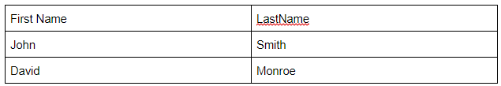

Query 2
English version | Find number of students who have confirmation of graduation in some major eg: basket weaving
SQL sentence | select count(firstName) as Number_of_students from Courses where graduation='confirm' and major='Basket Weaving';
Example of returned rows (cropped screen caption) | 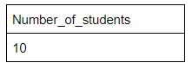

Query 3
English version | find name of instructors who teaches some course eg: 'English lit'
SQL sentence | select i.firstName,i.LastName from Instructor i, Section s, and Course c where s.instructorId=i.instructorId and s.courseId=c.courseId and c.name='English lit';
Example of returned rows (cropped screen caption) | 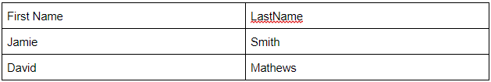

Query 4
English version | What are the credited hours for course eg: Journalism?
SQL sentence | select credit from Course where name='Journalism';
Example of returned rows (cropped screen caption) | 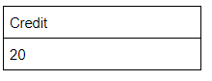

Query 5
English version | which course is held in room number eg: 7?
SQL sentence | select Name as CourseName from Course where RoomNumber=7;
Example of returned rows (cropped screen caption) | 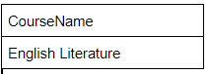

Query 6
English version | How many students have withdrawn from some class eg: History?
SQL sentence | select count(a.CourseId) as Count_Number from Alerts a, Course c where a.CourseId=c.CourseId and c.Name='History';
Example of returned rows (cropped screen caption) | 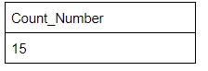

Query 7
English version | find prerequisite for a course eg: Computers
SQL sentence | select s.CourseId,s.prerequisite from Section s, Course c where s.CourseId=c.CourseId and c.Name='Computers';
Example of returned rows (cropped screen caption) | 