SRS Document of

**IoT Hospital Tracking System**

SWENG 586

Group 4

Ibrahima Ba  
Scott Beaver

Rosa Ciummo

Vernon D’Mello

James Giltner

Javonn Liner

2/26/2018

1. **Introduction**
   1. Purpose

To build a network of medical devices, sensors, inventory, and equipment to facilitate the highest quality of care to a patient throughout their entire course of treatment.

* 1. Scope

The “hospital tracking” system, herein referred to as “The System”, will consist of medical devices, sensors, inventory, and equipment, connected to a network that will track health data. The system will collect data on patients, staff members, specimens, equipment, and supplies to provide more efficient and improved health diagnostics and treatment. The system is intended to supplement the abilities of hospital employees to provide top-notch care to patients. Real-time diagnostic services will assist caregivers in high-pressure situations. Also, the remote monitoring of patients and reduction in audible alarms allows caregivers to keep a close eye on their vitals without noisy, invasive room visits.

* 1. Product Overview
     1. Product perspective

The system will provide network connectivity for medical devices, sensors, inventory, and equipment contained within the hospital campus. These items will be referred to as smart devices. It is not intended to develop new smart devices for the system; rather, the system will connect existing and future smart devices and develop the applications to provide interconnected patient care.

* + 1. Product functions

The system is devoted to delivering the highest quality of care through secure monitoring and tracking of patients, treatments, employees, rooms, labs and equipment. Patients are the center of the system, and treatment is supported by tracking spatial location and monitoring vitals. Patients can be located throughout the hospital using spatial tracking; this tracking will be used to classify the patient types and any existing conditions. The system will monitor vital signs of patients by using biosensors to track heart rate, oxygen levels, blood sugar levels, and many others. These sensors comprise medical body area networks (MBANs), which transmit vitals data to medical staff. This data is used to treat the patients to determine diagnosis and treatment plans by tracking medication and lab work through to discharge of the patient. During their time in the hospital a patient is connected to the system including room variables. Smart rooms allow the patient and medical staff to adjust temperature, lighting and other environmental configurations to provide a comfortable stay in the hospital. Medical staff and other employees will interact with the system and will be monitored using RFID to track locations and enforce hygiene standards. The RFID badge will track an employee’s location in the hospital and secure certain areas, limiting access to only authorized staff. Hygiene is a critical part of operating a hospital, so the system will enforce hygiene standards by tracking acts of sanitation. The system will also track labs through the entire lifecycle, from gathering specimens to analysis and reporting. To keep the hospital running smoothly, equipment and inventory will be tracked.

* + 1. User characteristics

Medical staff will be the primary users of the system and consist of doctors, nurses and technicians. These users work with the system on a daily basis to treat patients with the data gathered by the system. Patients are the center of the system and the source of the majority of data contained within the network. Families are integral parts of the health and well-being of patients, they too will be affected by the system. Hospital executives are sponsoring the system and will provide the guidance on the scope of the system and will be the deciding party if the system will be built. Stakeholder classes and their ranks are included in table 1.1.

|  |  |  |
| --- | --- | --- |
| **Class** | **Rank** | **Rationale** |
| Medical Staff | HIGH | Primary uses of the system and will have the most direct effects on patient care. |
| Patients | HIGH | The ultimate goal of the system should be to improve patient care. |
| Patient Families | HIGH | If the system works poorly or gives that appearance, a strong negative reaction from family members is likely. |
| Hospital executives | HIGH | The sponsor of the system with the decision whether or not to implement the system. |
| Hospital Administrators | HIGH | Hospital staff who manage the operations of the hospital and medical services. |
| IT Staff | HIGH | In charge of maintaining and developing new functionality of the system |
| Regulatory bodies (OCR, CMS, FDA, FCC, etc.) | HIGH | The system must be in compliance with regulations set forth by these agencies. |
| Insurance companies | HIGH | They end up paying much of the cost for medical decisions resulting from the collected information. |
| Illegal entities interested in the data generated | HIGH | A security breach would expose extremely personal data generated from a large number of people. |
| Security Director | HIGH | Privacy issues are of great importance. The security director’s concerns must be fully satisfied. |
| System competitors | HIGH | The system’s performance must be competitive with other similar systems. |
| Those building the system | HIGH | This is likely to be a complicated system that will be involved directly in life and death situations. |
| General public | MEDIUM | The success of the system may positively or negatively affect the perception of the hospitals that use it. |
| Privacy advocates | MEDIUM | Privacy concerns can be powerful motivators. If they take exception to the system, advocates could turn public opinion against it. |
| Maintenance personnel | MEDIUM | In addition to the software, such a system will have a large number of devices. Proper maintenance will be essential to ensure that all parts of the system are individually functional and working with all relevant components. |
| Workers organizations | MEDIUM | Unions could be problematic, but they are likely to have little impact on the actual system. |
| Competing hospitals | MEDIUM | Other hospitals will have an advantage if their system is superior, whereas hospitals with inferior systems may be motivated to upgrade. |
| Medical researchers | MEDIUM | They may be interested in the data, but won’t interact directly with the system. |
| Medical supply vendors | MEDIUM | Their impression of the system will likely depend on their perception of its effects on their profits, but they will not interact directly with it. |
| Tax payers | LOW | They have little say in where their money goes. |
| Politicians | LOW | If a politician gets involved, it’s likely because another stakeholder has issues. |
| Press | LOW | In the absence of self-inflicted injuries, the press is unlikely to play a large part in the development of the system. |

Table 1.1 - Stakeholder Classes

* + 1. Limitations

Healthcare is a highly regulated industry with strict requirements to adhere to for handling health information. The Health Insurance Portability and Accountability Act (HIPAA) standardizes how health data is shared and who has access to the data. The system is constrained to follow the standards set by such regulations.

* 1. Definitions, acronyms, and abbreviations

AES - Advanced Encryption Standard

BAC - Blood alcohol content

CFR - Code of Federal Regulations

FCC - Federal Communications Commission

FDA - Food and Drug Administration

GUI - Graphical user interface

HIPAA - Health Insurance Portability and Accountability Act

IoT - Internet of things

MBAN - Medical Body Area Network

PHI - Protected health information

RFID - Radio-frequency identification

ROI - Release of information

SSL - Secure Sockets Layer

1. **References**
2. Gooch, Kelly. “25 Largest Hospitals in America.” *Becker's Hospital Review*, 18 Jan. 2017, [www.beckershospitalreview.com/lists/25-largest-hospitals-in-americajan-18.htm](http://www.beckershospitalreview.com/lists/25-largest-hospitals-in-americajan-18.html)
3. Microsoft Accessibility guidelines
4. **External interfaces**
   1. Patient room control interface
      1. The interface shall be designed for a touchscreen tablet.
      2. The interface shall contain icons for different functions in a dock aligned to the bottom of the screen.
      3. The interface shall provide an icon to allow access to light control.
         1. The interface shall allow the patient to control lighting intensity.
         2. The interface shall allow the patient to turn lights on and off.
      4. The interface shall provide an icon to allow access to temperature control.
         1. The interface shall allow the patient to adjust the temperature in one degree interval.
      5. The interface shall provide an icon to allow access to allow TV control.
         1. The interface shall allow the patient to turn the TV on and off.
         2. The interface shall allow the patient to control the TV.
         3. The interface shall allow the patient to change the channel.
            1. The interface shall allow the patient to input a channel number directly.
            2. The interface shall allow the patient to scroll through channels.
      6. The interface shall provide an icon to allow access to background noise control.
         1. The interface shall allow the patient to choose from a list of different background noises.
         2. The interface shall allow the patient to adjust the volume.
         3. The interface shall allow the patient to turn the background noise on and off.
      7. The interface shall provide an icon to allow access to blinds control.
         1. The interface shall allow the patient to open and close the blinds.
         2. The interface shall provide control for vertical and horizontal blinds.
      8. The interface shall provide an icon to allow configurations of acceptable ranges and default settings.
         1. Access to system settings shall be protected by biometric authentication.
         2. System settings shall include the option to lock the tablet, thus preventing use by the patient.
   2. Transportable devices
      1. A wearable device shall be assigned to each healthcare provider.
         1. Healthcare provider’s devices shall lock their screens after 1 minute without user interaction.
         2. Devices shall be unlocked by the input of a password.
         3. Devices shall disallow password input after 5 failed attempts to enter the correct password.
            1. The device shall allow passwords after a system administrator has deactivated the device lock.
         4. The interface shall allow healthcare providers to view the patient information of patients under their care.
         5. The interface shall allow healthcare providers to update patient information.
         6. The interface shall be touch screen.
         7. The interface shall allow healthcare providers to send messages to the device of another healthcare provider.
         8. The interface shall keep record of appointments.
            1. The interface shall allow appointments to be added by the user or one of the supervisors.
            2. The interface shall alert the nurse that they have an appointment 10 minutes before the scheduled appointment.
         9. The interface shall alert the healthcare provider when they have an appointment or meeting.
         10. The interface shall notify the user when a patient under their care is reporting dangerous vitals information.
   3. Physician’s tablet
      1. The tablet shall take input from Physician's GUI.
      2. The tablet shall lock its screen after 2 minutes without user interaction.
      3. The tablet shall unlock through input of a PIN.
      4. The tablet shall disallow PIN input after 3 failed attempts to enter the correct pin
         1. The tablet shall allow PINs after a system administrator has deactivated the tablet lock or after 24 hours.
      5. The tablet shall show a dialog box for patient’s name.
      6. The tablet shall list medicines prescribed by the physician.
      7. The tablet shall list dosage of the prescribed medicine.
      8. The tablet shall give instructions of how the medicine should be taken by the patient.
      9. The tablet shall show how many days the patient should continue to take the prescription.
      10. The tablet shall allow access to medical charts.
      11. The tablet shall allow access to vital monitors.
          1. The tablet shall show a heart rate display monitor to read the current heart condition.
          2. The tablet shall show automatic blood pressure monitor that keeps track of blood pressure.
          3. The tablet shall show ultrasound machine to view body's internal structure.
          4. The tablet shall show x-ray machine to view the structure of bones.
   4. Lab storage unit
      1. The monitoring screen shall display temperature of climate-controlled storage units.
      2. The monitoring screen shall display alerts sent to lab supervisors and maintenance personnel if the temperature for a storage unit is not within an optimal range.
      3. The monitoring screen shall flash if the temperature for a storage unit is in a range that would damage its contents.
      4. The monitor shall allow lab supervisors to input optimal and functional temperature ranges for each unit.
      5. The monitoring screen shall display specimen inventory list.
      6. The monitoring screen shall display alerts to supervisor if lab not picked up on time.
      7. The monitoring screen shall flash red if door is open.
   5. Nursing station
      1. The nursing station shall display patient information.
      2. The nursing station shall display patient history.
      3. The nursing station shall search previously admitted patients.
      4. The nursing station shall search currently admitted patients.
      5. The nursing station shall monitor patients’ vitals.
      6. The nursing station shall receive alerts from patients.
      7. The nursing station shall alert nurses when a patient’s vitals reach critical levels.
      8. The nursing station shall monitor medications.
      9. The nursing station shall provide hospital information (e.g. hours of operation, map details, etc.)
      10. The nursing station shall provide specialist recommendations.
   6. Release of Information (ROI)
      1. The system shall only release protected health information (PHI) if the patient or the personal representative has authorized the request.
         1. The system shall store an ROI authorization from a patient.
         2. The system shall store an ROI authorization from a personal representative.
      2. The system shall allow ROIs only for approved entities.
      3. The system shall reject any requests without prior authorization.
      4. The system shall generate an invalid request letter for any unauthorized requests.
      5. Authorizations must contain a meaningful description of the information disclosed.
      6. Authorizations must contain the name of the entity who authorized the request.
      7. Authorizations must contain a signature of the entity who authorized the request.
      8. Authorizations must contain the name of the entity who made the request.
      9. The system shall de-identify patient data.
      10. Requests shall contain only de-identified PHI.
      11. Requests must contain an expiration date
      12. Data disclosed in a request must not be available after the expiration date.

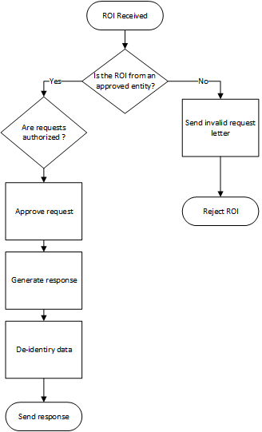

Figure 3.6 - ROI Flow Chart

1. **Hardware specifications**
   1. The system shall require a backup power source capable of powering all systems for no less than 24 hours.
   2. The system shall require a backup power source to power life-essential systems for 72 hours after power is lost.
   3. The system shall utilize only wireless sensors and devices that are compliant with FCC regulation 47 CFR Part 95, Subpart I - Medical Device Radio Communications Service.
   4. The system shall utilize transportable devices that are powered by rechargeable batteries.
      1. Transportable devices shall be able to withstand drops from a height of 6 feet without incurring internal or external damage.
      2. The devices shall alert the system if the battery life drops below 10%.
         1. The system shall utilize charging docks to store devices powered by batteries at the end of their cycle of use or when the devices alert the system that they need to be recharged, whichever comes first.
      3. The devices shall weigh less than 8 ounces.
2. **Patient monitoring** (Priority = HIGH)
   1. Spatial tracking
      1. The system shall track the location of each patient.
      2. The system shall denote the type of patient (e.g. ICU, outpatient) when tracking the patient.
      3. The system shall specially mark patients with a BAC of over 0.08, narcotics in their bloodstream, or other behavioral risk factors such as dementia.
      4. The system shall automatically email the coroner when a time of death has been entered.
   2. MBANs
      1. The system shall send an alert to the nurse’s station and spectralink phones if it loses its connection to an active sensor.
      2. The system shall email maintenance the sensor ID and room number if a sensor provides readings that appear to be faulty.
      3. The system shall provide an interactive diagram to show caregivers proper placement of each sensor in different monitoring scenarios.
      4. The system shall alert caregivers if a sensor provides readings that indicate it may not be properly placed.
         1. The placement diagram shall highlight the sensor in question and its proper placement.
      5. The system shall log the sanitation of reusable sensors after each patient.
   3. Vital signs

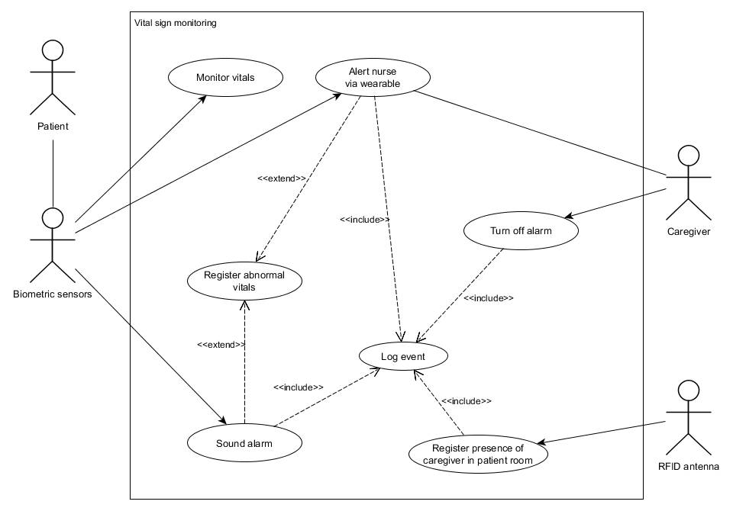

Figure 5.1 - Vitals Alerts Use Case Diagram

* + 1. The system shall transmit all vital signs to the nurses’ station for remote monitoring.
    2. The system shall provide default settings for when a vital sign reading is a concern and when it is an emergency.
    3. The system shall allow caregivers to adjust the “concern” and “emergency” ranges for each vital sign.
    4. The system shall send an alert to a device worn by the on-call nurse in the case of a concerning vital reading.
    5. The system shall continue sending concerning vital reading alerts to the nurse once each minute until the nurse is detected in the patient’s room.
    6. The system shall sound an audible alarm when vital signs are in emergency ranges.
    7. The system shall log all instances in which any given vital reading of a patient falls outside of normal ranges.
    8. The system shall automatically log when a caregiver comes within three feet of a patient when a vital signs alert is active.
    9. The system shall keep records of vitals response logs for no less than one year.
    10. The system shall remove a patient’s medical records from the database after the specified amount of time has passed for the following groups: (1) for adult patients, 10 years from the date the patient was last seen, (2) for minor patients, 28 years from the patient's birth, (3) for deceased patients, five years from the date of death.

1. **Patient treatment** (Priority = HIGH)
   1. Medication
      1. The system shall warn the physician if prescribed drugs are marked in the FDA database as interacting harmfully with one another.
      2. The system shall require the physician to acknowledge and override the drug interaction warning to administer drugs known to have a negative interaction.
      3. The system shall not dispense any combination of drugs known to have lethal interactions with one another.
      4. The system shall provide automatic dispensation of medication, both in pill form and IV solutions.
      5. The system shall create a log entry with the patient ID, medication, dosage, and the time and day each time medication is dispensed.
      6. The system shall analyze patient information (e.g. demographics and vitals) to suggest possible medications to physicians.
      7. System shall monitor outflow of addictive narcotic painkillers.
         1. System shall compare the drug and dose prescribed with the patient’s diagnosis and alert user when a suspect prescription was made.
   2. Diagnosis
      1. The system shall analyze patient data to create a differential diagnosis.
      2. The system shall order relevant lab work based on the differential diagnosis.
      3. The system shall allow the physician to override automatic diagnoses.
   3. Discharge planning
      1. The system shall print out informational/home care packets for each diagnosis the patient receives.
2. **Patient room controls** (Priority = LOW)

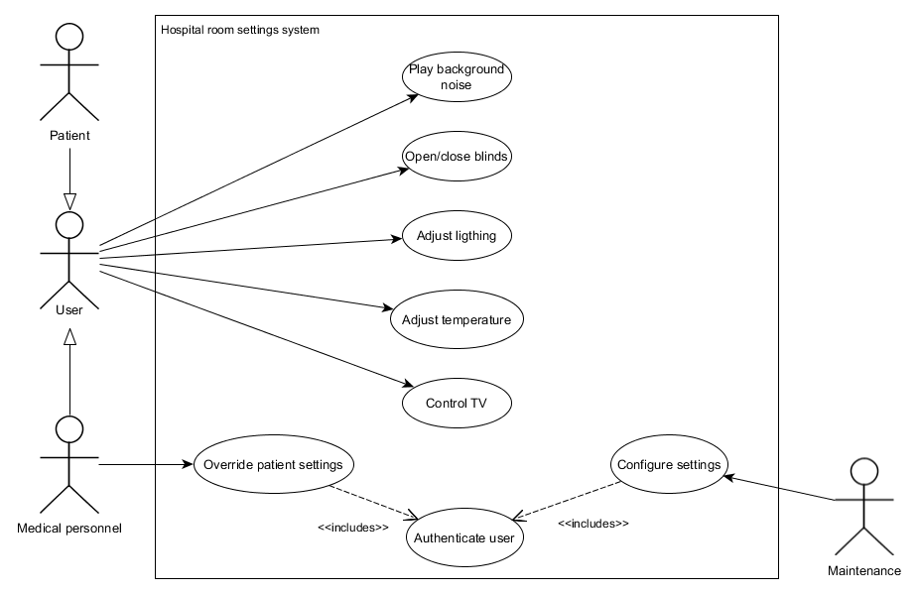

Figure 7.1 - Patient Room Use Case Diagram

* 1. The system shall allow patients to control certain variables in their rooms with an app on a hospital-owned tablet.
  2. The system shall allow the patient to open or close the room blinds.
  3. The system shall allow the patient to adjust the temperature in the room.
  4. The system shall allow the patient to control the channel and volume of the TV.
  5. The system shall allow the patient to control the lights in the room.
  6. The system shall allow the patient to choose from a selection of background noises to play in the room.
  7. The system shall allow the patient to set the volume of the background noise selected.
  8. The system shall allow hospital personnel to override the patient’s settings.
  9. The system shall allow authenticated hospital personnel to disable the option for patients to control their room.
  10. The system shall allow nurses to adjust defaults and acceptable ranges for each of the variables controlled by the app.
  11. The system shall automatically dim the lights at 9pm.
  12. The system shall automatically raise the lights if vital signs indicate an emergency.
  13. The system shall allow two zones of control in shared rooms.

1. **Employee monitoring** (Priority = HIGH)
   1. Spatial tracking
      1. The system shall track employee locations while they are on hospital premises.
      2. The system shall distinguish between various types of workers (physician, nurse, resident, etc.)
      3. The system shall notify supervisors when a nurse has been in the building for longer than 12 hours.
      4. The system shall notify supervisors when a resident has been in the hospital for longer than 28 hours.
   2. Hygiene enforcement

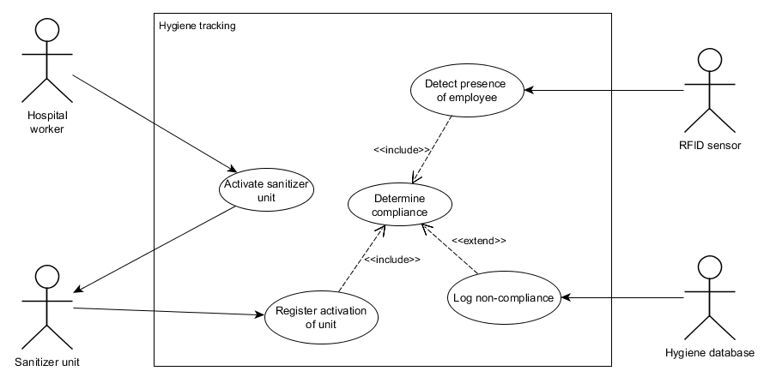

Figure 8.1 - Hygiene Enforcement Use Case Diagram

* + 1. The system shall have connected hand sanitizer dispensaries in all restrooms, patient rooms, examination rooms, and all other areas where proper procedure dictates hand sanitation.
    2. Each sanitizer dispenser shall be assigned a unique ID.
    3. The system shall detect whenever a hospital employee enters a hand hygiene area.
    4. The system shall create a log entry with the employee ID, sanitizer ID, time, and date if the employee is not in compliance with hand hygiene protocol.
       1. The system shall create a log entry if the employee leaves the restroom without sanitizing his or her hands.
       2. The system shall create a log entry if the employee does not sanitize his or her hands within 30 seconds of entering a patient’s room or other hand hygiene area.

1. **Medical laboratory** (Priority = MEDIUM)
   1. Storage unit monitoring
      1. The system shall monitor the temperature of climate-controlled storage units.
      2. The system shall text and/or email lab supervisors and maintenance personnel if the temperature for a storage unit is not within an optimal range.
      3. The system shall sound an alarm in the lab if the temperature for a storage unit is in a range that would damage its contents.
      4. The system shall allow lab supervisors to modify the optimal and functional temperature ranges for each unit.
   2. Analysis and reporting
      1. The system shall analyze patient lab results to suggest possible diagnoses.
      2. The system shall analyze the patient’s information to automatically suggest a set of appropriate laboratory tests.
      3. The system shall provide an interface for caregivers to remove automatic lab suggestions.
      4. The system shall present all lab results, both in-house and otherwise, in one unified report.
2. **Equipment and supplies** (Priority = MEDIUM)
   1. Equipment tracking
      1. The system shall notify security if equipment is removed from the hospital without authorization.
      2. The system shall provide an interface for authorized personnel to mark equipment as authorized for removal from the hospital.
   2. Equipment maintenance
      1. The system shall notify the maintenance department by text and email in the case of a detected equipment malfunction.
      2. The system shall notify the maintenance department by email when a piece of equipment is due for inspection and/or servicing.
   3. Supply management
      1. The system shall automatically order inventory when supplies run low.
      2. The system shall allow hospitals to set minimum quantities of each item before an automatic reorder is triggered.
3. **Security** (Priority = HIGH)
   1. Restricted areas

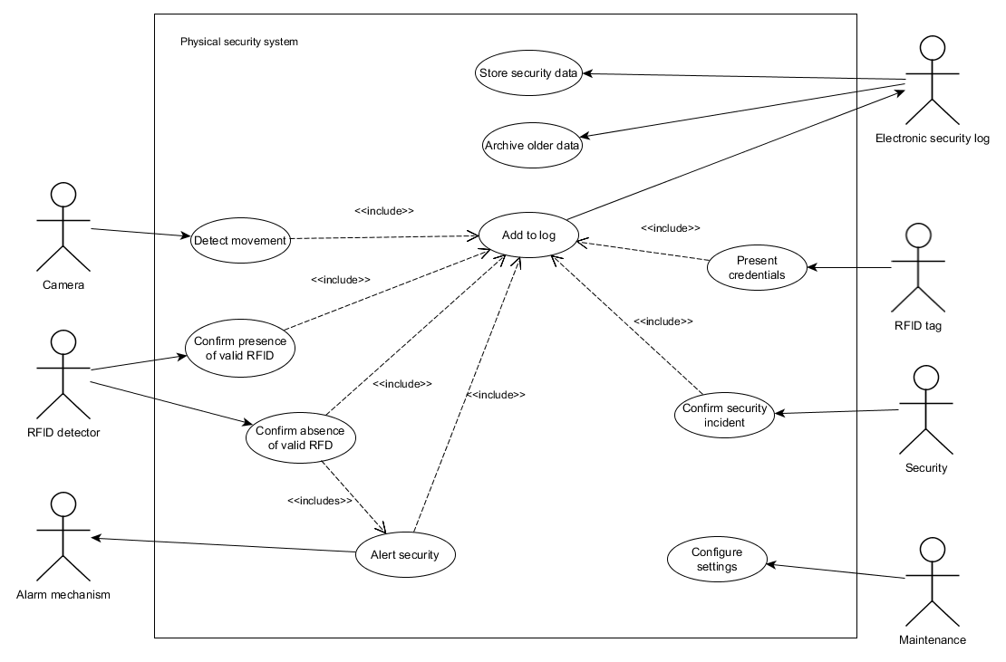

Figure 11.1 - Physical Security Use Case Diagram

* + 1. The system shall have RFID readers at all points of entry to restricted areas.
       1. The system shall require all occupants, including patients and guests, to carry a RFID badge.
       2. The system shall unlock doors for users with RFID cards indicating the occupant has the minimum level of authorization to enter.
       3. The system shall automatically relock the door after it has been opened.
       4. The system shall log the employee ID, date and time, and location of authorized restricted entry access and exit.
    2. The system shall have connected security camera at all points of entry to restricted areas.
    3. The system shall notify in security if movement is detected within three feet of an entry to a restricted area and a valid RFID tag is not detected.
       1. The system shall notify the local police department if a door is opened without a valid RFID tag present.
       2. The system shall begin recording footage once movement is detected and no RFID tag is present.
       3. The system shall store recordings in the security database.
  1. Interaction with outside agencies
     1. The system shall automatically notify local fire/police departments if a fire is detected.
     2. The system shall automatically notify the appropriate authorities when a caregiver inputs that there is evidence of child abuse.
     3. The system shall automatically notify the appropriate authorities when an injury that is covered under mandatory reporting requirements is input into the system.
  2. Patient privacy
     1. The system shall provide interactive aids – such as flowcharts – to assist caregivers in determining when it does not violate HIPAA to release information to third parties.
     2. The system shall be configurable to comply with state-specific laws that apply to each individual customer.
     3. The system shall allow patients to create an account to access their medical records.
     4. The system shall allow patients to access their account through a mobile app or web browser.

1. **Performance**
   1. Scalability
      1. The system shall give responses within 5 seconds of checking the patient’s information.
      2. The system must support 2000 people using it simultaneously.
      3. The system should be able to perform efficiently with many connections established simultaneously.
      4. The user-interface screen shall respond within 5 seconds.
      5. The systems must conform to the Microsoft Accessibility guidelines.
   2. Maintainability
      1. The system shall provide the capability to backup the data.
      2. The system shall keep a log of all the errors.
2. **Logical database**
   1. Types of information
      1. The system shall store patients’ relevant information.
         1. The system shall store blood pressures.
         2. The system shall store blood sugar levels.
         3. The system shall store blood types.
         4. The system shall store current medication.
         5. The system shall store allergies.
         6. The system shall store last known location.
         7. The system shall store contact information.
         8. The system shall store at least 1 emergency contact.
         9. The system shall store attached devices.
         10. The system shall store room number.
         11. The system shall store room settings.
         12. The system shall store lab results.
      2. The system shall store employee information.
         1. The system shall store last know check-in.
         2. The system shall store employees’ title.
         3. The system shall store current patients.
         4. The system shall store hygiene data.
      3. The system shall store device information.
         1. The system shall store serial numbers.
         2. The system shall store tracking information.
         3. The system shall store the devices purpose.
         4. The system shall store device alerts.
         5. The system shall store maintenance information.
      4. The system shall store security information.
         1. The system shall store video data.
         2. The system shall store alarm data.
         3. The system shall store logs of RFIDs that have entered areas of elevated authorization.
   2. Accessibility and security
      1. The system shall store data for at least 90 days.
      2. The system shall have a response time of at most 5 seconds.
      3. If the system data is unreachable it shall alert the user.
      4. The system shall allow multiple queries to database.
      5. The system shall only provide data if the user has the proper authorization.
      6. The system shall utilize cloud-based storage and processing.
      7. The system shall use a local database in the case of connectivity issues with cloud services.
      8. The system shall upload locally stored data to the cloud once connectivity has been restored.
      9. The system shall be able to store 10 TB of data.
3. **Design constraints**
   1. Internet bandwidth constraints
      1. The system shall not be installed in hospitals with more than 1600 beds to prevent poor performance caused by the connection of excessive devices.
      2. The system shall not communicate with devices that are more than a quarter mile off of the hospital campus.
   2. Hardware constraints
      1. The medical devices utilized shall have limited memory and RAM to prolong the battery life of the devices.
         1. Upon receiving data from a reporting medical device, the system shall send a confirmation of successful storage of data to the device.
         2. Upon receiving confirmation of storage from the system, the medical device shall delete the reported piece of data from its memory
      2. The system shall support interfaces that are compatible with the existing medical devices that are incorporated into the system.
      3. The system shall not require more voltage and current to function than the voltage and current already available in the hospital.
   3. Regulatory constraints
      1. The system shall support encryption of all medical devices in accordance with HIPAA.
      2. The system shall only incorporate devices that are compliant with FDA regulations for medical devices.
4. **Software system attributes**
   1. Availability
      1. Overall system availability shall be at least 99.9999999%.
      2. At least 95% of all equipment shall have the most recent software version.
   2. Maintainability
      1. If connection to the cloud is lost or compromised, the system shall gracefully degrade to local storage and processing.
      2. Software updates
         1. The system shall automatically update software when an update becomes available.
         2. The system shall update no more than 20% of each type of equipment at a time.
         3. Software updates shall be backwards compatible.
         4. The system shall text and email maintenance the equipment ID number and error message from any piece of equipment that fails to properly update its software.
         5. The system shall rollback any failed updates so that the equipment is still operational.
   3. Data security
      1. The system shall be accessible to hospital personnel only through hospital-owned devices.
      2. The system shall permit only designated software to exist on hospital-owned devices.
      3. The system shall use SSL for all web-based access.
      4. The system shall encrypt all patient data stored locally and on the cloud in accordance with AES.
      5. The system shall provide an interface to designate which employees are authorized to access a patient’s records.
      6. The system shall provide for access levels granting authorization to view all records, any number of specified records, or no records.
      7. The system shall not grant access to patient records by unauthorized users.
      8. Each time a medical record is accessed, the system shall create a log entry.
         1. The log entry shall contain the record ID, date and time of access, who accessed the record, the device, and if applicable, the IP address from which the user accessed the record.
5. **Supporting information**
6. Asma Haroon, Munam Ali Shah, Yousra Asim, Wajeeha Naeem, Muhammad Kamran and Qaisar Javaid, “Constraints in the IoT: The World in 2020 and Beyond” International Journal of Advanced Computer Science and Applications(ijacsa), 7(11), 2016. <http://dx.doi.org/10.14569/IJACSA.2016.071133>
7. Laplante, P. A. (2018). *Requirements engineering for software and systems*. Boca Raton: CRC Press.
8. Secretary, H. O., & (OCR), O. F. (2013, July 26). A Decision Tool: Authorization. Retrieved February 19, 2018, from https://www.hhs.gov/hipaa/for-professionals/special-topics/emergency-preparedness/authorization/index.html
9. **Appendices**

**Appendix A: Assumptions**

This document makes the assumption that certain required hardware - such as IoT-capable body sensors - is already available on the market. If this assumption were incorrect, additional requirements would be needed to detail new equipment to be manufactured for use with the system.

Furthermore, it is assumed that client hospitals will operate in a building that is conducive to wireless communications. Outdated wiring or the preponderance of certain building materials have the potential to interfere with dependable communication between system components. The system put forth in this document may not be feasible for clients in incompatible buildings without some renovations.

**Appendix B: Elicitation documentation excerpts**

*Life-cycle of a patient*

1. Patient Check-in
   1. A patient is checked into the hospital
   2. This patient fills out medical history and symptoms
   3. Patient is assigned a bed, room and physician
2. First patient encounter
   1. A nurse greets the patient and guides the patient to the bed they are assigned
   2. The nurse reviews symptoms
   3. Further health history questions are asked
3. Vitals
   1. Patient vitals are taken by the nurse
   2. Blood pressure, temperature, heart and lung function are recorded
   3. Patient is hooked up to monitoring devices
4. Physician first interaction
   1. Physician greets patient
   2. Physician reviews symptoms and medical history
   3. Physician reviews vitals
5. Physician diagnosis
   1. Physician provides a list of differential diagnoses
   2. Physician determines labs for diagnosis
   3. Nurse orders lab tests to confirm diagnosis
6. Lab test scheduling
   1. Test order is received by specified department
   2. Patient scheduled for testing
   3. Lab technician assigned to case
   4. Test materials ordered for lab
7. Lab test prework
   1. Patient checks in at specified lab
   2. Patient identity confirmed by lab technician
   3. Materials checked out of inventory
8. Lab execution
   1. Specimens gathered by technician
   2. All specimens documented by labeling and entering into system
   3. Specimens submitted for testing
9. Lab analysis
   1. Tests analyzed by system
   2. Analysis report generated
   3. Technician confirms analysis report
   4. Technician submits results to physician
10. Determination of diagnosis
    1. Physician analyzes test results
    2. Physician determines if a final diagnosis can be defined
    3. Lab test reiterated if further testing required
    4. Physician identifies diagnosis
11. Diagnosis presentation
    1. Physician determines course of treatment
    2. Physician informs patient of diagnosis
    3. Physician present treatment options
12. Treatment decision
    1. Patient receives informed consent
    2. Patient makes educated decision for treatment method
13. Treatment Coordination
    1. Nurse informs physician
    2. Nurse submits treatment to hospital administration
    3. Hospital administration assembles necessary medical staff, equipment and room for treatment
    4. Patient scheduled for treatment
14. Patient Treatment
    1. Patient checked in for treatment
    2. Patient monitored through treatment (vitals, location)
    3. Patient treated
    4. Patient moved to recovery
15. Patient Post-Op
    1. Patient monitored through recovery
    2. Patient scheduled for follow up checks
    3. Patient dismissed from hospital

*Stakeholder Interview Questions with Laddering*

Medical Staff

|  |  |
| --- | --- |
| Name an essential feature of the system? | An important feature of this system is to accurately maintain patient files |
| What are in the patient file? | Patient files contain lab results, allergies, and medical history |
| Why is this feature important? | To avoid a mix up in patients care |
| What other features depend on this feature? | The data from a patient's lab reports cannot be properly analyzed without this |
| How is the analysis done? | The doctor compares the lab results with the patient's allergies and medical history |

Table B1 - Medical Staff Interview Responses

Patients

|  |  |
| --- | --- |
| Name an essential feature of the system | An essential feature of this system is to give doctors fast access to my test results |
| What is the current time for your doctors to access your lab results after they are completed? | Up to 6 hours we would like to get that down to 2 hours |
| Why is this feature important? | Faster results means faster care |
| What other features depend on this feature? | The doctor’s analysis cannot be complete until the test results are received |

Table B2 - Patient Interview Responses

Patient's Families

|  |  |
| --- | --- |
| Name an essential feature of the system | An essential feature of this system be able to track our family member’s results and medical interactions remotely |
| Where will you be? | I travel a lot for work so I would like for it to be accessible anywhere I have internet access |
| Why is this feature important? | I want to be able to monitor my family members care even if i am not available to be in the hospital |

Table B3 - Patient’s Family Interview Responses

Hospital Executives

|  |  |
| --- | --- |
| Name an essential feature of the system | The system should save the company time and money |
| Why is this feature important? | Money is what keeps the hospital running |
| What other features depend on this feature? | This should not be used as an excuse to cut corners |

Table B4 - Hospital Executive Interview Responses

Hospital Administrators

|  |  |
| --- | --- |
| Name an essential feature of the system | The most important feature is traceability. Equipment, supplies, and specimens need to be traceable through their entire journey and this information needs to be stored for at least a year |
| Why is this feature important? | So that we can find anything if it gets lost or if we get sued we have a record of what happened |
| What might be something that the hospital gets sued for? | Mixing patient files |
| What other features depend on this feature? | Tracking of equipment and specimens |

Table B5 - Patients Interview Responses

Hospital Security Director

|  |  |
| --- | --- |
| Name an essential Feature of the system | An essential feature of this system is that it protects patients’ private data |
| Which patient data is private? | Name, Address, Social Security Number and health ID number |
| Why is this feature important? | To prevent identity theft |
| How does identity theft occur? | Usually through system breaches but sometime through the leaking of unauthorized information |
| What other features depend on this feature? | Accurate Patient identification |

Table B6 - Hospital Security Director Interview Responses

IT Staff

|  |  |
| --- | --- |
| Name an essential Feature of the system | The most essential feature is that the system shall be easy to maintain |
| What is the experience of your IT staff (who is maintaining it)? | 2 year associates degree in information technology |
| Why is this feature important? | We don’t want to have to call someone in everytime the system breaks |
| What other features depend on this feature? | The system upgrades depend on how easy the system is to maintain |

Table B7 - IT Staff Interview Responses