A Short-term Industry Internship
on
AI for Medical Intelligence

A short-term industry internship report submitted in partial fulfillment for the award of degree in

BACHELOR OF TECHNOLOGY
IN
COMPUTER SCIENCE AND ENGINEERING

Under the esteemed guidance of Sri J. Swami Naik Associate Professor
Department of Computer Science and Engineering

G. PULLA REDDY ENGINEERING COLLEGE(Autonomous):KURNOOL

(Affiliated to JNTU,ANANTAPUR)

2026

Department of Computer Science and Engineering

G. PULLA REDDY ENGINEERING COLLEGE(Autonomous): KURNOOL
(Affiliated to JNTU,ANANTAPUR)

A Short-term industry internship Report by

Javvaji Shalini 249X5A05U1

J. Swami Naik Dr. N. Kasiviswanath
Associate Professor, Professor and HOD,
Department of C.S.E, Department of C.S.E,
GPREC, Kurnool. GPREC, Kurnool

ProgramBook
Short Term Industry Internship

G .Pulla Reddy Engineering College(Autonomous)
(Affliated to Jawarharlal Nehru Technological University, Anantapur.)

2026

SHORT TERM INDUSTRY INTERNSHIP DETAILS

Name of the College: G Pulla Reddy Engineering College

Department: Computer Science & Engineering

Name of the Guide: J. Swami Naik

Duration of the Internship: 8 weeks From: 04-05-2026 To: 25-06-2026

Name and address of the Organization : Intel Unnati in GPREC
Name of the Student: Javvaji Shalini

Program of Study: B.Tech in Computer Science and Engineering

Year of Study: III

Register Number: 249X5A05U1

Internship Domain: Artificial Intelligence and Machine Learning Internship Title: Heart Disease Prediction Using Machine Learning. Date of Submission:

Signature of Internship Coordinator

Dr. K. Kavitha Associate Professor, CSE Deparment,

GPREC
DECLARATION

I, Javvaji Shalini a student of Bachelor of Technology Program Reg.No. 249X5A05U1 of the Department of Computer Science and Engineering, G. Pulla Reddy Engineering College do hereby declare that I have completed the mandatory industry internship from 04-05-2026 to 25-06-2026 in intel Unnati under the Faculty Guideship of Sri. J. Swami Naik, Department of Computer Science and Engineering, G . Pulla Reddy Engineering College(Autonomous), Kurnool.

(Signature and Date)

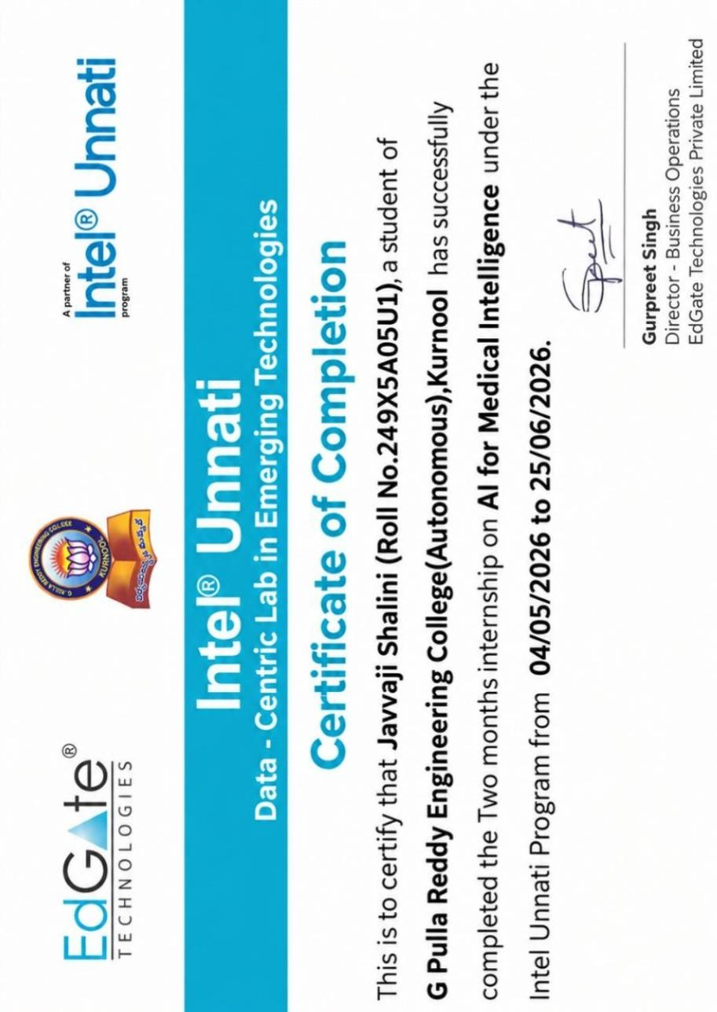

ACKNOWLEDGEMENTS

I wish to express my deep sense of gratitude to my internal supervisor Sri J.Swami Naik, Assistant Professor of Computer Science and Engineering Department, G. Pulla Reddy Engineering College.
My sincere thanks to our Internship Coordinator Dr.K.Kavitha for her immaculate guidance,constant encouragement and cooperation which have made possible to bring out this internship work.

I am thankful to our Head of the Department Dr.N.Kasiviswanath, for his whole hearted support and encouragement during the internship.

We are grateful to our Internship Dean Dr.A.Vishnuvardhan Reddy and to our respected Principal Dr.B.Sreenivasa Reddy for providing requisite facilities and helping us in providing such a good environment.

I wish to convey my acknowledgements to all the staff members of the Computer Science and Engineering Department for giving the required information needed for my internship work.

Finally, I wish to thank all our friends and well wishers who have helped me directly or indirectly during the course of this internship work.

Abstract
This Short-Term Industry Internship was undertaken at the Department of CSE (AI & ML), G. Pulla Reddy Engineering College, in collaboration with Intel® Unnati, from 04-05-2026 to 25-06-2026 in hybrid mode. The internship provided practical exposure to Artificial Intelligence, Machine Learning, data preprocessing, model development, web application development, database management, and software engineering practices in a healthcare-oriented application domain.

As part of the internship, a project titled “PlacePrep: Heart Disease Prediction Using Machine Learning” was developed to demonstrate the practical application of machine learning techniques for preliminary cardiovascular risk prediction. The system accepts relevant health parameters from users—such as age, sex, chest pain type, resting blood pressure, serum cholesterol, fasting blood sugar, and electrocardiographic results—and processes the input through a trained machine learning model to generate a prediction. The project involved studying and preprocessing clinical heart disease datasets, handling missing or anomalous values, performing exploratory data analysis, feature scaling, feature selection, and implementing classification algorithms. Different machine learning models were evaluated using standard performance measures such as accuracy, precision, recall, F1-score, and confusion matrix, followed by model selection and tuning.

The trained model was integrated into a Django-based web application using Python for backend processing and HTML, CSS, and JavaScript for the frontend. The application also included user authentication, prediction-result display, and prediction-history storage using a SQL-based database. Testing and debugging were performed to verify the functionality of the integrated system, followed by documentation and final project presentation.

Overall, the internship provided hands-on experience in the complete machine learning development lifecycle, from data preparation and model training to web application integration and testing. It also strengthened technical, analytical, problem-solving, communication, teamwork, and documentation skills in an industry-oriented environment.

TABLE OF CONTENTS

Internship Details………………………………………………………………………………………i

Declaration……………………………………………………………………………………………..ii

Certificate from Organization…………………………………………………………………………iii

Acknowledgement……………………………………………………………………………………..iv

Abstract………………………………………………………………………………………………..v

1. INTRODUCTION………………………………………………………………………………..1-5

1.1 ABOUT THE INTERNSHIP COMPANY / ORGANIZATION……………………………………….3

1.2 VIRTUAL / OFFLINE INTERNSHIP DETAILS……………………………………………………...4

2. WORK DONE DURING INTERNSHIP………………………………………………………….6-20

2.1 INTERNSHIP OVERVIEW………………………………………………………………......7
  - PYTHON PROGRAMMING………………………………………………………………….7
  - ADVANCED PYTHON PROGRAMMING………………………………………………….8
  - HTML…………………………………………………………………………………………..9
  - CSS…………………………………………………………………………………………….9
  - JAVASCRIPT………………………………………………………………………………….10
  - ARTIFICIAL INTELLIGENCE FUNDAMENTALS………………………………………..10
  - MACHINE LEARNING FUNDAMENTALS………………………………………………..11-15
  - WEB APPLICATION DEVELOPMENT…………………………………………………….16
2.10 PROJECT INTEGRATION…………………………………………………………………...17
2.11 SOFTWARE TESTING AND DEBUGGING………………………………………………...18
2.12 DOCUMENTATION AND PRESENTATION……………………………………………….19
  - SKILLS ACQUIRED………………………………………………………………………….19-20

3 .CASE STUDY/PROJECT COMPLETED……………………………………………………...…21-49
  - INTRODUCTION TO THE PROJECT………………………………………………………...22
  - OBJECTIVES OF THE PROJECT……………………………………………………………..23
  - SCOPE OF THE PROJECT…………………………………………………………………….23
  - SYSTEM REQUIREMENTS…………………………………………………………………..24
  - DATASET COLLECTION AND UNDERSTANDING……………………………………….26-27
  - DATA PREPROCESSING MODULE………………………………………………………….28
  - EXPLORATORY DATA ANALYSIS…………………………………………………………30
  - FEATURE SELECTION………………………………………………………………………..31
  - TRAINING AND TESTING DATA……………………………………………………………32
3.10 MODEL EVALUATION… 33
3.11 HYPERPARAMETER TUNING 34
  - MODEL SERIALIZATION… 34
  - DJANGO WEB APPLICATION MODULE…………………………………………………35
  - CKD PREDICTION MODULE………………………………………………………………38
  - DATABASE MODULE………………………………………………………………………40
  - USER REGISTRATION AND LOGIN MODULE…………………………………………..35-37
  - PREDICTION HISTORY MODULE…………………………………………………………38-40
  - DEVELOPMENT MODULE…………………………………………………………………41
  - TESTING AND DEBUGGING MODULE…………………………………………………..42-43
  - INTEGRATION OF PROJECT MODULES…………………………………………………44-47
  - LIMITATIONS OF THE PROJECT………………………………………………………….48
  - FUTURE ENHANCEMENTS………………………………………………………………..49

4. ACTIVITY LOG……………………………………………………………………………………51

5. CONCLUSION……………………………………………………………………………………...54

References………………………………………………………………………………………55
LIST OF FIGURES

FIGURE NO. | FIGURE NAME | PAGE NO
3.1 | Heart Disease Dataset Preview | 27
3.2 | Heart Disease Prediction Home Page | 36
3.3 | User Registration Page | 37
3.4 | User Login Page | 37
3.5 | Heart Disease Prediction Input Page | 39
3.6 | Prediction Result Page | 40

LIST OF TABLES

TABLE NO | TABLE NAME | PAGE NO
1.1 | Internship Details | 4
2.1 | Skills Acquired During the Internship | 19
3.1 | Technology Stack Used in the Project | 25
3.3 | Dataset Features and Descriptions | 26
3.4 | Machine Learning Model Comparison | 34

CHAPTER 1 INTRODUCTION
1.INTRODUCTION
Artificial Intelligence and Machine Learning have become important areas of Computer Science and Engineering, with applications in healthcare, education, finance, business, and many other domains. Machine learning techniques enable computer systems to analyze data, identify patterns, and generate predictions that can support decision-making. In the healthcare domain, machine learning can be applied to medical datasets to study relationships between health parameters and disease outcomes.
As a Computer Science and Engineering student, gaining practical experience in Artificial Intelligence and Machine Learning is important for understanding how theoretical concepts are applied to real-world problems. Classroom learning provides the fundamental knowledge of programming, databases, algorithms, and machine learning, while an industry-oriented internship provides an opportunity to apply these concepts through practical development activities.

To gain such practical exposure, I undertook a Short-Term Industry Internship under the Department of CSE (AI & ML), G. Pulla Reddy Engineering College, in collaboration with Intel® Unnati. The internship was conducted in hybrid mode from 04-05-2026 to 25-06-2026 as part of the B.Tech curriculum. The internship focused on Artificial Intelligence, Machine Learning, and their application in the medical domain. The official internship offer letter describes the program as an eight-week hands-on internship and training program in “AI for Medical Intelligence.”

During the internship, I worked on the development of PlacePrep: “Heart Disease Prediction Using Machine Learning.” The project involved the complete machine learning workflow, beginning with understanding the problem and studying the healthcare dataset, followed by data preprocessing, exploratory data analysis, feature preparation, model development, model evaluation, and selection of a suitable model. Multiple classification algorithms were studied and implemented as part of the development process.

The trained machine learning model was subsequently integrated into a Django-based web application. The application was designed to accept relevant health parameters—such as age, sex, chest pain type, resting blood pressure, serum cholesterol, fasting blood sugar, resting electrocardiographic results, maximum heart rate achieved, exercise-induced angina, and ST depression—from the user and provide a prediction result. Additional application features included user authentication, prediction-history storage, database integration, and a responsive frontend developed using HTML, CSS, and JavaScript. The project therefore provided practical exposure not only to machine learning but also to backend development, database management, frontend development, testing, and software documentation.

The internship also provided an opportunity to develop professional skills such as problem solving, communication, teamwork, documentation, project planning, and presentation. The weekly activities progressed from project onboarding and dataset analysis to model development, web integration, authentication, testing, documentation, and final project presentation.

This internship helped bridge the gap between academic learning and practical implementation by providing hands-on experience in developing a machine learning-based application. It strengthened my understanding of the machine learning development lifecycle and provided valuable experience in applying programming, data analysis, web development, and software engineering concepts to a practical problem.

ABOUT THE INTERNSHIP COMPANY / ORGANIZATION

The Short-Term Industry Internship was conducted through the Department of Computer Science and Engineering (Artificial Intelligence & Machine Learning), G. Pulla Reddy Engineering College (Autonomous), Kurnool, in collaboration with Intel® Unnati. The internship was organized as part of the academic and industry-oriented learning initiative to provide students with practical exposure to emerging technologies and real-world application development.

The internship program was focused on Artificial Intelligence, Machine Learning, and Deep Learning concepts with applications in the medical domain. According to the internship offer letter, the program was structured as an eight-week hands-on internship and training program intended to provide practical exposure to AI and ML technologies and their real-world applications.

The internship environment combined academic guidance with practical project development. Students were expected to understand project requirements, study relevant datasets and technologies, implement assigned tasks, participate in reviews, maintain project documentation, and present their work. The internship activities followed a progressive development process, beginning with project onboarding and requirement analysis and continuing through data preprocessing, machine learning model development, application integration, testing, documentation, and final presentation.

The program provided exposure to technologies and tools used throughout the project, including Python, Pandas, NumPy, Scikit-learn, Matplotlib, Seaborn, Django, HTML5, CSS3, JavaScript, SQL, Git, GitHub, Visual Studio Code, Jupyter Notebook, and Google Colab. These tools supported different stages of the project, from data analysis and machine learning model development to web application development and version control.

The organization and internship program provided an environment in which theoretical knowledge could be applied to a practical healthcare-oriented machine learning problem. The experience helped strengthen technical skills while also encouraging systematic problem solving, documentation, communication, and project-based learning.

VIRTUAL / OFFLINE INTERNSHIP DETAILS

The internship was carried out in Hybrid Mode (Online + Offline) from 04-05-2026 to 25-06-2026 for a duration of 8 weeks. The internship was conducted by the Department of Computer Science and Engineering (AI & ML), G. Pulla Reddy Engineering College (Autonomous), Kurnool, in collaboration with Intel® Unnati.

The internship focused on Artificial Intelligence and Machine Learning, with practical work on “PlacePrep: : Heart Disease Prediction Using Machine Learning.The work involved understanding the dataset, data preprocessing, exploratory data analysis, machine learning model development and evaluation, and integrating the trained model with a web application using Django.

The internship provided practical exposure to Python, Pandas, NumPy, Scikit-learn, data visualization, Django, HTML, CSS, JavaScript, SQL, Git, and GitHub. It helped in developing technical, problem-solving, documentation, and project implementation skills.

Internship Details

Table No 1.1:Internship Details

Particular | Details
Internship Domain | Artificial Intelligence and Machine Learning
Project | PlacePrep: Heart Disease Prediction Using Machine Learning
Mode | Hybrid (Online + Offline)
Duration | 04-05-2026 to 25-06-2026
Total Duration | 8 Weeks
Programme | B.Tech – CSE
Organization | Department of CSE (AI & ML), GPREC, in collaboration with  Intel® Unnati

CHAPTER 2

WORK DONE DURING

INTERNSHIP

WORK DONE DURING INTERNSHIP

Internship Overview

The internship followed a progressive learning and implementation approach in the field of Artificial Intelligence and Machine Learning. The initial phase focused on programming fundamentals and web technologies, followed by practical work related to the development of a machine learning-based heart disease prediction application.

The internship activities included Python programming, advanced Python concepts, HTML, CSS, JavaScript, artificial intelligence fundamentals, machine learning, data collection, data preprocessing, exploratory data analysis, feature engineering, model development, model evaluation, hyperparameter tuning, web application development, integration, testing, debugging, documentation, and presentation.

The work progressed from basic technical learning to practical project implementation. The internship records show that the project was developed using Python, Scikit-learn, Django, HTML, CSS, JavaScript, SQL, Git, GitHub, Jupyter Notebook, Google Colab, Visual Studio Code, and other supporting tools.

Python Programming

Python was used as the primary programming language for data processing, machine learning implementation, and backend development.

The training and practical activities covered the following fundamental Python concepts:

- Variables
- Data types
- Operators
- Conditional statements
- Loops
- Functions
- Lists
- Tuples
- Dictionaries
- Sets
- File handling
- Exception handling
- Object-oriented programming

These concepts provided the programming foundation required for developing data-processing scripts and machine learning applications. Python was particularly useful because the machine learning workflow required repeated operations such as loading datasets, manipulating data, preprocessing attributes, training models, and evaluating their results.

Advanced Python Programming

Advanced Python programming concepts were studied to improve the ability to develop structured and reusable programs.

The major topics included:

- Functions and parameter passing
- Variable scope
- Classes and objects
- Constructors
- Methods
- Inheritance
- Object-oriented programming
- File handling
- Exception handling

Understanding these concepts helped in organizing project code into reusable components and handling errors during application development.
The knowledge of object-oriented programming was also useful while working with frameworks and libraries used in the project.

HTML

HTML (HyperText Markup Language) was used to understand the structure of web pages and develop the basic components of the application interface.

The practical learning included:

- Headings and paragraphs
- Forms
- Input fields
- Tables
- Images
- Hyperlinks
- Page structure
- Form-based user interaction

In the diabetes prediction application, HTML can be used to provide the structure for pages such as the landing page, health-parameter input form, and prediction result page. The internship records also mention preparing wireframes for the landing page, input form, and result page.

CSS

CSS (Cascading Style Sheets) was used for designing and formatting web pages. The learning activities included:
- CSS selectors
- Fonts
- Colors and text formatting
- Margins and padding
- Page layouts
- Form styling
- Responsive design
- User-interface organization

CSS helped in creating a more organized and readable interface for the application. Responsive design concepts were considered so that the web interface could provide a convenient user experience across different screen sizes.

JavaScript

JavaScript was introduced to add interactive behavior to web pages. The concepts covered included:
- Variables
- Operators
- Functions
- Conditional statements
- Loops
- Events
- Basic client-side interaction

JavaScript can support activities such as client-side input validation and interactive behavior within the prediction form.The combination of HTML, CSS, and JavaScript provided the basic frontend foundation for interacting with the backend and machine learning components.

Artificial Intelligence Fundamentals

The internship provided an introduction to Artificial Intelligence (AI) and its application in practical problem-solving.Artificial Intelligence was studied as a computational approach for developing systems capable of processing information and supporting intelligent decision-making.Healthcare was used as a practical application area during the internship. The diabetes prediction project demonstrated how AI and machine learning techniques can be applied to healthcare-related data for preliminary prediction.The project provided practical exposure to the relationship between healthcare data, machine learning algorithms, prediction systems, and software applications.

Machine Learning Fundamentals

Machine Learning was one of the major technical areas of the internship. The heart disease prediction problem was treated as a classification problem, where the model learns patterns from cardiovascular health-related attributes—such as age, blood pressure, serum cholesterol, chest pain type, and resting electrocardiographic results—and predicts the corresponding presence or absence of heart disease.The general workflow followed during the project was:

Medical Dataset
↓
Data Collection
↓
Data Preprocessing
↓
Exploratory Data Analysis
↓
Feature Engineering and Selection
↓
Train-Test Split
↓
Model Training
↓
Model Evaluation
↓
Model Comparison
↓
Hyperparameter Tuning
↓
Final Model Selection
↓
Web Application Integration

This workflow provided practical understanding of the complete machine learning development process rather than focusing only on model training.

Data Collection and Dataset Understanding

The Heart Disease dataset (such as the UCI Heart Disease Dataset) was studied and used for the heart disease prediction activity. The dataset contains clinical healthcare-related attributes such as age, sex, chest pain type, resting blood pressure, serum cholesterol, fasting blood sugar, resting electrocardiographic results, maximum heart rate achieved, exercise-induced angina, and ST depression.

Before applying machine learning algorithms, the dataset was examined to understand:

- Number of records
- Number of attributes
- Data types
- Input features
- Target variable
- Missing or invalid values
- Feature distributions
- Relationships between attributes
- Understanding the dataset was important because the quality and structure of the input data directly affect subsequent preprocessing and model development.

Data Preprocessing
Data preprocessing was performed to prepare the raw dataset for machine learning.
The major preprocessing activities included:

- Loading the dataset using Python and Pandas.
- Examining the structure and characteristics of the dataset.
- Identifying missing or invalid values.
- Handling inappropriate zero values in relevant medical attributes.
- Applying suitable imputation techniques.
- Preparing numerical attributes.
- Applying feature scaling.
- Dividing the dataset into training and testing data.
- Reviewing and testing the preprocessing pipeline.

The internship records specifically mention handling missing or invalid values in clinical attributes such as resting blood pressure, serum cholesterol, maximum heart rate, and ST depression. Standardization and scaling were then applied before splitting the data into training and testing sets to ensure uniform feature distribution across algorithms.

Exploratory Data Analysis

Exploratory Data Analysis (EDA) was performed to understand patterns and relationships within the heart disease dataset.

The major activities included:

- Studying feature distributions.
- Examining the distribution of the target classes.
- Analyzing relationships between medical attributes.
- Studying correlations among features.
- Creating statistical plots.
- Creating correlation heatmaps.
- Identifying useful patterns before model development.

Matplotlib and Seaborn were used for data visualization. The internship records specifically mention analyzing correlations between medical parameters and cardiovascular disease outcomes using heatmaps. EDA helped in understanding the dataset before proceeding to machine learning model developmen.

Feature Engineering and Selection

Feature engineering and feature selection were performed to prepare relevant input attributes for the machine learning models.Feature selection involves identifying attributes that provide useful information for the prediction task. Feature engineering involves preparing or transforming attributes into a suitable form for machine learning.

The internship records indicate that relevant medical attributes were selected for the prediction task during the third week.This stage helped in understanding the importance of selecting appropriate features before training classification models.

Model Training

After preprocessing and feature preparation, the dataset was divided into training and testing portions.The training data was provided to different classification algorithms so that the models could learn relationships between the input medical attributes and the target outcome.

The following machine learning models were implemented during the internship:

Logistic Regression

Logistic Regression was implemented as a baseline classification model. It provided a starting point for comparing the performance of other classification algorithms.

Decision Tree

Decision Tree classification was implemented to learn decision-based relationships between the input features and the target outcome.

Random Forest

Random Forest was implemented as an ensemble-based classification approach. Multiple decision trees are used together to produce the final classification.

K-Nearest Neighbors

K-Nearest Neighbors (KNN) was implemented as a distance-based classification algorithm. It classifies an input based on the characteristics of nearby training examples.

Support Vector Machine
Support Vector Machine (SVM) was also implemented and studied as a margin-based classification approach.

Model Testing and Evaluation
After training, the machine learning models were evaluated using the test data to measure their performance and ability to make accurate predictions on unseen data.
The evaluation process used several classification metrics:

- Accuracy – measures the proportion of correctly classified observations out of the total observations.

- Precision – measures how many of the cases predicted as positive were actually positive.
- Recall – measures how many of the actual positive cases were correctly identified by the model.
- F1-Score – provides a combined measure of precision and recall and is useful when both metrics are important.
- Confusion Matrix – shows the distribution of correct and incorrect classifications, including true positives, true negatives, false positives, and false negatives.

These evaluation metrics were used to assess and compare the performance of the different machine learning models developed during the internship. Based on these results, the models were compared to determine their suitability for the heart disease prediction system.

Hyperparameter Tuning

After comparing the machine learning models, hyperparameter tuning was performed to improve the selected model.The internship records specify the use of Grid Search with Cross-Validation (GridSearchCV) for hyperparameter tuning.

The general process was:

Initial Model
↓
Define Hyperparameters
↓
Grid Search
↓
Cross-Validation
↓
Compare Configurations
↓
Select Suitable Parameters
↓
Train Final Model

This provided practical experience in improving a machine learning model systematically instead of relying only on default parameter settings

Web Application Development

After the machine learning component was developed, the project was extended into a web application.

The application provides an interface through which users can enter health-related parameters and obtain a prediction from the trained machine learning model.

The basic application flow is:

User Opens Application
↓
Enters Health Parameters
↓
Input Validation
↓
Backend Processing
↓
Data Preprocessing
↓
Machine Learning Model
↓
Prediction
↓
Result Displayed

The frontend was developed using HTML, CSS, and JavaScript, while Python and Django were used for backend processing and model integration.

Project Integration

The machine learning model was integrated with the web application so that the prediction process could be accessed through a user interface.

The integration connects the different layers of the application:

Frontend
↓
Django Backend
↓
Input Processing
↓
Preprocessing
↓
Trained ML Model
↓
Prediction Result
↓
Frontend Display

This integration demonstrates how a machine learning model can be converted from an experimental notebook implementation into an application-oriented system.

The internship records also mention integrating the trained model into a Django-based application for real-time prediction.

Software Testing and Debugging

Testing was performed throughout the development process to identify functional errors and verify that the application worked as expected.

The testing activities included:

- Module testing
- Integration testing
- Input validation testing
- Prediction testing
- Interface testing
- Error handling
- Final application testing
The internship activities also included fixing bugs and optimizing application performance. A systematic debugging process was followed:
Confirm Resolution Testing
↓
Problem Detection
↓
Reproduce the Issue
↓
Identify the Source
↓
Analyze the Cause
↓
Apply Correction
↓
Retest

This process helped improve the reliability of both the machine learning workflow and the web application.

Documentation and Presentation

Documentation was maintained throughout the internship to record the technical work, learning outcomes, implementation activities, and project progress.

The final activities included:

- Preparing technical documentation.
- Recording project activities.
- Preparing the internship report.
- Preparing presentation materials.
- Demonstrating the project.
- Presenting progress to the mentor.
- Incorporating mentor feedback.
- Completing the final project submission.

The internship records specifically mention project demonstrations, mentor reviews, documentation, presentation, and final submission activities.

Skills Acquired

The internship helped develop both technical and professional skills.
Table 2.1: Skills Acquired

Skill | Learning Outcome
Python | Programming, data processing, and problem solving
Advanced Python | Structured and reusable programming
HTML | Webpage structure and forms
CSS | Webpage styling and responsive design
JavaScript | Web interactivity and client-side functionality
Artificial Intelligence | Understanding AI applications in healthcare
Machine Learning | Classification model development
Pandas and NumPy | Data manipulation and numerical processing
Matplotlib and Seaborn | Data visualization and EDA
Scikit-learn | Machine learning implementation and evaluation
Django | Backend development and ML integration
SQL | Database-related application development
Git and GitHub | Version control and source-code management
Testing | Identifying functional problems
Debugging | Finding and correcting implementation issues
Documentation | Technical documentation and report preparation
Presentation | Project demonstration and technical communication
Teamwork | Collaboration with mentors and members

CHAPTER 3
HEART DISEASE PREDICTION USING MACHINE LEARNING

HEART DISEASE PREDICTION USING MACHINE LEARNING

Introduction to the Project
During the internship, a machine learning-based healthcare application titled “Heart Disease Prediction Using Machine Learning” was developed. The project focuses on applying machine learning techniques to medical data to predict whether a patient is likely to have heart disease based on selected clinical parameters.

Heart disease is one of the major health conditions that can affect individuals due to various clinical and lifestyle-related factors. Early identification of potential heart disease risk can support further medical examination and clinical decision-making. The developed system demonstrates how machine learning can be applied to healthcare data to build a preliminary prediction application.

The project combines data preprocessing, exploratory data analysis, feature selection, machine learning, model evaluation, Django web development, database management, authentication, and software testing into a single application.

The overall development process followed a systematic workflow from dataset preparation to machine learning model development and web application integration.

Problem Statement
Traditional medical assessment requires healthcare professionals to examine patient information, medical history, clinical measurements, and other relevant factors before reaching a clinical conclusion.
The objective of this project is to develop a machine learning-based system that analyzes selected patient health parameters and generates a preliminary prediction related to heart disease.
Major Problem
To develop a web-based machine learning system that accepts relevant patient health parameters and predicts the possibility of heart disease using a trained classification model.
The system is intended as a decision-support and educational prediction application and should not be considered a replacement for professional medical diagnosis.

Objectives of the Project
The main objectives are:
- To understand the application of Artificial Intelligence and Machine Learning in healthcare.
- To collect and understand a heart disease dataset.
- To preprocess medical data before applying machine learning algorithms.
- To identify relevant features for heart disease prediction.
- To perform Exploratory Data Analysis (EDA).
- To develop and train suitable machine learning classification models.
- To improve the selected model using hyperparameter tuning.
- To save the trained machine learning model.
- To develop a Django-based web application.
- To provide an interface for entering patient health parameters.
- To store prediction-related information in a database.
- To implement user registration and login.
- To provide prediction-history functionality.
- To test and document the complete application.

Scope of the Project
The scope of the Heart Disease Prediction System includes:
- Medical dataset analysis
- Data cleaning
- Missing-value handling
- Data preprocessing
- Exploratory Data Analysis
- Feature selection
- Machine learning classification
- Model evaluation
- Hyperparameter tuning
- Model serialization
- Django backend development
- Frontend development
- Database integration
- User authentication
- Prediction history
- Application testing
- Security testing
- Deployment testing
The system is intended to demonstrate the technical implementation of a machine learning healthcare application and does not replace clinical diagnosis. This limitation is consistent with the uploaded project documentation.

System Requirements
    - Hardware Requirements
The system requires a computer capable of supporting:
      - Python programming
      - Data processing
      - Machine learning model training
      - Database operations
      - Web application development
      - Basic requirements include:
      - Processor
      - RAM
      - Storage
      - Network connectivity
      - Development environment
3.5.2 Software Requirements
Table 3.1: Software Requirements
Technology stack used:

Category | Technology
Programming Language | Python
Machine Learning | Scikit-learn
Data Processing | Pandas, NumPy
Data Visualization | Matplotlib, Seaborn
Backend | Django
Frontend | HTML5, CSS3, JavaScript
Database | SQLite / MySQL
Development | VS Code, Jupyter Notebook
Version Control | Git, GitHub
Testing | Postman

Important Attributes
For your Heart Disease Prediction project, the commonly used attributes are: Table 3.2: Important Attributes

Feature | Description
Age | Age of the patient
Sex | Gender of the patient
Chest Pain Type | Type of chest pain
Resting BP | Resting blood pressure
Cholesterol | Serum cholesterol level
Fasting Blood Sugar | Blood sugar measurement
Resting ECG | Resting electrocardiographic result
Max Heart Rate | Maximum heart rate achieved
Exercise-Induced Angina | Angina caused by exercise
Old peak | ST depression induced by exercise
Slope | Slope of peak exercise ST segment
Major Vessels | Number of major vessels
Thalassemia | Thalassemia-related attribute
Target | Heart disease / no heart disease

Dataset Collection and Understanding
The heart disease dataset is used as the primary source of data for developing and evaluating the machine learning models. The dataset contains patient-related attribute that are useful for identifying patterns associated with heart disease.
Before applying machine learning algorithms, the dataset is examined to understand its structure, number of records, attributes, data types, missing values, and target variable.
The important attributes considered in the project include:

Table 3.3: Dataset Collection and Understanding

Feature | Description
Age | Age of the patient
Sex | Gender of the patient
Chest Pain Type | Type of chest pain experienced
Resting Blood Pressure | Blood pressure measured at rest
Cholesterol | Cholesterol level
Fasting Blood Sugar | Fasting blood sugar condition
Resting ECG | Resting electrocardiographic result
Maximum Heart Rate | Maximum heart rate achieved
Exercise-Induced Angina | Angina caused by exercise
Oldpeak | ST depression value
Slope | Slope of the peak exercise ST segment
Major Vessels (CA) | Number of major vessels
Thalassemia | Thalassemia-related attribute
Target | Heart disease class

The dataset is loaded using Python and Pandas. Initial inspection is performed to understand the data before preprocessing.

Data Loading Code:
import pandas as pd
df = pd.read_csv("heart.csv") print(df.head()) print(df.shape) print(df.info())

Output:
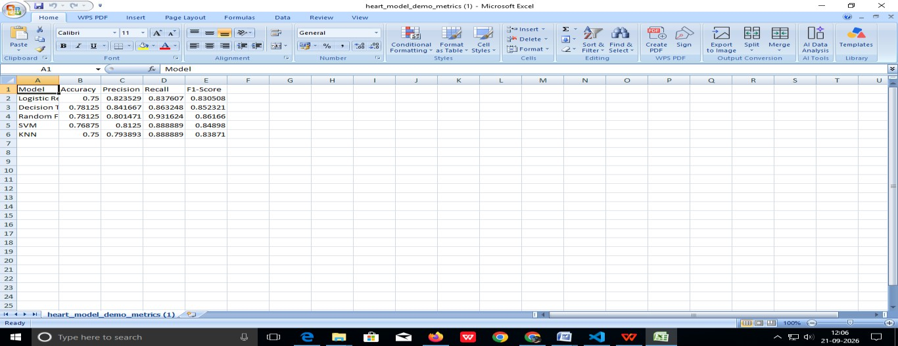
Figure 3.1: Heart Disease Dataset Preview

Result :
The dataset was successfully loaded and inspected. The initial analysis provides information about the records, attributes, data types, and structure of the dataset. This information is used for the subsequent preprocessing steps.

Data Preprocessing
Data preprocessing is an important stage in machine learning because raw data may contain missing values, inconsistent formats, categorical values, or other issues that can affect model performance.

In this project, the dataset is first inspected and then prepared for machine learning. The preprocessing process includes checking the dataset structure, identifying missing values, preparing the features, encoding categorical values where required, and separating the input features from the target variable.

The general preprocessing process is:

Raw Dataset
↓
Data Inspection
↓
Cleaning
↓
Missing Value Handling
↓
Encoding
↓
Feature Preparation
↓
Processed Dataset

Code:
print(df.shape) print(df.info()) print(df.isnull().sum())

Result:
The dataset was inspected successfully and the required preprocessing steps were identified. The processed data is then used for exploratory analysis and machine learning model development.

Handling Missing Values
Missing values can affect the performance of machine learning algorithms. Therefore, missing values are identified before training the models.

Data Encoding and Feature
Preparation Machine learning algorithms generally require numerical input values.
Therefore, categorical attributes are converted into suitable numerical representations when necessary.

After preprocessing, the dataset is divided into input features and the target variable.
The input features represent the patient health parameters, while the target variable represents the heart disease class.

Exploratory Data Analysis (EDA)

Exploratory Data Analysis is performed to understand the characteristics and distribution of the dataset. EDA helps identify patterns, relationships, distributions, and possible anomalies in the data.

The following visualizations are used during the analysis:

- Target class distribution
- Age distribution
- Cholesterol distribution
- Maximum heart rate distribution
- Resting Blood Pressure Distribution
- Chest Pain Type Distribution
- Gender Distribution
- Fasting Blood Sugar Analysis
- Exercise-Induced Angina Analysis
- Correlation Analysis
- Feature-Wise Comparison with Target Variable
- Key Findings from Exploratory Data Analysis
- Chest pain type distribution
- Box plots
- Correlation heatmap

Feature Selection
Feature selection is performed to identify the attributes that are useful for predicting heart disease.
Important features may include:
- Age
- Sex
- Chest pain type
- Resting blood pressure
- Cholesterol
- Fasting blood sugar
- Resting ECG
- Maximum heart rate
- Exercise-induced angina
- Oldpeak
- Slope
- Major vessels
- Thalassemia
Feature selection helps reduce unnecessary information and provides the machine learning model with suitable predictive attributes.

Train-Test Split
After preprocessing, the dataset is divided into:

Training Dataset
Used to train the machine learning models.

Testing Dataset
Used to evaluate the trained models on previously unseen data.

Workflow
Heart Disease Dataset
↓
Preprocessed Dataset
↓
Feature Matrix + Target
↓
Train-Test Split
↙ ↘
Training Data Testing Data

Model Training
↓
Prediction
↓
Evaluation

Machine Learning Model Development
Multiple classification algorithms are considered to develop the heart disease prediction system. Using multiple models allows their performance to be evaluated and compared.
The following algorithms are used:

Logistic Regression
Logistic Regression is a classification algorithm used to predict the probability of a class. It is suitable for binary classification problems.

Decision Tree
Decision Tree uses a tree-based structure to make predictions by applying a sequence of decision rules

Random Forest
Random Forest combines multiple decision trees and uses their collective predictions to produce the final classification.

Support Vector
MachineSupport Vector Machine attempts to find a suitable decision boundary that separates different classes.

K-Nearest Neighbors
KNN classifies a new instance based on the classes of its nearest neighboring data points. Result
Five machine learning classification approaches were selected for development and comparison in the heart disease prediction system

Model Evaluation
The trained models are evaluated using:

Accuracy
Measures the proportion of total predictions that are correctly classified.

Precision
Measures how many observations predicted as positive are actually positive.

Recall
Measures how many actual positive observations are correctly identified.

F1-Score
Combines precision and recall into a single metric.

Confusion Matrix
Shows:
- True Positive
- True Negative
- False Positive
- False Negative

These evaluation measures are also specified in the uploaded case-study format.

Model Comparison

Table 3.4: Performance Comparison of Machine Learning Models
:
Model | Accuracy | Precision | Recall | F1-Score
Logistic Regression | 0.75000 | 0.823529 | 0.837607 | 0.830508
Decision Tree | 0.78125 | 0.841667 | 0.863248 | 0.852321
Random Forest | 0.78125 | 0.801471 | 0.931624 | 0.861660
SVM | 0.76875 | 0.812500 | 0.888889 | 0.849800
KNN | 0.75000 | 0.793893 | 0.888889 | 0.838710

Hyperparameter Tuning

Hyperparameter tuning is performed to identify suitable parameter combinations for the selected machine learning model. Grid Search with Cross-Validation can be used to systematically evaluate different parameter combinations.

Model Serialization

After selecting and tuning the final model, the trained model is saved using model serialization. Serialization allows the trained model to be reused without training it again whenever a prediction is requested by the web application.

Workflow:

Training
↓
Evaluation
↓
Tuning
↓
Final Model
↓
Serialization

This allows the web application to load the trained model without retraining it for every prediction.

Django Web Application
A Django-based web application is developed to provide an interface for the Heart Disease Prediction System.
Application Workflow User
↓
Web Interface
↓
Django Backend
↓
Input Validation
↓
Data Preprocessing
↓
Trained Heart Disease Model
↓
Prediction
↓
Result

User Registration and Login

The registration module allows a new user to create an account by entering the required details. The submitted information is validated before it is stored. Registration provides the basic identity needed to associate prediction records with a user.
The login module verifies the credentials of a registered user. After successful authentication, the user

During registration, a new user provides details such as name, email address, username, and password. The system validates the submitted information before creating the account. Validation helps ensure that required fields are completed correctly and that duplicate accounts are not created.
Passwords are stored securely using appropriate password-hashing mechanisms rather than storing them directly in plain text. This provides an additional layer of security for user credentials.
The login module allows registered users to authenticate themselves using their credentials. When the user submits the login form, the system verifies the provided information against the registered account details. If the credentials are valid, an authenticated session is created and the user is redirected to the appropriate dashboard or home page.
After successful login, users can access protected features such as:
- Heart disease prediction form
- Prediction history
- Previous prediction results
- User profile/account information
- Dashboard
- Logout functionality

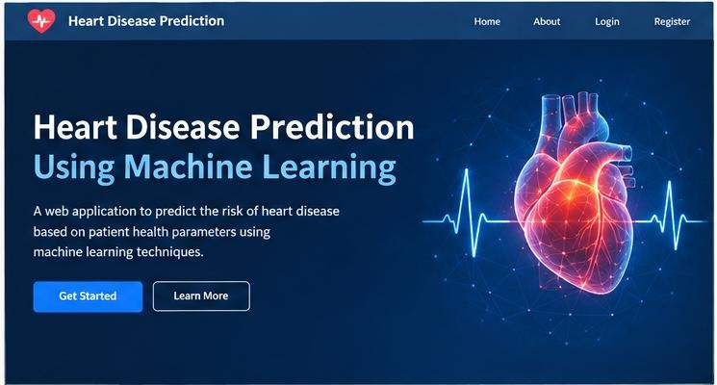

Figure 3.2: Heart Disease Prediction Home Page

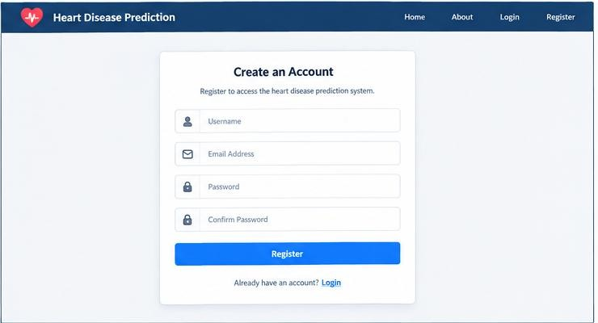

Figure 3.3 : User Registration Page

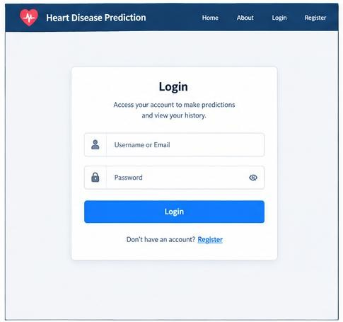
Figure 3.4: User Login Page

Result:
The registration and authentication functionality was implemented successfully, allowing users to access the prediction system through authenticated sessions.

Heart Disease Prediction Module

The Heart Disease Prediction Module is the central component of the application. It is responsible for accepting patient-related parameters, processing the input data, and generating a heart disease prediction using the trained machine learning model.

Prediction Process

Patient Parameters
↓
Input Validation
↓
Data Formatting
↓
Data Preprocessing
↓
Load Trained Model
↓
Generate Prediction
↓
Display Result

The system collects the required patient parameters through the web interface. The entered data is first validated and formatted into the required structure. It is then preprocessed using

the same preprocessing steps applied during model training. After preprocessing, the trained machine learning model is loaded and used to generate the prediction.

The prediction result is displayed to the user through the web interface in a simple and understandable format, such as:
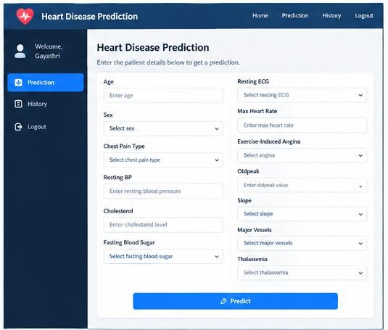
Figure 3.5: Heart Disease Prediction Input Page

Possible application outputs are:

- Heart Disease Detected
- No Heart Disease Detected

The prediction result can also be associated with the currently logged-in user and stored in the database along with the relevant prediction details. This allows the user to access their previous prediction records through the prediction history module.
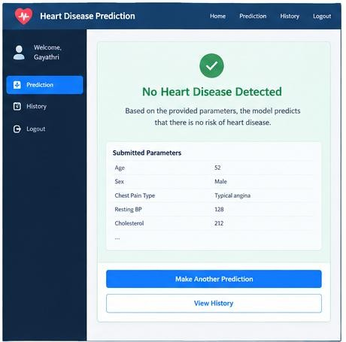

Figure 3.6 : Heart Disease Prediction Result Page

Result:
The prediction module successfully accepts the required patient parameters and generates a preliminary machine-learning prediction using the trained model.

Database Module
A database can be used to store application-related information. The database may contain:
    - User information
    - Patient input parameters
    - Prediction results
    - Prediction date/time
    - Prediction history

Frontend Development
The frontend of the application is developed using HTML5, CSS3, and JavaScript.
The frontend provides a user-friendly interface for interacting with the application. The main frontend :
    - Home Page
    - Registration Page
    - Login Page
    - Prediction Input Page
    - Prediction Result Page
    - Prediction History Page

HTML is used to structure the pages, CSS is used for styling, and JavaScript can be used for client-side interactions and validation.

Result:
A simple and user-friendly frontend interface was developed to allow users to interact with the heart disease prediction system.

Backend Development
The backend is developed using Python and Django. It handles application requests, user authentication, input validation, model loading, prediction processing, and database operations.
The major backend responsibilities include:
    - Processing user requests
    - Managing authentication
    - Validating patient inputs
    - Loading the trained model
    - Preparing model inputs
    - Generating predictions
    - Storing prediction records
    - Retrieving prediction history

Result
The Django backend successfully connects the frontend, machine learning model,
and database components.

Debugging Process

Identify Error
↓
Reproduce Error
↓
Locate Source
↓
Correct Code
↓
Retest
↓
Verify Functionality

Testing and Debugging

Testing is performed to verify that each module of the application works correctly and that the complete system functions as expected.

The following areas are tested:

    - User registration
    - User login
    - User logout
    - Input validation
    - Prediction generation
    - Database storage
    - Prediction history
    - Unauthorized access
    - Frontend navigation
    - Complete end-to-end operation

The debugging process involves identifying errors, reproducing the issue, locating the cause, correcting the implementation, and testing the application again.

Testing Results

Table 3.5: Testing Results

Test Case | Expected Result | Actual Result | Status
User Registration | Account should be created | Account was created successfully | Pass
User Login | User should be authenticated | User was authenticated successfully | Pass
Invalid Input | Validation message should appear | Validation message was displayed | Pass
Patient Prediction | Prediction should be generated | Prediction was generated successfully | Pass
Database Storage | Prediction should be stored | Prediction was stored successfully | Pass
Prediction History | Previous records should  appear | Previous prediction records  were displayed | Pass
User Logout | Session should terminate | User session was terminated successfully | Pass
Unauthorized Access | Access should be restricted | Unauthorized access was restricted | Pass

Result
Deployment testing verifies the overall functionality and integration of the
application before final documentation and demonstration

3.24 Integration of Project Modules

The project consists of multiple modules that are integrated to form a complete heart disease prediction system.

Table 3.6: Integration of Project Modules

Module | Function
User Registration | Creates user accounts
Login | Authenticates users
Dashboard | Provides access to application features
Patient Input | Accepts health parameters
Preprocessing | Prepares input data
ML Prediction | Generates prediction
Result Display | Shows prediction result
Database | Stores application data
Prediction History | Displays previous records
Security | Controls authenticated access

The integrated system follows:

Frontend
↓
Django Backend
↓
Preprocessing
↓

ML Model
↓
Prediction
↓
Database
↓
History

Result :

All major modules are integrated to provide a complete end-to-end heart disease prediction applicati

Complete Project Workflow

Problem Identification
↓
Dataset Collection
↓
Dataset Understanding
↓
Data Cleaning
↓
Missing-Value Handling
↓
Data Encoding
↓
Exploratory Data Analysis
↓
Feature Selection
↓
Train-Test Split
↓
Machine Learning Model Training
↓
Model Testing
↓
Model Evaluation
↓
Hyperparameter Tuning
↓
Final Model
↓
Model Serialization
↓
Django Integration
↓
User Authentication
↓
Patient Parameter Input
↓
Heart Disease Prediction
↓
Database Storage
↓
Prediction History
↓
Testing and Security
↓
Deployment Testing
↓
Final Documentation

Major Project Components
The major components of the project are: Table
3.7: Major Project Components

Component | Description
Dataset Module | Provides heart disease data
Preprocessing Module | Cleans and prepares data
EDA Module | Performs data analysis
Feature Module | Prepares selected features
ML Module | Trains classification models
Evaluation Module | Measures model performance
Serialization Module | Saves trained model
Authentication Module | Manages users
Prediction Module | Generates predictions
Database Module | Stores records
History Module | Displays previous predictions
Frontend Module | Provides user interface
Backend Module | Handles application logic

Result:
The project components work together to provide the complete functionality of the heart disease prediction system.

Pseudocode

BEGIN
Load Heart Disease Dataset Preprocess Dataset
Handle Missing Values Encode Categorical Data Select Features
Perform EDA
Split Data into Training and Testing Sets Train ML Models
Logistic Regression Decision Tree Random Forest SVM
KNN
Test Models
Calculate Accuracy, Precision, Recall and F1-Score Compare Models
Tune Selected Model if Required Save Final Model
Start Django Application User Registration and Login Accept Patient Parameters Validate and Preprocess Input Load Saved Model
Generate Prediction IF Prediction = 1
Display "Heart Disease Detected" ELSE
Display "No Heart Disease Detected" END IF
Store Prediction in Database Display Prediction History Test and Verify Application END

Limitations
Although the proposed system provides a machine learning-based preliminary prediction, it has certain limitations.

- The performance of the system depends on the quality and characteristics of the dataset used for training.
- The model may not generalize equally to all patient populations or healthcare environments.
- The prediction generated by the system is a preliminary machine-learning prediction and should not be considered a medical diagnosis.
- The accuracy of the prediction can be affected by incorrect or incomplete patient information.
- Dataset imbalance, noisy data, and variations in data distribution may affect model performance.
- The developed system is primarily intended for academic and preliminary decision-support purposes.
- Extensive independent validation would be required before considering the system for real-world clinical use.
- Machine learning models may not always provide an easily understandable explanation for every individual prediction.

3.28 Future Enhancements
Future versions can include:
- Larger and more diverse heart disease datasets
- Additional feature engineering
- More machine learning algorithms
- Advanced hyperparameter optimization
- Explainable AI for prediction interpretation
- Graphical visualization of patient parameters
- Improved prediction-history analysis
- Scalable database
- Cloud deployment
- Healthcare-data privacy mechanisms
- Independent dataset validation

CHAPTER 4

ACTIVITY LOG

ACTIVITY LOG FOR THE INTERSHIP

Week No | Date | Brief description  of the  Daily activity | Learning Outcome | Guide/ Mentor  Signature
Week 1 | 04-05-2026  to  09-05-2026 | Internship orientation, project discussion, and requirement analysis. | Understood project requirements and
 |  |  | AI/MLbasics.
Week 2 | 11-05-2026  to  16-05-2026 | Studied Python and collected/understood the Heart Disease dataset. | Studied Python and  collected/understood the Heart
 |  |  | Disease dataset.
Week 3 | 18-05-2026  to  23-05-2026 | Data preprocessing and exploratory data analysis. | Learned data cleaning and  EDA.
Week 4 | 25-05-2026  to  30-05-2026 | Feature selection and ML model training. | Learned feature selection and model training.
Week 5 | 01-06-2026  to  06-06-2026 | Model testing, evaluation, and comparison. | Learned ML evaluation  techniques.
Week 6 | 08-06-2026  to  13-06-2026 | Hyperparameter tuning and model integration preparation. | Learned model optimization  and serialization.
Week 7 | 15-06-2026  to  20-06-2026 | Developed Django web application and database modules. | Learned Django and database integration.
Week 8 | 22-06-2026  to  25-06-2026 | Testing, debugging, documentation, and project demonstration. | Improved testing, debugging, and presentation skills.

CHAPTER 5

CONCLUSION

Conclusion
The project “Heart Disease Prediction Using Machine Learning” was developed as a machine learning-based web application for preliminary prediction of heart disease from selected patient health parameters. The project covers the complete development process, beginning with dataset collection and understanding, followed by preprocessing, missing-value handling, feature preparation, exploratory data analysis, and feature selection.

Multiple machine learning classification algorithms were considered, including Logistic Regression, Decision Tree, Random Forest, Support Vector Machine, and K-Nearest Neighbors. The models were trained and evaluated using suitable performance metrics such as accuracy, precision, recall, F1-score, and confusion matrix. Model tuning and serialization were also included as part of the machine learning development process.

The trained model was integrated into a Django-based web application. The application provides user registration, login, patient parameter input, heart disease prediction, database storage, and prediction history. The integration of the machine learning model with the web application provides a complete system through which users can enter the required parameters and receive a preliminary prediction.
Overall, the project provided practical experience in Python programming, data preprocessing, machine learning, data visualization, model evaluation, Django web development, database management, testing, debugging, and system integration. The developed application demonstrates how machine learning can be combined with web technologies to create a practical healthcare-oriented academic application. However, the prediction should be treated only as a preliminary machine-learning output and not as a replacement for professional medical diagnosis

References

- Janosi, A., Steinbrunn, W., Pfisterer, M., & Detrano, R. (1989). Heart Disease Dataset. UCI Machine Learning Repository. DOI: 10.24432/C52P4X.This is especially important if your project uses the Cleveland Heart Disease dataset. The UCI repository lists 303 instances and 13 commonly used predictive features.
UCI Heart Disease Dataset
- Shinde, P., Sanghavi, M., & Tran, T. A. (2025). A Survey on Machine Learning Techniques for Heart Disease Prediction. SN Computer Science, 6, 334.Springer article

- Kumar, S., Garg, R., Kaur, J., Johar, A., Singh, et al. (2025). A comprehensive review of machine learning for heart disease prediction: challenges, trends, ethical considerations, and future directions. Frontiers in Artificial Intelligence, 8, 1583459. DOI: 10.3389/frai.2025.1583459. PubMed article

- Azmi, J., Arif, M., Nafis, M. T., Alam, M. A., Tanweer, S., & Wang, G. (2022). A systematic review on machine learning approaches for cardiovascular disease prediction using medical big data. Medical Engineering & Physics, 105, 103825. DOI: 10.1016/j.medengphy.2022.103825.
- Wan, S., Wan, F., & Dai, X.-j. (2025). Machine learning approaches for cardiovascular disease prediction: A review. This review discusses ML algorithms, preprocessing, cross-validation, evaluation metrics, interpretability, and ethical considerations in cardiovascular prediction.

Student Self Evaluation of the Short-Term Industry Internship
Student Name: Javvaji Shalini
Registration No: 249X5A05U1
Term Of Internship: From 04-05-2026 To25-06-2026
Date of Evaluation:
Organization Name & Address: Intel Unnati GPREC
Name of the Mentor/Guide: Sri. J.Swami Naik, Associate Professor, GPREC
Mobile Number: 7337411605

Please rate your performance in the following areas:

Rating Scale: Letter grade of CGPA calculation to be provided
- Oral communication | 1 | 2 | 3 | 4 | 5
2) Written communication | 1 | 2 | 3 | 4 | 5
3) Initiative | 1 | 2 | 3 | 4 | 5
4) Interaction with staff | 1 | 2 | 3 | 4 | 5
5) Attitude | 1 | 2 | 3 | 4 | 5
6) Dependability | 1 | 2 | 3 | 4 | 5
7) Ability to learn | 1 | 2 | 3 | 4 | 5
8) Planning and organization | 1 | 2 | 3 | 4 | 5
9) Professionalism | 1 | 2 | 3 | 4 | 5
10) Creativity | 1 | 2 | 3 | 4 | 5
11) Quality of work | 1 | 2 | 3 | 4 | 5
12) Productivity | 1 | 2 | 3 | 4 | 5
13) Progress of learning | 1 | 2 | 3 | 4 | 5
14) Adaptability to organization’s culture/policies | 1 | 2 | 3 | 4 | 5
15) Overall Performance | 1 | 2 | 3 | 4 | 5

Signature of the Student

Evaluation by the Mentor/Guide of the Industry Internship
Student Name: Javvaji Shalini
Registration No: 249X505U1
Term of Internship: From: 04-05-2026 To 25-06-2026
Date of Evaluation:
Organization Name & Address: Intel Unnati GPREC
Name of the Mentor/Guide: Sri. J. Swami Naik Associate Professor, GPREC
Mobile Number: 7337411605

Please rate the student’s performance in the following areas:
Please note that your evaluation shall be done independent of the Student’s self evaluation
Rating Scale: 1 is lowest and 5 is highest rank

Rating Scale: Letter grade of CGPA Calculation to be Provided
- Oral communication | 1 | 2 | 3 | 4 | 5
2) Written communication | 1 | 2 | 3 | 4 | 5
- Initiative | 1 | 2 | 3 | 4 | 5
- Interaction with staff | 1 | 2 | 3 | 4 | 5
- Attitude | 1 | 2 | 3 | 4 | 5
- Dependability | 1 | 2 | 3 | 4 | 5
7) Ability to learn | 1 | 2 | 3 | 4 | 5
8) Planning and organization | 1 | 2 | 3 | 4 | 5
9) Professionalism | 1 | 2 | 3 | 4 | 5
10) Creativity | 1 | 2 | 3 | 4 | 5
11) Quality of work | 1 | 2 | 3 | 4 | 5
12) Productivity | 1 | 2 | 3 | 4 | 5
13) Progress of learning | 1 | 2 | 3 | 4 | 5
14) Adaptability to organization’s culture/policies | 1 | 2 | 3 | 4 | 5
15 ) Overall Performance | 1 | 2 | 3 | 4 | 5

Signature of the Mentor /Guide

