1. **Purpose**

Purpose

1. **Scope**

Socpe

1. **Background**
   1. The RF20000 Controller is ArthroCare next generation controller.
2. **Standards**
3. **Equipment**
4. **Materials**
   1. N/A
5. **Procedure**

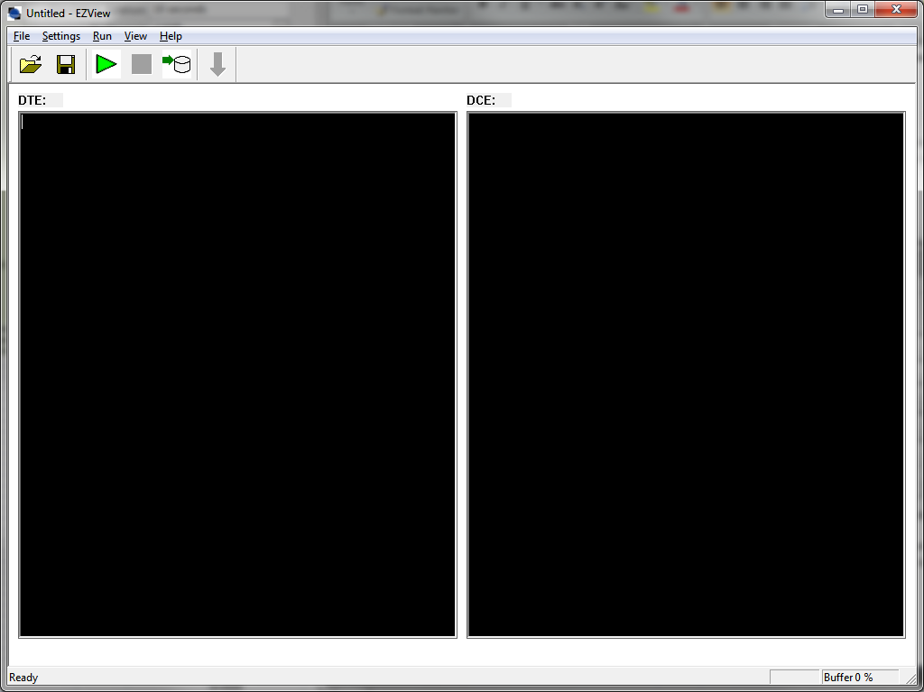

* 1. Testing
     1. Testing procedure and requirements are defined on the following test cases.

1. **Software Version**

| **Step #** | **Requirement Element** | **Test Step** | **Result** | **Tester Initial/Date** |
| --- | --- | --- | --- | --- |
|  | **N/A** | Step 1 | Result 1 |  |
|  | **N/A** | Step 2 | Result 2 |  |
|  | **XXX315** | Step 3 | Result 3 |  |

1. **Wand Connection**

| **Step #** | **Requirement Element** | **Test Step** | **Result** | **Tester Initial/Date** |
| --- | --- | --- | --- | --- |
|  | **N/A** | Step 1 | Result 1 |  |
|  | **N/A** | Step 2 | Result 2 |  |
|  | **XXX316** | Step 3 | Result 3 |  |

1. **Acceptance Criteria**

The acceptance criterion for the test protocol is to ensure the expected outputs are the result of the predefined inputs and potential failure modes. Any issues identified during the testing which may result in changes to the system hardware and/or software will require a repeat of this test protocol with or without modification depending on the nature of the system modifications.

1. **Reference Documents**
2. **Forms**
3. **Appendices**