Jaewoo.choi

55532

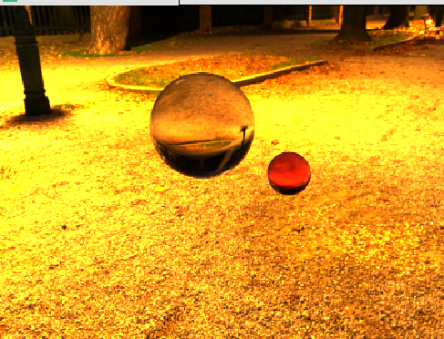

4096 trace

There is only Image based lighting with two Transmission BSDF and MIS weights.

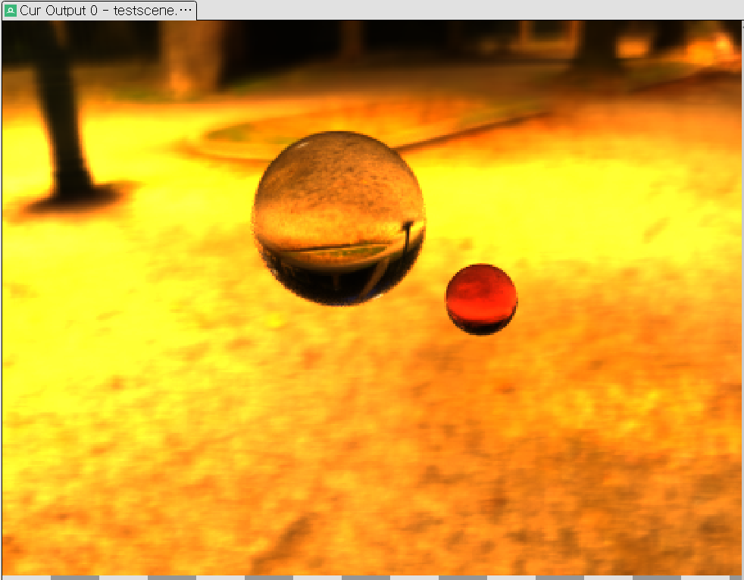

4096 trace

Image based lighting with two Transmission BSDF and MIS weights.

Also there are depth of field in backGround.

4096 trace

Image based lighting with two Transmission BSDF and MIS weights.

Also there are depth of field in backGround and red one.