MAT 300 Homework 8
Jaewoo.choi
First Name : Jaewoo

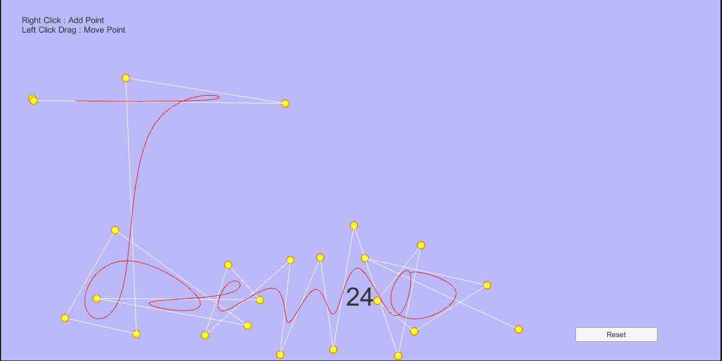
Degree 3
Knot Sequence J : [0,1,2,3,4,5,6,7,8,9,10 ]
Knot Sequence a : [11,12,]
Knot Sequence e : [14,15,16]
Knot Sequence w : [17,18,19,20 ]
Knot Sequence o : [21,22,23,24 ]
Knot Sequence o : [25,26,27 ]

virtual public void RenderLines1(List<Vector3> points, Color color)
{
int size_ = points.Count;
List<Vector3> result = new List<Vector3>();

float a = KnotSequence[Degree];
float b = KnotSequence[N - Degree - 1];

if (Degree < size_ && size_ < (N - Degree))
for (float i = a; i < b; i += 0.1f)
{
J = FindJ(KnotSequence, i);
result.Add(P_d_J(i, KnotSequence, (int)J, Degree, Degree));
}

GL.Begin(GL.LINES);
material.SetPass(0);

for (int i = 0; i < result.Count - 1; i++)
{
GL.Color(Color.red);
GL.Vertex(result[i]);
GL.Vertex(result[i + 1]);
}
GL.End();
}

public float FindJ(List<float> Knot, float tVal)
{
for (int i = 0; i < Knot.Count - 1; i++)
{
if (Knot[i] <= tVal && tVal < Knot[i + 1])
return i;
}
return 0;
}

public Vector3 P_d_J(float t, List<float> t_i, int index_, int d, int k)
{
if (k == 0)
{
if (index_ < 0 || index_ >= points.Count)
return new Vector3(0, 0, 0);
return points[index_];
}

Vector3 left = ((t - t_i[index_]) / (t_i[index_ + d - (k - 1)] - t_i[index_])) * P_d_J(t, t_i, index_, d, k - 1);
Vector3 right = ((t_i[index_ + d - (k - 1)] - t) / (t_i[index_ + d - (k - 1)] - t_i[index_])) * P_d_J(t, t_i, index_ - 1, d, k - 1);

return left + right;
}

