ASSIGNMENT
Solve a Real-Life Problem Using AI Tools
Practical AI Skills
Student Name | Nafeesa batool
Class / Section | Ai class
Submission Date | 20 april
Topic Selected | Weak healthcare system

Step 1: Choose a Real-Life Problem
Write your chosen problem here: weak healthcare system in quetta

Step 2: Use at Least 3 AI Tools
ChatGPT
Google Gemini
Canva AI

AI Tool Used | Prompt You Wrote | Result You Got
ChatGPT | 1: why the healthcare system in quetta is weak and how it affects people's lives? also explain the causes, problems and possible solution.  2: design a awareness poster on 'weak healthcare system in quetta' show over crowded hospitals, tired docters, patients waiting. add bold title 'SAVE HEALTHCARE IN QUETTA'. use red and blue colors, modern design and a clear message. | 🏥 Why healthcare in Quetta is weak  - Few hospitals and clinics  - Lack of modern equipment and medicines  - Shortage of doctors and nurses  - Poverty and expensive treatment  - Poor management and low funding  ⚠️ Main problems  - Long waiting times  - Overcrowded hospitals  - Poor quality treatment  - Weak emergency services  - People must travel to other cities  👥 Effects on people’s lives  - Increased illness and deaths  - High financial burden on families  - Delayed treatment makes diseases worse  - Poor people suffer the most  💡 Possible solutions  - Build more hospitals and improve facilities  - Hire and train more medical staff  - Provide free or low-cost treatment  - Ensure availability of medicines  - Use telemedicine for remote areas  - Increase government funding and management  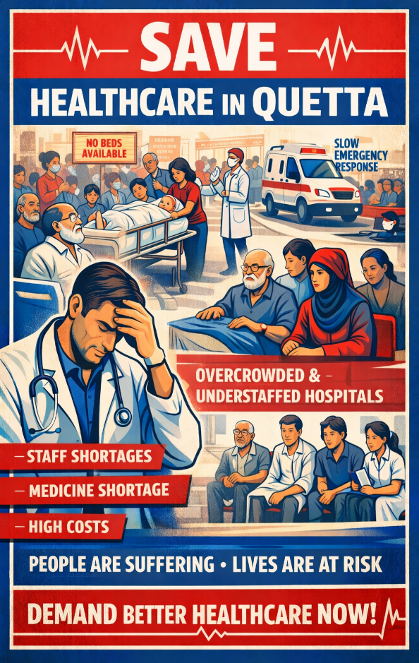
Google Gemini | 1: discuss the problems of the healthcare system in Quetta including its causes, effects on citizens and solution.  2: design a awareness poster on 'weak healthcare system in quetta' show over crowded hospitals, tired docters, patients waiting. add bold title 'SAVE HEALTHCARE IN QUETTA'. use red and blue colors, modern design and a clear message. | 🚩 Core Problems & Their Causes  - Geographic & Resource Strain: Being the only major medical hub for a vast, sparsely populated province, Quetta's hospitals are overwhelmed by patients traveling from remote districts.  - Infrastructure Deficit: Major public hospitals like Civil Hospital and Bolan Medical Complex (BMC) suffer from outdated or non-functional equipment (CT scans, MRIs) and frequent shortages of life-saving medicines.  - Human Resource Gap: There is a critical shortage of doctors and nursing staff. Many professionals avoid the region due to security concerns or a lack of career incentives, leading to "absenteeism."  - Security Challenges: Recurrent terrorism-related events (such as the attacks in early 2026) place an exceptional sudden burden on trauma centers and medical staff.  📉 Effects on Citizens  - High Mortality: Lack of localized care leads to high maternal and infant mortality rates during the long journey to Quetta.  - Financial Ruin: Patients are often forced to buy their own surgical supplies and medicines from private pharmacies because public stocks are empty.  - Trust Deficit: Citizens often resort to expensive private clinics or travel to Karachi for treatment due to poor service quality in state-run hospitals.  ✅ Recent Solutions & Reforms (2025–2026)  - Health Insurance Policy 2026: Launched in March 2026, this policy provides government employees with up to 1 million PKR in annual coverage for treatment at top-tier hospitals.  - Telemedicine & Digitization: In collaboration with SUPARCO, the government is connecting 1,500 health centers via satellite to provide remote consultations, reducing the need for travel to Quetta.  - Public-Private Partnerships: New collaborations with private medical institutes (like the Aria Institute) aim to treat life-threatening diseases like cancer within the province.  - Staffing Reforms: Over 600 medical officers were recently promoted to fill vacant specialist slots, and stricter accountability measures have been introduced to curb doctor absenteeism.  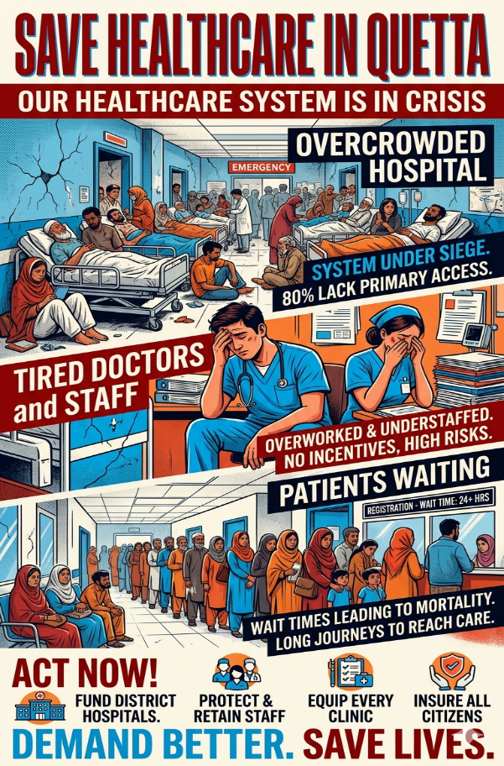
Canva Ai | 1: why the healthcare system in quetta is weak and how it affects people's lives? also explain the causes, problems and possible solution.  2: : design a awareness poster on 'weak healthcare system in quetta' show over crowded hospitals, tired docters, patients waiting. add bold title 'SAVE HEALTHCARE IN QUETTA'. use red and blue colors, modern design and a clear message. | Main Causes:  - Severe underfunding and resource allocation issues  - Geographic challenges (vast, remote areas)  - Shortage of trained medical professionals  - Poor governance and policy implementation  - Rapid population growth outpacing infrastructure  Key Problems:  - Infrastructure: Outdated equipment, limited hospitals, overcrowded facilities (Civil Hospital handles far more patients than capacity)  - Medicine Shortages: Essential drugs unavailable in public hospitals; patients forced to buy from expensive private pharmacies  - Staff Shortage: Lack of qualified doctors and nurses leading to misdiagnosis  - Accessibility: Over 80% of Balochistan's population lacks primary healthcare access  - High Costs: Unaffordable private healthcare; ineffective health card programs  Impact on People's Lives:  - Patients travel to other cities for basic treatment, causing delays in emergencies  - Poor families cannot afford private care or medicines  - Increased mortality rates, especially for women and children  - Misdiagnosis and inadequate treatment due to staff/equipment shortages  - Financial burden pushing families into poverty  Possible Solutions:  - Increase Budget: Allocate more funds specifically for healthcare infrastructure  - Incentivize Staff: Offer better salaries and benefits to attract qualified medical professionals  - Mobile Clinics: Deploy mobile healthcare units to remote areas  - Equipment Upgrades: Modernize diagnostic and treatment facilities  - Medicine Supply Chain: Ensure consistent availability of essential drugs in public hospitals  - Public-Private Partnerships: Collaborate to expand affordable healthcare access  - Training Programs: Establish local medical training centers to build workforce  - 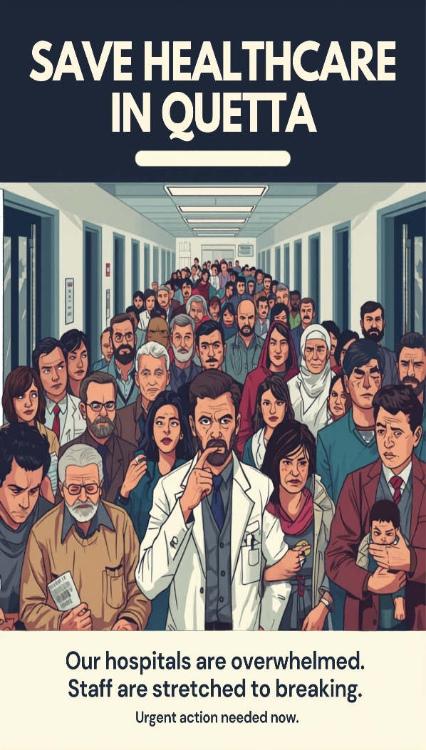

Step 3: creating my final output as 1-page PDF summarizing your problem, tools and results.

Submission Structure
- The problem I selected and why I chose it?
Because healthcare is a basic human need, but many people in Quetta still face difficulties in getting proper treatment. Many people travel to karachi for better medical treatment.
- The AI tools you used
ChatGPT, Google Gemini, Canva
- The prompts you wrote for each tool
Already mentioned
- The output generated by each tool
Mentioned.
- What you learned from using AI for this task
I’ve learned that AI tools like ChatGPT, Gemini and Canva help in writing, designing and making my work easier.
- One limitation of AI that you noticed during the process
One limitation I noticed is “AI sometimes gives incomplete information, so still needs human checking.

Critical Thinking Questions
Answer these three questions in your submission. There is no single right answer. You will be graded on how well you explain your reasoning.

- Was the AI always correct? Give an example of something it got right and something it got wrong.
no AI isn’t always correct.AI correctly helped me create a better poster, Sometimes AI added extra details that were not needed for my task.
- Did you need to edit or improve any of the AI output? What changes did you make and why?
Yes, i needed to edit and improve some AI output. I removed extra or unnecessary points that ere not needed for my task.
- Do you think AI could fully replace a human doing this task? Explain your answer.
No AI is helpful for correcting grammar, creating posters etc but humans are still needed to make sure.

Bonus Challenge (Optional)
For extra credit: Give the exact same prompt to two different AI tools. Compare the results and explain which one performed better and why. Include both outputs in your submission.
I have done.. i used the same prompt for creating an image for all AI tools (ChatGPT, Gemini, Canva) the results were amazing but i prefer ChatGPT because it is better at understanding instructions and turning ideas into clear. It helped me explain healthcare problems in quetta and gave a perfect image which defines my topic.

