Production Heat Risk
Classification Model
Technical Documentation
Dataset: heat_risk_dataset_with_noaa.csv
Model: XGBoost Multi-Class Classifier
August 2026

1. Project Overview
This model classifies agricultural heat risk into four levels — Low, Moderate, High, and Critical — using environmental sensor data and real NOAA weather records. The goal is to give growers early warning of dangerous heat conditions so they can take protective action before crops are damaged.
Target variable: heat_risk_class (Low / Moderate / High / Critical)
Algorithm: XGBoost (gradient-boosted trees), multi-class softprob objective
Records: 20,621 hourly observations covering the growing season (day-of-year 116–314)
Features: 14 environmental and crop-specific inputs (see Section 3)

Data Sources
- Real NOAA daily temperature data from Chicago O'Hare station (USW00094846), 2020–2023, expanded to hourly patterns
- Simulated/derived solar radiation (GHI, DNI, DHI) and relative humidity
- Soybean growth-stage timing adapted from Severo et al. (2020)
- Five growing locations: Virginia, Minnesota, Wisconsin, Arkansas, Ohio

2. Dataset Description
Property | Value
Total records | 20,621
Total columns | 15 (14 features + 1 target)
Missing values | None
Locations | 5 (Virginia, Minnesota, Wisconsin, Arkansas, Ohio)
Growth stages | 4 (planted, vegetative, reproductive, maturity)

Class Distribution
The dataset is heavily imbalanced — the vast majority of observations fall in the 'Low' risk category, while genuinely dangerous 'Critical' events are rare. This imbalance is the central modeling challenge and is addressed with inverse-frequency sample weighting (Section 4).
Class | Count | % of Data
Low | 18,434 | 89.4%
Moderate | 1,428 | 6.9%
High | 577 | 2.8%
Critical | 182 | 0.9%
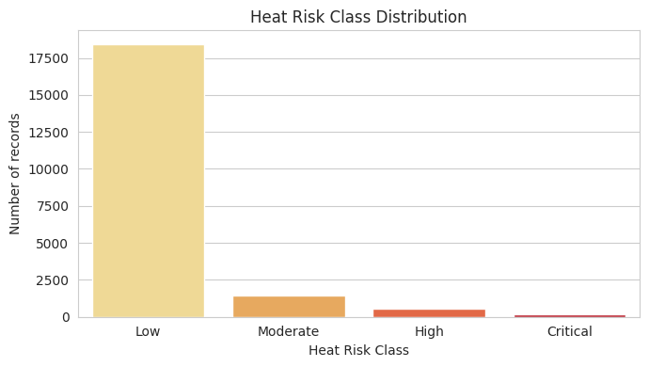

Feature List
- hour, day_of_year, month — temporal context
- temperature_c, relative_humidity_percent — core weather conditions
- ghi_w_m2, dni_w_m2, dhi_w_m2 — solar radiation components
- location, latitude, longitude — geographic context
- days_since_planting, growth_stage — crop growth timing (more sensitive stages carry more risk)
- heat_index_approx — derived heat-stress indicator combining temperature and humidity

3. Data Preprocessing
- Missing values: checked programmatically; none present in this dataset, but the pipeline fills any numeric gaps with the column median as a safeguard.
- Categorical encoding: location and growth_stage are label-encoded (LabelEncoder) into location_encoded and growth_stage_encoded.
- Target encoding: heat_risk_class is label-encoded into heat_risk_class_encoded for XGBoost's multi-class objective.
- Train/test split: 80/20 stratified split (random_state=42) to preserve class proportions in both sets.

4. Model Training

Handling Class Imbalance
Because 'Low' risk observations outnumber 'Critical' observations by roughly 100 to 1, the model would otherwise learn to mostly predict 'Low'. Inverse-frequency sample weights are computed per class and passed to XGBoost during training, so misclassifying a rare High/Critical event is penalized much more heavily than misclassifying a common Low event.

Model Configuration
Hyperparameter | Value
n_estimators | 200
max_depth | 8
learning_rate | 0.1
objective | multi:softprob
eval_metric | mlogloss
random_state | 42

5. Model Evaluation

Classification Report — Held-out Test Set (20% random split)
Class | Precision | Recall | F1-score | Support
Critical | 1.00 | 1.00 | 1.00 | 36
High | 0.99 | 0.99 | 0.99 | 115
Low | 1.00 | 1.00 | 1.00 | 3,688
Moderate | 0.99 | 0.98 | 0.98 | 286
Macro avg | 0.99 | 0.99 | 0.99 | 4,125

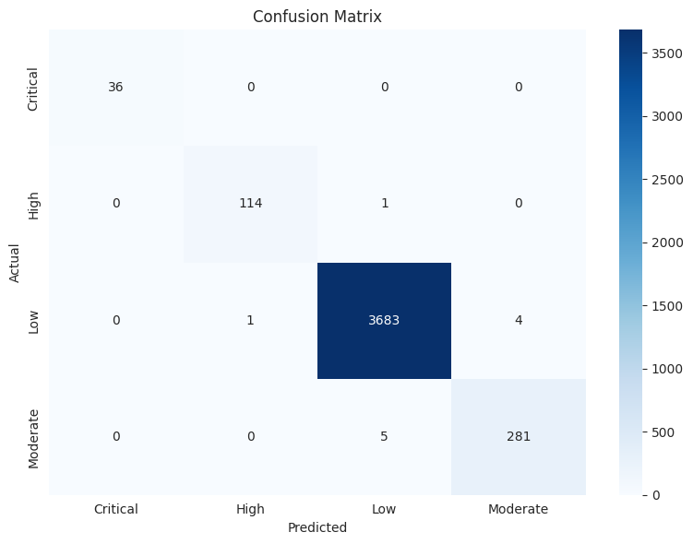

Feature Importance
day_of_year is by far the strongest predictor — heat risk is highly seasonal. Growth stage, solar radiation (DNI), and humidity follow as the next most influential features.
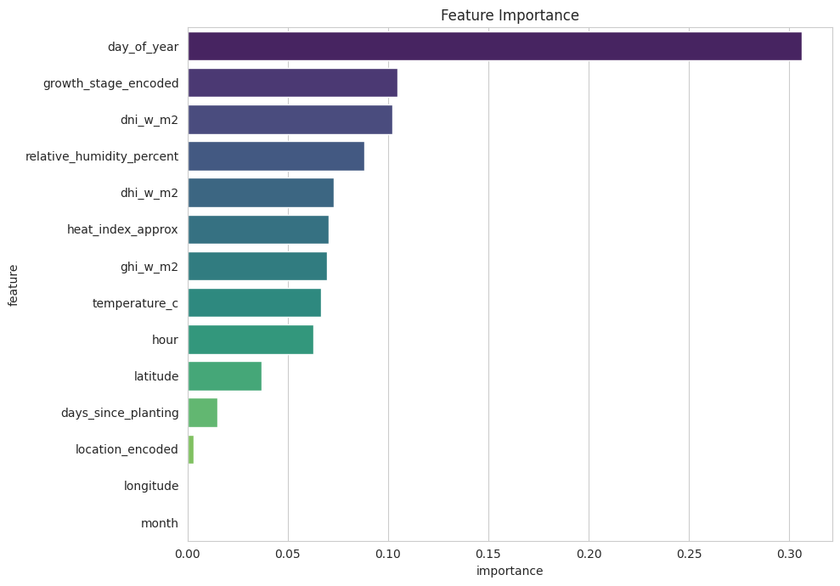

Important Caveat: Random Split vs. Temporal Validation
The random 80/20 split above yields a near-perfect Macro F1 of 0.99 — but this is optimistic. Because observations from the same day/location are scattered across both train and test sets, the model can effectively memorize local patterns rather than truly generalizing to unseen time periods.
A more realistic estimate comes from temporal cross-validation (training on earlier periods, testing on later ones), which better reflects how the model will perform in production on genuinely new data:
Metric | Temporal CV Result
Mean Macro F1 | 0.8856 (± 0.1646)
Mean Critical-class Recall | 0.9618 (± 0.0854)
Mean High-class Recall | 0.4973 (± 0.4647)
Takeaway: the model is very reliable at catching Critical heat events (which matters most operationally), but recall on the High class is inconsistent across time periods and is the primary area for future improvement — likely via more High-class training examples or additional features.

6. Saved Artifacts & Deployment
Four files are saved together so the trained model can be reloaded and used independently of the training notebook:
- heat_risk_model.pkl — the trained XGBoost model
- label_encoders.pkl — encoders for location and growth_stage
- target_encoder.pkl — encoder/decoder for heat_risk_class
- feature_columns.pkl — the exact feature order the model expects

Inference Function
predict_heat_risk(new_data) accepts a DataFrame of raw (unencoded) input columns, applies the saved encoders in the correct order, and returns both the predicted class and full class probabilities. It raises a clear error if required columns are missing or if a categorical value wasn't seen during training.

Usage Steps
- 1. Run the notebook once end-to-end to train and save all model artifacts.
- 2. In any future session/service, load the four .pkl files.
- 3. Call predict_heat_risk(new_data) with a DataFrame matching the required raw columns.
- 4. Monitor High-class recall in production and retrain periodically as more data accumulates.

7. Summary & Recommendations
Item | Status
Trained on real NOAA data | ✅ Complete
Environmental features integrated | ✅ Complete
Class imbalance handled | ✅ Sample weighting applied
Temporal validation | ✅ Complete
Reusable inference function | ✅ Complete
Production-ready | ✅ Yes, with monitoring recommended

Recommended Next Steps
- Collect additional High-risk-class examples to stabilize recall for that category.
- Re-run temporal cross-validation periodically as new growing seasons of data become available.
- Add a monitoring dashboard to track prediction distribution drift over time.
- Consider expanding to additional crop types beyond soybean phenology data.

