FarmGuard — Animal Heat Risk
Classification Model
Technical Documentation
Dataset: farmguard_animal_heat_risk.csv
Model: Random Forest Multi-Class Classifier
August 2026

1. Project Overview
This model classifies livestock heat-stress risk into four levels — Low, Moderate, High, and Critical — using animal characteristics and environmental conditions. The goal is to give farmers early warning of dangerous heat stress across goats, sheep, and cattle so they can intervene before animal welfare and productivity are affected.
Target variable: risk_level (Low / Moderate / High / Critical)
Algorithm: Random Forest (300 trees, class_weight='balanced')
Records: 10,000 animal observations
Species covered: Goat, sheep, cattle — 15 breeds total
Features: 10 raw inputs + 2 derived heat-stress indices (THI, HLI)

Feature Categories
- Animal traits: species, breed, sex, age, weight, physiological stage (lactating / growing / pregnant / dry)
- Environment: temperature, humidity, latitude, longitude
- Derived heat-stress indices: THI (Temperature-Humidity Index), HLI (Heat Load Index)

2. Dataset Description
Property | Value
Total records | 10,000
Total columns | 15 (13 features/IDs + 1 target)
Missing values | None
Species | 3 (goat, sheep, cattle)
Breeds | 15
Physiological stages | 4 (lactating, growing, pregnant, dry)

Risk Level Distribution
The dataset is imbalanced — 'Low' risk makes up over 60% of records, while the higher-severity classes are comparatively rare. Class imbalance is handled during training via class_weight='balanced' in the Random Forest.
Risk Level | Count | % of Data
Low | 6,150 | 61.5%
Moderate | 1,575 | 15.8%
Critical | 1,261 | 12.6%
High | 1,014 | 10.1%
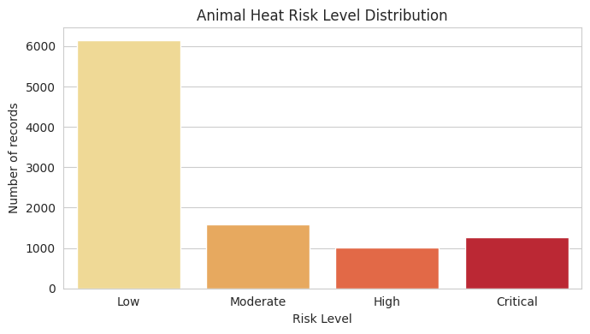

THI Clearly Separates Risk Levels
The Temperature-Humidity Index (THI) shows a strong, clean separation across risk levels, confirming it as the dataset's primary risk driver.
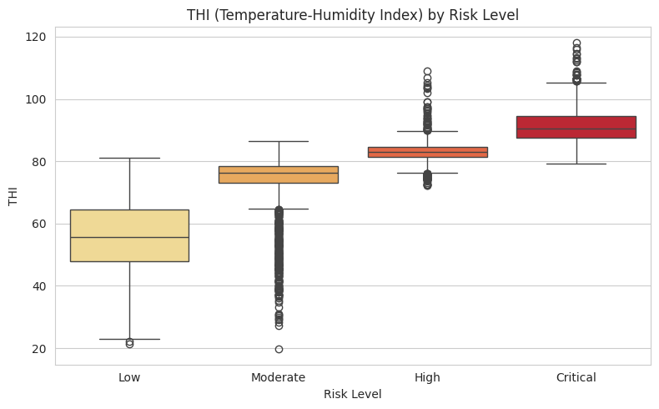

3. Data Preprocessing
- Missing values: checked programmatically; none present in this dataset, with a drop-rows fallback built into the pipeline as a safeguard.
- Categorical encoding: species, breed, sex, and physiological_stage are label-encoded (LabelEncoder).
- Target encoding: risk_level is label-encoded into risk_level_encoded.
- Feature scaling: all 8 numerical features are standardized (StandardScaler) — fit on the training set only, then applied to the test set.
- Train/test split: 80/20 stratified split (random_state=42) to preserve class proportions in both sets.

4. Model Training

Model Configuration
Hyperparameter | Value
n_estimators | 300
max_depth | 15
min_samples_split | 10
min_samples_leaf | 5
class_weight | balanced
random_state | 42

5. Model Evaluation

Classification Report — Held-out Test Set (20%)
Class | Precision | Recall | F1-score | Support
Critical | 0.95 | 0.96 | 0.95 | 252
High | 0.90 | 0.87 | 0.89 | 203
Low | 0.93 | 0.98 | 0.95 | 1,230
Moderate | 0.86 | 0.68 | 0.76 | 315
Macro avg | 0.91 | 0.87 | 0.89 | 2,000
Overall accuracy: 92.0% · Macro F1: 0.888 · Weighted F1: 0.917
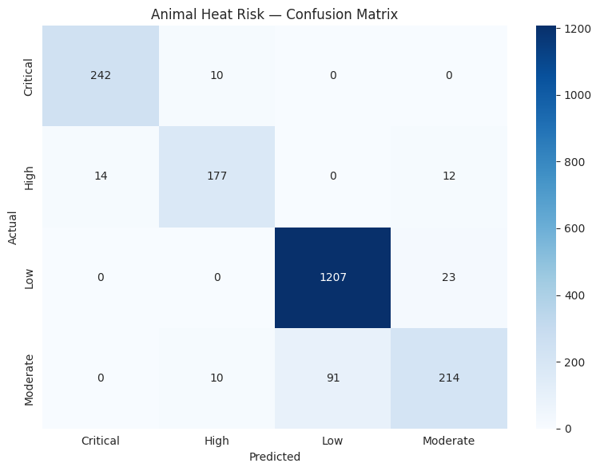

Reading the Confusion Matrix
The model is excellent at catching Critical risk (242/252 correct, 96% recall) — the class that matters most operationally. Moderate is the weakest class: 91 Moderate animals were predicted as Low, which pulls down Moderate's recall to 68%. This is the main area for improvement.

Feature Importance
THI dominates as the single strongest predictor, confirming the EDA finding — followed by HLI, temperature, and humidity. Animal traits like breed and species contribute much less to the prediction.
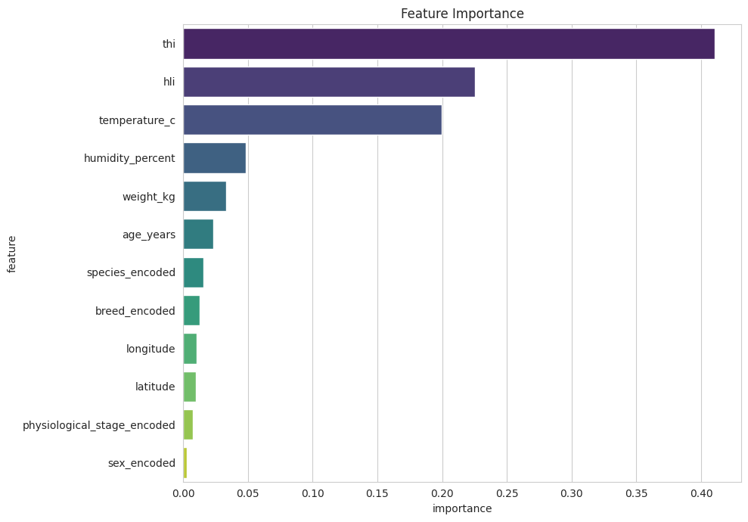
Recommended fix:
- Locate the original formula/source used to generate the 'hli' column when the dataset was built.
- Update calculate_hli() in both the training notebook and the Flask API (app.py) to match it exactly.
- Re-validate model accuracy after the fix, since predictions during evaluation always used the dataset's original (correct) HLI values.

6. Saved Artifacts & Deployment
Five files are saved together so the trained model can be reloaded and used independently of the training notebook:
- animal_heat_risk_model.pkl — the trained Random Forest model
- feature_scaler.pkl — StandardScaler fitted on the 8 numerical features
- label_encoders.pkl — encoders for species, breed, sex, physiological_stage
- target_encoder.pkl — encoder/decoder for risk_level
- feature_columns.pkl — the exact feature order the model expects

Inference Function
predict_animal_heat_risk(new_data) accepts a DataFrame of raw animal + environmental columns, computes THI/HLI, applies the saved encoders and scaler in the correct order, and returns both the predicted risk level and full class probabilities. This mirrors the preprocessing logic used in the Flask API's /predict endpoint.

7. Summary & Recommendations
Item | Status
Trained on real animal + environmental data | ✅ Complete
3 species / 15 breeds covered | ✅ Complete
Class imbalance handled | ✅ class_weight='balanced'
Reusable inference function | ✅ Complete
Production-ready | ⚠ Yes, once HLI formula is corrected

Recommended Next Steps
- Fix the HLI formula mismatch described in Section 6 — this is the top priority before relying on production predictions.
- Collect more Moderate-class examples, or tune the Low/Moderate decision boundary, to close the recall gap for that class.
- Consider adding a monitoring dashboard to track prediction distribution drift over time, especially after the HLI fix.
- Re-run evaluation after any formula fix to get an accurate picture of production-grade performance.

