**Report**

Jawad Ahmad

**Introduction:**

This assignment focuses on building a simple movie recommender system based on popularity. The goal is to identify trending movies for the 'Trending Now' section by sorting the dataset using the 'score' column. This method highlights the most popular movies for recommendations

**Goal:**

The goal is to create a system that suggests trending movies using only their popularity scores. By sorting the dataset based on the 'score' column, we can find and recommend the most popular movies.

**Results:**

The top 10 movies with the highest scores are identified as 'Trending Now.'

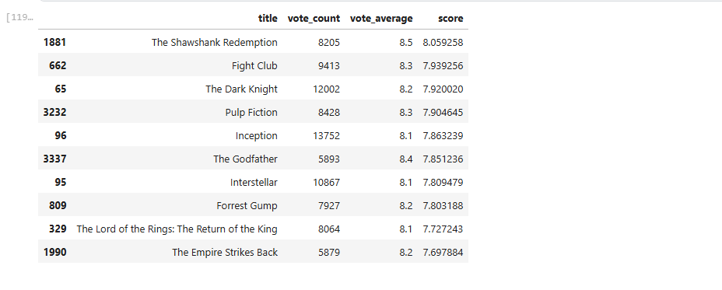

**Display:**

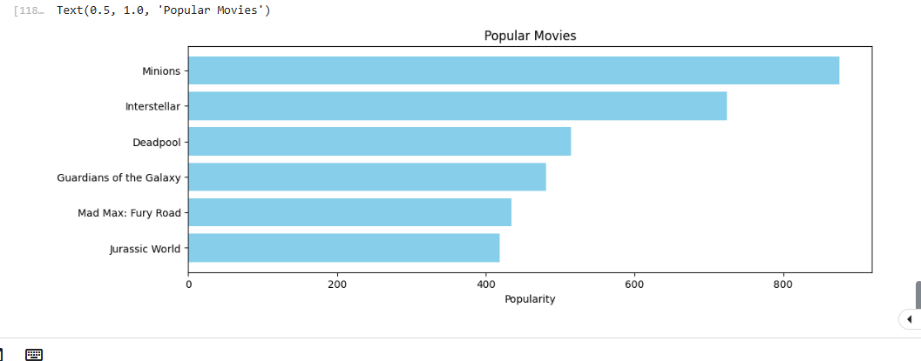

**Analysis:**

The system successfully ranks movies by popularity, making it easier to highlight trending ones.

**Limitations:**

It only uses popularity scores and doesn’t include factors like genres or user preferences.

**Conclusion:**

The recommender system created in this assignment effectively identifies trending movies by organizing the dataset according to the 'popularity' column. It efficiently highlights the most popular movies, making them suitable for display in the 'Trending Now' section.