Dynamic Disaster Relief Database (DDRD)



By

Abdul Razaq

Roll No: 10

Jawad Ahmed

Roll No: 04

Muhammad

Roll No: 22

Supervisor

Toseef Ahmed Abbasi

Lecturer

DEPARTMENT OF COMPUTER SCIENCES & INFORMATION TECHNOLOGY

FACULTY OF SCIENCES

UNIVERSITY AZAD JAMMU & KASHMIR

MUZAFFARABAD

Session: 2023–2027

APPROVAL CERTIFICATE



It is certified that the project work presented in this report entitled **“Dynamic Disaster Relief Database (DDRD)”** given by **Jawad Ahmed**, **Muhammad**, and **Abdul Razaq, of** **Session (2023–2027)** supervised by **Mr. Toseef Ahmed Abbasi**, **Lecturer**, in our opinion is fully adequate in scope and quality for the degree of **Bachelor of Science in Computer Science (BSCS).**

(**Supervisor)**

Toseef Ahmed Abbasi

Lecturer, Department of

CS & IT Neelum Campus

ABSTRACT

The Dynamic Disaster Relief Database (DDRD) is a Django-based web platform designed to streamline coordination in disaster relief efforts. It centralizes management of disaster zones, victims, NGOs, volunteers, and campaigns through a robust PostgreSQL backend and secure REST API. DDRD offers role-based access, real-time analytics, and a structured dashboard to support relief operations. Its responsive design, data encryption, and concurrent user handling ensure a scalable, secure, and efficient solution for disaster management organizations.

**Keywords:** Disaster Management, Django, REST API, PostgreSQL, Real-Time Analytics

UNDERTAKING

We certify that research work titled “Dynamic Disaster Relief Database (DDRD)” is our own work. The work has not been presented elsewhere for assessment. Where material has been used from other sources it has been properly acknowledged / referred.

Signature of Student

Jawad Ahmed

Muhammad

Abdul Razaq

Acknowledgements

We would like to express our deepest gratitude to our supervisor, Mr. Toseef Ahmed Abbasi, Lecturer, for his invaluable guidance and support throughout this project. We are also thankful to the Department of CS & IT, University of Azad Jammu & Kashmir, for providing us with the resources and support necessary to complete our project. Finally, we thank our families and peers for their constant encouragement and patience during this endeavor.

Table of Contents

Introduction 8

1.1 Statement of the Problem 8

1.2 Objectives 8

1.2.1 Centralized Data Management 8

1.2.2 Role-Based Access and User Management 9

1.2.3 Real-Time Communication and Coordination 9

1.2.4 Relief Campaign Management 9

1.2.5 Volunteer Coordination 10

1.2.6 Data Analytics and Decision Support 10

1.2.7 Interoperability with External Systems 10

1.2.8 Scalability and Performance 10

1.3 Organization of the Thesis 11

Feasibility Study 11

2.1 Technical Feasibility 11

2.2 Operational Feasibility 12

2.3 Economic Feasibility 13

Requirements 15

3.1 Functional Requirements 15

3.2 Non-Functional Requirements 17

System Architecture 18

4.1 System Architecture Diagram 18

4.2 Use Case Diagram 19

20

4.3 Class Diagram 20

4.4 Sequence Diagrams 21

4.5 Database Design (ERD / Table Schemas) 23

4.5.1 Database Design (Table Schemas) 24

System GUI 24

Register Page 24

Login Page 25

Admin Dashboard 26

NGO Dashboard 27

Volunteer Dashboard 28

Add Campaign Page 29

Implementation Plan 30

6.1. Technologies and Tools Used 30

6.2. Steps / Milestones 31

Testing 33

Types of Tests 33

Testing Tools and Methodologies 34

Findings and Outcomes 34

List of Figures

Fig 1: System Architecture Diagram ………………………………………………………………………….…19

Fig 2: System Use Case Diagram …………………………………………………………………………….….20

Fig 3: System Class Diagram ………………………………………………………………………………….…21

Fig 4.1: Sequence Diagrams - Volunteer Registration ……………………………………………………….….22

Fig 4.2: Sequence Diagrams - NGO Posts Relief Campaign. ……………………………………………………22

Fig 5: System Database Design (ERD). ………………………………………………………………………….23

Fig 6: Register Page. ……………………………………………………………………………………………..25

Fig 7: Login Page. ………………………………………………………………………………………………..26

Fig 8: Admin Dashboard Page. …………………………………………………………………………………..27

Fig 9: NGO Dashboard Page. ……………………………………………………………………………………28

Fig 10: Volunteer Dashboard Page. ……………………………………………………………………………29

Fig 11: Add Campaign Page. …………………………………………………………………………………...30

List of Tables

Table1: Estimated Costs Breakdown ……………………………………………………………………………14

Table2: Database Design………………………………………………………………...………………………24

Table3: Test Cases………………………………………………………………...………………………..……34

CHAPTER 1

# Introduction

## 1.1 Statement of the Problem

Natural disasters, whether earthquakes, floods, or hurricanes, cause massive disruptions to communities, often leading to significant loss of life and property. In the aftermath of these events, coordinating relief efforts becomes a crucial challenge for governments, NGOs, and volunteer organizations. Despite the availability of resources and volunteers willing to help, many disaster relief efforts suffer from poor coordination,fragmented information, and lack of real-time communication. This leads to delays in delivering essential services to victims, duplication of efforts, and overall inefficiency in the disaster response process.

Currently, many disaster relief operations rely on manual processes or isolated systems that do not provide a comprehensive overview of the situation or enable stakeholders to work together seamlessly. These shortcomings result in data silos, missed opportunities to optimize resources, and difficulties in tracking the progress of relief campaigns. Consequently, the effectiveness of the response is compromised, and the well-being of the victims is further at risk.

To address these challenges, there is a clear need for a centralized digital platform that can bring together all stakeholders – from administrators and NGOs to volunteers and data analysts – to share accurate information in real time and work collaboratively to ensure that relief efforts are swift, targeted, and efficient.

## 1.2 Objectives

The **Dynamic Disaster Relief Database (DDRD)** project has been conceptualized to fill critical gaps in disaster relief efforts through the development of a centralized, digital platform. The following objectives have been identified to ensure that the DDRD system meets the needs of its stakeholders and delivers on its promise of more efficient and effective disaster management.

### 1.2.1 Centralized Data Management

One of the primary objectives of DDRD is to provide a centralized and secure database that stores comprehensive data about disaster events, including details about victims, affected areas, relief campaigns, volunteers, and resources. By replacing fragmented and manual data collection methods with a single source of truth, DDRD aims to:

* Reduce data silos and inconsistencies.
* Make information easily accessible to authorized users.
* Provide a holistic view of the ongoing and past disaster relief efforts.

A centralized system enhances the decision-making process, as all stakeholders can rely on up-to-date and accurate data for their operational needs.

### 1.2.2 Role-Based Access and User Management

The DDRD system is designed to support multiple user roles, each with specific permissions and responsibilities. This includes administrators who manage disaster records and system settings, NGOs that launch and manage relief campaigns, and volunteers who sign up to offer their help. The objectives in this area are:

* Implement secure registration and login for all users.
* Enforce role-based access control to ensure that users only see information relevant to their role.
* Facilitate easy onboarding and management of users, reducing the administrative burden.

This ensures that data is protected and that users can efficiently perform their assigned tasks without unnecessary complexity.

### 1.2.3 Real-Time Communication and Coordination

Disaster relief efforts are highly dynamic and require real-time updates and seamless communication among stakeholders. DDRD aims to:

* Enable real-time sharing and updating of information about victims, campaigns, and volunteer activities.
* Provide tools for stakeholders to collaborate and coordinate relief efforts efficiently.
* Ensure that relief efforts are aligned with real-world conditions as they evolve.

These objective addresses one of the most significant challenges in disaster management—ensuring that everyone involved is working with the latest, most accurate data.

### 1.2.4 Relief Campaign Management

Non-Governmental Organizations (NGOs) play a crucial role in providing aid to disaster-affected communities. DDRD seeks to empower NGOs by providing:

* A streamlined interface to launch and manage relief campaigns.
* Tools to track resources and ensure that aid is delivered to those who need it most.
* Analytics to monitor campaign progress and impact.

By facilitating effective campaign management, DDRD helps NGOs focus their efforts where they are needed most.

### 1.2.5 Volunteer Coordination

Volunteers are essential to disaster relief efforts, but without proper coordination, their work can be underutilized or duplicated. DDRD aims to:

* Allow volunteers to view available campaigns and register their interest.
* Help administrators and NGOs assign tasks based on volunteer availability and location.
* Track volunteer activities to ensure accountability and measure impact.

This ensures that every volunteer hour is spent effectively and in service of the greater mission.

### 1.2.6 Data Analytics and Decision Support

DDRD recognizes the power of data-driven decision-making in improving disaster response. As such, it aims to:

* Provide real-time dashboards and visualizations to support situational awareness.
* Enable data analysis to identify gaps, allocate resources effectively, and plan future relief campaigns.
* Support continuous improvement by collecting data on relief operations for future reference.

This objective underscores DDRD’s role not just as an operational tool, but as a system for continuous learning and improvement.

### 1.2.7 Interoperability with External Systems

Recognizing the need to work with other platforms and agencies involved in disaster relief, DDRD sets the following objectives:

* Provide REST API endpoints to enable data sharing with external systems.
* Ensure that DDRD can integrate seamlessly with other disaster management tools or government databases.
* Support future enhancements such as GIS mapping and SMS alerts.

This ensures that DDRD is a flexible and future-ready system.

### 1.2.8 Scalability and Performance

Finally, DDRD aims to be a robust and reliable platform, even during high-traffic periods when disaster events unfold. Key objectives in this area include:

* Support up to 1000 concurrent users without performance degradation.
* Maintain API response times under 2 seconds to ensure quick and responsive interactions.
* Provide a secure and fault-tolerant environment that can operate reliably under real-world disaster conditions.

By meeting these performance objectives, DDRD ensures that stakeholders can depend on the system when it matters most.

## 1.3 Organization of the Thesis

This thesis is organized as follows:  
**Undertaking** – Thanking supervisors, contributors, or mentors.  
**Abstract** – A one-page summary of the project’s goals, approach, and results.  
**Table of Contents** – As detailed above.  
**List of Figures** – For screenshots, diagrams, etc.  
**List of Tables** – For any tabular data or test case tables.  
**Chapters** – Each chapter as in the table of contents, using a consistent format with headings, subheadings, and numbered sections.  
**References** – Formatted as per your institution’s style guide (APA, MLA, etc.).  
A**ppendices** – Additional data, source code snippets, or large diagrams.

CHAPTER 2

# Feasibility Study

The feasibility study for the **Dynamic Disaster Relief Database (DDRD)** assesses whether the proposed system can be successfully developed and implemented in real-world scenarios. The analysis addresses technical, operational, and economic factors to ensure that the DDRD project is viable, sustainable, and cost-effective.

## 2.1 Technical Feasibility

Technical feasibility examines whether the project can be implemented using current technologies, tools, and expertise. It evaluates the technical resources available, identifies potential challenges, and assesses whether the project’s requirements align with existing capabilities.

**Key Points:**

The DDRD system is built using the **Django web framework**, a robust, scalable, and well-supported Python-based framework ideal for building complex web applications. Django provides built-in features such as authentication, data modeling, and an admin interface, reducing development complexity.

The system uses **PostgreSQL**, a reliable and powerful relational database known for its stability, data integrity, and ability to handle large datasets. PostgreSQL’s open-source nature and strong community support make it a cost-effective choice.

DDRD leverages the **Django REST Framework** to expose API endpoints. This ensures interoperability and future integration with external systems such as government databases or GIS mapping tools.

**Deployment and Hosting**

The system is designed to be deployed on Linux-based servers (e.g., Ubuntu) using Gunicorn and Nginx for production-level performance. This ensures scalability and robust handling of concurrent requests.

**Security Measures**

The system implements secure authentication, role-based access control, and data encryption during transmission (using HTTPS). Django’s built-in security features, combined with best practices for secure coding, ensure data protection.

**Scalability and Reliability**  
 With a target of supporting up to **1000 concurrent users**, DDRD’s architecture can be scaled horizontally (load balancing) and vertically (upgrading server resources). Django’s ORM and PostgreSQL’s performance ensure smooth operation even under high load.

**Challenges and Mitigation:**

* **Integration with External Systems**: APIs must be well-documented and compatible with external platforms.
* **Real-Time Data Handling**: DDRD’s architecture uses AJAX and API endpoints to support real-time updates without overloading the server.
* **Deployment**: Requires experienced DevOps practices to ensure smooth deployment and maintenance.

## 2.2 Operational Feasibility

Operational feasibility determines whether the DDRD system can be effectively adopted, operated, and maintained by the target users and stakeholders.

**Key Points:**

**Stakeholder Support**  
 The DDRD project has the backing of disaster management agencies, NGOs, and community volunteers. Early involvement of these stakeholders ensures the system’s design aligns with real operational needs.

**User Training and Adoption**  
 DDRD is built with a user-friendly interface using Django templates and intuitive workflows. Minimal training will be required for users to navigate the system. Documentation and training materials will be provided to support onboarding.

**Role-Based Access and Accountability**

Role-based access control ensures that users only see and interact with data relevant to their role, minimizing errors and ensuring data security.

**Real-Time Communication**

The system’s real-time data sharing improves coordination and minimizes information delays—a critical factor during disaster response.

**Maintenance and Updates**  
 The DDRD system is designed to be maintainable. Django’s modular architecture allows for easy updates, while PostgreSQL ensures data integrity.

**Potential Operational Challenges:**

* **Resistance to Change**: Users accustomed to traditional paper-based processes may initially resist digital adoption. This will be addressed through training and demonstration of DDRD’s benefits.
* **Connectivity Issues**: In disaster-prone areas with poor internet connectivity, using DDRD may be challenging. A mobile or offline version is identified as a future enhancement.
* **Data Privacy Concerns**: DDRD implements encryption and strict access control to protect sensitive data.

## 2.3 Economic Feasibility

Economic feasibility assesses whether the benefits of the DDRD project outweigh the costs, ensuring it is **financially sustainable** and offers a strong return on investment (ROI).

**Cost Factors:**

**Development Costs**

* Developer salaries or contract fees.
* Project management and documentation expenses.
* Costs of setting up a development and testing environment.

**Hardware and Infrastructure**

* Hosting costs for Linux-based servers (e.g., cloud services like AWS, Azure, or DigitalOcean).
* Storage and data backup solutions.

**Operational Costs**

* Ongoing maintenance and updates.
* User training sessions and support materials.
* Monitoring and analytics tools.

**Future Enhancements**

* Potential costs for adding GIS mapping, SMS alerts, or mobile app development.

**Estimated Costs Breakdown (hypothetical example):**

|  |  |
| --- | --- |
| **Category** | **Estimated Cost (USD)** |
| Development | $15,000 |
| Hosting and Deployment | $2,500/year |
| Maintenance and Support | $3,000/year |
| Training and Adoption | $1,500 (one-time) |
| Contingency Fund | $2,000 |
| **Total Estimated Cost** | **$24,000** |

Table 1

**Expected Benefits:**

* Improved coordination reduces duplication of relief efforts and speeds up response time.
* Centralized data ensures better decision-making, improving outcomes for victims.
* Digital record-keeping minimizes paperwork and human errors.
* Potential to expand DDRD for regional or national use, maximizing long-term value.

**Return on Investment (ROI):**

The system’s ROI comes from:

* **Time and labor savings** by reducing manual processes.
* **Faster disaster response** leading to lives saved and better resource allocation.
* **Data-driven insights** to improve future disaster planning and policymaking.

Given these expected benefits and the relatively modest cost of implementation, the DDRD project is economically feasible and is expected to deliver significant social and financial returns.

CHAPTER 3

# Requirements

This chapter outlines the detailed **functional** and **non-functional requirements** for the DDRD system. These requirements serve as a blueprint for development and ensure that the system meets the expectations and needs of all stakeholders involved in disaster management.

## 3.1 Functional Requirements

The functional requirements define what the DDRD system must do to achieve its objectives. They describe the specific behaviors, features, and interactions that the system must support.

**FR1: User Registration and Authentication**

* The system must provide secure registration and login functionality for all user roles: administrators, NGOs, and volunteers.
* Passwords must be stored securely using hashing algorithms.
* Role-based access must be enforced during login.

**FR2: User Role Management**

* The system must support multiple user roles, each with specific permissions.
* Administrators must be able to add, edit, or remove users and assign roles.
* NGOs and volunteers must be able to update their own profiles.

**FR3: Disaster Zone Management**

* Administrators must be able to create, edit, and delete disaster zone records.
* Each record must include the type of disaster, location, date, and description.
* Disaster zone data must be viewable by all relevant stakeholders.

**FR4: Victim Data Management**

* Administrators must be able to create and update victim profiles.
* Victim profiles must include name, location, status (e.g., displaced, injured), and aid received.
* Victim data must be searchable and sortable for efficient management.

**FR5: NGO Management and Campaign Launch**

* NGOs must be able to create and manage relief campaigns.
* Campaign records must include NGO details, campaign description, status, and resources needed.
* NGOs must be able to update campaign progress and mark campaigns as complete.

**FR6: Volunteer Registration and Task Management**

* Volunteers must be able to register in the system and indicate their availability.
* Volunteers must be able to view available campaigns and accept tasks.
* NGOs and administrators must be able to assign volunteers to specific campaigns based on availability and need.

**FR7: Dashboard and Data Visualization**

* The system must provide a real-time dashboard displaying key metrics (e.g., number of active campaigns, number of registered volunteers, victims helped).
* Data visualization tools (charts, graphs) must be included to aid decision-making.

**FR8: Real-Time Updates and Notifications**

* Stakeholders must receive real-time updates when disaster records, campaigns, or volunteer assignments change.
* Notifications can be delivered via system alerts or email.

**FR9: API Endpoints for External Integration**

* The system must expose REST API endpoints to enable data sharing with external systems.
* APIs must include authentication to ensure data security.

**FR10: Reporting and Data Export**

* The system must provide tools to generate reports on campaigns, victim data, and volunteer activities.
* Reports must be exportable in common formats (e.g., CSV, PDF).

## 3.2 Non-Functional Requirements

Non-functional requirements describe how the system must **perform** and the **constraints** it must meet. They ensure that DDRD is **reliable, scalable, secure, and user-friendly**.

**NFR1: Performance**

* The system must support up to **1000 concurrent users** without performance degradation.
* API response times must be **less than 2 seconds** under normal load.

**NFR2: Availability and Reliability**

* The system must be available **24/7** during disaster response periods.
* Data must be backed up regularly to prevent loss in case of system failure.
* The system must support **disaster recovery plans** to ensure continuity.

**NFR3: Scalability**

* The system must be designed to handle increased data volume and user load as needed.
* Horizontal scalability (adding servers) and vertical scalability (upgrading server resources) must be supported.

**NFR4: Security**

* All sensitive data (e.g., victim information, user credentials) must be encrypted during transmission (using HTTPS).
* The system must implement **secure password storage** and **two-factor authentication** (if feasible).
* Role-based access control must be enforced throughout the system to ensure data privacy.

**NFR5: Usability and Accessibility**

* The system must have an **intuitive interface** that can be easily used by disaster management teams, NGOs, and volunteers.
* The interface must follow **web accessibility guidelines (WCAG)** to ensure usability for all users, including those with disabilities.

**NFR6: Maintainability and Support**

* The system must be developed using **clean, modular code** that follows best practices (PEP8 for Python).
* System updates and maintenance tasks must be documented and straightforward to implement.
* Technical support resources must be provided to users.

**NFR7: Compliance and Data Protection**

* The system must comply with relevant data protection regulations (e.g., GDPR or local data protection laws).
* Data retention and deletion policies must be clearly defined to ensure privacy.

**NFR8: Compatibility**

* The system must be compatible with **major web browsers** (Chrome, Firefox, Safari, Edge).
* APIs must follow **REST standards** to ensure compatibility with third-party systems.

**NFR9: Documentation and Training**

* Complete system documentation must be provided for developers and end-users.
* User guides and training materials must be made available to facilitate onboarding and use.

CHAPTER 4

# System Architecture

The system design for the Dynamic Disaster Relief Database (DDRD) presents a comprehensive and professional view of how the application is structured. This chapter includes system architecture diagrams, use case diagrams, class and sequence diagrams, and a detailed database design. These models collectively define how different components interact and how the system will operate in production environments.

## 4.1 System Architecture Diagram

The system architecture diagram depicts the major components of DDRD and their interactions.

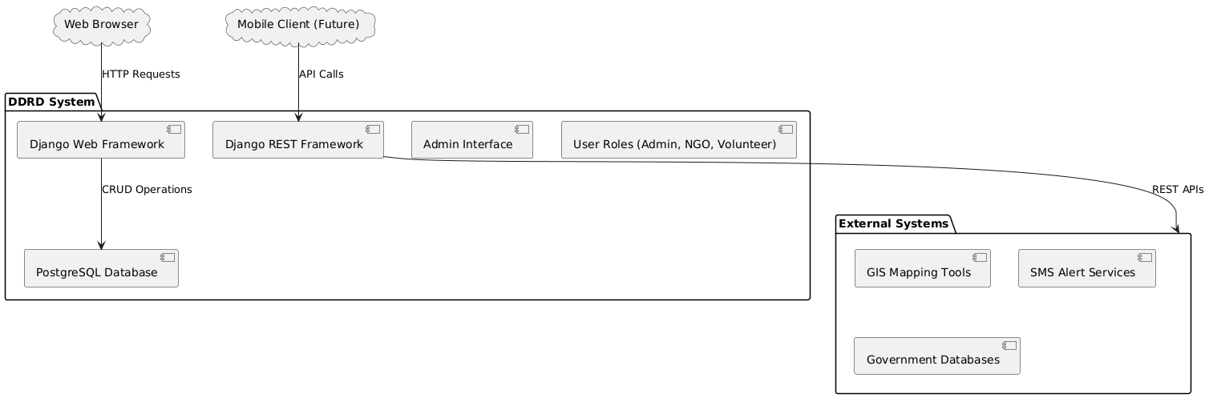

Fig 1: System Architecture Diagram

## 4.2 Use Case Diagram

The Use Case Diagram demonstrates how various users interact with DDRD.

# 

Fig 2: Use Case Diagram

## 4.3 Class Diagram

The Class Diagram illustrates the key classes and their relationships.

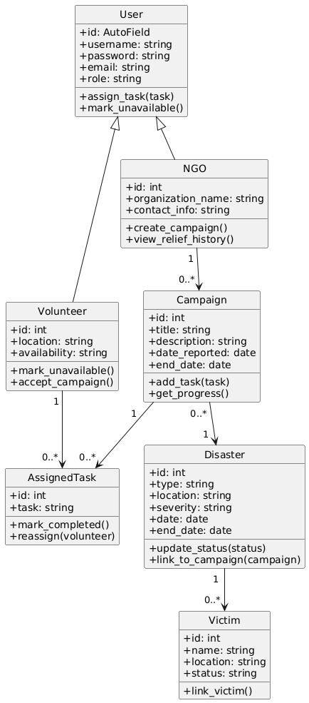

Fig 3: Class Diagram

## 4.4 Sequence Diagrams

Two key sequence diagrams include:

- Volunteer Registration

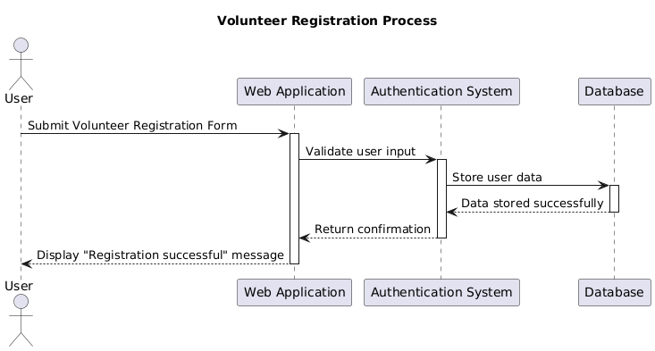  
Fig 4.1: Volunteer Registration Process

- NGO Posting Relief Campaign  
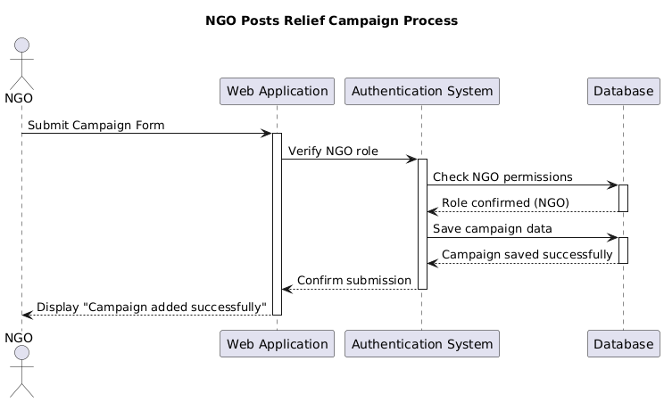

Fig 4.2: Sequence Diagram - NGO Posts Relief Campaign

## 4.5 **Database Design (ERD / Table Schemas)**

The Entity-Relationship Diagram (ERD) visually depicts the database schema.

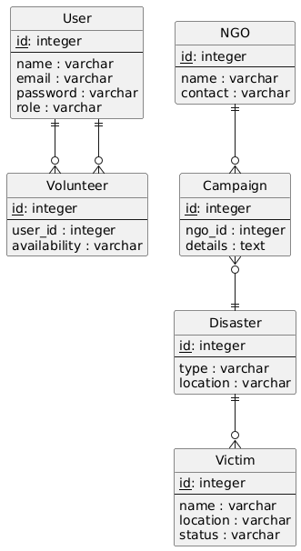

Fig 5: Database Design (ERD)

### 4.5.1 Database Design (Table Schemas)

|  |  |
| --- | --- |
| Table | Columns |
| User | id, name, email, password, role |
| Victim | id, name, location, status |
| Disaster | id, type, location, date |
| NGO | id, name, contact |
| Volunteer | id, user_id (FK), availability |
| Campaign | id, ngo_id (FK), details, status |

Table 2

CHAPTER 5

# System GUI

## ****Register Page****

The Register page of the DDRD system is designed to facilitate easy onboarding of new users. It requires the user to input their name, desired username, password, and select their role (either NGO or Volunteer). This ensures role-specific access control from the beginning. The layout is straightforward and user-friendly, allowing users to complete the registration process quickly and efficiently.

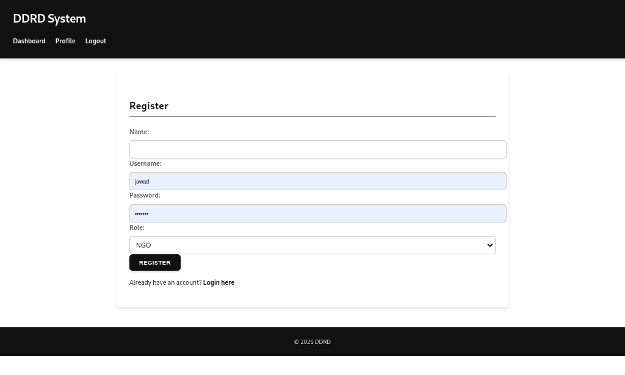Fig 6: Register Page

## ****Login Page****

The Login page provides a secure gateway for users to access the DDRD system. It contains fields for the username and password, and includes basic error messaging for incorrect credentials. This page ensures that only authorized users can log in and access the appropriate dashboards and functionalities assigned to their roles. The design emphasizes clarity and simplicity to promote ease of use.

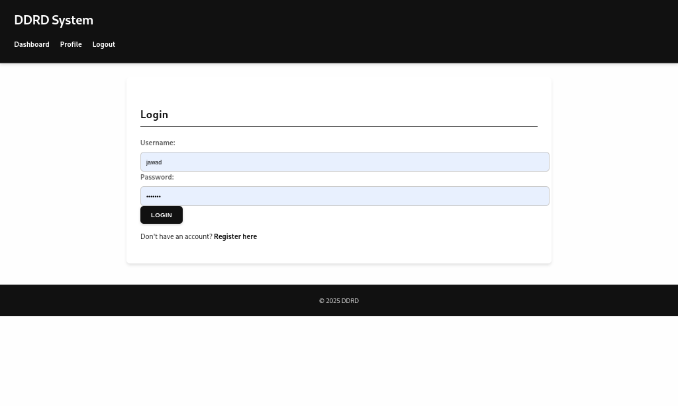Fig 7: Login Page

## ****Admin Dashboard****

The Admin Dashboard is the central control panel for system administrators. It offers an overview of critical data within the DDRD system, including lists of all registered disasters, victims, and volunteers. Administrators can manage these records comprehensively — adding, editing, or deleting entries as needed. The dashboard is designed to provide admins with clear access to important data, supporting efficient system management and oversight.

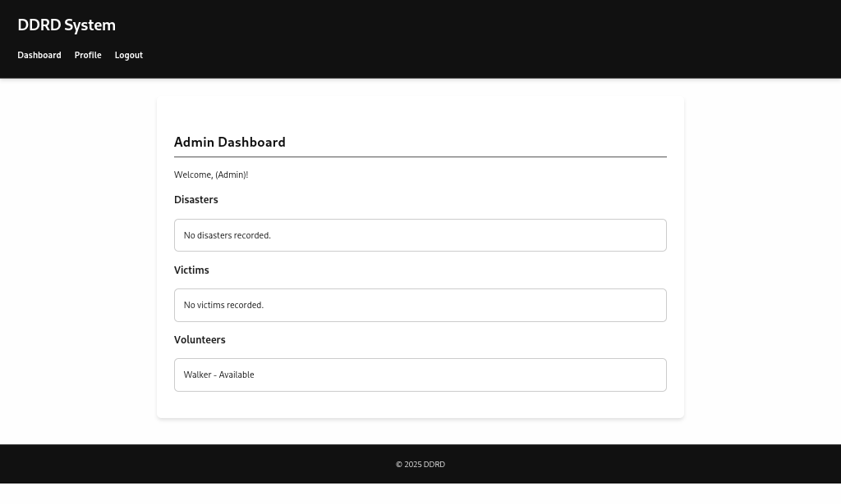Fig 8: Admin Dashboard Page

## ****NGO Dashboard****

The NGO Dashboard is tailored specifically for NGO users to manage their relief campaigns. It displays a list of current campaigns associated with the NGO and provides functionalities to add new campaigns, edit existing ones, and delete campaigns when necessary. This interface ensures that NGOs can keep their relief activities organized and up to date, encouraging efficient management and deployment of resources.

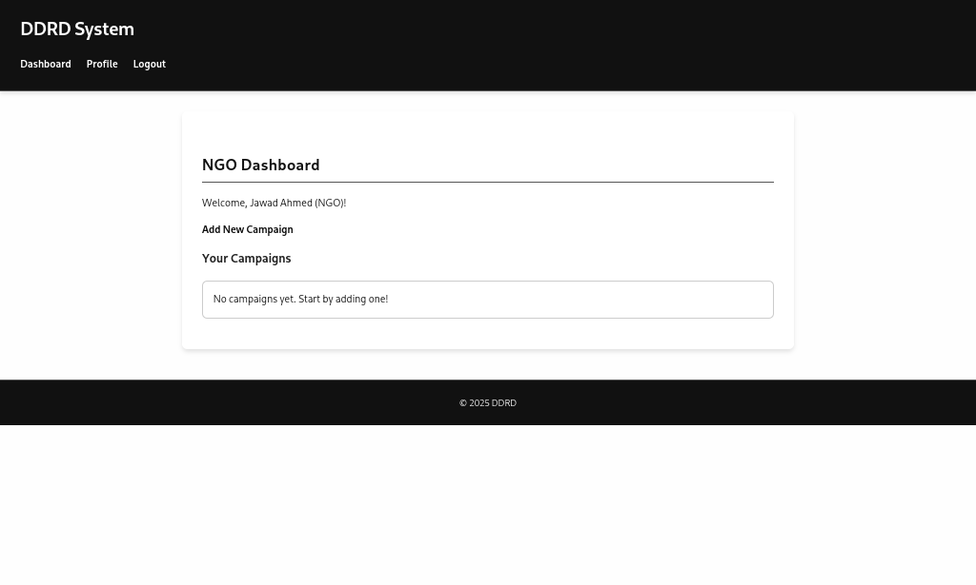

Fig 9: NGO Dashboard Page

## ****Volunteer Dashboard****

The Volunteer Dashboard focuses on volunteers’ participation in relief efforts. It presents a list of available campaigns that the volunteer can view or choose to accept. The design aims to motivate volunteers by providing clear and accessible information about active campaigns. This allows them to easily identify opportunities to contribute to relief work and join efforts where they are most needed.

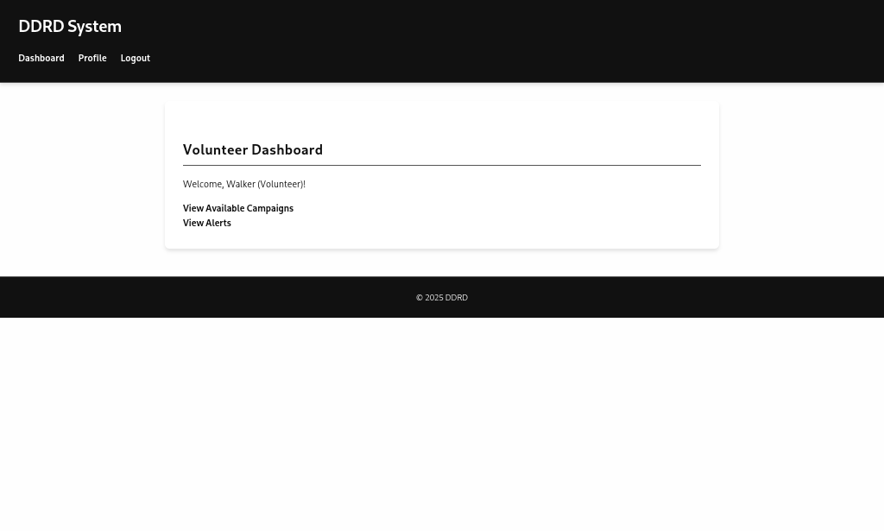Fig 10: Volunteer Dashboard Page

## ****Add Campaign Page****

The Add Campaign page is where NGO users can initiate new relief campaigns. The page features a straightforward form that captures key details of the campaign, including a detailed description and its current status. The simplicity of the form’s design ensures that NGOs can quickly and accurately create new campaigns, making it easier to mobilize relief efforts and coordinate volunteer involvement.

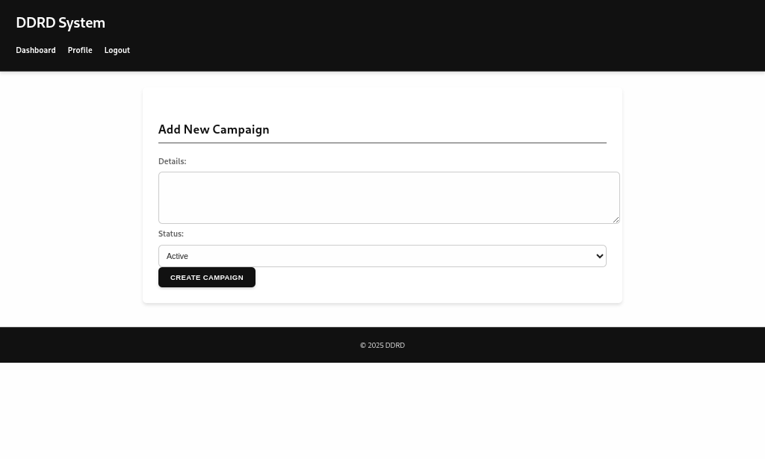Fig 11: **Add Campaign** Page

CHAPTER 6

# Implementation Plan

## 6.1. ****Technologies and Tools Used****

The DDRD system leverages a range of modern technologies and tools to ensure a robust, scalable, and user-friendly application. The main technologies and tools used in the development of the DDRD system include:

* **Programming Language**: Python
* **Framework**: Django, a high-level Python web framework that promotes rapid development and clean, pragmatic design.
* **Database**: SQLite (for development and testing) and PostgreSQL (for potential production deployment).
* **Front-End**: HTML, CSS, and JavaScript to ensure responsive and accessible interfaces.
* **Template Engine**: Django’s built-in template language for dynamic content rendering.
* **Version Control**: Git for source code management and versioning.
* **Development Environment**: Visual Studio Code (VSCode), a powerful code editor that supports Django development with integrated debugging tools.
* **Operating System**: Linux (Kali Linux in the development phase), chosen for its flexibility and powerful development ecosystem.
* **Deployment (Future Scope)**: Tools like Gunicorn and Nginx for production deployments, ensuring scalability and performance.
* **Libraries/Packages**: Django’s built-in authentication, crispy forms (if used), and any required Django packages for form handling and security.

This combination of technologies ensures that the DDRD system is modern, secure, and capable of scaling to meet the needs of disaster relief efforts.

## 6.2. ****Steps / Milestones****

The implementation of the DDRD system is structured around clearly defined milestones to ensure systematic development and timely delivery:

**1. Requirements Gathering and Analysis**

* Identified the key features of the DDRD system based on the needs of NGOs, volunteers, and administrators.
* Conducted stakeholder interviews and reviewed best practices for disaster management systems.

**2. System Design and Architecture**

* Designed the overall system architecture, including defining the data models and relationships (ER diagrams, UML diagrams).
* Created wireframes and initial UI/UX designs for the different dashboards and modules.

**3. Environment Setup**

* Configured the development environment, including setting up the Python virtual environment (venv), installing Django and dependencies, and initializing the Git repository for version control.
* Created the initial Django project and applications (relief app) to modularize the system.

**4. Core Development**

* Implemented user authentication and role-based access control (admin, NGO, volunteer).
* Developed the core modules: disaster management, campaign management, victim management, and volunteer management.
* Integrated dynamic data handling and template rendering for the different roles.

**5. User Interface Implementation**

* Created user-friendly HTML templates for the different dashboards and forms.
* Applied CSS for styling and ensured responsive design for better usability on various devices.

**6. Testing and Debugging**

* Conducted thorough testing of all features, including login, registration, dashboard functionalities, and data management.
* Fixed any bugs and refined the user interface based on feedback.

**7. Data Integrity and Security**

* Implemented data validation and CSRF protection in all forms to ensure secure data handling.
* Verified that only authorized roles can access their respective functionalities.

**8. Deployment Preparation (Future Scope)**

* Outlined plans for deployment in a production environment, including database migration to PostgreSQL, static file handling, and performance optimization using production-ready servers.

**9. Documentation and User Training**

* Prepared detailed user documentation and system manuals to assist future users.
* Planned training sessions or materials for system administrators, NGOs, and volunteers to ensure smooth onboarding.

**10. Feedback and Future Enhancements**

* Gathered feedback from initial users and stakeholders to identify areas for improvement.
* Outlined future enhancements, such as real-time notifications, geolocation mapping, and integration with external relief services.

CHAPTER 7

# Testing

Testing is a critical phase in the DDRD system’s development, ensuring that the application meets functional, performance, and security standards. Multiple types of testing have been conducted to validate the system’s robustness and usability.

## ****Types of Tests****

**Unit Testing**  
Unit testing focuses on individual components of the DDRD system, such as views, models, and forms. It ensures that each function behaves as expected in isolation.  
For example, unit tests verify that the **add_campaign** view properly creates a campaign only when accessed by authorized NGO users.

**Integration Testing**  
Integration testing ensures that different modules of the DDRD system work together seamlessly. It verifies interactions between components like user authentication, campaign management, and data handling.  
For example, testing that an NGO user can log in, add a campaign, and then see it reflected in their dashboard.

**System Testing**  
System testing validates the entire DDRD system as a whole, checking end-to-end workflows and role-specific behavior.  
For example, testing that a volunteer can view active campaigns posted by NGOs and accept them as expected.

**Acceptance Testing**  
Acceptance testing involves validating the system against the original requirements and confirming that all features are implemented correctly and function as intended.  
For example, ensuring that only administrators can access disaster and victim management modules.

**Security Testing**  
Security testing ensures the DDRD system is protected from common vulnerabilities, such as CSRF, XSS, and unauthorized access to role-specific pages.

| ****Test Case ID**** | ****Description**** | ****Expected Result**** | ****Role**** |
| --- | --- | --- | --- |
| TC01 | Verify that login works for valid credentials | User is redirected to their dashboard | All users |
| TC02 | Verify that invalid login credentials show errors | Error message is displayed | All users |
| TC03 | NGO can create a new campaign | Campaign appears in NGO dashboard | NGO |
| TC04 | Volunteer cannot access add campaign page | Access forbidden error | Volunteer |
| TC05 | Admin can view all victims | List of victims displayed on admin dashboard | Admin |
| TC06 | CSRF protection is enabled in all forms | CSRF token present; submission fails without it | All users |
| TC07 | Volunteers can view and accept campaigns | Campaign is added to volunteer’s accepted list | Volunteer |
| TC08 | Admin can add and edit disasters | Disaster details saved and updated correctly | Admin |

Table 3

## Testing Tools and Methodologies

* **Manual Testing**: Initial testing was conducted manually to validate the user interface and system behavior.
* **Django Test Framework**: Utilized Django’s built-in test framework (TestCase classes) for automated unit and integration testing.
* **Browser Testing**: Ensured the system worked across major browsers like Chrome and Firefox.
* **Database Testing**: Verified data integrity during CRUD operations for disasters, campaigns, volunteers, and victims.

## Findings and Outcomes

Testing revealed and resolved several minor issues, including missing CSRF tokens in forms and inconsistencies in role-based access control. As a result of rigorous testing, the DDRD system is now robust, secure, and reliable for deployment.

**CONCLUSIONS**

The DDRD system represents a significant step forward in managing disaster relief efforts. It offers a comprehensive platform for NGOs, volunteers, and administrators to coordinate campaigns, manage data, and ensure that relief efforts are effectively delivered to those in need.

Through a methodical development process that included careful planning, robust system design, thorough testing, and continuous feedback integration, the DDRD system has achieved its primary objectives:

**Streamlined Disaster Management**  
By consolidating the management of disasters, victims, and volunteers, the DDRD system ensures that all stakeholders have clear and easy access to the data they need.

**Role-Based Access and Efficiency**  
The system effectively differentiates between the roles of admin, NGO, and volunteer, providing tailored dashboards and workflows to ensure each user’s tasks are streamlined and secure.

**Secure and Scalable**  
With proper CSRF protection, secure authentication, and a modular design, the DDRD system is well-prepared for scaling and deployment in real-world scenarios.

**User-Centric Design**  
The system’s intuitive interfaces, designed to be responsive and user-friendly, promote engagement from all users and ensure ease of use, even for those with minimal technical skills.

In conclusion, the DDRD system stands as a robust and adaptable solution for coordinating disaster relief efforts. Future enhancements could include integrating real-time notifications, mapping of relief efforts using GIS, and advanced data analytics to better support decision-making. Through continuous improvement and stakeholder collaboration, DDRD aims to empower communities and streamline the delivery of critical relief resources.

Recommendations

1. **Mobile App Integration:** A Flutter-based mobile version is recommended for broader accessibility and field use by volunteers and NGO staff.
2. **GIS Mapping:** Integrating a GIS-based visualization tool would enhance spatial understanding of disaster impact zones.
3. **Automated Alerts:** Adding SMS and email alert systems for victims and volunteers would significantly improve response time.
4. **Multi-language Support:** Including local language options will increase accessibility in diverse regions affected by disasters.
5. **Government Integration:** Linking DDRD with government relief databases can improve efficiency and transparency in aid distribution.

**Future Scope & Improvements**

**Real-Time Updates and Notifications**:

Integrating live alerts and notifications to inform volunteers of new campaigns and status updates.  
**Geolocation and Mapping**:

Implementing mapping tools (like Google Maps or OpenStreetMap) to visualize disaster locations and relief campaigns, making it easier to coordinate efforts in real-time.  
**Enhanced Reporting and Analytics**:

Adding data analysis and visual dashboards to help NGOs and administrators better understand the impact of their campaigns.  
**Scalability for Production**:

Preparing the system for deployment in a production environment, including using PostgreSQL and deployment tools like Gunicorn and Nginx for performance and security.  
**Mobile App Integration**:

Developing a companion mobile app to ensure that relief workers and volunteers can access and manage campaigns directly from their smartphones.  
**User Training and Documentation**:

Expanding user manuals, training materials, and video guides to ensure that all stakeholders can confidently use the DDRD system.

**REFERENCES**

**Django Project Documentation**  
<https://docs.djangoproject.com/>

**W3Schools** – HTML, CSS, and JavaScript References  
<https://www.w3schools.com/>

**Django REST Framework (for future API integration)**  
<https://www.django-rest-framework.org/>

**Python Programming Language**  
<https://www.python.org/>

**Stack Overflow** – Community discussions and code examples  
<https://stackoverflow.com/>

**GitHub** – Open-source examples and Django projects  
<https://github.com/>

**DigitalOcean** – Deployment best practices and tutorials  
<https://www.digitalocean.com/community/>

**Abbreviations**

**CRUD**: Create, Read, Update, Delete

**REST API**: Web-based interface for system-to-system communication

**Django**: Python-based web framework

**PostgreSQ**L: Open-source relational database

**NGO**: Non-Governmental Organization

**DDRD**: Dynamic Disaster Relief Database

**UI**: User Interface

**API**: Application Programming Interface