OptimAlze Buddy – AI-Powered Digital Services Agent
User Stories & Acceptance Criteria
Version 1.0

Document Control
Item | Details
Project | OptimAlze Buddy
Document Title | User Stories & Acceptance Criteria
Date | October 26, 2023
Prepared By | Product & Development Team
Approved By | [To be filled]
Distribution | Development, QA, Product, Stakeholders

Table of Contents
- Introduction
  - 1.1 Purpose
  - 1.2 Scope
  - 1.3 Definitions
- User Personas
- User Stories & Acceptance Criteria
  - 3.1 Conversational Information Retrieval
  - 3.2 Service Request & Form Completion
  - 3.3 Document Upload & Validation
  - 3.4 Appointment Scheduling
  - 3.5 Administrative Oversight & Analytics
  - 3.6 Multi-Channel Integration
- System Architecture & Workflow Diagram
- Acceptance Criteria Tables
  - Table 1: Core Conversational Functionality
  - Table 2: Document Processing & Validation
  - Table 3: Integration & Performance
- Conclusion

1. Introduction
1.1 Purpose
This document outlines user stories and acceptance criteria for the OptimAlze Buddy system, an AI-powered digital services agent for government and municipal services. It ensures development aligns with public sector requirements for accuracy, compliance, and citizen service improvement.
1.2 Scope
Covers conversational interface, RAG-based information retrieval, service task execution, document validation, appointment scheduling, and administrative oversight. Excludes backend government system modifications, payment processing, and legal decision-making systems.
1.3 Definitions
- RAG: Retrieval-Augmented Generation for policy-grounded responses
- Agentic Workflows: Automated multi-step task execution
- Document Intelligence: Computer vision and validation for uploaded documents
- Service Catalog: Available government services and procedures
- Zero-Hallucination: Responses strictly based on verified policy documents

2. User Personas
- Citizen User (Maria)
  - Needs quick, accurate answers about government services and help completing applications.
- Government Case Worker (David)
  - Uses the system to reduce repetitive inquiries and ensure document quality before processing.
- Municipal IT Admin (Sarah)
  - Manages service catalog, monitors system performance, and reviews analytics.
- Public Service Manager (James)
  - Oversees service delivery metrics and citizen satisfaction improvements.
- Senior Citizen (Robert)
  - Requires simple, guided interactions with minimal technical expertise.

3. User Stories & Acceptance Criteria
3.1 Conversational Information Retrieval
User Story: As a citizen, I want to ask natural language questions about government services and receive accurate, policy-based answers so that I can understand requirements without searching multiple websites.
Acceptance Criteria:
- System responds within 3 seconds to text queries.
- Answers cite specific policy documents or regulations.
- Zero hallucination: No fabricated information or policies.
- Provides follow-up suggestions for related questions.
- Handles 95% of common information requests without escalation.
3.2 Service Request & Form Completion
User Story: As a citizen applying for a permit, I want the system to guide me through form completion conversationally so that I can submit accurate applications without confusion.
Acceptance Criteria:
- Identifies intent from natural conversation (e.g., "I need to renew my driver's license").
- Presents form fields one at a time with clear explanations.
- Validates each input immediately (format, required fields).
- Saves progress and allows continuation later.
- Submits completed forms to appropriate government system.
3.3 Document Upload & Validation
User Story: As a citizen submitting supporting documents, I want real-time validation of my uploads so that I can correct issues immediately rather than having my application rejected later.
Acceptance Criteria:
- Accepts PDF, JPG, PNG up to 10MB each.
- Validates document type matches requirement (e.g., proof of address).
- Checks document quality: legibility, completeness, non-blurry.
- Verifies information consistency with form inputs.
- Provides specific rejection reasons with remediation guidance.
3.4 Appointment Scheduling
User Story: As a citizen needing in-person service, I want to find and book available appointments through conversation so that I can avoid phone wait times and website navigation.
Acceptance Criteria:
- Integrates with government appointment systems (Calendly, Microsoft Bookings, etc.).
- Shows available time slots based on service type and location.
- Allows rescheduling and cancellation of existing appointments.
- Sends confirmation and reminder notifications.
- Provides directions and preparation instructions for appointment.
3.5 Administrative Oversight & Analytics
User Story: As a municipal IT admin, I want to monitor system performance and citizen interactions so that I can optimize services and identify common issues.
Acceptance Criteria:
- Dashboard shows key metrics: conversation volume, completion rates, escalation frequency.
- Identifies trending questions and service requests.
- Tracks document rejection reasons and common errors.
- Provides conversation transcripts for quality review.
- Generates weekly performance reports automatically.
3.6 Multi-Channel Integration
User Story: As a government agency, I want citizens to access services through multiple channels (web, WhatsApp, SMS) so that we can serve diverse populations with varying technology access.
Acceptance Criteria:
- Web interface with accessibility compliance (WCAG 2.1 AA).
- WhatsApp Business API integration for text-based interactions.
- SMS fallback for basic information requests.
- Consistent experience and capabilities across all channels.
- Channel-appropriate interface adaptations (e.g., simpler flows for SMS).

4. System Architecture & Workflow Diagram
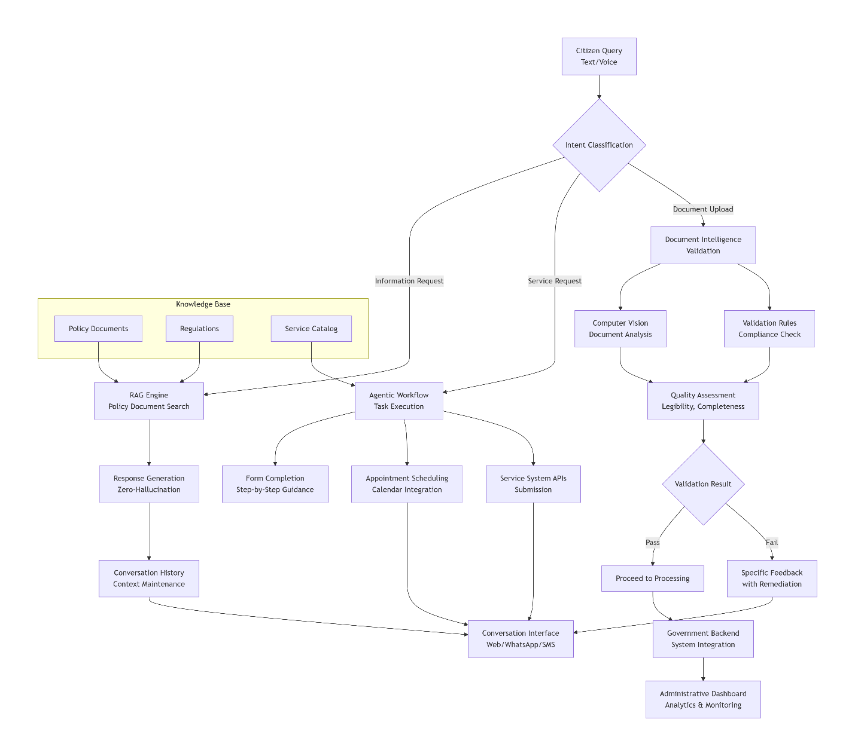

Figure 1: OptimAlze Buddy – System Architecture & Citizen Interaction Workflow

5. Acceptance Criteria Tables
Table 1: Core Conversational Functionality
ID | Feature | Acceptance Criteria | Test Method
CC-01 | Natural Language Understanding | Correctly identifies intent in 95% of citizen queries. | Test with 1000 sample queries across service categories.
CC-02 | RAG Accuracy | Provides policy-grounded answers with zero hallucinations. | Verify answers against source policy documents.
CC-03 | Context Maintenance | Maintains conversation context for at least 10 turns back. | Multi-step conversation testing.
CC-04 | Response Time | Average response time <3 seconds for information queries. | Performance monitoring under load.
CC-05 | Escalation Handling | Smoothly transfers to human agent when unable to assist. | Test edge cases and complex requests.
CC-06 | Multi-language Support | Supports primary local languages with equal accuracy. | Test same queries in different languages.
Table 2: Document Processing & Validation
ID | Feature | Acceptance Criteria | Test Method
DP-01 | Document Upload | Accepts PDF, JPG, PNG up to 10MB with progress indicator. | Upload various document types and sizes.
DP-02 | Type Validation | Identifies document type (ID, proof of address, certificate) with 98% accuracy. | Test with labeled document dataset.
DP-03 | Quality Assessment | Detects blurry, cropped, or incomplete documents with 95% accuracy. | Submit intentionally poor-quality documents.
DP-04 | Information Extraction | Extracts relevant data (names, dates, IDs) from documents for auto-fill. | Compare extracted data with manual entry.
DP-05 | Compliance Check | Validates documents against specific service requirements. | Test with compliant/non-compliant document pairs.
DP-06 | Feedback Quality | Provides specific, actionable feedback for rejected documents. | Verify rejection reasons guide users to correct issues.
Table 3: Integration & Performance
ID | Attribute | Acceptance Criteria | Test Method
IP-01 | System Availability | 99.9% uptime during government operating hours (7 AM-7 PM). | 90-day continuous monitoring.
IP-02 | API Integration | Successfully integrates with 3+ government backend systems (appointments, forms, CRM). | End-to-end testing with each integrated system.
IP-03 | Multi-Channel Support | Consistent functionality across web, WhatsApp, and SMS interfaces. | Parallel testing on all channels.
IP-04 | Scalability | Handles 1,000 concurrent users with <5% performance degradation. | Load testing with simulated user traffic.
IP-05 | Data Security | Complies with government data protection standards (GDPR, local regulations). | Security audit and compliance verification.
IP-06 | Administrative Tools | Dashboard provides real-time metrics and exportable reports. | Validate all dashboard metrics against backend data.
IP-07 | Citizen Satisfaction | 85%+ satisfaction rate in post-interaction surveys. | Monthly satisfaction surveys and analysis.

6. Conclusion
This document provides comprehensive user stories and acceptance criteria for the OptimAlze Buddy system. By meeting these criteria, the platform will transform citizen-government interactions through accurate, conversational service delivery that reduces administrative burden while improving citizen satisfaction.
The acceptance criteria ensure the system delivers on its core promise: providing a unified, intelligent interface that combines policy-accurate information retrieval, guided service completion, and proactive document validation—all available 24/7 through citizens' preferred communication channels.
The OptimAlze Buddy represents a significant advancement in GovTech, moving beyond simple chatbots to create an action-capable digital clerk that understands public sector workflows, ensures compliance, and delivers measurable improvements in service delivery efficiency and citizen experience.

