Optimaizer Grader – Intelligent Rubric-Driven Assessment Platform
User Stories & Acceptance Criteria
Version 1.0

Document Control
Item | Details
Project | Optimaizer Grader
Document Title | User Stories & Acceptance Criteria
Date | October 26, 2023
Prepared By | Product & Education Technology Team
Approved By | [To be filled]
Distribution | Development, QA, Product, Stakeholders

Table of Contents
- Introduction
  - 1.1 Purpose
  - 1.2 Scope
  - 1.3 Definitions
- User Personas
- User Stories & Acceptance Criteria
  - 3.1 Rubric Creation & Configuration
  - 3.2 Instructor Style Learning
  - 3.3 Batch Submission Grading
  - 3.4 Feedback Generation & Personalization
  - 3.5 Anomaly Detection & Quality Assurance
  - 3.6 LMS Integration & Workflow Support
- Grading System Workflow Diagram
- Acceptance Criteria Tables
  - Table 1: Core Grading Functionality
  - Table 2: Instructor Adaptation & Learning
  - Table 3: Integration & Performance
- Conclusion

1. Introduction
1.1 Purpose
This document outlines user stories and acceptance criteria for the Optimaizer Grader system, an intelligent rubric-driven assessment platform. It ensures development aligns with educational needs for consistent, scalable, and high-quality grading while preserving instructor nuance and pedagogical goals.
1.2 Scope
Covers rubric management, instructor style learning, automated grading, feedback generation, anomaly detection, and LMS integration. Excludes plagiarism detection, peer review management, and student identity verification systems.
1.3 Definitions
- Rubric-Anchored Grading: Evaluation strictly based on predefined criteria with weighted scoring
- Instructor Style Learning: AI adaptation to individual educator's grading patterns and feedback preferences
- Human-in-the-Loop: System flags uncertain cases for human review before finalizing grades
- Grading Anomaly: Statistical outliers or inconsistencies in automated grading patterns
- Feedback Template Bank: Repository of reusable, customizable comment templates

2. User Personas
- University Professor (Dr. Chen)
  - Needs consistent grading across large classes while maintaining academic standards.
- High School Teacher (Ms. Rodriguez)
  - Wants to reduce grading time while providing personalized feedback to students.
- Teaching Assistant (Alex)
  - Needs to grade consistently with professor's standards and provide detailed feedback efficiently.
- Online Course Instructor (Jordan)
  - Requires scalable grading solution for hundreds of students across multiple time zones.
- Department Chair (Dr. Williams)
  - Oversees grading consistency and quality assurance across multiple instructors.
- Student (Taylor)
  - Receives timely, detailed feedback that explains grading decisions and provides improvement guidance.

3. User Stories & Acceptance Criteria
3.1 Rubric Creation & Configuration
User Story: As a professor, I want to create and configure detailed grading rubrics so that assessments are evaluated against consistent, objective criteria.
Acceptance Criteria:
- System supports rubric creation with multiple criteria categories and weighted scoring.
- Allows point ranges (0-5, 0-10) or percentage-based scoring per criterion.
- Enables criteria descriptions at multiple performance levels (excellent, good, poor).
- Supports rubric templates for reuse across assignments.
- Exports rubrics to standard formats (PDF, CSV) for sharing.
3.2 Instructor Style Learning
User Story: As a teaching assistant, I want the system to learn from my grading adjustments so that it aligns with the professor's specific expectations and feedback style.
Acceptance Criteria:
- Captures instructor overrides to automated grades and feedback.
- Learns from pattern of adjustments across multiple assignments.
- Adapts feedback tone and specificity to match instructor's style.
- Provides confidence scores indicating how well it has learned instructor preferences.
- Allows resetting of learned patterns if teaching approach changes.
3.3 Batch Submission Grading
User Story: As an online course instructor, I want to grade hundreds of submissions efficiently while maintaining quality consistency across all evaluations.
Acceptance Criteria:
- Processes batch uploads of student submissions (text, PDF, images).
- Applies rubric criteria consistently across all submissions.
- Grades 100 submissions in under 15 minutes.
- Flags submissions requiring human review (low confidence, anomalies).
- Provides batch summary statistics and grade distribution analysis.
3.4 Feedback Generation & Personalization
User Story: As a high school teacher, I want students to receive detailed, constructive feedback that explains their scores and provides actionable improvement suggestions.
Acceptance Criteria:
- Generates criterion-specific comments based on rubric scoring.
- Provides positive reinforcement alongside constructive criticism.
- Suggests specific resources or activities for improvement.
- Maintains consistent feedback quality across all students.
- Allows easy editing of generated feedback before release.
3.5 Anomaly Detection & Quality Assurance
User Story: As a department chair, I want to identify grading inconsistencies or potential bias patterns to ensure fair assessment across all students.
Acceptance Criteria:
- Flags statistical outliers in grading patterns.
- Detects potential bias indicators (grade clusters by demographic factors).
- Provides anomaly reports with visualizations and explanations.
- Tracks grader consistency metrics over time.
- Supports anonymous grading mode to reduce unconscious bias.
3.6 LMS Integration & Workflow Support
User Story: As a university instructor, I want seamless integration with our Learning Management System so that grading fits naturally into existing teaching workflows.
Acceptance Criteria:
- Integrates with major LMS platforms (Canvas, Moodle, Blackboard, D2L).
- Syncs assignment details, submissions, and student rosters automatically.
- Pushes grades and feedback back to LMS gradebook.
- Supports single sign-on with institutional credentials.
- Maintains data privacy and security standards (FERPA compliance).

4. Grading System Workflow Diagram
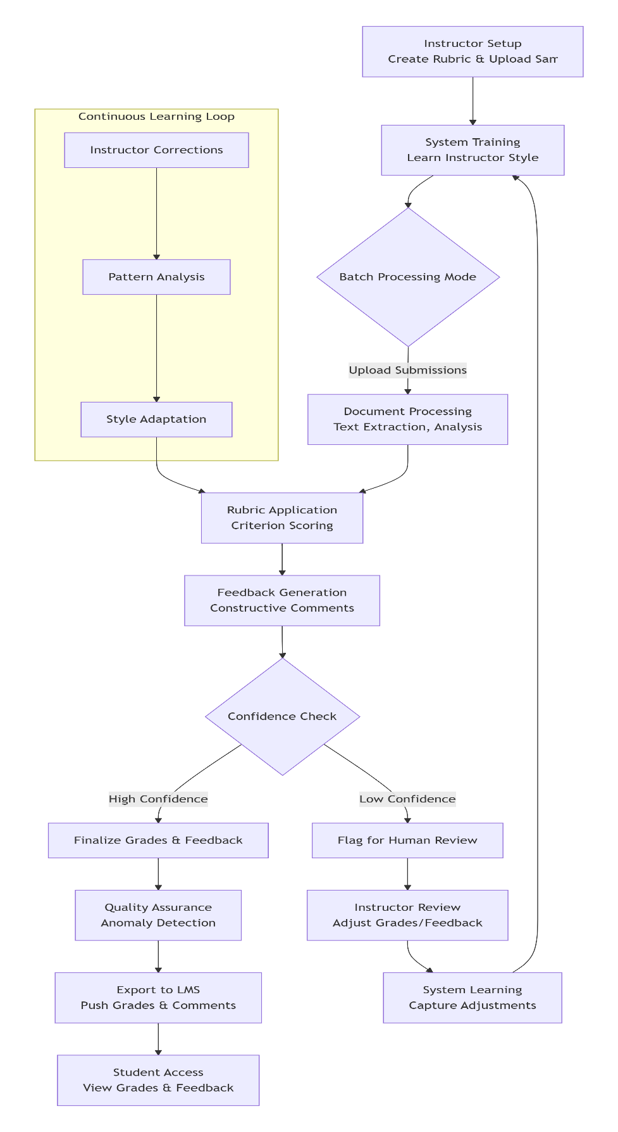

*Figure 1: Optimaizer Grader – Human-in-the-Loop Assessment Workflow*

5. Acceptance Criteria Tables
Table 1: Core Grading Functionality
ID | Feature | Acceptance Criteria | Test Method
CG-01 | Rubric Creation | Supports 5-10 criteria with weighted scoring and detailed descriptors. | Create sample rubrics for different assignment types.
CG-02 | Automated Scoring | Applies rubric consistently with <5% variance from human grader on trained criteria. | Compare system vs human scores on sample submissions.
CG-03 | Feedback Quality | Generates specific, actionable feedback for each criterion level. | Educator review of generated feedback quality.
CG-04 | Multi-Format Support | Processes text, PDF, Word docs, and image-based submissions. | Test with various file formats and submission types.
CG-05 | Batch Processing | Grades 100 submissions in ≤15 minutes with consistent quality. | Performance testing with simulated batch loads.
CG-06 | Grade Calculation | Accurately calculates weighted totals and converts to letter grades per rubric. | Verify calculations against manual gradebook entries.
Table 2: Instructor Adaptation & Learning
ID | Feature | Acceptance Criteria | Test Method
IA-01 | Style Learning | Adapts to instructor grading style within 20-30 corrected submissions. | Track system accuracy improvement with instructor corrections.
IA-02 | Confidence Scoring | Provides confidence scores (0-100%) for each automated assessment. | Verify confidence scores correlate with human agreement rates.
IA-03 | Feedback Tone Matching | Mirrors instructor's feedback tone (encouraging, direct, detailed) in generated comments. | Compare AI vs instructor feedback blind reviews.
IA-04 | Human-in-the-Loop | Flags 10-15% of submissions for human review based on confidence thresholds. | Monitor flagging accuracy and adjust threshold settings.
IA-05 | Learning Persistence | Retains learned patterns across multiple assignments and semesters. | Test system recall after extended periods without use.
IA-06 | Reset Capability | Allows instructors to reset learned patterns when changing grading approaches. | Verify clean slate functionality after reset command.
Table 3: Integration & Performance
ID | Attribute | Acceptance Criteria | Test Method
IP-01 | LMS Integration | Seamless integration with Canvas, Moodle, Blackboard for data sync. | End-to-end testing with each supported LMS.
IP-02 | Data Privacy | Complies with FERPA and institutional data protection policies. | Security audit and compliance verification.
IP-03 | System Availability | 99.5% uptime during academic grading periods (midterms, finals). | Monitor during peak academic calendar periods.
IP-04 | Scalability | Supports 500+ concurrent users during peak grading periods. | Load testing with simulated instructor and TA users.
IP-05 | Anomaly Detection | Identifies grading inconsistencies with 90% accuracy. | Test with intentionally introduced grading anomalies.
IP-06 | Bias Monitoring | Flags potential demographic bias patterns in grading distributions. | Analyze system performance on diverse student datasets.
IP-07 | Reporting | Generates comprehensive grading analytics and consistency reports. | Validate report accuracy against raw grading data.
IP-08 | Turnaround Time | Reduces grading time by 70% compared to manual grading for trained assignments. | Comparative timing studies with control groups.

6. Conclusion
This document provides comprehensive user stories and acceptance criteria for the Optimaizer Grader system. By meeting these criteria, the platform will effectively address the "grading bottleneck" in education through intelligent automation that preserves pedagogical quality while dramatically reducing instructor workload.
The system's unique human-in-the-loop approach, instructor style learning capabilities, and robust anomaly detection ensure it serves as a true teaching assistant rather than a replacement for educator judgment. By combining rubric-anchored objectivity with adaptive personalization, Optimaizer Grader enables scalable, consistent, and meaningful assessment across diverse educational contexts.
The acceptance criteria ensure the product delivers its core value: decoupling the mechanical burden of grading from the intellectual work of assessment, thereby freeing educators to focus on teaching, mentoring, and curriculum development while ensuring students receive timely, detailed, and fair feedback.

