Hezop PID Reader
User Stories & Acceptance Criteria
Version 1.0

Document Control
Item | Details
Project | Hezop PID Reader
Document Title | User Stories & Acceptance Criteria
Date | October 26, 2023
Prepared By | Product & Engineering Team
Approved By | [To be filled]
Distribution | Development, QA, Product, Stakeholders

Table of Contents
- Introduction
  - 1.1 Purpose
  - 1.2 Scope
  - 1.3 Definitions
- User Personas
- User Stories & Acceptance Criteria
  - 3.1 Core P&ID Processing
  - 3.2 Data Extraction & Structuring
  - 3.3 Search & Query Capabilities
  - 3.4 Integration & Export
  - 3.5 Validation & Quality Assurance
  - 3.6 Legacy Drawing Support
- System Workflow Diagram
- Acceptance Criteria Tables
  - Table 1: Core Functionality Acceptance
  - Table 2: Integration & Export Acceptance
  - Table 3: Quality & Performance Acceptance
- Conclusion

1. Introduction
1.1 Purpose
This document outlines user stories and acceptance criteria for the Hezop PID Reader. It serves as a guide for development, testing, and validation, ensuring the delivered product meets user needs and business objectives.
1.2 Scope
Covers functional and non-functional requirements for P&ID digitization, data extraction, search, integration, and validation features. Excludes administrative features (user management, billing) and third-party tool development.
1.3 Definitions
- P&ID: Piping and Instrumentation Diagram
- Equipment: Pumps, compressors, filters, furnaces, etc.
- Instruments: Valves, sensors, controllers
- Structured Data: Machine-readable output (JSON, database)
- Digital Twin: A virtual representation of a physical asset

2. User Personas
- Process Engineer (Alex)
  - Needs quick access to equipment details, line numbers, and process hierarchies for design reviews and troubleshooting.
- Digital Transformation Lead (Sam)
  - Focuses on digitizing legacy drawings and integrating P&ID data with CMMS/ERP for plant intelligence.
- Safety/HAZOP Engineer (Jordan)
  - Requires accurate instrument and valve data for safety reviews, compliance, and risk assessments.
- Maintenance Manager (Taylor)
  - Uses searchable P&ID data to locate components, plan maintenance, and update work orders.

3. User Stories & Acceptance Criteria
3.1 Core P&ID Processing
User Story: As a Process Engineer, I want to upload P&ID drawings (PDF, image, CAD) so that they are automatically parsed and digitized.
Acceptance Criteria:
- System accepts PDF, PNG, JPG, TIFF, and DWG files.
- File size limit: Up to 200 MB per drawing.
- Upload progress is visible; user receives confirmation upon completion.
- Invalid or corrupted files are rejected with a clear error message.
3.2 Data Extraction & Structuring
User Story: As a Digital Transformation Lead, I want equipment, instruments, tags, and line numbers extracted into structured formats so that I can build a machine-readable asset database.
Acceptance Criteria:
- Recognizes at least 95% of standard ISA symbols for equipment and instruments.
- Extracts tag numbers (e.g., P-101, T-202) with 98% accuracy.
- Captures line numbers, fluid/service descriptions, and flow directions.
- Outputs data in JSON format with consistent schema.
3.3 Search & Query Capabilities
User Story: As a Maintenance Manager, I want to search for specific tags or equipment across all processed P&IDs so that I can quickly locate components without manual drawing review.
Acceptance Criteria:
- Full-text search by tag, equipment type, or line number.
- Search results show exact drawing and location coordinates.
- Query response time under 2 seconds for up to 10,000 drawings.
- Filters allow narrowing by plant area, system, or drawing number.
3.4 Integration & Export
User Story: As a Digital Transformation Lead, I want to export structured P&ID data to CMMS, ERP, or digital twin platforms so that I can synchronize engineering data with operational systems.
Acceptance Criteria:
- Export options: JSON, CSV, SQL insert scripts, REST API.
- API supports OAuth2 authentication and pagination.
- Scheduled exports can be configured (daily, weekly).
- Mapping templates allow field customization for target systems.
3.5 Validation & Quality Assurance
User Story: As a Safety Engineer, I want the system to highlight potential reading errors or inconsistencies so that I can validate data before using it for HAZOP studies.
Acceptance Criteria:
- Flags symbols with low confidence scores (<90%) for review.
- Detects missing tags or duplicate identifiers.
- Provides an audit trail of changes made during validation.
- Allows manual correction and re-import of validated data.
3.6 Legacy Drawing Support
User Story: As a Digital Transformation Lead, I want to process scanned, low-quality, or hand-drawn legacy P&IDs so that I can digitize old plant documentation.
Acceptance Criteria:
- Accepts grayscale and color-scanned images (150–300 DPI minimum).
- Includes pre-processing for skew correction, noise reduction, and contrast enhancement.
- Accuracy target: 85%+ for symbols and tags on legacy drawings.
- Logs quality warnings for poor-resolution inputs.

4. System Workflow Diagram
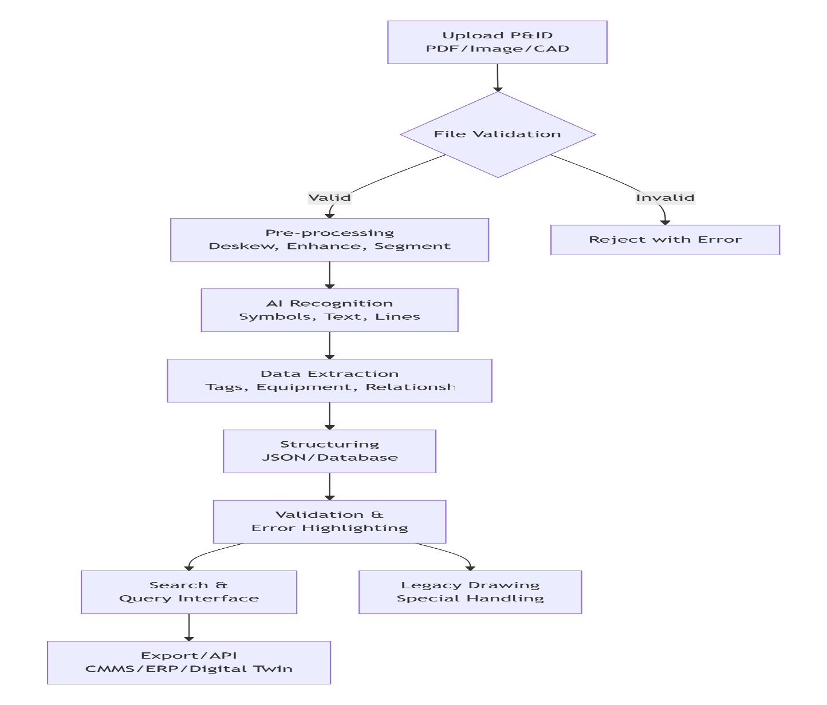

5. Acceptance Criteria Tables
Table 1: Core Functionality Acceptance
ID | Feature | Acceptance Criteria | Test Method
FC-01 | File Upload | Accepts PDF, PNG, JPG, TIFF, DWG up to 200 MB; shows upload progress. | Upload test files of each format.
FC-02 | Symbol Recognition | Recognizes ≥95% of ISA symbols; extracts equipment/instrument types. | Use ISA-standard P&ID sample set.
FC-03 | Tag Extraction | Extracts tag numbers with 98% accuracy; captures full tag-string. | Compare extracted tags with manual count.
FC-04 | Line Data Capture | Captures line numbers, fluid/service, flow direction, and line class. | Verify against drawing annotations.
FC-05 | Relationship Mapping | Identifies connections between equipment and instruments; creates adjacency lists. | Validate with known process flows.
Table 2: Integration & Export Acceptance
ID | Feature | Acceptance Criteria | Test Method
IE-01 | JSON Export | Outputs structured JSON with schema matching API documentation. | Validate JSON schema, required fields.
IE-02 | CSV Export | Generates CSV with headers: Tag, Type, Description, DrawingID, Coordinates. | Open in Excel; verify data integrity.
IE-03 | REST API | Provides endpoints for data fetch; supports OAuth2, pagination, filtering. | Use Postman to test API calls.
IE-04 | Scheduled Export | Allows configuration of daily/weekly automated exports to cloud storage. | Set up schedule; verify file generation.
Table 3: Quality & Performance Acceptance
ID | Attribute | Acceptance Criteria | Test Method
QP-01 | Processing Speed | Processes ≤50 MB P&ID within 5 minutes on standard cloud instance. | Time processing of sample drawings.
QP-02 | Search Performance | Returns search results in ≤2 seconds for 10K drawings. | Load test with simulated queries.
QP-03 | Accuracy | Maintains ≥95% symbol recognition and ≥98% tag extraction on clean digital drawings. | Benchmark against labeled test set.
QP-04 | Legacy Drawing Support | Achieves ≥85% accuracy on scanned/hand-drawn P&IDs. | Test with legacy drawing archive.
QP-05 | Availability | System uptime ≥99.5% during business hours (8 AM–6 PM local time). | Monitor over 30-day period.

6. Conclusion
This document provides a detailed breakdown of user stories and acceptance criteria for the Hezop PID Reader. By meeting these criteria, the system will successfully transform static P&ID drawings into structured, intelligent plant data—enabling engineers and AI systems to drive digital transformation, improve safety, and optimize plant operations.
The defined acceptance criteria ensure the product delivers core value: eliminating manual interpretation, reducing errors, and providing a searchable, integrable digital foundation for modern process plants.

