AutoPrice AI – Used Vehicles Price Prediction
User Stories & Acceptance Criteria
Version 1.0

Document Control
Item | Details
Project | AutoPrice AI
Document Title | User Stories & Acceptance Criteria
Date | October 26, 2023
Prepared By | Product & Data Science Team
Approved By | [To be filled]
Distribution | Development, QA, Product, Stakeholders

Table of Contents
- Introduction
  - 1.1 Purpose
  - 1.2 Scope
  - 1.3 Definitions
- User Personas
- User Stories & Acceptance Criteria
  - 3.1 Price Prediction for Individual Sellers
  - 3.2 Batch Processing for Dealerships
  - 3.3 Emission & Regulatory Compliance Integration
  - 3.4 Multi-Model Prediction Support
  - 3.5 Market Analysis & Insights
  - 3.6 API Integration
- System Architecture Diagram
- Acceptance Criteria Tables
  - Table 1: Core Prediction Functionality
  - Table 2: Data Processing & Integration
  - Table 3: Performance & Compliance
- Conclusion

1. Introduction
1.1 Purpose
This document outlines user stories and acceptance criteria for the AutoPrice AI system, a specialized used vehicle price prediction platform for European markets. It ensures development aligns with business objectives and user needs for transparent, data-driven vehicle valuation.
1.2 Scope
Covers price prediction features, emission compliance integration, batch processing, API capabilities, and market analysis. Excludes vehicle history reports, dealer inventory management, and financing calculations.
1.3 Definitions
- CO₂ Class: Vehicle emission category per EU standards
- LLM-Based Reasoning: Price prediction using large language models for contextual analysis
- Statistical Modeling: Traditional regression/ML models for price prediction
- Fair Market Price: Estimated price based on current market data and vehicle attributes
- Supported Brands: Mercedes-Benz, BMW, Audi, Kia, Volkswagen, Peugeot, Volvo, Ford

2. User Personas
- Individual Seller (Luca)
  - Needs accurate price estimate for personal vehicle sale in Belgium market.
- Used Car Dealer (Sophie)
  - Requires batch pricing for inventory and integration with dealership management system.
- Fleet Manager (Marco)
  - Manages company vehicle disposal with emphasis on emission compliance and residual value.
- Marketplace Analyst (Elena)
  - Uses price trends and market insights to optimize platform pricing strategies.
- Buyer (Thomas)
  - Seeks fair price validation when purchasing used vehicles.

3. User Stories & Acceptance Criteria
3.1 Price Prediction for Individual Sellers
User Story: As an individual seller, I want to input my vehicle details and receive a fair market price estimate so that I can price my vehicle competitively.
Acceptance Criteria:
- System accepts required inputs: brand, model, year, mileage, fuel type, emission class, warranty status.
- Optional inputs: optional extras, condition rating, service history.
- Returns price prediction with confidence interval (±€ range).
- Provides explanation of key factors affecting price (mileage, age, emissions).
- Response time under 3 seconds for single prediction.
3.2 Batch Processing for Dealerships
User Story: As a dealership manager, I want to upload a CSV of multiple vehicles and receive price predictions in bulk so that I can quickly price my entire inventory.
Acceptance Criteria:
- Accepts CSV with columns matching single prediction inputs.
- Processes up to 1,000 vehicles in batch.
- Provides downloadable results CSV with predictions and confidence scores.
- Includes batch summary statistics (average price, value distribution).
- Processing time under 2 minutes for 100 vehicles.
3.3 Emission & Regulatory Compliance Integration
User Story: As a fleet manager, I want emission class and CO₂ data to be considered in pricing so that I can account for regulatory impacts on vehicle value.
Acceptance Criteria:
- System recognizes EU emission standards (Euro 1-6).
- CO₂ tax implications reflected in price predictions for relevant markets.
- Flags vehicles likely to face future regulatory restrictions.
- Provides emission-based price adjustment explanation.
- Updates automatically when emission regulations change.
3.4 Multi-Model Prediction Support
User Story: As a data analyst, I want to choose between LLM-based and statistical modeling approaches so that I can balance explainability with contextual reasoning.
Acceptance Criteria:
- Toggle between "LLM Reasoning" and "Statistical Model" modes.
- LLM mode provides natural language explanations of price factors.
- Statistical mode shows feature importance scores and confidence intervals.
- Both models maintain prediction accuracy within 5% of each other.
- Model performance metrics accessible to admin users.
3.5 Market Analysis & Insights
User Story: As a marketplace analyst, I want to see price trends and market insights for specific vehicle segments so that I can make data-driven platform decisions.
Acceptance Criteria:
- Dashboard shows price trends by brand, model, and region.
- Identifies undervalued/overvalued market segments.
- Provides supply-demand analysis for vehicle types.
- Exportable reports with charts and key findings.
- Updates weekly with latest market data.
3.6 API Integration
User Story: As a platform developer, I want to integrate price predictions via API so that I can embed valuation services in our marketplace.
Acceptance Criteria:
- REST API endpoints for single and batch predictions.
- API authentication via API keys with rate limiting.
- Response formats: JSON with structured prediction data.
- API documentation with code examples in 3 languages.
- 99.5% API uptime during business hours.

4. System Architecture Diagram
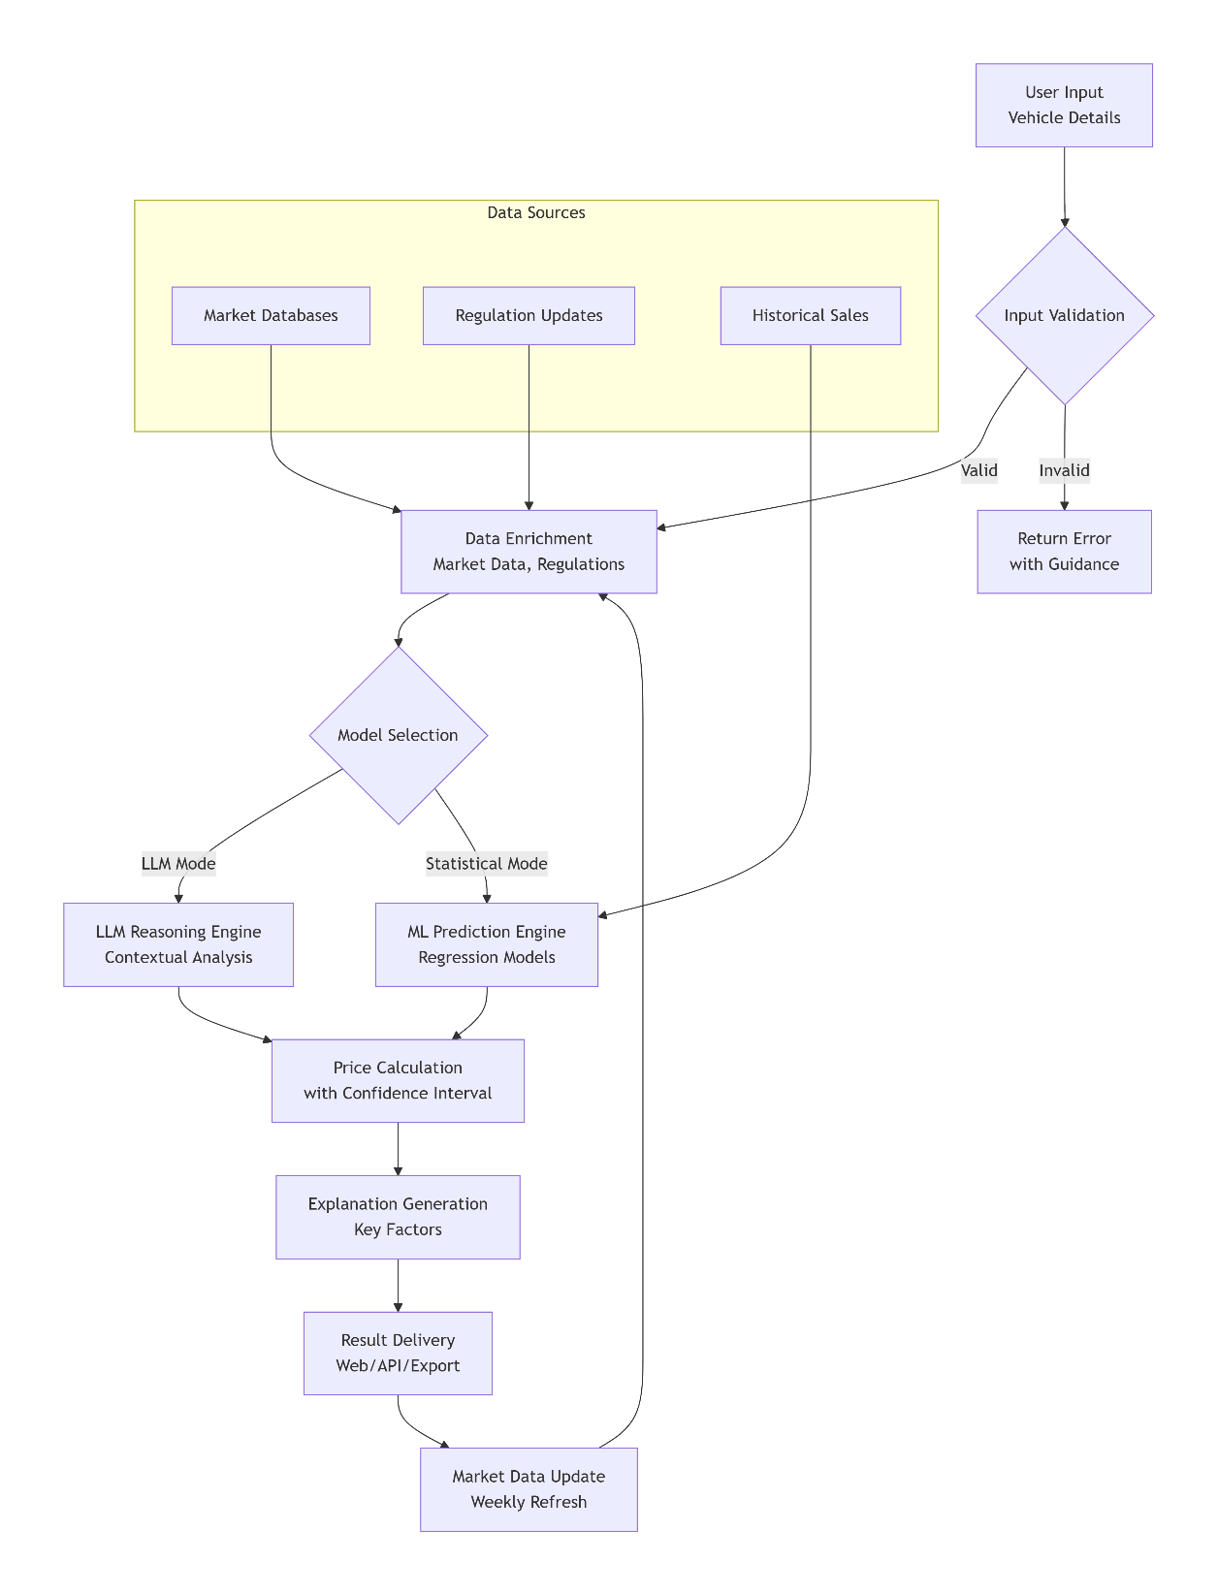

Figure 1: AutoPrice AI – Prediction System Architecture

5. Acceptance Criteria Tables
Table 1: Core Prediction Functionality
ID | Feature | Acceptance Criteria | Test Method
CP-01 | Single Prediction | Returns price within 8% of actual sale price for 90% of test cases. | Validate against historical sales data.
CP-02 | Required Fields | Requires brand, model, year, mileage, fuel type, emission class. | Submit forms with missing required fields.
CP-03 | Confidence Interval | Provides ±€ range with 95% confidence level for each prediction. | Statistical validation of confidence intervals.
CP-04 | Explanation | Lists top 3 price factors with impact percentages. | Verify factor ranking matches known market influences.
CP-05 | Supported Brands | Accurately processes all 8 supported brands with brand-specific depreciation curves. | Test each brand with multiple model examples.
Table 2: Data Processing & Integration
ID | Feature | Acceptance Criteria | Test Method
DI-01 | Batch Processing | Processes 100-vehicle CSV in <2 minutes with 95% prediction accuracy. | Upload test CSV files of varying sizes.
DI-02 | CSV Export | Outputs results with columns: VIN, Prediction, Confidence, KeyFactors. | Open exported CSV in Excel; validate structure.
DI-03 | API Integration | REST API returns predictions within 500ms for authenticated requests. | Load test API with 100 concurrent requests.
DI-04 | Data Enrichment | Automatically enriches basic inputs with market data, regional adjustments. | Compare predictions with/without enrichment.
DI-05 | Regulation Updates | Updates price calculations within 24 hours of emission regulation changes. | Simulate regulation change; monitor update timing.
Table 3: Performance & Compliance
ID | Attribute | Acceptance Criteria | Test Method
PC-01 | Prediction Accuracy | Maintains MAE (Mean Absolute Error) <€800 for vehicles under €50,000. | Cross-validation with holdout dataset.
PC-02 | Processing Speed | Single prediction <3 seconds, batch (100 vehicles) <2 minutes. | Performance testing with simulated loads.
PC-03 | Emission Compliance | Correctly applies Euro class adjustments per current EU regulations. | Test vehicles across different emission classes.
PC-04 | Model Consistency | LLM and statistical models produce predictions within 5% of each other. | Run parallel predictions with both models.
PC-05 | Regional Focus | Belgium market predictions achieve 3% higher accuracy than generic EU models. | Compare Belgium-specific vs generic predictions.
PC-06 | System Availability | 99% uptime during European business hours (8 AM-8 PM CET). | 30-day monitoring with uptime tracking.

6. Conclusion
This document provides comprehensive user stories and acceptance criteria for the AutoPrice AI system. By meeting these criteria, the platform will deliver accurate, regulation-aware price predictions that address the European used vehicle market's unique challenges. The system's dual-model approach, emission compliance integration, and batch processing capabilities position it as a specialized solution for individual sellers, dealerships, and marketplace platforms seeking transparent, data-driven vehicle valuation.
The acceptance criteria ensure the product delivers its core value: reducing pricing subjectivity, incorporating regulatory factors, and providing reliable market-aligned price references for European used vehicles.

