<Course Code> <Course Name> <Section> <Semester year>
CS/SE, SST, UMT
<Assignment #>

Submitted to
Syed Farooq Ali

Submitted By: Jawad ali
<Student Name, Id> f2022266686

Contents
Discussion Partner 3
Question 1 3
Code 3
Description of Code 3
Result 3
Input and Output Images 3
Question 2 5
Code 5
Description of Code 5
Result 5
Input and Output Images 5

Discussion Partner
Shaheer Zahid

Question 1
Implementation of Affine Warping Function

Code
function applyAffineTransforms()
inputFile = 'mecca06.pgm';
imageMatrix = double(imread(inputFile));
[height, width] = size(imageMatrix);
centerX = width / 2;
centerY = height / 2;

fileID = fopen('transformations_log.txt', 'w');

% Transformation A: X-Shear followed by 45° Counterclockwise Rotation
shearMatrix = createXShear(0.8);
rotationMatrix = createRotationMatrix(45, centerX, centerY);
combinedMatrix = rotationMatrix * shearMatrix;
logAndSaveTransformation(imageMatrix, combinedMatrix, 'A', 'a_transformed.pgm', fileID);

% Transformation B: 45° Rotation followed by X-Shear
combinedMatrix = shearMatrix * rotationMatrix;
logAndSaveTransformation(imageMatrix, combinedMatrix, 'B', 'b_transformed.pgm', fileID);

% Transformation C: Scale in X by factor of 2
scaleMatrix = createScalingMatrix(2, 1);
adjustedMatrix = adjustForCenter(scaleMatrix, centerX, centerY);
logAndSaveTransformation(imageMatrix, adjustedMatrix, 'C', 'c_transformed.pgm', fileID);

% Transformation D: Scale in Y by factor of 4
scaleMatrix = createScalingMatrix(1, 4);
adjustedMatrix = adjustForCenter(scaleMatrix, centerX, centerY);
logAndSaveTransformation(imageMatrix, adjustedMatrix, 'D', 'd_transformed.pgm', fileID);

% Transformation E: Shear X by 0.5
shearMatrix = createXShear(0.5);
adjustedMatrix = adjustForCenter(shearMatrix, centerX, centerY);
logAndSaveTransformation(imageMatrix, adjustedMatrix, 'E', 'e_transformed.pgm', fileID);

% Transformation F: Shear Y by 0.5
shearMatrix = createYShear(0.5);
adjustedMatrix = adjustForCenter(shearMatrix, centerX, centerY);
logAndSaveTransformation(imageMatrix, adjustedMatrix, 'F', 'f_transformed.pgm', fileID);

% Transformation G: Rotate by 45°
rotationMatrix = createRotationMatrix(45, centerX, centerY);
logAndSaveTransformation(imageMatrix, rotationMatrix, 'G', 'g_transformed.pgm', fileID);

% Transformation H: Rotate by 45° then Translate
rotationMatrix = createRotationMatrix(45, centerX, centerY);
translationMatrix = createTranslationMatrix(46.3387, -11.8712);
combinedMatrix = translationMatrix * rotationMatrix;
logAndSaveTransformation(imageMatrix, combinedMatrix, 'H', 'h_transformed.pgm', fileID);

fclose(fileID);
end

function T = createXShear(shearFactor)
T = [1 shearFactor 0; 0 1 0; 0 0 1];
end

function T = createYShear(shearFactor)
T = [1 0 0; shearFactor 1 0; 0 0 1];
end

function T = createScalingMatrix(scaleX, scaleY)
T = [scaleX 0 0; 0 scaleY 0; 0 0 1];
end

function T = createTranslationMatrix(tx, ty)
T = [1 0 tx; 0 1 ty; 0 0 1];
end

function T = createRotationMatrix(angle, cx, cy)
rad = deg2rad(angle);
T = [cos(rad) -sin(rad) 0; sin(rad) cos(rad) 0; 0 0 1];
T = adjustForCenter(T, cx, cy);
end

function T = adjustForCenter(M, cx, cy)
toOrigin = createTranslationMatrix(-cx, -cy);
back = createTranslationMatrix(cx, cy);
T = back * M * toOrigin;
end

function logAndSaveTransformation(imageMatrix, transformationMatrix, label, outputFileName, fileID)
fprintf(fileID, '--- %s Transformation Matrix ---\n', label);
fprintf(fileID, '%f %f %f\n%f %f %f\n%f %f %f\n\n', transformationMatrix');
transformedImage = applyBackwardWarp(imageMatrix, transformationMatrix);
imwrite(uint8(transformedImage), outputFileName, 'pgm');
end

function outputImage = applyBackwardWarp(inputImage, transformationMatrix)
invMatrix = inv(transformationMatrix);
[rows, cols] = size(inputImage);
outputImage = zeros(rows, cols);

for y = 1:rows
for x = 1:cols
src = invMatrix * [x; y; 1];
x0 = src(1);
y0 = src(2);

if x0 >= 1 && y0 >= 1 && x0 <= cols - 1 && y0 <= rows - 1
x1 = floor(x0); y1 = floor(y0);
dx = x0 - x1; dy = y0 - y1;

% Bilinear interpolation
pixelValue = (1-dx)*(1-dy)*inputImage(y1, x1) + ...
dx*(1-dy)*inputImage(y1, x1+1) + ...
(1-dx)*dy*inputImage(y1+1, x1) + ...
dx*dy*inputImage(y1+1, x1+1);
outputImage(y, x) = pixelValue;
end
end
end
end

Description of Code
The code reads a grayscale image and applies a series of affine transformations like shear, rotation, scaling, and translation using transformation matrices. Each transformation (A–H) modifies the image differently by combining or reordering basic operations. The center of the image is used to ensure accurate rotation and scaling. Each result is saved as an image file, and the applied transformation matrices are logged in a text file.

Result
The script produces 8 output images, each demonstrating a unique geometric transformation:
- A & B: Show the effect of changing the order of rotation and shear. The resulting images differ significantly, confirming that affine transformations are not commutative.
- C & D: Display horizontal and vertical stretching, respectively. Image C is stretched sideways, while D appears taller.
- E & F: Show shear along the X and Y axes, respectively. The grid-like appearance of the image is slanted in the respective directions.
- G: Presents a 45° rotation of the image around its center.
- H: Rotates the image and then shifts its position using translation.
Each output image is saved and can be compared with the original to study the visual effect of each transformation. The transformation matrices used are also logged in a text file for referenc

Input and Output Images
Part a
Input Image  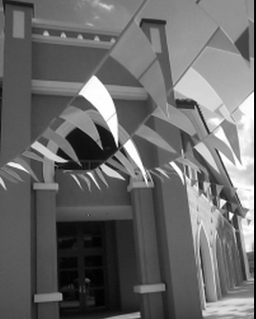 | Output Image  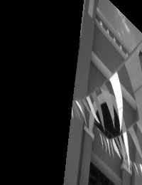

Part b
Input Image | Output Image  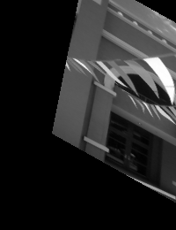

Part c
Input Image | Output Image  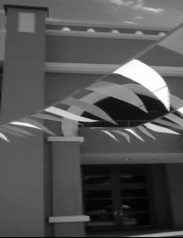

Part d
Input Image | Output Image  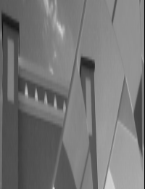

Part e
Input Image | Output Image  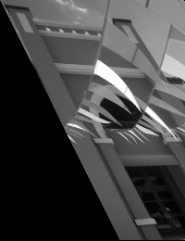

Part f
Input Image | Output Image  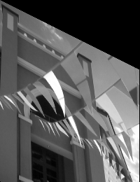

Part g
Input Image | Output Image  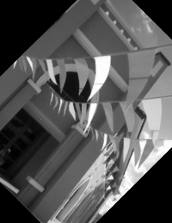

Part h
Input Image | Output Image  