PROJECT REPORT
E-Commerce Sales Analysis
Brazilian E-Commerce (Olist) Dataset

Prepared by | Jawad Ihsan
Project type | Individual project
Project duration | 5 days
Dataset source | Kaggle

Tools: Excel | Python (Pandas) | MySQL | Power BI

1. Executive Summary
This individual project analyses the Brazilian E-Commerce (Olist) dataset to explore sales performance, orders, customers, monthly revenue patterns, product categories, geographic performance and payment methods. Excel was used for initial data checking, Python with Pandas for data preparation and analysis, MySQL for business-question queries, and Power BI for an interactive dashboard.
The reported results include total sales of 9.23M, 54K orders and 43K unique customers. SP (São Paulo) was reported as the highest-sales state, Credit Card as the most popular payment method, and cama_mesa_banho as the highest-revenue product category.

2. Project Objectives
- Understand the structure and quality of an e-commerce dataset.
- Prepare data for analysis by checking missing values, duplicates and date fields.
- Answer practical business questions using SQL.
- Summarise sales and customer insights through a Power BI dashboard.
- Communicate findings that can support business decision-making.

3. Dataset Overview
Dataset: Brazilian E-Commerce (Olist), obtained from Kaggle. The project owner reported an original/final working dataset size of 118,299 rows and 32 columns. These counts are reproduced as supplied and have not been independently revalidated for this report.

4. Tools and Technologies
Tool | Project use
Excel | Initial data checking and review
Python (Pandas) | Data import, cleaning checks, date conversion and analysis
MySQL | SQL business questions using SELECT, GROUP BY and aggregate functions
Power BI | One-page dashboard, KPI cards, visuals and slicers/filters

5. Data Cleaning and Preparation
- Imported the e-commerce dataset and reviewed its structure.
- Removed columns considered unnecessary for the analysis.
- Checked the dataset for null values and duplicate records.
- Handled missing values and converted date fields to date format.
- Used Pandas for data preparation and analysis.
The exact column-by-column removal list and the specific missing-value treatment were not provided, so this report describes the confirmed workflow without naming unverified transformations.

6. SQL Business Questions and Results
Business question | Reported result
Total sales revenue | 9.23M
Total orders | 54K
Unique customers | 43K
Monthly sales revenue | Monthly trend analysed; monthly figures not supplied
Highest-revenue product category | cama_mesa_banho
Highest-sales state | SP (São Paulo)
Most popular payment method | Credit Card
Five SQL business questions were answered. The confirmed SQL techniques used were SELECT, GROUP BY and aggregate functions.

7. Power BI Dashboard
A one-page Power BI dashboard was developed with five KPI cards: Total Sales, Total Orders, Average Order Value (AOV), Average Review Score and Total Customers. Slicers/filters were also included. The dashboard topics discussed for the project include monthly sales trend, state-wise sales, payment method analysis, order status, product category performance and delivery performance.
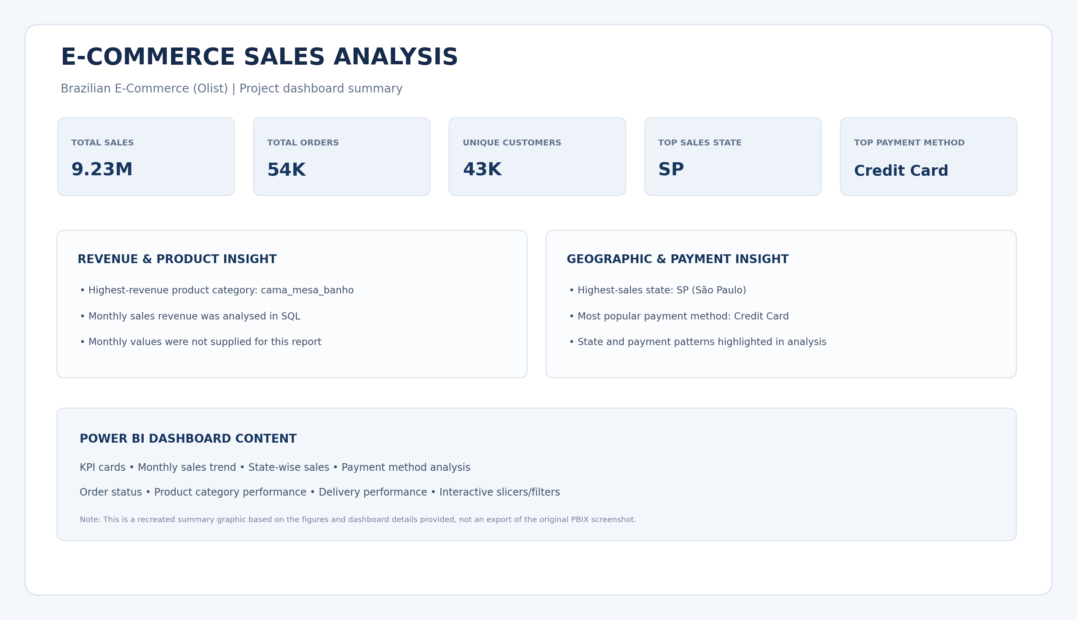
Figure 1. Recreated dashboard summary using confirmed project results.

8. Key Findings
- Reported total sales were 9.23M.
- The analysis covered 54K orders and 43K unique customers.
- SP (São Paulo) was the highest-sales state.
- Credit Card was the most popular payment method.
- The cama_mesa_banho category generated the highest reported revenue.
- Monthly sales revenue was analysed to review performance over time.

9. Recommendations
- Review the cama_mesa_banho category to understand which products and sellers contribute most to its revenue.
- Study sales performance in SP and compare it with other states to identify opportunities for regional growth.
- Continue monitoring payment-method preferences and ensure a smooth checkout experience for popular methods.
- Use monthly sales trends to identify seasonal peaks and periods that may need promotional support.
- Track delivery performance and customer review scores together to identify possible service improvements.

10. Conclusion
The E-Commerce Sales Analysis project demonstrates an end-to-end analytical workflow, from initial data checking and preparation to SQL-based business analysis and Power BI visualisation. The reported results show a total sales figure of 9.23M across 54K orders and 43K unique customers. SP was identified as the leading state by sales, Credit Card as the most popular payment method, and cama_mesa_banho as the highest-revenue product category. These findings can help a business focus on important product categories, regional performance and customer payment preferences. Further work could include deeper monthly trend analysis, customer segmentation, seller performance analysis and delivery-quality investigation.

11. Project Assistance and Acknowledgement
This was an individual project completed by Jawad Ihsan over five days. ChatGPT was used as a learning and problem-solving assistant during the project, including support with Python/Pandas, SQL concepts and Power BI dashboard development. The project work and reported findings are presented by the project owner.

12. Limitations and Reporting Notes
- The report uses project figures and findings supplied by the project owner; the underlying dataset was not independently reprocessed for this document.
- Monthly revenue values, average order value, average review score and average delivery time were not provided as final figures, so they are not invented here.
- The dashboard image included in this report is a recreated summary graphic based on confirmed figures and described dashboard elements, not the original Power BI screenshot or PBIX export.

