**Name: Jawad Chughtai**

**Reg# 122100**

**Course: Advanced programming**

**LAB # 3**

**Introduction**

We have learned how to install R and R studio. It is used to make graphs. Data analysis can also be done using R.

**Approach**

* Install R and R Studio.
* Build first application using R
* Installing the data set ‘mtcars’
* Drawing different graphs on the dataset ‘mtcars’

**Graph 1**

**Code**

attach(mtcars)

plot(wt, mpg, main = "Milege vs Weight", xlab = "Weight", ylab = "Mileage",

+pch = 18, col = "red")

text(wt, mpg, row.names(mtcars), cex = 0.6, pos = 4, col = "black")

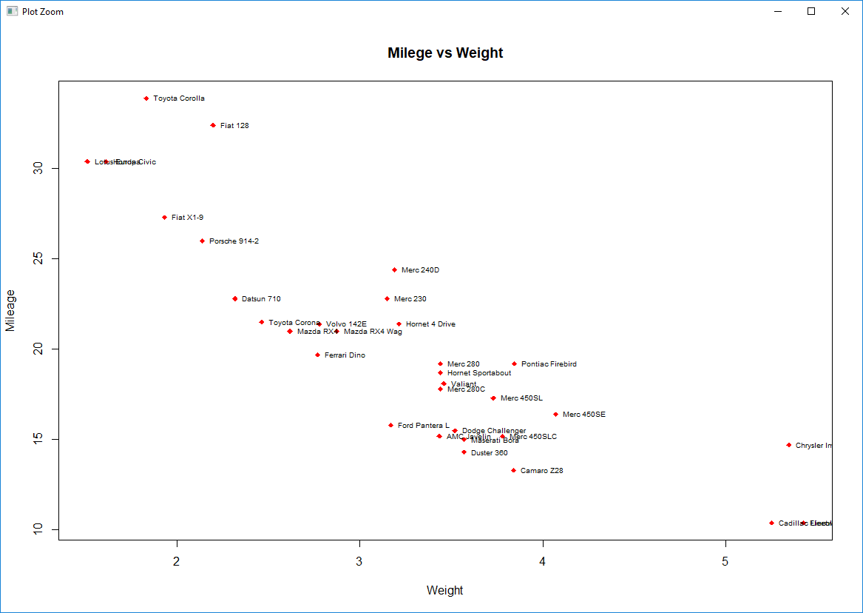

**Graph 2**

**Code**

attach(mtcars)

plot(hp, mpg, main = "Horsepower vs Mileage", xlab = "Horsepower", ylab = "Mileage",

+ pch = 15, col = "black")

text(hp, mpg, row.names(mtcars), cex = 0.6, pos = 4, col = "red")

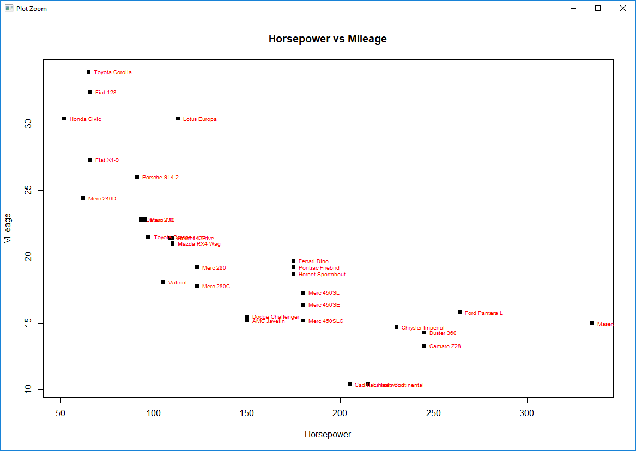

**Graph 3:**

**Code**

boxplot(disp, hp, main = "Displacement vs Horsepower", xlab = "Displacement", ylab = "Horsepower",

+ pch = 15, col = "blue")

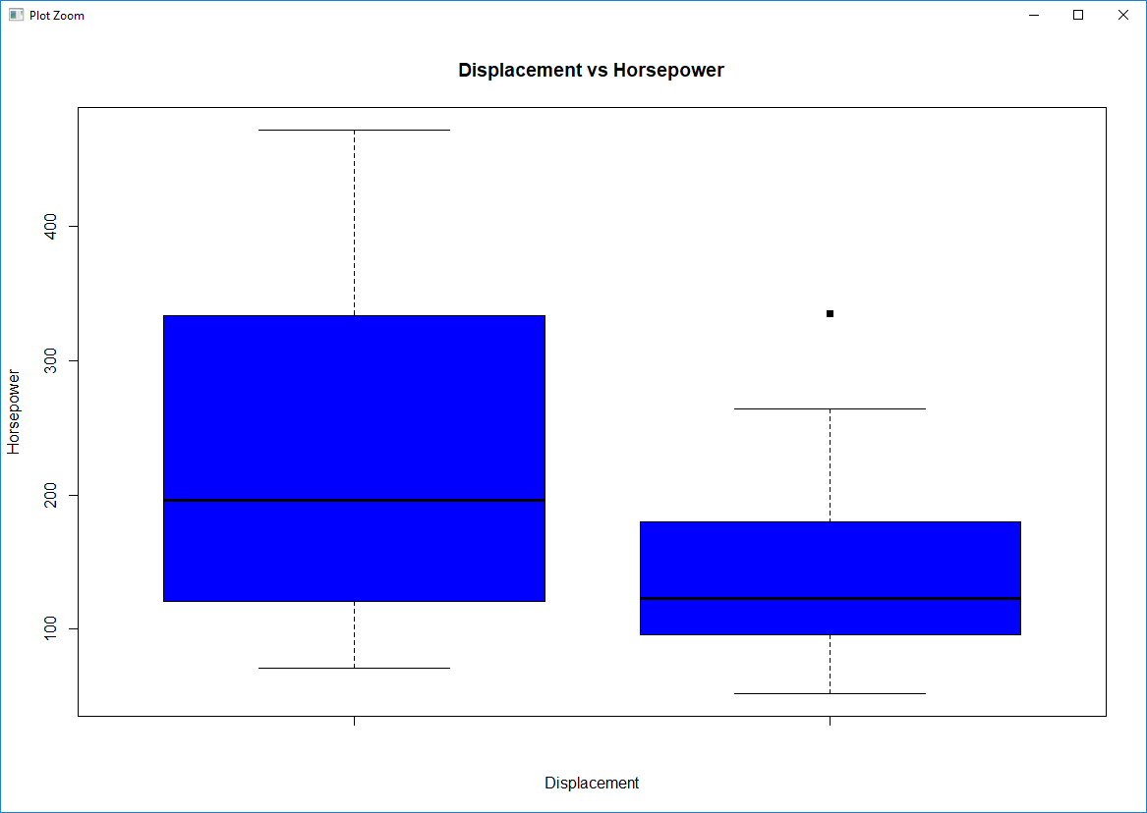

**Link on GitHub:**