Name: Abdul Jawad

ID: 1708588

Github: <https://github.com/jawadefaj/CSE_264_CV>

Part 1:

All the graphs are in data.xlsx file sheet 1. I have used excels regression on my data. Blue channel is in odd shape. That is because I think the paper, I used has bluish effect and not proper Lambertian. You will find corresponding image in the folder named above the sheet. I used pixel 3A and the light source is bright light. I used cloudy mode for white balancing.

Part 2:

The photos are organized as follows: (all the images are properly annotated in the data file). Each row is for different illuminant. First 15, WB = 0, last 15, WB = 1.

Light sources:

* sunlight
* fluorescent
* tungsten bulb

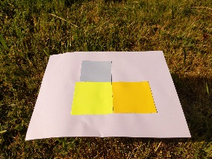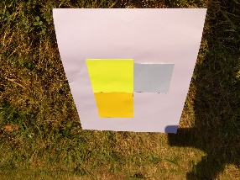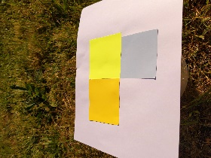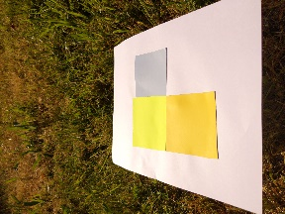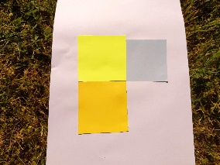

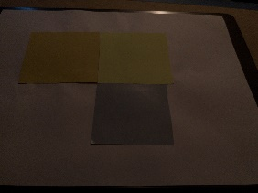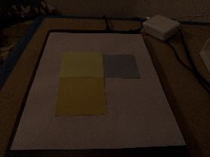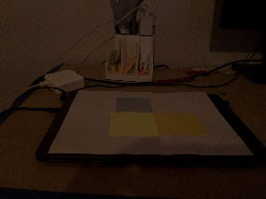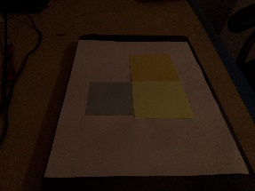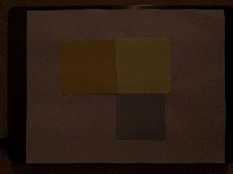

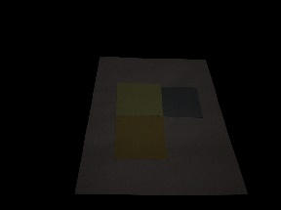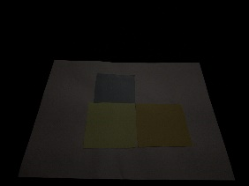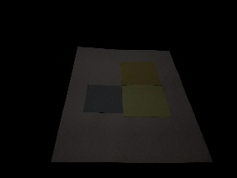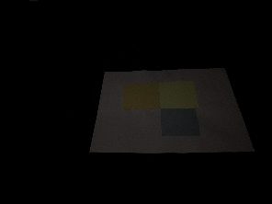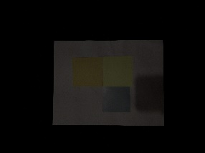

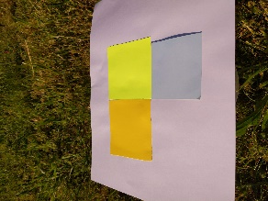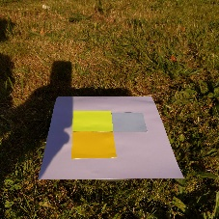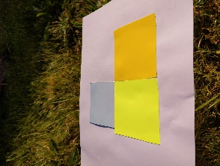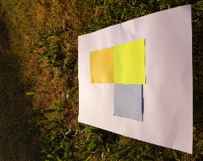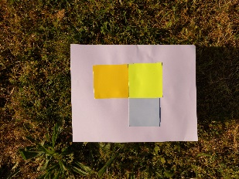

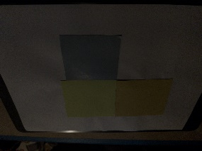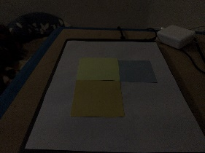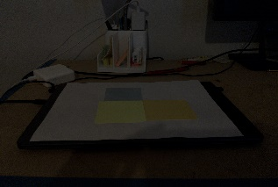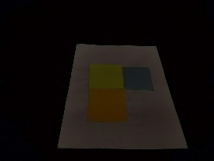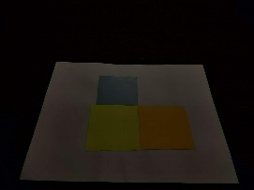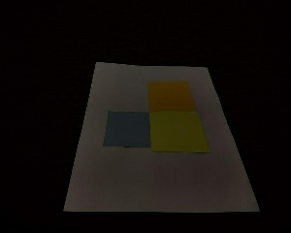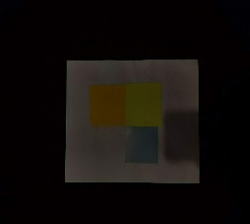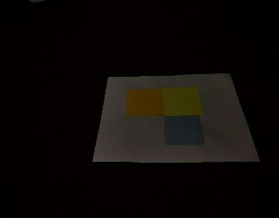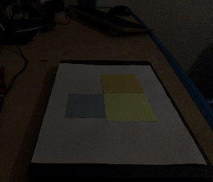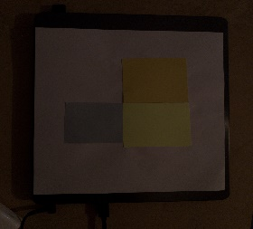

Part 3:

Python file for generating the graph is in folder Task3 named plot.py. First image without white balance. Second on with white balance.

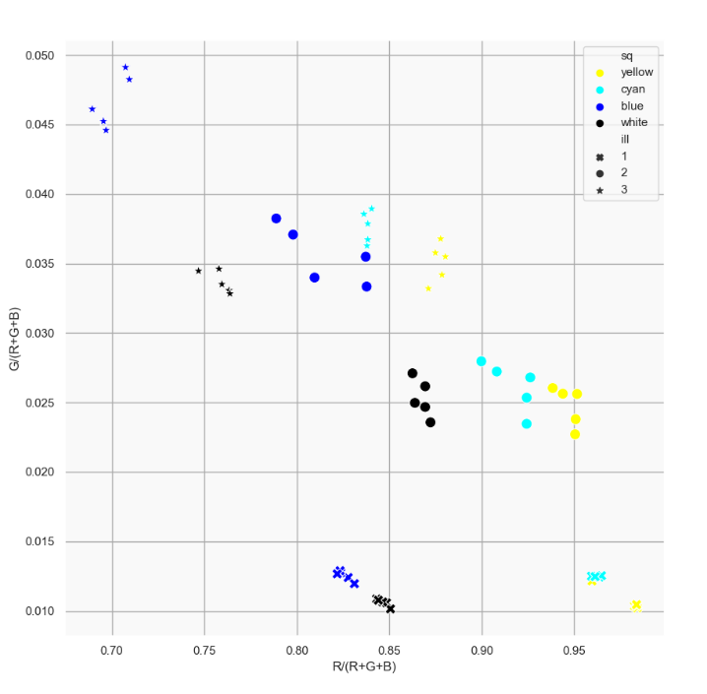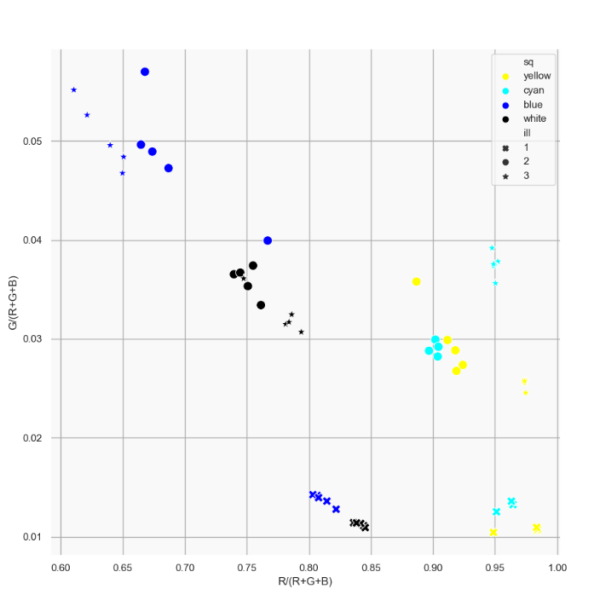

I cut those colored surfaces from a magazine and those were glossy (more than white paper). It is the reason why those points are dispersed. Some point for different illuminant overlapped. This is because I have used close color. (Yellow, Neon(Brightest yellow), white(bluish), sky blue). Besides elevation changed and due to the glossiness of the paper, the points are sparse.

Part 4:

Python file for this part is named plotpart4.py.

White patch method:

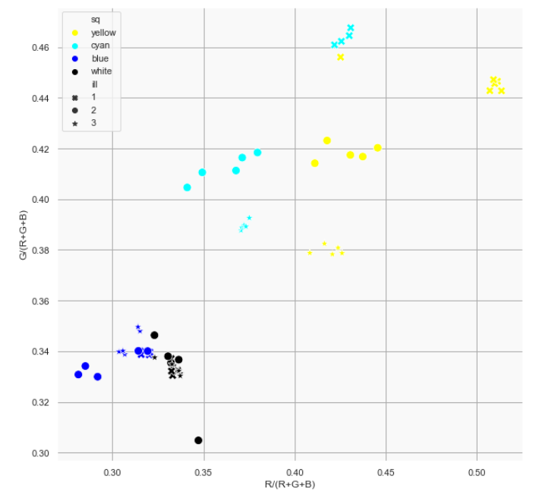

* Due to the whiteness of the chosen color, all points after the white patch method are diagonally dense.
* For illuminant 2, values for R channel decreased highly. That is because of the tungsten light.

Gray world method:

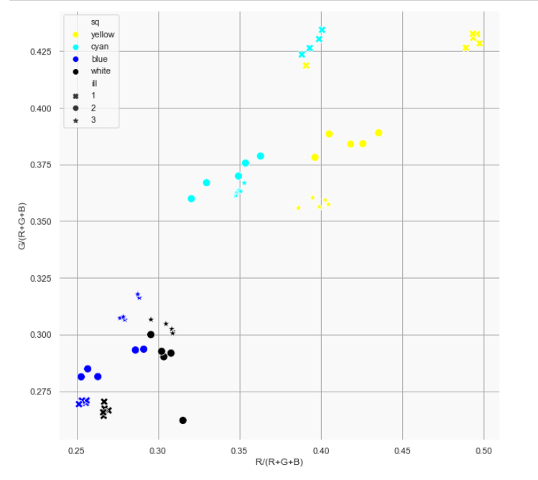

* Other patches remained almost same as white patch method except the white patch itself. Clusters are more sparse than the white patch method.

White world method:

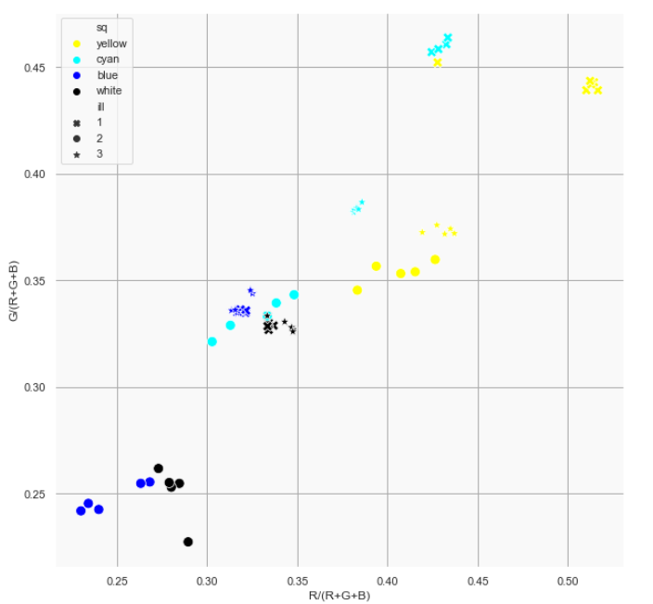

* White world gives better result overall. I think that is because of the color similarity of the patch.

Overall, the points are scattered for the following reason:

* Color similarity of the patch
* Glossiness (due to paper type)
* Ambient light during third light source.
* Elevation change while taking photos in sunlight.