Vertex AI Layout to JSON System
  - Developer and User Manual
Status | Phase 1 handoff manual
Audience | Developer or operator with no prior project knowledge
Verified | 16 September 2026
Repository | https://github.com/jawadengineer12/gcp-vertex-ai
Stable service | https://layout-test-api-6euw7jlffa-uc.a.run.app
Original backend source | 3ceb766
Focused fix source | 230e505
Active revision | layout-test-api-continue-20260916 (100% traffic)

Scope: Phase 1 operation, maintenance, corpus extension, validation, troubleshooting, and Cloud Run deployment. Phase 2 is excluded.

How to use this manual
This manual is both an onboarding guide and an operating procedure. A first-time developer should complete Sections 2 through 5 before changing data or code. Sections 7 and 8 describe the two sample-maintenance paths. Sections 9 through 12 are the release and incident procedures. Section 14 is a guided exercise that combines the entire workflow.
Reader goal | Start here | Stop when
Run an existing layout locally | Sections 2 through 5 | A validated JSON file is written and passes the schema check
Add a normal example | Section 7 | Corpus and vector counts match and tests pass
Add a relationship-aware example | Section 8 | Special-case normalization and dedicated tests pass
Deploy an approved change | Sections 9 through 11 | The candidate and stable URLs both pass the API checks
Investigate a 502 | Section 12 | The request ID identifies the failing stage and the corrected revision is verified

Before using any command: read the label immediately above it. Commands run either in PowerShell at the repository root, inside the activated Python environment, or in the Google Cloud project. Do not paste placeholder values literally.

1. Purpose and verified behavior
The system converts natural-language page-layout intent into strict LayoutProject JSON for a downstream Adobe/InDesign-oriented workflow. It combines deterministic layout planning, template/requirement resolution, retrieval, reranking, Gemini generation, bounded retries, and validation.
User prompt → deterministic layout plan/template requirements → information collection
→ local vector + BM25 retrieval → CrossEncoder reranking → sanitized context
→ Gemini JSON generation → strict validation
→ bounded retry → local/GCS output and optional publisher handoff
Entry point | File | Purpose
CLI | main.py | Local interactive generation; optional --publish.
API | api.py | Stateless FastAPI local/Cloud Run test surface.
Layout Generator | streamlit_app.py | Internal Streamlit client for the API.
Pipeline | services/pipeline_service.py | Shared retrieval, generation, repair, retry, validation.
Schema | schemas/layout_schema.py | Strict converter-facing contract.

1.1 What the system does
The caller chooses one of four templates and describes the desired page or spread. The system resolves required information, finds similar examples, generates strict JSON, repairs deterministic constraint violations where possible, and rejects output that still violates the schema or layout rules. A successful response is suitable for the downstream converter contract. It is not automatically published unless the caller explicitly enables publishing.

1.2 What the system does not do
- It does not fine-tune Gemini when a developer adds examples.
- It does not manage the external publisher dashboard or retrieve a generated PDF.
- It does not deploy a managed Vertex Vector Search index. Retrieval uses the checked-in vector JSON file.
- It does not store API conversation state. A caller must resubmit the original prompt, request ID, and answers after a needs_input response. The Streamlit client retains those values in its own session while the page remains open.
- It does not include Phase 2 implementation.

1.3 Processing stages and ownership
Stage | Primary implementation | Observable success
Configuration | core/config.py | Required project, region, paths, and optional output settings load without an exception
Requirement resolution | services/requirement_agent.py | Known values and missing fields match the selected template and deterministic plan
Retrieval and reranking | services/retrieval_service.py | Candidate examples are returned and reranked
Generation | services/generation_service.py | Gemini returns a JSON-compatible object
Validation | services/validation_service.py | Schema and production layout rules pass
Output | services/output_service.py | Validated JSON is returned and optionally saved or handed to the publisher

2. Access and first-day checklist

2.1 Repository
1. Open https://github.com/jawadengineer12/gcp-vertex-ai.
2. Confirm repository jawadengineer12/gcp-vertex-ai. It was publicly visible at verification time.
3. Confirm default branch main.
4. Clone and enter it:
git clone https://github.com/jawadengineer12/gcp-vertex-ai.git
cd gcp-vertex-ai
git branch --show-current
Success: README.md, pyproject.toml, api.py, main.py, services/, scripts/, and tests/ exist. If cloning fails, verify URL, proxy policy, and GitHub access.
The repository was public when this manual was verified. That does not establish whether a named person has been formally onboarded or should retain access if the repository becomes private. The project owner must confirm the GitHub organization, repository owner, and the client account that should administer access. Do not place personal access tokens in .env or repository files.
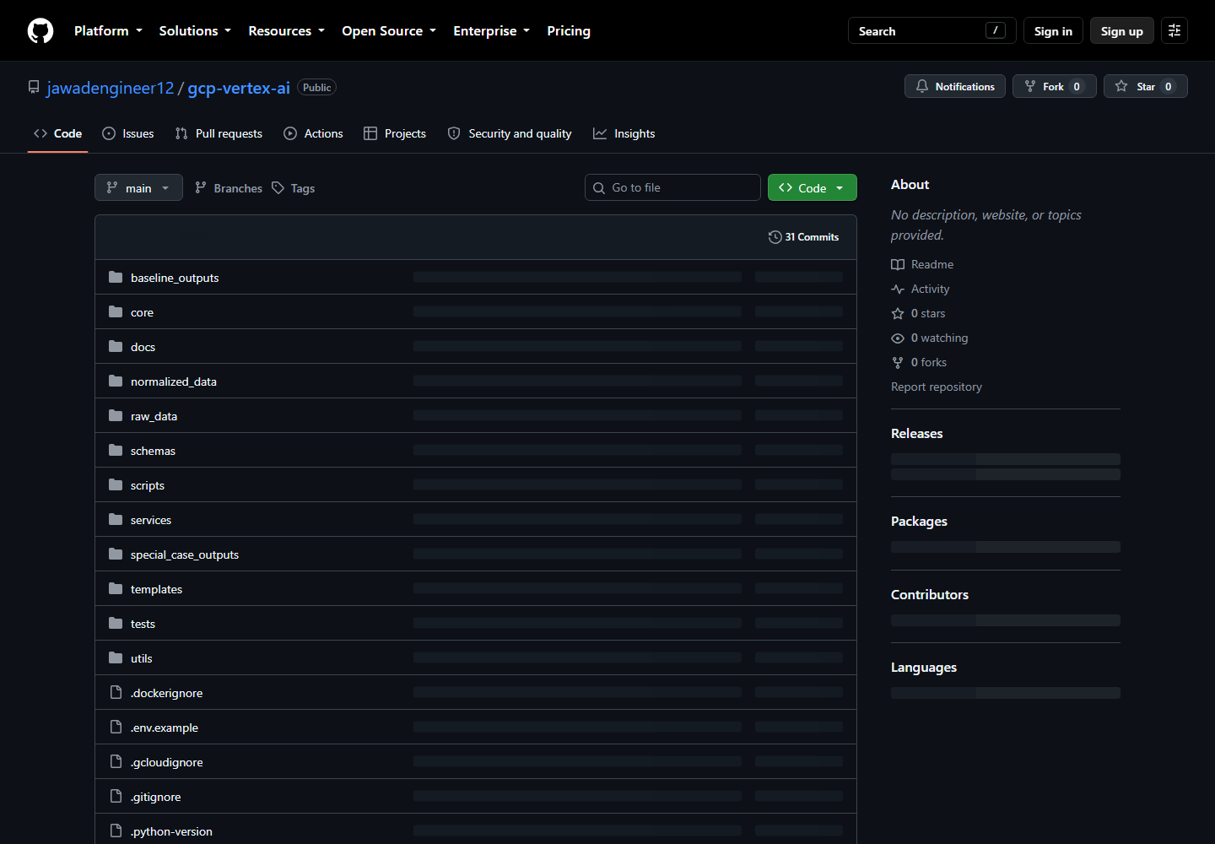
Verified repository, default branch, and top-level folders.

2.2 Branch
A branch is a named Git line of work used to isolate and review a change.
git switch main
git pull --ff-only
git switch -c feature/add-layout-example
Success: git branch --show-current prints the new branch.
Work only on the focused branch. Before committing, use git status --short to distinguish intended files from local archives, generated output, credentials, or unrelated user changes. A branch is not delivered merely because it exists locally; it must be pushed and reviewed or merged according to the team process.

2.3 Google Cloud
Item | Verified value
Project | angular-lambda-421320
Region/service | us-central1 / layout-test-api
Runtime identity | vertex-layout-dev-sa@angular-lambda-421320.iam.gserviceaccount.com
Inbound key | Secret Manager layout-api-key; value never documented.
Publisher key | Separate Secret Manager publisher-api-key.

Run in Windows PowerShell:
gcloud.cmd auth login
gcloud.cmd config set project angular-lambda-421320
gcloud.cmd auth application-default login
gcloud.cmd config get-value project
Success: the last command prints the project and gcloud.cmd auth list --filter=status:ACTIVE shows the intended account. Local Python uses ADC; Cloud Run uses its service identity. If access fails, ask the project administrator. The repository verifies roles/aiplatform.user for model calls and Secret Manager accessor for mapped runtime secrets; organization-specific deployer roles were not fully enumerated.
Actor | Minimum responsibility | Verification
Local developer | Clone or pull the repository, create ADC, call Vertex in the approved project | gcloud auth list, project check, and a non-publishing generation
Cloud Run deployer | Build source, deploy revisions, update traffic, and read logs | Zero-traffic deployment and service description succeed
Runtime service account | Call Vertex and access only mapped secrets or approved GCS objects | Revision configuration shows the expected identity and the application completes a request
Secret administrator | Create or rotate secret versions without exposing values | Secret metadata and numeric version mapping are correct

The exact human IAM roles depend on the client organization. Typical permissions may be delivered through custom roles or groups, so this manual does not invent role bindings. Ask the project administrator for least-privilege access if any verification command returns Permission Denied.
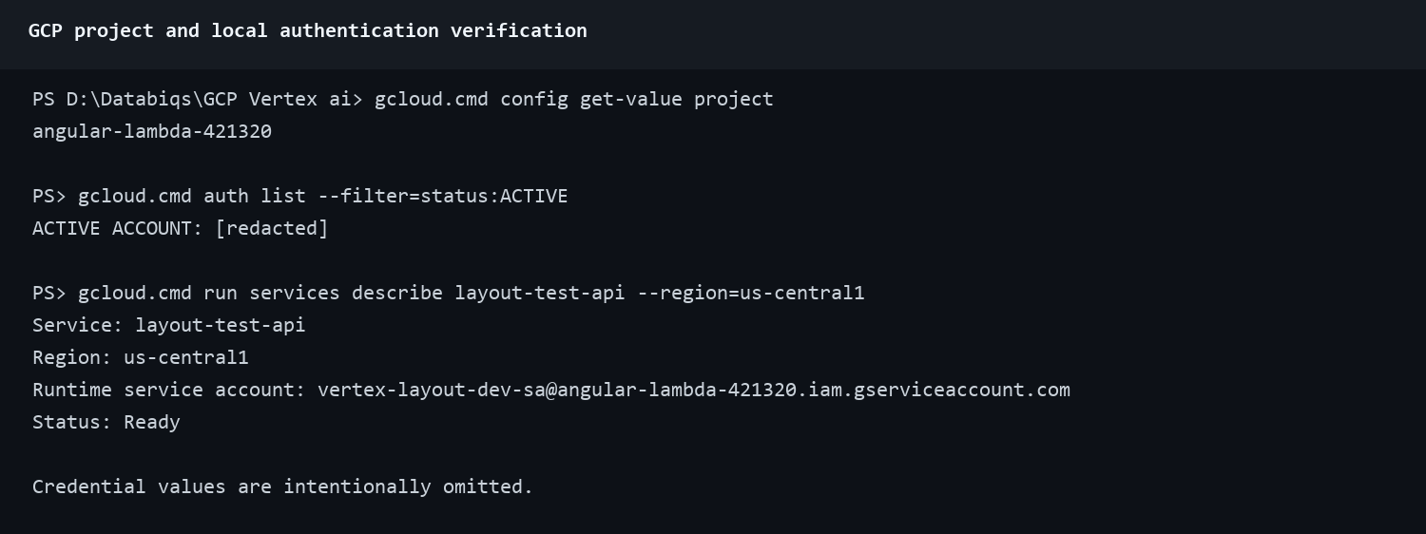
Redacted project, authentication, service, region, and runtime identity verification.

3. Repository map
Path | Purpose
core/ | Configuration, logging, Vertex client.
services/ | Primary application implementation.
schemas/ | Strict Pydantic layout contract.
templates/ | Four template definitions.
raw_data/ | Training workbook, font list, source/reference data.
normalized_data/layout_prompt_library_updated.json | Normal retrieval corpus (32 verified examples).
normalized_data/vertex_index_data.json | Checked-in vectors (32 × 768 verified).
normalized_data/special_case_library.json | Three whole-project relationship cases.
scripts/ | Import, normalization, embedding, retrieval, and index utilities.
tests/ | 58 verified tests after the focused retry change.
baseline_outputs/ | Four checked-in normal JSON baselines.
special_case_outputs/ | Three checked-in special-case JSON outputs.

3.1 Files excluded from deployment or Git
.gitignore and .gcloudignore serve different purposes. Git exclusions prevent local credentials, environments, logs, and generated files from entering source control. Cloud build exclusions keep unnecessary or sensitive files out of the deployment archive. The current Cloud Run source upload excludes .git, environment files, secret directories, key files, virtual environments, caches, logs, generated outputs, documentation, tests, most raw data, archives, and alternate vector-index files. It explicitly retains raw_data/Font List.csv and the configured normalized_data/vertex_index_data.json.
Checked-in items can still be excluded from the Cloud Run archive. For example, the tracked training workbook remains available to developers but is not required by the API container. Verify exclusions with gcloud meta list-files-for-upload before a release. Stop if it prints a credential, .env, private key, or unexpected archive.

4. Local setup

4.1 Virtual environment
Start: PowerShell in the repository root.
python -m venv .venv
.\.venv\Scripts\Activate.ps1
python --version
python -c "import sys; print(sys.executable)"
Success: prompt normally shows (.venv), Python is 3.12+, and executable is under .venv\Scripts. If activation is blocked, use .\.venv\Scripts\python.exe explicitly or follow administrator policy; do not weaken machine-wide security settings.
Activation applies only to the current terminal. Open a new terminal only when a procedure explicitly calls for another process, such as starting the API and Streamlit separately. Activate the environment in each terminal, or prefix commands with uv run. Do not run maintenance scripts from scripts/; remain at the repository root so relative paths resolve correctly.

4.2 Dependencies
uv sync --frozen
uv lock --check
Success: both exit 0. The XLSX importer uses pandas and requires an Excel engine available in the environment. Alternative: python -m pip install -e .; prefer the lockfile for reproducible handoff work. If pandas reports a missing openpyxl engine, install it in the active environment before running the importer; it is not declared directly by this baseline.
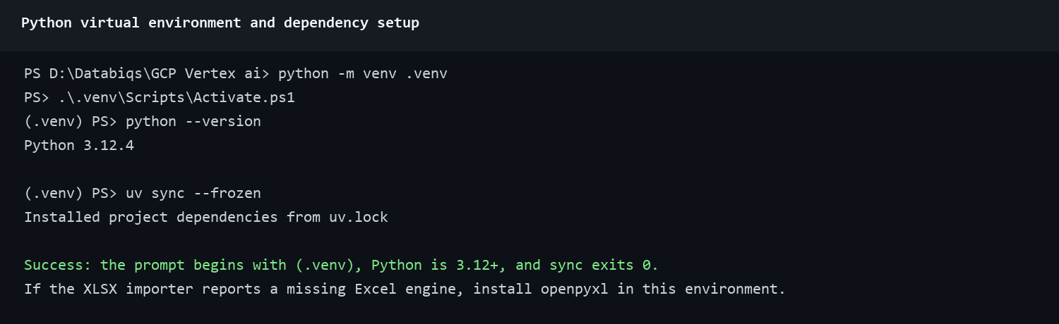
Verified environment, Python, lock synchronization, and XLSX dependency.

4.3 Configuration
Copy-Item .env.example .env
Set at least GOOGLE_CLOUD_PROJECT=angular-lambda-421320 and GOOGLE_CLOUD_LOCATION=us-central1. Never commit .env.
Key | Behavior/default
PROMPT_LIBRARY_PATH | normalized_data/layout_prompt_library_updated.json
SPECIAL_CASE_LIBRARY_PATH | normalized_data/special_case_library.json
EXCEL_FILE_PATH | raw_data/trainingData_Local.xlsx
VERTEX_INDEX_DATA_PATH | normalized_data/vertex_index_data.json
FONT_LIST_PATH | raw_data/Font List.csv
OUTPUT_FILE | outputs/generated_layout.json
LOCAL_OUTPUT | Default true.
GCS_BUCKET/GCS_OBJECT_NAME | Optional GCS destination.
LAYOUT_API_KEY/LAYOUT_API_URL | Inbound API secret and Streamlit target.
PUBLISHER_API_URL/PUBLISHER_API_KEY | Both required for explicit publisher handoff.
ENABLE_RUN_TRACE | Default true locally; traces under outputs/run_traces.
MAX_RETRIES | Default 3 generation attempts.

Configuration precedence: shell environment variables override values loaded from .env. Cloud Run uses revision environment variables and Secret Manager mappings rather than the developer's local file. When troubleshooting, verify the environment where the failing process actually runs.
Configuration type | Local development | Cloud Run
GCP identity | Application Default Credentials created by gcloud auth application-default login | Attached service account
Non-secret settings | .env or current PowerShell session | Revision environment variables
Inbound and publisher keys | Current session or uncommitted .env | Pinned Secret Manager versions
Output files | Repository-relative local path or approved GCS bucket | Ephemeral container file system or approved GCS bucket

4.4 First checks
python -m unittest tests.test_layout_pipeline.LocalVectorStoreTests
python -m unittest discover tests
python tests/validate_prompt_library.py
Verified: 3 vector tests pass; full suite reports 58 tests OK; prompt validation reports 32 examples and 108 Article assets.

5. Run locally

5.1 CLI
python main.py
Select a template, enter a prompt, answer requested fields, and wait. Success: Validated JSON saved (local): ... and the configured output exists. Failure after all retries exits 1 and prints validation details; inspect logs/pipeline.log. Publishing is opt-in only:
python main.py --publish

5.2 API
Terminal 1:
$env:LAYOUT_API_KEY="replace-with-a-long-random-local-value"
$env:ENABLE_RUN_TRACE="false"
uv run uvicorn api:app --host 0.0.0.0 --port 8080 --workers 1
Success: Uvicorn listens and Invoke-RestMethod http://localhost:8080/health returns {"status":"ok"}. Protected routes without the key should return 401.
Fully resolved request:
$headers=@{"x-api-key"=$env:LAYOUT_API_KEY}
$body=@{request_id=$null;prompt="Create a one-page article titled Service Verification";template_id="magazine_article";answers=@{article_title="Service Verification";author_name="Test Operator";hero_image_url=$null};publish=$false}|ConvertTo-Json -Depth 5
Invoke-RestMethod http://localhost:8080/v1/layouts -Method Post -Headers $headers -ContentType application/json -Body $body
Success: HTTP 200, status=completed, non-empty layout, and publisher=null. HTTP 200 needs_input is normal: resend the original prompt, returned request ID, and all answers. The API stores no session.
HTTP result | Meaning | Operator action
200 needs_input | The request is valid but required template fields are unresolved | Enter the fields and select Submit details; the Streamlit client resubmits the same request ID
200 completed | Generation and validation passed | Inspect or download the layout; confirm publisher is null when publishing was disabled
502 generation_failed, retryable=true | Generation exhausted its configured validation attempts | The Layout Generator shows Continue; selecting it starts a fresh request with the saved prompt, template, answers, and publish choice
502 publish_failed | Validated layout exists but outbound handoff failed | Preserve the layout and request ID; check publisher state before retrying because a duplicate job is possible
401 | Inbound API key missing or incorrect | Load the current secret without printing it
422 | Request body, template, answer, or URL violates the API contract | Read the structured detail and correct the request
503 | Server or publisher configuration is unavailable | Correct configuration; the retry Continue control is not shown for this response

5.3 Layout Generator
Terminal 2:
$env:LAYOUT_API_URL="http://localhost:8080"
uv run streamlit run streamlit_app.py
Open http://localhost:8501, enter the API URL and same password-masked key, select Connect, choose a template, enter a prompt, keep Publish off, and submit. Success: Connected, four templates, “Layout generated successfully. It was not published.”, timings, validated JSON, and Download JSON.

5.3.1 Missing information
1. Choose Magazine Article.
2. Enter a prompt that omits its title or author.
3. Select Generate layout.
4. Expect HTTP 200 needs_input. The interface displays A few more details. This is expected, not an error.
5. Enter the requested values and select Submit details. This control is intentionally not labeled Continue.
Success: generation begins using the same request ID and accumulated answers. If submission returns 422, inspect the answer type and require HTTPS for image URLs.

5.3.2 Continue after exhausted generation attempts
1. If Gemini cannot produce a valid layout after the configured attempts, the API returns HTTP 502 with status=generation_failed, the failed request ID, and retryable=true.
2. The Layout Generator preserves the prompt, selected template, accumulated answers, and publish choice in its session.
3. The page displays: “This layout is taking longer than expected and could not be completed after the available attempts.”
4. Select Continue.
5. The client sends the saved input again with request_id=null. The API creates a fresh request ID and runs the complete pipeline again.
Success: Continue is absent before a retryable generation failure; it appears after the structured 502 response; the fresh request completes; the retry panel disappears; validated JSON and Download JSON are available. Closing or refreshing the Streamlit page may discard the locally retained input. Publisher failures do not show Continue because blind resubmission could create a duplicate external job.
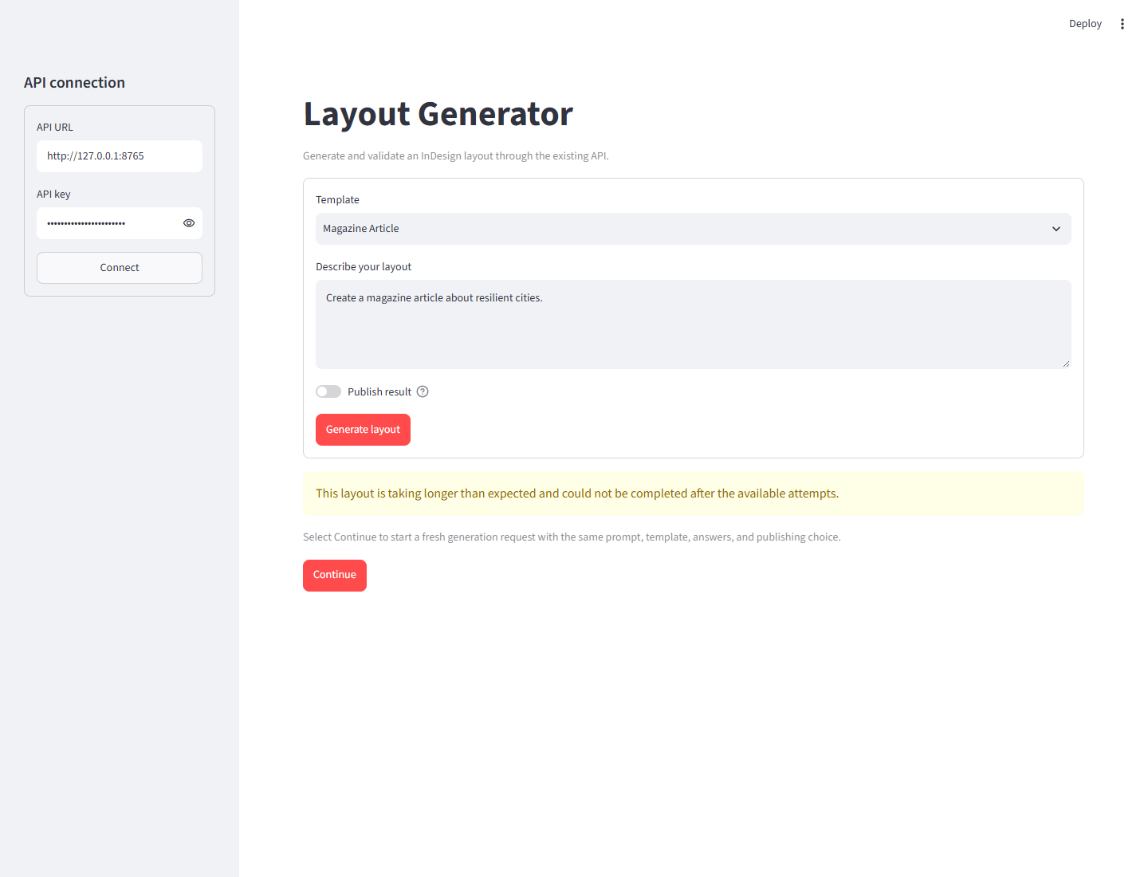
Deterministic verification of the retry screen after an exhausted generation response. Continue appears only after the structured 502 failure.
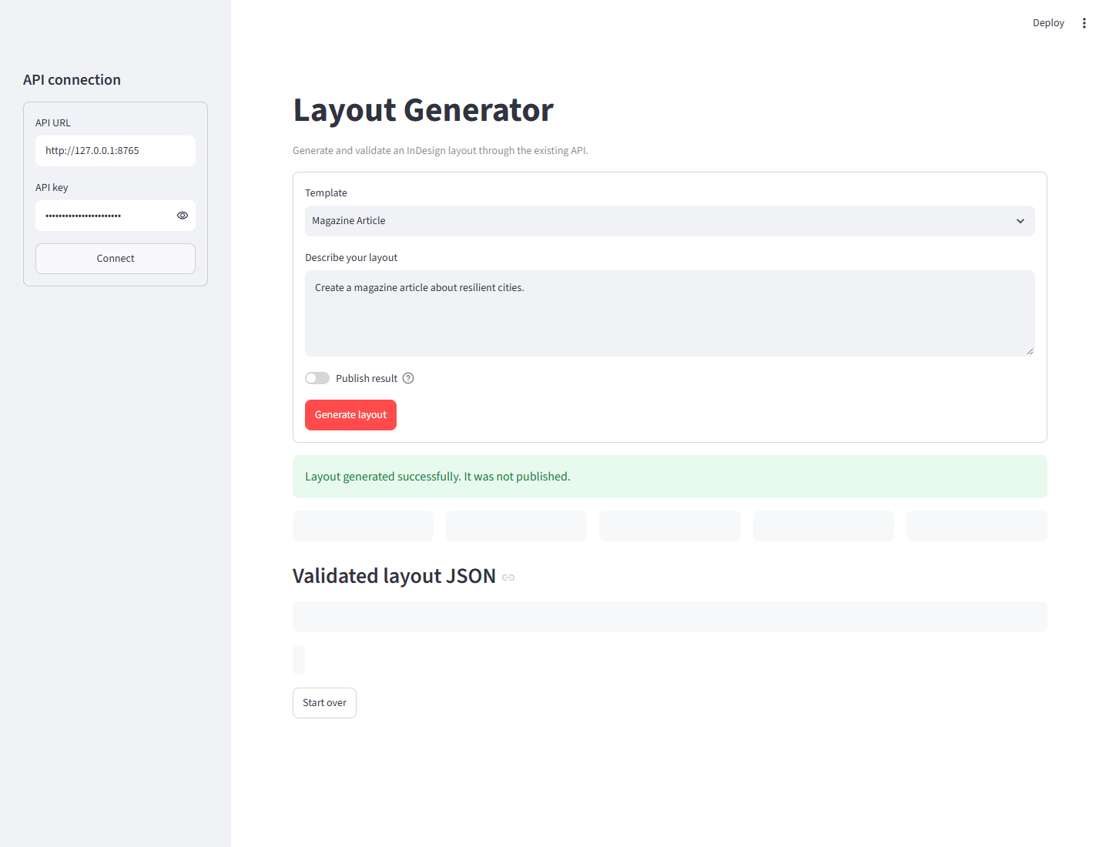
The fresh request completed with the saved prompt and answers. The retry panel disappeared and publishing remained disabled.
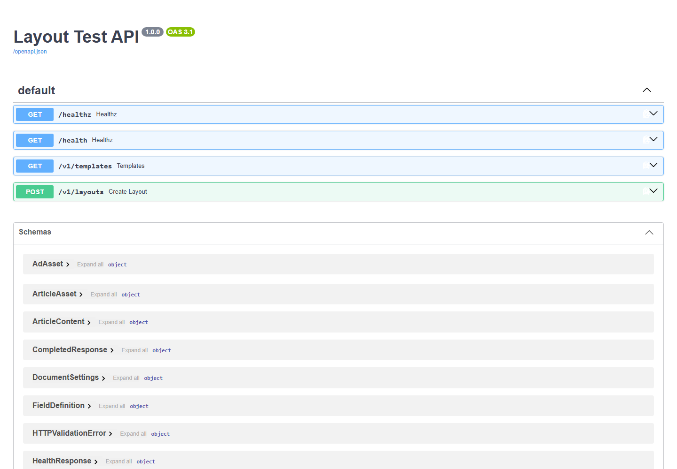
Deployed Swagger page showing health, templates, and layout routes.

6. Templates, special cases, and validation
The source of truth for the four templates (magazine_article, editorial_page, cover_page, advertisement) is templates/*.json and protected GET /v1/templates. Deterministic layout planning may add prompt-specific image requirements.
A special case is a whole layout whose meaning depends on relationships: same-page threaded text, cross-page threaded text, or cross-page image spread. Source: normalized_data/special_case_library.json; outputs: special_case_outputs/; tests: tests/test_special_cases/.
Validation covers strict schema/types, page indexes, safe margins/bleed, approved fonts, Article overlap, threading links and autoFit, image spreads, page counts, and explicit position/size/column constraints.
python -c "import json; from pathlib import Path; from schemas.layout_schema import LayoutProject; p=Path('baseline_outputs/normal_cover.json'); LayoutProject.model_validate(json.loads(p.read_text(encoding='utf-8'))); print('VALID:',p)"
Success: prints VALID and exits 0. This checks schema; runtime ValidationService additionally applies layout rules. API status=completed and CLI validated-save text are the clearest end-to-end success criteria.
Validation layer | What it proves | What failure looks like
Pydantic schema | Required fields, strict types, enum values, nested assets, and forbidden extra fields are correct | The command exits nonzero with the failing field path
Production validation service | Page bounds, margins, overlap, fonts, threading, spreads, page count, and prompt constraints are safe | The pipeline records validation errors and retries with cumulative feedback
API completion | The shared pipeline produced a schema-valid and rule-valid layout | Status is not completed, or the layout is missing
Baseline regression | Checked-in representative outputs remain accepted by the current schema and rules | A baseline or special output fails its test or validation command

Do not treat valid JSON syntax alone as success. A file can parse with json.loads and still violate the converter schema, use an unapproved font, overlap Article frames, place an asset outside page bounds, or break a text thread.
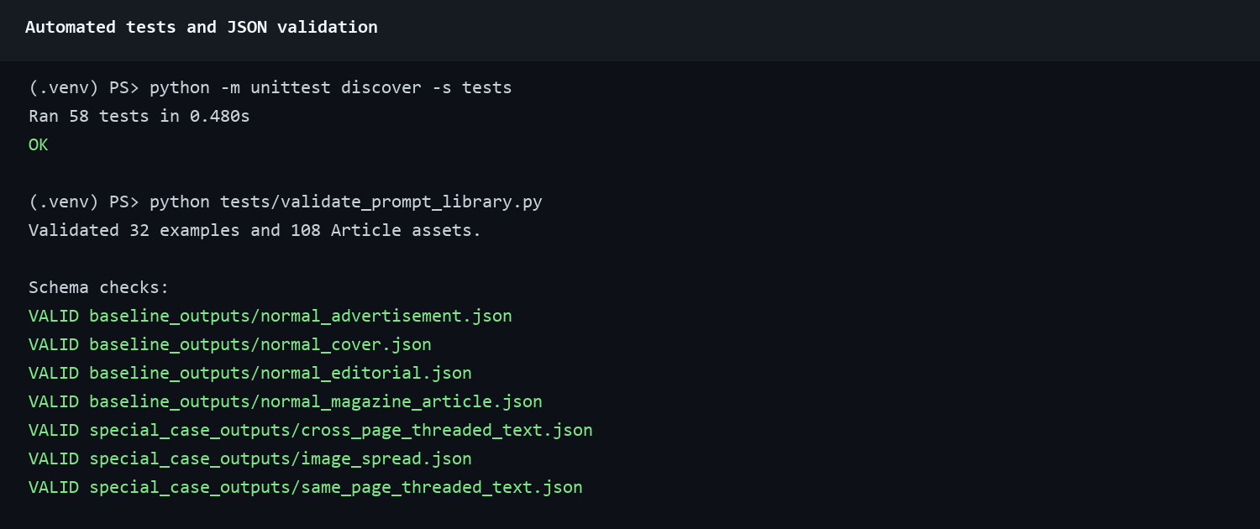
Verified 74-test suite, prompt validation, and checked-in JSON baselines/special outputs.

7. Normal sample workflow

7.1 Prepare and append
1. Start on a branch.
2. Create raw_data/new_examples.xlsx.
3. Include exact columns Page Number, Generated Prompt (Input), and Expected JSON Object (Output). The expected value must parse as JSON and contain a non-empty assets array.
4. Point the session to it and append:
$env:EXCEL_FILE_PATH="raw_data/new_examples.xlsx"
python -m scripts.append_excel_to_prompt_library
Success: Appended count equals intended rows, no unexpected invalid/empty rows, and total rises by that count. The verified one-row exercise increased 32 to 33. File/path failures mean the environment variable or working directory is wrong; Excel-engine errors mean dependencies are stale.
The checked-in source workbook is raw_data/trainingData_Local.xlsx. Verification found 92 rows and these six columns:
Column | Use
Project Name | Human-readable source grouping
Source JSON File | Reference to the originating expected JSON
Source PDF File | Reference to the originating PDF when available
Page Number | Source page or page context
Generated Prompt (Input) | Retrieval intent stored as intent
Expected JSON Object (Output) | JSON object stored as expected_output

The importer requires the exact workbook headers, including the parenthetical Input and Output text. Do not use the full 92-row workbook as an append source unless every row is intentionally new. The script appends valid rows and does not deduplicate them.
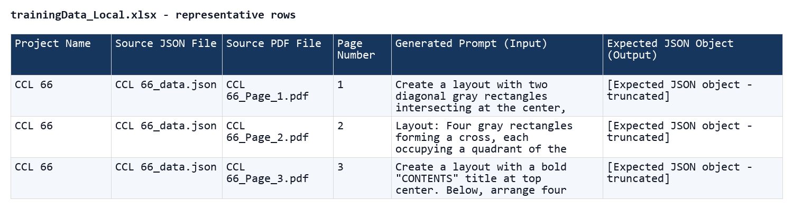
Representative rows from the tracked XLSX workbook. Expected JSON cells are deliberately truncated for readability.
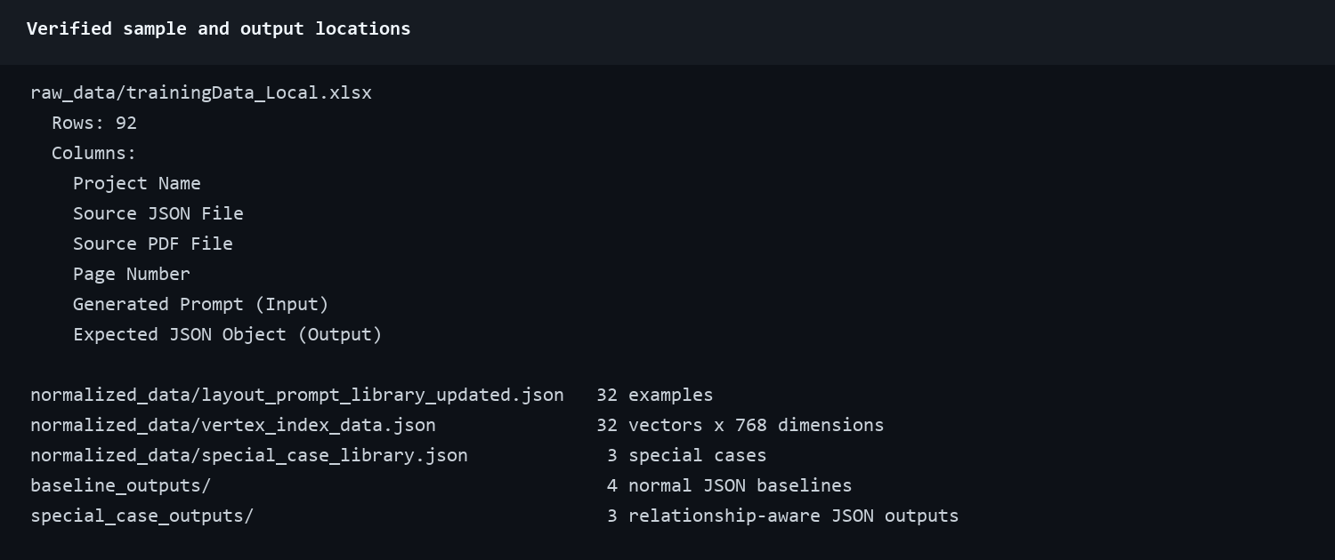
Verified workbook columns and all sample/vector/output locations.

7.2 Validate and normalize
python tests/validate_prompt_library.py
python -m scripts.normalize_prompt_library `
--source normalized_data/layout_prompt_library_updated.json `
--output normalized_data/layout_prompt_library_sanitized.json
Runtime retrieval already sanitizes selected examples. The normalization command creates a review artifact; it does not update configured vectors unless configuration is deliberately changed.
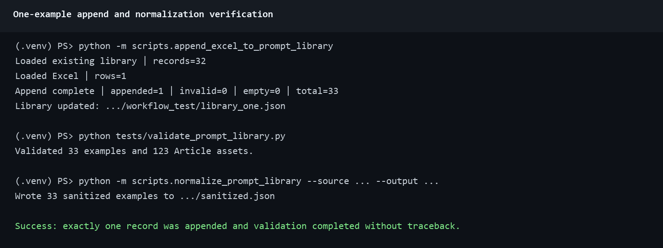
Verified one-row append, validation, and normal-library normalization in an isolated copy.

7.3 Regenerate embeddings
python -m scripts.prepare_vertex_vector_data
python -m unittest tests.test_layout_pipeline.LocalVectorStoreTests
The first command is a paid Vertex text-embedding-004 call over the full configured library. It rewrites VERTEX_INDEX_DATA_PATH. Success: vector count equals library count, command prints Success, and 3 alignment/dimension tests pass. Commit the prompt library and vector file together.
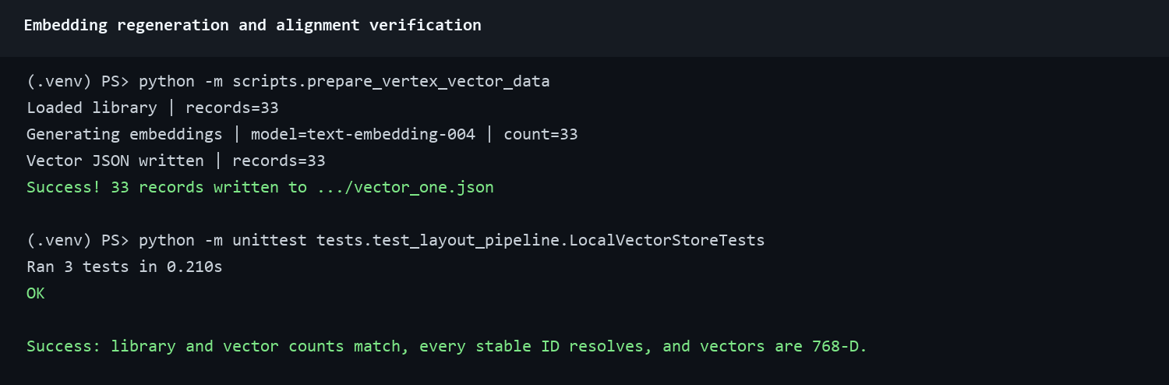
Verified embedding regeneration to a temporary file and vector alignment.

8. Special-case workflow
1. Document the relationship and evidence.
2. Add/update a whole-project case in a source JSON matching the special library shape.
3. Normalize to a candidate file:
python -m scripts.normalize_special_case_library `
--source path/to/special_cases_source.json `
--output normalized_data/special_case_library.candidate.json
4. Diff candidate against normalized_data/special_case_library.json.
5. Replace only after review and add/update dedicated tests.
6. Run:
python -m unittest tests.test_special_cases.test_special_cases
python -m unittest discover tests
Success: both end in OK. Special-case changes do not require normal-library embeddings unless the normal prompt library also changed.

9. Representative generation and release checks
The baseline repository has no demo_readiness_matrix or demo_generation_matrix module. Do not document or run those names on this branch. Use the checked-in deterministic suites first:
python -m unittest tests.test_special_cases.test_special_cases
python -m unittest discover -s tests
Success: the special-case suite and full suite report OK. For a live representative generation, run python main.py, choose the relevant template, use a reviewed prompt, and keep publishing disabled. A live success requires the validated-save message and a saved JSON that passes the Section 6 schema check. Vertex/Gemini calls may cost money and vary between runs.
uv lock --check
python -m unittest discover tests
python tests/validate_prompt_library.py
python -m unittest tests.test_layout_pipeline.LocalVectorStoreTests
git diff --check

10. Local, GCS, and publisher output

10.1 Local
LOCAL_OUTPUT=true
OUTPUT_FILE=outputs/generated_layout.json
The CLI writes validated JSON. outputs/ and traces are excluded from Git.
Local output is the safest development default. The API returns the layout in its response and does not use OUTPUT_FILE as a persistent API store. Cloud Run container storage is ephemeral, so use GCS or the response body when an artifact must survive a revision restart.

10.2 GCS
LOCAL_OUTPUT=false
GCS_BUCKET=approved-bucket-name
GCS_OBJECT_NAME=layouts/generated_layout.json
Success: CLI prints Validated JSON saved (gcs): gs://.... On failure check bucket, project, IAM, and object path. This is unrelated to checked-in baseline/special output folders.

10.3 Publisher handoff
Publisher handoff is the optional outbound POST to the external queue configured by PUBLISHER_API_URL. OutputService wraps validated JSON as var documentData=<json>; in the publisher envelope. The repository does not include the external dashboard, job polling, or PDF retrieval workflow.
PUBLISHER_API_URL=https://approved-publisher-host/path
PUBLISHER_API_KEY=[secure value; never committed]
PUBLISHER_CREATED_BY=approved-operator-identity
PUBLISHER_PROJECT=approved-project-label
CLI requires --publish; API requires "publish":true. Keep false for smoke tests. Publisher failure returns 502 with status=publish_failed and preserves the validated layout.
A publisher smoke test is not equivalent to generation verification. It creates an outbound request that may create a real queued job. Before enabling it, identify the approved publisher environment, expected created-by/project metadata, who will confirm the queue entry, and how duplicate submissions are handled. If the API reports publish_failed, do not blindly resubmit because the remote system may have accepted the first request before the response failed.

11. Cloud Run deployment

11.1 Preflight
1. Use a reviewed commit in the repository root. Record git rev-parse HEAD.
2. Run Section 9 checks.
3. Require a clean git status --short. Do not deploy an uncommitted working tree.
4. Confirm .gcloudignore excludes secrets, .env, keys, archives, venv, logs, outputs, docs/tests, and raw data except font list.
5. Compare the candidate against the approved baseline with git diff --name-status 3ceb766..HEAD. For this fix, runtime changes must be limited to api.py, streamlit_app.py, and their focused tests.
6. Record the source commit in the release record. Do not add or change a Cloud Run environment variable merely for documentation.

11.2 Zero-traffic candidate
$PROJECT_ID="angular-lambda-421320"
$REGION="us-central1"
$SERVICE="layout-test-api"
$SUFFIX="candidate-YYYYMMDD"
gcloud.cmd run deploy $SERVICE --source . `
--project=$PROJECT_ID --region=$REGION `
--revision-suffix=$SUFFIX --tag=$SUFFIX --no-traffic `
--quiet
Success: build SUCCESS, revision Ready, candidate URL printed, and stable traffic remains unchanged. Updating the existing service inherits configuration. For a new service/project, follow GCP_SETUP.md for APIs, runtime identity, pinned secrets, CPU/memory/concurrency/timeout/scale.

11.3 Candidate verification
1. GET /health without key: 200 and status ok. Use this path for external Cloud Run checks.
2. GET /v1/templates with key from Secret Manager: 200 and four templates.
3. POST fully resolved publish=false: 200, completed, non-empty validated layout, publisher null.
4. Confirm missing information uses Submit details, not Continue.
5. Run the deterministic failed-first/success-second UI check: require structured generation failure, Continue, a fresh request ID, and successful validated output with the saved answers.
6. Filter logs by request ID; expect retrieval, reranking, generation, validation, pipeline, request.
7. Compare candidate CPU, memory, service account, environment variables, and secret mappings with the approved baseline revision before promotion.
Cloud Run health-path note: the application defines both /health and /healthz, and both pass locally. In the verified Cloud Run environment, Google Front End returned its own HTML 404 for the exact external /healthz path while /health, /docs, and /openapi.json reached the application. No /healthz request appeared in container logs. Use /health as the documented external probe.

11.4 Promote and verify stable URL
gcloud.cmd run services update-traffic layout-test-api `
--project=angular-lambda-421320 --region=us-central1 `
--to-revisions=layout-test-api-$SUFFIX=100
Repeat health, templates, and publish=false generation on the stable URL. Record revision, request ID, timings, and rollback target.
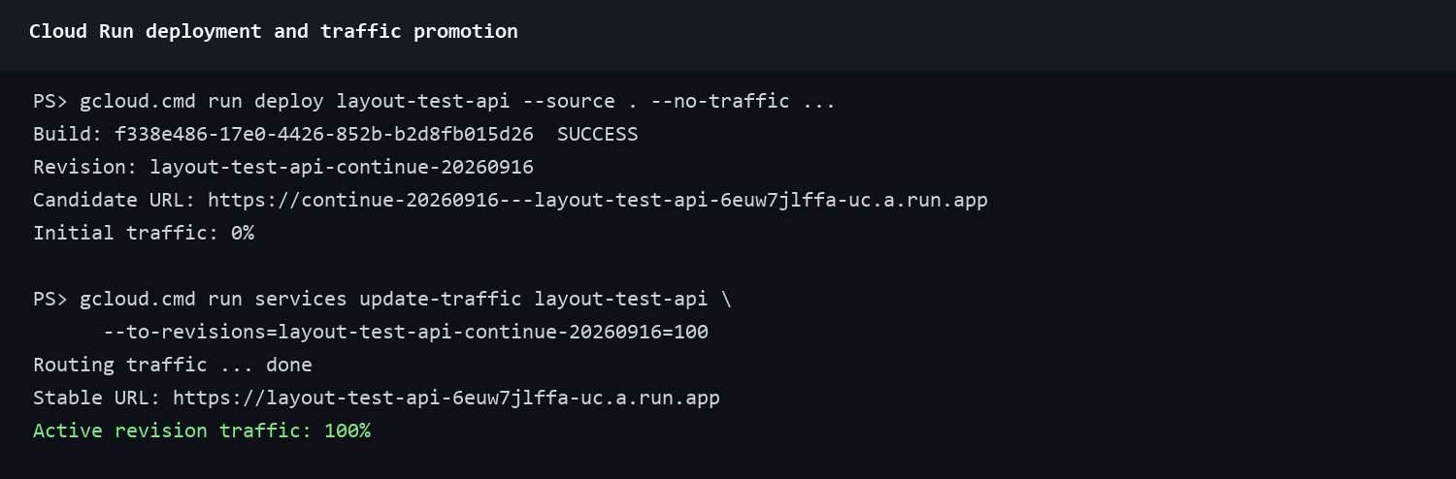
Verified zero-traffic deployment and 100% promotion.
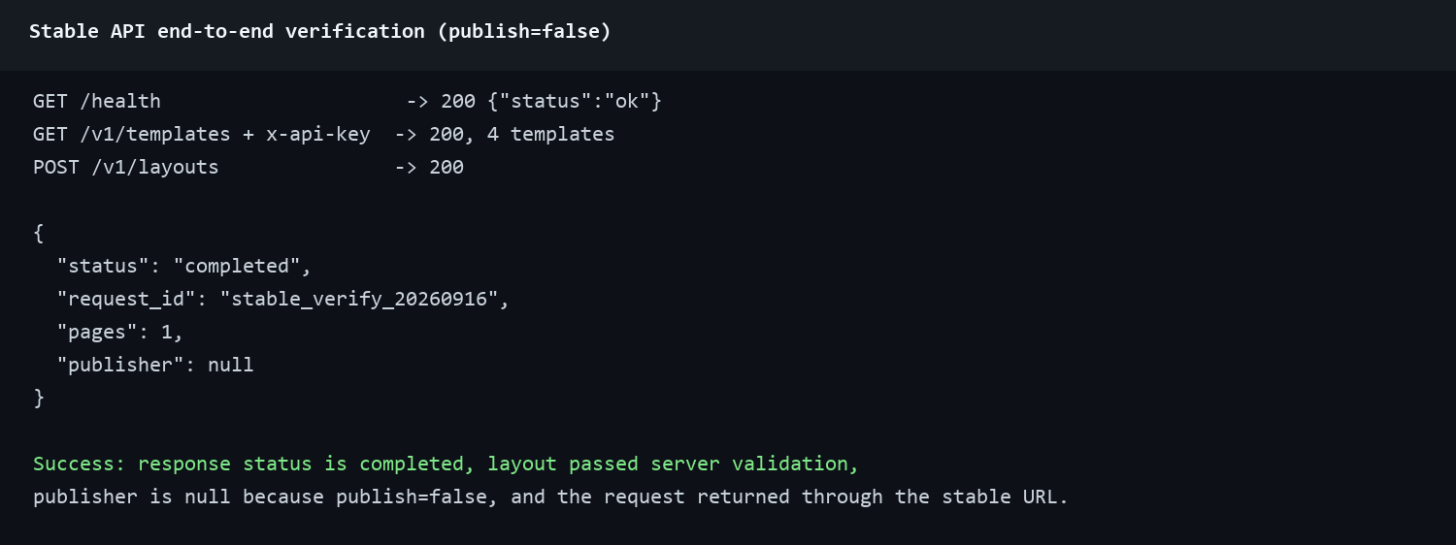
Verified stable API end-to-end success with publishing disabled.

12. HTTP 502 investigation and resolution

12.1 Evidence and cause
Cloud Run request logs contained three representative 502 responses on 28 August 2026 against layout-test-api-constraints-20260824, after 98-251 seconds. Request req_6d1f20f4077949b392a61a2fb541a3c7 logged three Gemini generations, three validation retries, then pipeline failed retries=2. No publisher stage ran. The reported failures were therefore stochastic Gemini JSON/schema/geometry failures before publisher handoff, not a Cloud Run network gateway fault.
The approved production baseline was revision layout-test-api-constraints-20260824, verified against Git commit 3ceb766. A later, broader revision was temporarily promoted during documentation work; it was returned to 0% and the approved baseline was restored to 100% before this focused fix was prepared.

12.2 Applied fix and verification
1. Kept the complete backend at the approved 3ceb766 baseline.
2. Changed exhausted generation failures from a generic HTTP detail response to structured JSON containing status=generation_failed, retryable=true, the request ID, and the error description.
3. Changed Streamlit to retain the prompt, template, accumulated answers, and publish choice after only that response.
4. Reserved Continue for this retryable generation-failure state. Missing required fields now use Submit details.
5. Continue resubmits the saved input with no request ID, which makes the API create a fresh request and run the full pipeline again.
6. Kept publisher failure separate; it preserves validated JSON but does not offer an automatic Continue because the remote queue may already have accepted the job.
7. Ran 58 tests. A deterministic browser scenario returned needs_input, then a retryable 502, then HTTP 200 completed; it asserted that the failed request carried all answers and the Continue request carried the same answers with request_id=null.
8. Confirmed with git diff --name-only 3ceb766 that no semantic-planning, generation, retrieval, validation, dependency, Docker, or runtime-configuration implementation was added.
Status: the requested Continue recovery is implemented, verified locally, deployed as layout-test-api-continue-20260916, and receiving 100% traffic. Candidate and stable checks passed: health 200, structured generation-failure schema present, four templates, and a real publish=false generation completed with one validated page and publisher=null. The rollback target is layout-test-api-constraints-20260824.
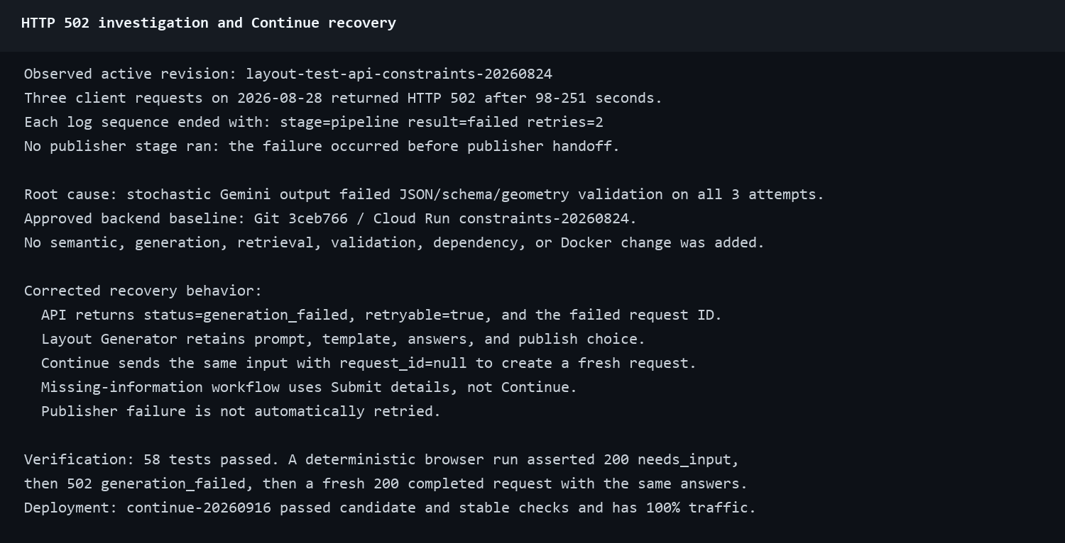
Redacted root-cause evidence, fixes, and verification.

12.3 Troubleshooting
Symptom | Action
Google HTML 404 for /healthz with no request log | Use /health for the external Cloud Run probe; verify /docs or /openapi.json if routing is still uncertain.
Application JSON 404 | Verify the requested application path against /openapi.json.
401 | Verify x-api-key, secure local variable, and active secret mapping.
422 | Read detail: strict type/extra field/unknown template or answer/unsafe image URL.
502 generation_failed | Record the failed request ID. In Layout Generator, select Continue once to create a fresh request with the retained input. If it fails repeatedly, stop and inspect logs rather than looping indefinitely.
503 | Verify revision environment variables, secret mappings, IAM, publisher configuration, and Vertex availability. Correct configuration before retrying.
502 publish_failed | Preserve layout/request ID; do not blindly retry because the queue may have accepted it.
Long request | Check the 900-second client/service timeout and filter logs by request ID to identify the slow stage.

gcloud.cmd logging read `
'resource.type="cloud_run_revision" AND resource.labels.service_name="layout-test-api" AND jsonPayload.request_id="<REQUEST_ID>"' `
--project=angular-lambda-421320 --limit=50 `
--format='table(timestamp,resource.labels.revision_name,jsonPayload.stage,jsonPayload.result,jsonPayload.retries,jsonPayload.duration_ms)'

13. Security
- Never put live keys, service-account private keys, passwords, or tokens in Git, screenshots, documents, URLs, or shared Postman values.
- Use separate Secret Manager secrets for inbound and publisher keys; pin numeric versions.
- Use ADC locally and Cloud Run identity in deployment; do not package service-account JSON.
- Keep publish=false until a real publisher job is authorized.
- Use only public HTTPS image URLs.
- The client review PDF contained an API-key value. Treat it as exposed and rotate it in a coordinated change. It was not rotated here because that would invalidate existing client configuration.

14. Guided end-to-end exercise

1 - Access and branch
git clone https://github.com/jawadengineer12/gcp-vertex-ai.git
cd gcp-vertex-ai
git switch -c exercise/add-one-example
Success: expected files exist and current branch matches.

2 - Environment/authentication
python -m venv .venv
.\.venv\Scripts\Activate.ps1
uv sync --frozen
gcloud.cmd auth application-default login
gcloud.cmd config set project angular-lambda-421320
Success: venv Python is active, sync exits 0, project is correct.

3 - Add exactly one example
Create raw_data/exercise_one_example.xlsx with one valid row and exact required columns.
$env:EXCEL_FILE_PATH="raw_data/exercise_one_example.xlsx"
python -m scripts.append_excel_to_prompt_library
Success: appended 1, invalid 0, empty 0, total +1. Stop if different.

4 - Normalize and validate
python tests/validate_prompt_library.py
python -m scripts.normalize_prompt_library --source normalized_data/layout_prompt_library_updated.json --output normalized_data/layout_prompt_library_sanitized.json
Success: new total validates and same number is normalized; review Git diff.

5 - Regenerate embeddings
python -m scripts.prepare_vertex_vector_data
python -m unittest tests.test_layout_pipeline.LocalVectorStoreTests
Success: vector count equals corpus, 3 tests OK.

6 - Tests
python -m unittest discover -s tests
python tests/validate_prompt_library.py
git diff --check
Success: 58 or current higher count OK, prompt validation passes, no diff errors.

7 - Generation and JSON
python main.py
Use relevant template, representative prompt, no --publish. Success: validated save message; run Section 6 direct schema check on saved file and require exit 0.

8 - Test revision
$SUFFIX="exercise-YYYYMMDD"
gcloud.cmd run deploy layout-test-api --source . --project=angular-lambda-421320 --region=us-central1 --revision-suffix=$SUFFIX --tag=$SUFFIX --no-traffic --quiet
Success: build SUCCESS, revision Ready, tagged URL, 0% stable traffic.

9 API and Layout Generator verification
1. Use candidate URL.
2. Load the inbound key from Secret Manager into a secure local variable without printing it.
3. Verify /health and four templates.
4. Confirm an incomplete request shows Submit details and not Continue.
5. Use the deterministic retry check to force a generation failure after the available attempts.
6. Require the friendly warning and Continue; select it once.
7. Require a fresh request ID, completed status, non-empty validated JSON, publisher null, and Download JSON.
8. Filter logs by both request IDs.
Success: Continue appears only for the retryable generation failure; the second request reuses all saved input, succeeds, and removes the retry panel.

10 Handoff
git status --short
git diff --check
git add <intentional files>
git commit -m "docs: complete Phase 1 handoff"
git push -u origin <branch>
Commit the prompt library and vector file together with intentional code and tests. Do not add local archives, credentials, generated output, or unrelated user files. Record the source commit, revision, request ID, and rollback target. Stable promotion follows the normal team approval process.

15 Phase 1 release checklist
Gate | Required evidence
Source control | Focused branch pushed, working tree clean except known local-only files, source commit recorded
Baseline scope | git diff --name-status 3ceb766..HEAD contains only the approved retry behavior, focused tests, and documentation
Dependencies | uv lock --check succeeds
Unit tests | 58 or current higher count reports OK
Corpus | Prompt library validates and vector count matches corpus count
Representative generation | Reviewed prompt completes with publishing disabled and saved JSON passes schema validation
Retry recovery | Forced generation failure shows Continue only after the structured 5xx; the fresh request keeps all input and can complete
Candidate revision | Ready at zero stable traffic and tagged URL passes health, templates, generation, and retry recovery
Stable revision | 100% traffic, /health returns 200, API and Layout Generator pass
Security | No secret value appears in Git, screenshots, commands, logs, or the manual
Documentation | Manual, feedback matrix, screenshots, revision, and unresolved external checks agree

15.1 Items outside repository verification
- The client organization must identify the permanent GitHub access owner and confirm Henry's account onboarding if the repository becomes private.
- The client IAM administrator must define the exact human deployer grants.
- The external publisher owner must define queue inspection, job-status polling, generated-PDF retrieval, and duplicate-submission handling.
- The inbound API key exposed in the review PDF requires a coordinated rotation. Do not rotate it without updating every approved client.

Appendix A - Command reference
Task | Command
Venv | python -m venv .venv
Activate | .\.venv\Scripts\Activate.ps1
Install | uv sync --frozen
ADC | gcloud.cmd auth application-default login
CLI | python main.py
API | uv run uvicorn api:app --host 0.0.0.0 --port 8080 --workers 1
Streamlit | uv run streamlit run streamlit_app.py
Append | python -m scripts.append_excel_to_prompt_library
Normal normalize | python -m scripts.normalize_prompt_library --source ... --output ...
Special normalize | python -m scripts.normalize_special_case_library --source ... --output ...
Embeddings | python -m scripts.prepare_vertex_vector_data
Tests | python -m unittest discover -s tests
Special-case tests | python -m unittest tests.test_special_cases.test_special_cases
Live generation | python main.py with a reviewed prompt and no --publish

Appendix B - Glossary
Term | Meaning
Baseline outputs | Checked-in normal regression JSON under baseline_outputs/.
Branch | Named Git line of work.
Deployment revision | Immutable Cloud Run version to which traffic can be routed.
Embedding | 768-dimensional retrieval vector; not a fine-tuned model.
GCS output | Optional validated-JSON upload to configured Cloud Storage.
Publisher handoff | Explicit outbound submission to external publisher queue.
Special case | Relationship-aware whole layout such as threaded frames or image spread.
Validation success | Schema and all production rules passed; API completed or CLI validated save.

End of Phase 1 final manual. Phase 2 is intentionally excluded.

