HireSight - Be Seen, Be Hired
Project Repository: GitHub - HireSight (https://github.com/jawadhameedbaloch/HireSight)

1. Project Overview
HireSight is an advanced AI-powered resume screening and matching application designed to streamline the recruitment process. It leverages Natural Language Processing (NLP) and Machine Learning (ML) to analyze resumes against job descriptions (JDs), providing a semantic match score that goes beyond simple keyword matching.
The goal of HireSight is to help candidates "Be Seen" by optimizing their resumes for Applicant Tracking Systems (ATS) and to help recruiters "Be Hired" by identifying the most suitable candidates efficiently.

2. Key Features

📄 Resume & Job Description Analysis
- Dual Input Support: Users can upload Resumes and Job Descriptions in PDF format or paste the text directly.
- Automated Text Extraction: The system automatically extracts text from PDF documents using `PyMuPDF`.

🧠 Intelligent Skill Extraction
- Keyword Matching: Extracts key technical skills (e.g., Python, React, AWS, Machine Learning) from both the resume and the JD.
- Gap Analysis: Identifies Matching Skills (skills present in both) and Missing Skills (skills required by the JD but missing in the resume).

🎯 Semantic Matching Engine
- Sentence Transformers: Uses the `all-MiniLM-L6-v2` model from `sentence-transformers` to generate vector embeddings for the resume and the job description.
- Cosine Similarity: Calculates the semantic similarity between the two text embeddings to produce a Match Score (0-100%).
- Suitability Assessment: Automatically determines if a candidate is "Suitable" based on a threshold (e.g., Match Score >= 60%).

🎨 Modern & Responsive UI
- Dark Mode Aesthetic: Features a sleek, dark-themed user interface with glassmorphism effects.
- Interactive Elements: Dynamic buttons, progress metrics, and clear visual feedback for matched/missing skills.

3. Technical Architecture

Tech Stack
- Frontend: Streamlit (https://streamlit.io/) - For a fast, interactive, and data-centric web interface.
- Language: Python 3.x
- NLP & ML:
- `sentence-transformers`: For state-of-the-art semantic text embeddings.
- `scikit-learn` / `torch`: Underlying frameworks for model inference.
- Data Processing:
- `pandas`: For data handling.
- `PyMuPDF (fitz)`: For robust PDF text extraction.
- `Regular Expressions (re)`: For pattern-based skill extraction.

Model Details
- Model Used: `all-MiniLM-L6-v2`
- Purpose: This model maps sentences & paragraphs to a 384 dimensional dense vector space and can be used for tasks like clustering or semantic search. It is optimized for speed and performance, making it ideal for real-time resume analysis.

4. Project Screenshots

Application Interface
Here are the screenshots of the HireSight application in action:
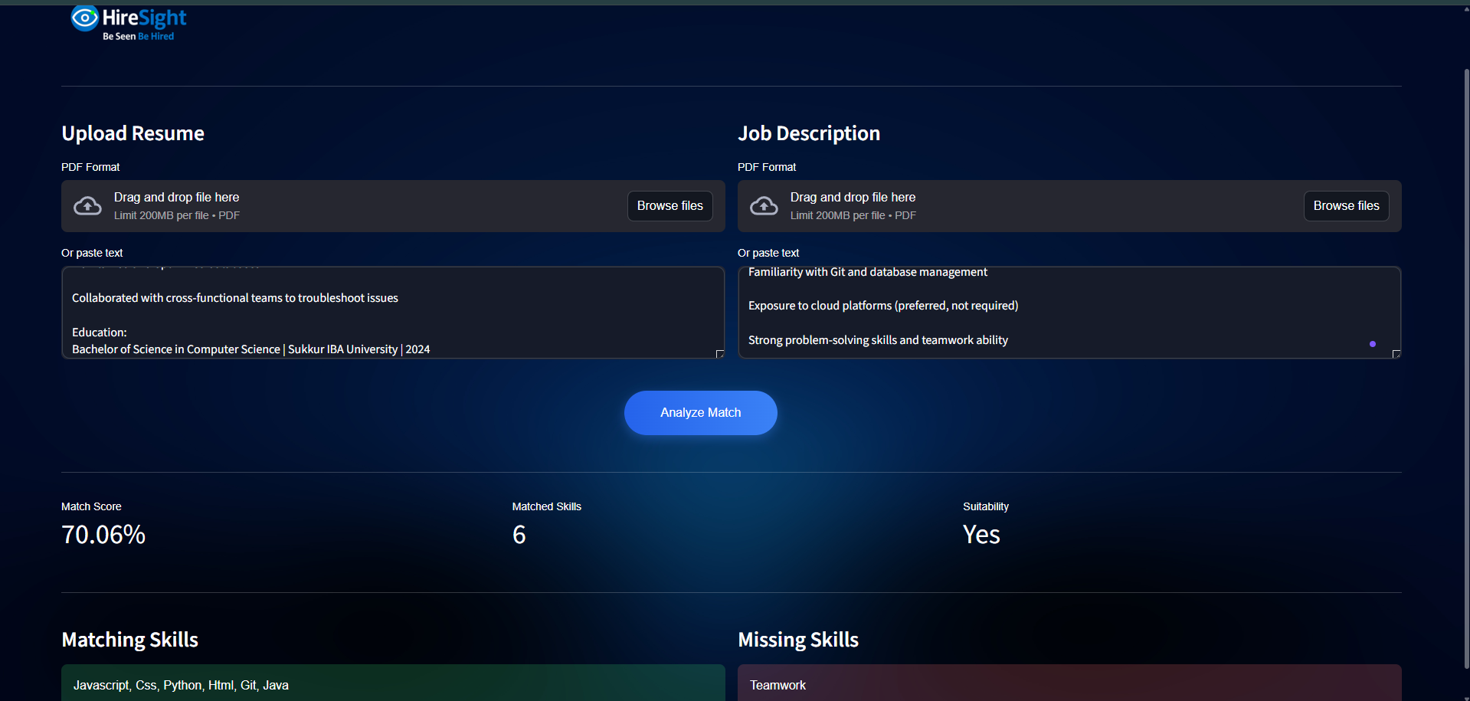
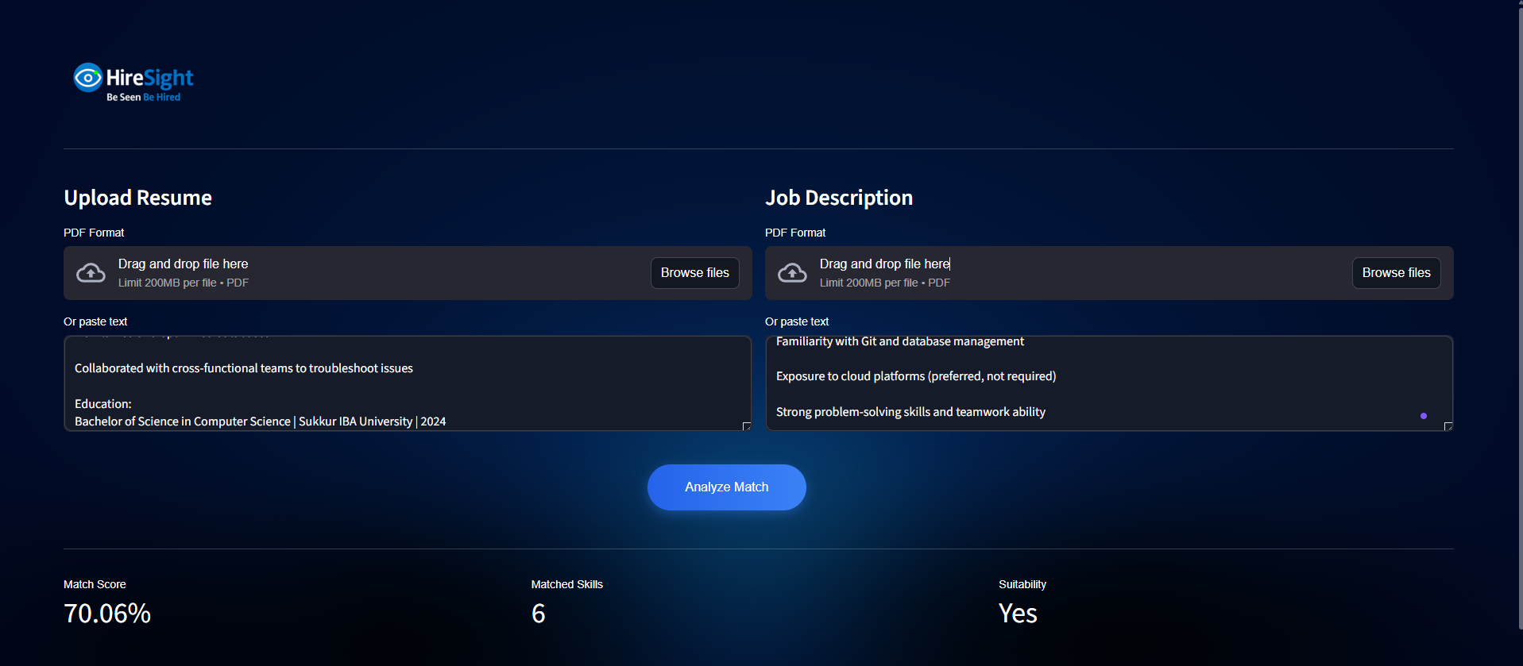


5. Model Training & Analysis
The project includes a comprehensive analysis pipeline (`HireSight_full.ipynb`) which likely covers data exploration, model testing, and performance evaluation.

Analysis Visualizations
Below are visualizations generated during the model training and analysis phase:
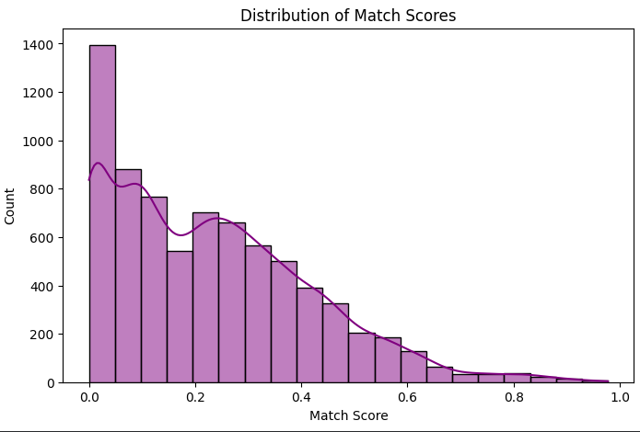
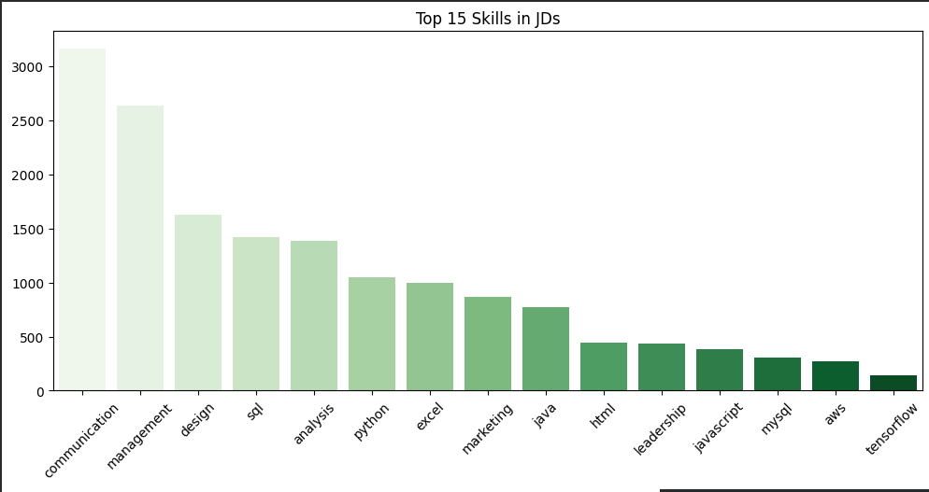
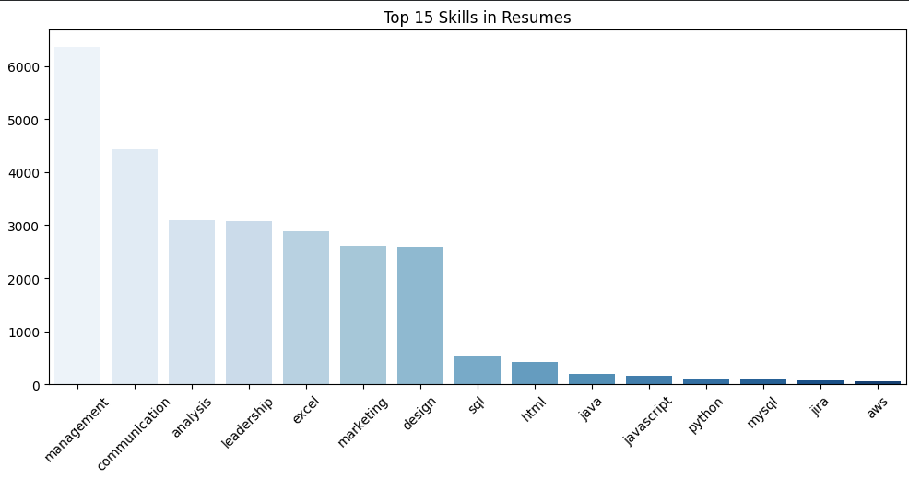
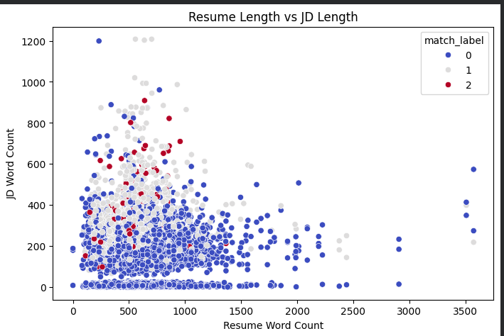
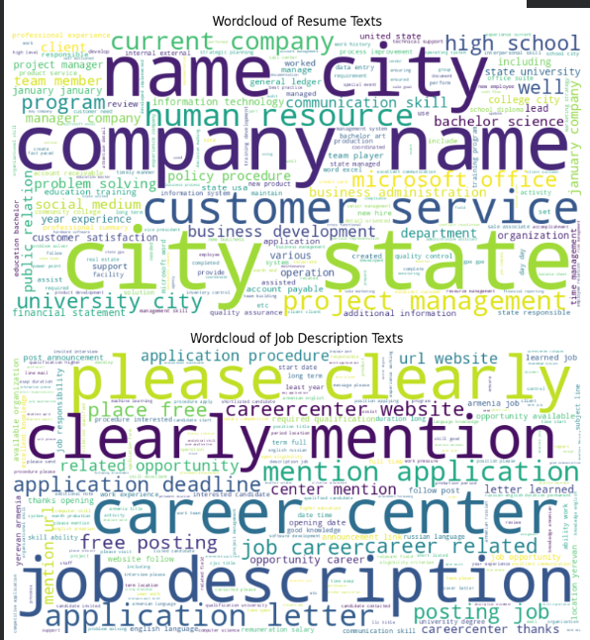
---
*Report generated by Antigravity*

