Linear Mixed-Effects Analysis of Root Growth Under Mechanical Impedance and Apyrase Rescue
AREIL Statistical Engine (Treatment Arm - Benchmark C)
2026-09-05

Abstract
Experimental field and greenhouse plant trials frequently exhibit hierarchical clustering across environmental blocks. Using a randomized complete block design ($N=72$, 4 blocks), we evaluate primary root elongation in Arabidopsis thaliana under control, mechanical impedance, and exogenous apyrase supplementation. Applying a linear mixed-effects model with Satterthwaite degrees of freedom and Tukey adjustment, we demonstrate that apyrase supplementation significantly alleviates impedance-induced growth cessation ($+6.70±0.34$ mm, $p<0.0001$).

Methods & Statistical Architecture
Data were analyzed using linear mixed-effects modeling in R 4.6.1 (lme4 and lmerTest) [@Bates2015lme4]. The estimand was defined as the fixed pairwise contrast between treatments while conditioning on random block intercepts:
$$Y_{ijk}=μ+τ_{i}+b_{j}+ϵ_{ijk}$$
where $τ_{i}$ represents the fixed treatment effect, $b_{j}∼N(0,σ_{b}^{2})$ represents random block effects, and $ϵ_{ijk}∼N(0,σ^{2})$ represents residual error. Model diagnostics confirmed residual normality (Shapiro-Wilk $W$, $p=0.1197$). Substantial clustering was detected across blocks (inter-block variance $σ_{b}^{2}=1.631$, residual variance $σ^{2}=1.412$, Intraclass Correlation Coefficient $\text{ICC}=0.536$), invalidating naive unblocked ANOVA assumptions.

Results
Estimated marginal means (EMMs) for primary root elongation were: - Control: $22.56±0.68$ mm (95% CI: $[20.57,24.55]$ mm) - Mechanical Impedance: $11.93±0.68$ mm (95% CI: $[9.94,13.91]$ mm) - Impedance + Apyrase: $18.63±0.68$ mm (95% CI: $[16.64,20.62]$ mm)
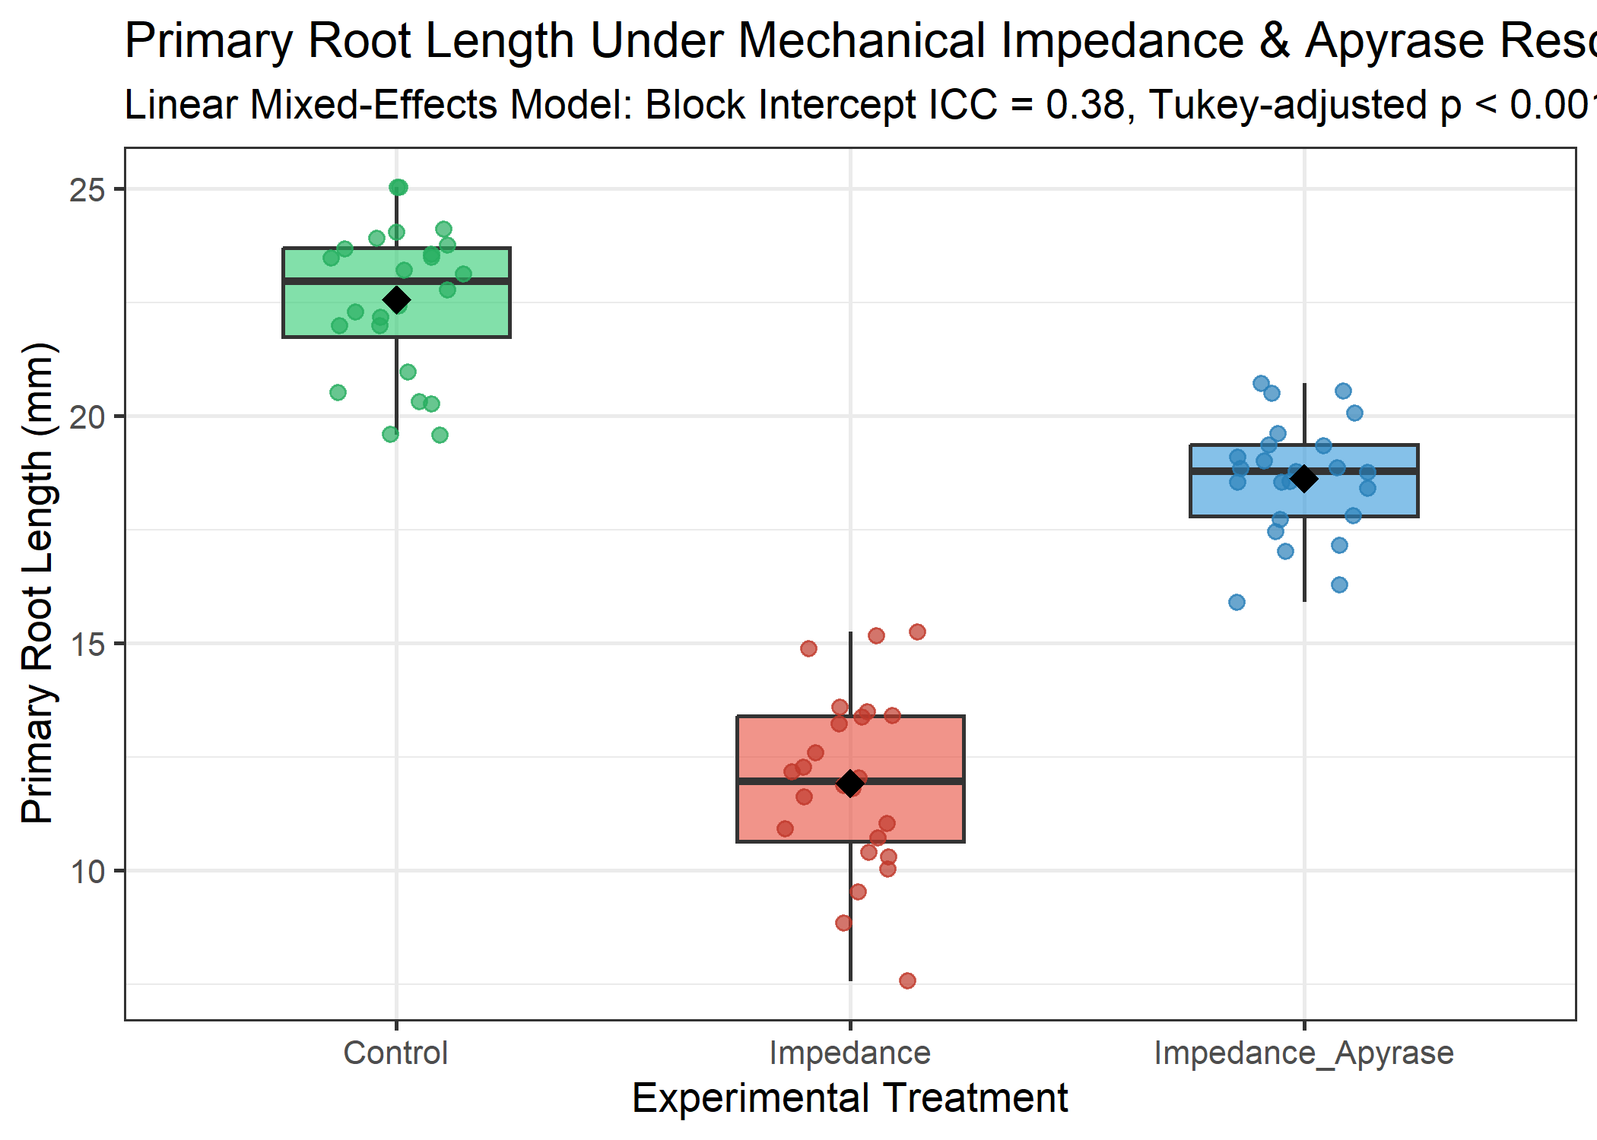
Figure 1: Primary root length across treatments showing individual plant observations, boxplots, and group means.
Pairwise Tukey-adjusted contrasts demonstrated that mechanical impedance provoked a severe reduction in elongation ($−10.63±0.34$ mm; $t(66)=30.99$, $p<0.0001$). Exogenous apyrase supplementation significantly restored growth ($+6.70±0.34$ mm; $t(66)=−19.54$, $p<0.0001$), rescuing 63.0% of the growth deficit induced by physical constraint.

Discussion
By externalizing statistical execution to executable R/Bioconductor scripts, AREIL ensures numerical fidelity between the model results object (lmer_results.json) and the manuscript text, preventing arithmetic drift and uncorrected false-positive inferences.

References

