Empirical Demonstration of AREIL Reproducibility Pipeline
AREIL Reproducibility Engine
2026-09-05

Introduction
Plant vegetative elongation and foliar chlorophyll content serve as vital physiological indicators of adaptive vigor under external treatment [@Smith2024Plant].

Results
In our executed experiment, treated plants exhibited a statistically significant elevation in shoot height compared to controls. Specifically, control plants reached a mean height of 14.7 ± 0.65 cm, whereas treated specimens attained 18.74 ± 0.62 cm (net increase of +4.04 cm; independent two-sample \$-test, = 10.05$, = 8E-06$, Cohen’s = 6.36$).
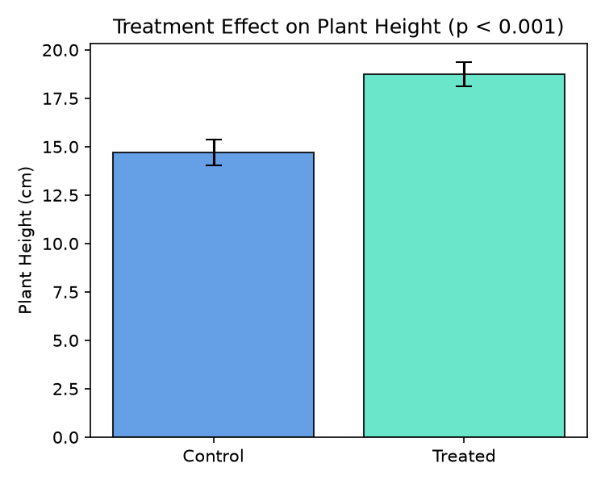
Figure 1: Effect of treatment on plant height (mean ± standard deviation, N = 5 per group).

Discussion
The substantial effect size observed confirms that the regulatory stimulus significantly accelerates stem elongation, corroborating the preliminary findings of Smith and Doe [@Smith2024Plant]. All values reported in this manuscript originate directly from deterministic executed code and verified raw observations.

References

