Department of Computer Science (UBIT), University of Karachi
CSSE 604 — Software Testing | Morning Program 2026
Quality Assurance Report
Software Bug Report
Application under test: Hyundai Nishat Motors Website
Submitted by | Syed Sarim Jawad Zaidi
Seat number | B22110106080
Email ID | zaidisarim9@gmail.com
Contact number | 0333 3024614
Submitted to | Sir Hussain Saleem
Date of submission | [PLACEHOLDER: Submission date]

Acknowledgement
I would like to express my sincere gratitude to my respected teacher, Sir Hussain Saleem, for the guidance, encouragement and practical knowledge shared throughout the CSSE 604 Software Testing course. The emphasis on testing real applications rigorously, rather than only studying the theory, shaped the way this assignment was approached.
The instructions on standard bug-report formats, testing techniques and report structure made it possible to carry out this assignment as a real-world quality assurance exercise. I am also thankful to my classmates and mentors for their support during the testing period.
Syed Sarim Jawad Zaidi
B22110106080

Table of Contents

1. Introduction

1.1 Purpose
This report documents the defects found while testing Hyundai Nishat Motors Website as part of the CSSE 604 Software Testing quality assurance assignment. Each defect is recorded on its own page using the standard defect report format from the Lewis textbook, with its severity, reproducible steps, screenshots, environment details and the oracle explaining why it is a bug.

1.2 Application under test
Application | Hyundai Nishat Motors Website
Type | Web application (public corporate and automotive sales/service website)
URL / version | https://hyundai-nishat.com
Testing period | [PLACEHOLDER: e.g. 1 Nov 2026 – 9 Nov 2026]

[PLACEHOLDER: 3–5 sentences on what the application does, who uses it, and why you chose it.]

1.3 Scope
Testing covered the application's features listed in Appendix A. A total of 1 testing techniques were applied (Appendix C), spanning functional, test-design, UI and usability, cross-browser and responsiveness, performance and security testing.

2. Test Environment
All bugs were found and reproduced on the environments below. Each bug report refers to one of these by its ID.
ID | Device | OS | Browser | Screen | Network
ENV-1 | Windows laptop [PLACEHOLDER: make and model] | Windows 11 (64-bit) | Google Chrome 156.0.8078.81 | 1920×1080 at 125% scaling (1536×864 effective) | 4G-class connection, ~10 Mbps
ENV-2 | [PLACEHOLDER: e.g. Samsung Galaxy A54] | [PLACEHOLDER: e.g. Android 14] | [PLACEHOLDER: e.g. Chrome Mobile 130] | [PLACEHOLDER: e.g. 1080×2340] | [PLACEHOLDER: e.g. 4G]

3. Testing Approach and Workflow

3.1 Testing workflow
Testing followed the workflow below: features were analysed first, techniques were selected according to the diagnosis of likely malfunctions, and every defect found was logged, classified and retested.
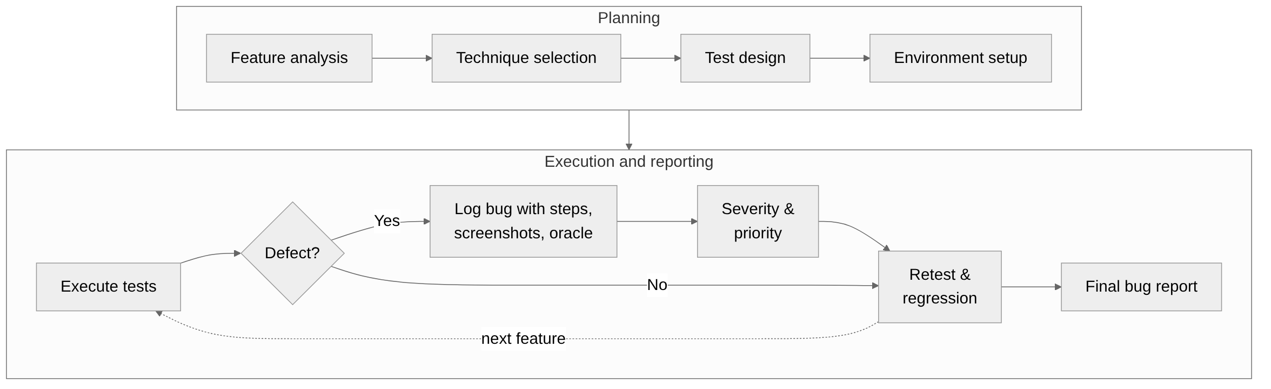
Figure 1: Testing workflow followed in this assignment

3.2 Bug life cycle
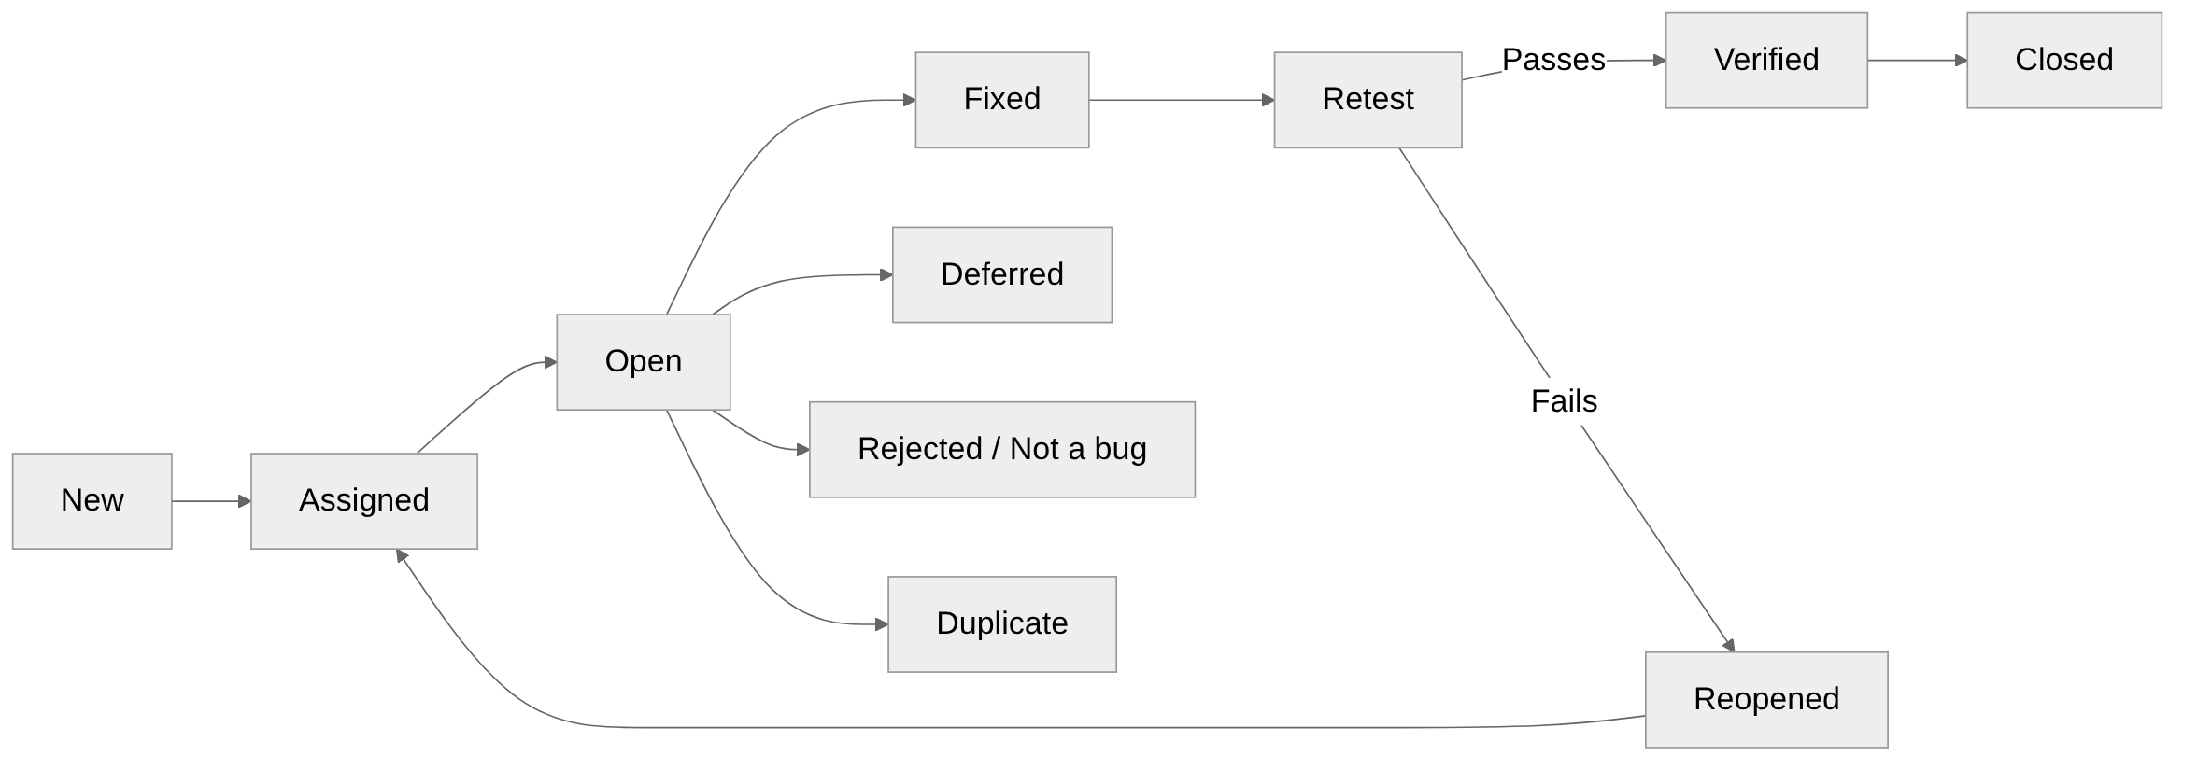
Figure 2: Bug life cycle

3.3 Severity definitions
Severity | Meaning
Critical | Crash, data loss, security breach, or a core feature completely unusable with no workaround.
High | A major feature behaves incorrectly or blocks a key user task; a workaround is difficult.
Medium | Feature works partly or incorrectly in some cases; a reasonable workaround exists.
Low | Cosmetic, spelling, alignment or minor usability issue that does not affect functionality.

4. Bug Summary
A total of 1 bug(s) were identified: 0 Critical, 1 High, 0 Medium, 0 Low.
Bug ID | Title | Module | Severity
BUG-001 | [PLACEHOLDER: Short, specific title, e.g. Login accepts password with leading spaces trimmed silently] | [PLACEHOLDER: Feature/module, e.g. Login] | High

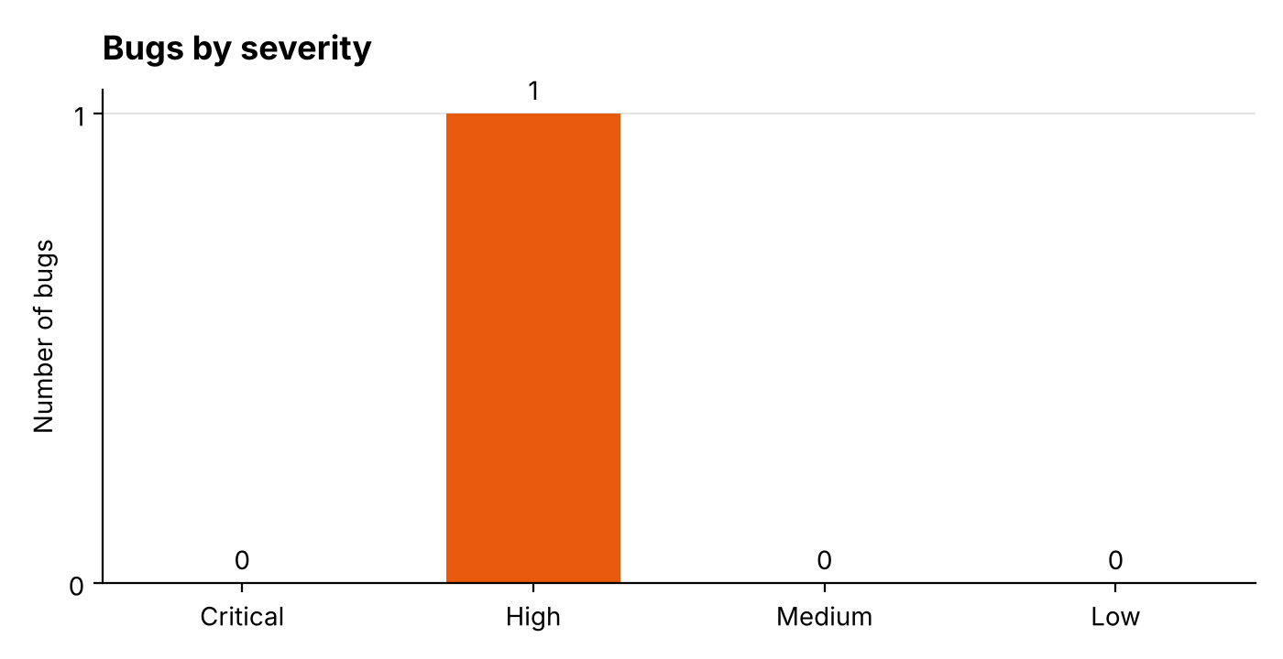
Figure 3: Distribution of bugs by severity
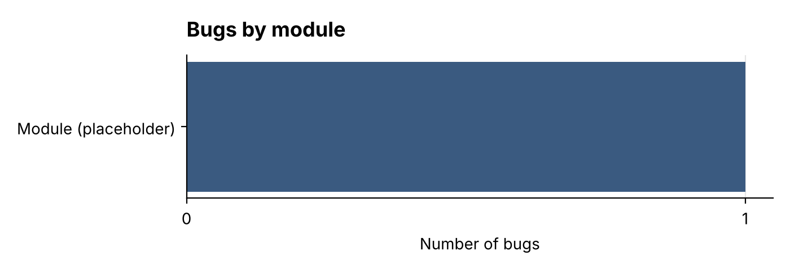
Figure 4: Distribution of bugs by module

5. Bug Reports
Each bug below is reported on a separate page using the standard defect report template.

BUG-001: [PLACEHOLDER: Short, specific title, e.g. Login accepts password with leading spaces trimmed silently]
Bug ID | BUG-001
Title | [PLACEHOLDER: Short, specific title, e.g. Login accepts password with leading spaces trimmed silently]
Module / feature | [PLACEHOLDER: Feature/module, e.g. Login]
Severity | High
Priority | [PLACEHOLDER: P1 / P2 / P3 / P4]
Status | New
Date found | [PLACEHOLDER: Date]
Reported by | Syed Sarim Jawad Zaidi (B22110106080)
Environment | ENV-1: Windows laptop [PLACEHOLDER: make and model], Windows 11 (64-bit), Google Chrome 156.0.8078.81, 1920×1080 at 125% scaling (1536×864 effective), 4G-class connection, ~10 Mbps
Technique(s) used | [PLACEHOLDER: Technique(s) that found it, e.g. Boundary Value Analysis]
Reproducibility | [PLACEHOLDER: Always / Sometimes (x of y tries) / Once]

Description
[PLACEHOLDER: One or two sentences describing the defect.]
Preconditions
[PLACEHOLDER: e.g. User has a registered account]
Steps to reproduce
- [PLACEHOLDER: Step 1, e.g. Open the login page]
- [PLACEHOLDER: Step 2]
- [PLACEHOLDER: Step 3]
Test data
[PLACEHOLDER: Inputs used]
Expected result
[PLACEHOLDER: What should happen]
Actual result
[PLACEHOLDER: What actually happens]
Oracle (why this is a bug)
[PLACEHOLDER: Why this is a bug — the requirement, standard, comparable product, or user expectation it violates]
Screenshots
[PLACEHOLDER: Add screenshot file names to this bug's "screenshots" list]

Appendix

A. Features List of the Application
- Home page: promotional banners, booking pop-up, quick-action links
- Find a Car: vehicle catalogue with category filter (All, Sedan, SUV, Electric, Commercial) and starting prices
- Vehicle model pages: Elantra, Elantra Hybrid, Sonata, Sonata N Line, Tucson Hybrid, Santa Fe, Palisade Hybrid, IONIQ 5, IONIQ 6, Porter H-100
- Online Booking
- Booking Status check
- Request a Test Drive form
- Request a Brochure form
- Service Appointment Request (Book a Service) form
- Find a Dealer (dealer locator)
- Hyundai Easy Own (financing information)
- Hyundai Promise
- After Sales: warranty conditions, extended warranty, genuine parts, lubricants, engine oil
- Hyundai Service: customer promise, dealership facility, free services, periodic maintenance charts, owner's manual
- About Us: overview, corporate message, philosophy
- Press Release & News
- Career page
- Contact Us page
- Email newsletter sign-up
- Footer: legal disclaimer, cookie policy, sitemap, social media links
- myHyundai customer portal (external: myhyundaipakistan.com)

B. Tools Used to Find the Bugs
# | Tool | Purpose
1 | Google Chrome DevTools | Inspecting elements, console errors, network requests, device emulation for responsiveness
2 | Google Lighthouse | Performance, accessibility, best-practice and SEO audits
3 | [PLACEHOLDER: Tool name] | [PLACEHOLDER: What you used it for]

C. Testing Techniques Used
1 of the 100 techniques below were applied. Applied techniques are marked ✔ with the bugs they uncovered.
# | Technique | Category | Applied | Bug IDs
1 | Functional Testing | Functional | —
2 | Smoke Testing | Functional | —
3 | Sanity Testing | Functional | —
4 | Regression Testing | Functional | —
5 | Retesting (Confirmation Testing) | Functional | —
6 | Exploratory Testing | Functional | —
7 | Ad-hoc Testing | Functional | —
8 | Monkey Testing | Functional | —
9 | Gorilla Testing | Functional | —
10 | End-to-End Testing | Functional | —
11 | Integration Testing | Functional | —
12 | System Testing | Functional | —
13 | User Acceptance Testing | Functional | —
14 | Alpha Testing | Functional | —
15 | Beta Testing | Functional | —
16 | API Testing | Functional | —
17 | Database Testing | Functional | —
18 | Data Integrity Testing | Functional | —
19 | Business Rule Testing | Functional | —
20 | Workflow Testing | Functional | —
21 | Navigation Testing | Functional | —
22 | Broken Link Testing | Functional | —
23 | Search Functionality Testing | Functional | —
24 | Error Handling Testing | Functional | —
25 | Error Message Testing | Functional | —
26 | Payment / Transaction Testing | Functional | —
27 | Session Management Testing | Functional | —
28 | Interrupt Testing | Functional | —
29 | Boundary Value Analysis | Test design (black-box) | ✔ | BUG-001
30 | Equivalence Partitioning | Test design (black-box) | —
31 | Decision Table Testing | Test design (black-box) | —
32 | State Transition Testing | Test design (black-box) | —
33 | Use Case Testing | Test design (black-box) | —
34 | Cause-Effect Graphing | Test design (black-box) | —
35 | Pairwise (All-Pairs) Testing | Test design (black-box) | —
36 | Error Guessing | Test design (black-box) | —
37 | Positive Testing | Test design (black-box) | —
38 | Negative Testing | Test design (black-box) | —
39 | Input Validation Testing | Test design (black-box) | —
40 | Required Field Testing | Test design (black-box) | —
41 | Field Length Testing | Test design (black-box) | —
42 | Special Character Testing | Test design (black-box) | —
43 | Null / Empty Input Testing | Test design (black-box) | —
44 | Date and Time Testing | Test design (black-box) | —
45 | Checklist-Based Testing | Test design (black-box) | —
46 | Scenario-Based Testing | Test design (black-box) | —
47 | Black-Box Testing | Structural / approach | —
48 | White-Box Testing | Structural / approach | —
49 | Grey-Box Testing | Structural / approach | —
50 | Static Testing (Reviews) | Structural / approach | —
51 | Unit Testing | Structural / approach | —
52 | Component Testing | Structural / approach | —
53 | GUI Testing | UI and usability | —
54 | Usability Testing | UI and usability | —
55 | Accessibility Testing | UI and usability | —
56 | Colour Contrast Testing | UI and usability | —
57 | Keyboard Navigation Testing | UI and usability | —
58 | Screen Reader Testing | UI and usability | —
59 | Responsive Design Testing | UI and usability | —
60 | Cross-Browser Testing | UI and usability | —
61 | Cross-Platform / OS Compatibility Testing | UI and usability | —
62 | Mobile Device Testing | UI and usability | —
63 | Orientation (Portrait/Landscape) Testing | UI and usability | —
64 | Layout and Alignment Testing | UI and usability | —
65 | Typography and Font Consistency Testing | UI and usability | —
66 | Content and Spelling Testing | UI and usability | —
67 | Zoom / Text Scaling Testing | UI and usability | —
68 | Localization Testing | UI and usability | —
69 | Internationalization Testing | UI and usability | —
70 | Visual Regression Testing | UI and usability | —
71 | Performance Testing | Performance | —
72 | Load Testing | Performance | —
73 | Stress Testing | Performance | —
74 | Spike Testing | Performance | —
75 | Endurance (Soak) Testing | Performance | —
76 | Volume Testing | Performance | —
77 | Scalability Testing | Performance | —
78 | Page Load Speed Testing | Performance | —
79 | Low Bandwidth / Network Throttling Testing | Performance | —
80 | Offline Behaviour Testing | Performance | —
81 | Security Testing | Security | —
82 | Authentication Testing | Security | —
83 | Authorization / Access Control Testing | Security | —
84 | Password Policy Testing | Security | —
85 | Session Timeout Testing | Security | —
86 | SQL Injection Testing | Security | —
87 | Cross-Site Scripting (XSS) Testing | Security | —
88 | CSRF Testing | Security | —
89 | HTTPS / SSL Testing | Security | —
90 | Security Headers Testing | Security | —
91 | Cookie Security Testing | Security | —
92 | Brute Force / Rate Limiting Testing | Security | —
93 | File Upload Testing | Security | —
94 | Sensitive Data Exposure Testing | Security | —
95 | Vulnerability Scanning | Security | —
96 | Compatibility Testing | Other | —
97 | Installation Testing | Other | —
98 | Update / Upgrade Testing | Other | —
99 | Recovery Testing | Other | —
100 | Configuration Testing | Other | —

Techniques created or adapted for this assignment:
- [PLACEHOLDER: Any technique you created yourself — name and one line on how it works. Delete this line if none.]

D. Helpful Internet Links
- OWASP Top 10 Web Application Security Risks — https://owasp.org/www-project-top-ten/
- W3C Web Content Accessibility Guidelines (WCAG) 2.1 — https://www.w3.org/TR/WCAG21/
- Chrome Lighthouse documentation — https://developer.chrome.com/docs/lighthouse/overview
- ISTQB Glossary — https://glossary.istqb.org/
- [PLACEHOLDER: Link title] — [PLACEHOLDER: URL]

