Quality Engineering & Business Statistics — Project Report and Study Guide
Oct 11, 2026 · Syed Sarim Jawad Zaidi (B22110106080)

1. Table of Contents
- Table of Contents
- Core Theoretical Overview
  - The Quality Attributes Framework: how Testing bifurcates
  - Quality Control (QC) stream: Simulation Methods, Simulation Tools, Graphical Views, Results
  - Quality Assurance (QA) stream: Inspection and Review, Change Management (RFC, RFM), Testing Methods, Test Cases, Testing Oracle, Workflow Checklist, Results
  - Bridge to statistical quality control (Levin and Rubin, Chapter 10)
- Practice Questions: Scenario and Analytical
  - Scenario questions with analytical answers
  - Analytical (compare-and-contrast) questions
- Numerical Questions: Representative Problems from the Wider Textbook
  - Frequency distributions, central tendency and dispersion
  - Probability
  - Probability distributions: binomial, Poisson, normal
  - Sampling distributions and estimation
  - Hypothesis testing: one and two samples
  - Chi-square and analysis of variance
  - Regression and correlation
  - Time series and index numbers
- Numerical Questions: Chapter 10, Quality and Quality Control (primary focus)
  - x̄-charts and R-charts (process mean and variability)
  - p-charts (fraction defective)
  - c-charts (defects per unit)
  - Total Quality Management
  - Acceptance sampling and the OC curve
- Required Diagrams for the Project Report
  - Testing Framework flowchart
  - SPC dashboard (x̄ and R charts)
  - Acceptance sampling OC curve with AQL and LTPD

2. Core Theoretical Overview
Testing is not one activity but two parallel streams that serve the same goal: proving that a system meets its quality attributes. Quality Control (QC) measures and simulates the product to detect deviation. Quality Assurance (QA) governs the process to prevent deviation. Both streams end in a Results block, and only the two result sets together support a release decision.

2.1 The Quality Attributes Framework: how Testing bifurcates
The framework reads top-down in four tiers:
- Testing (the umbrella). Every verification and validation activity on the system.
- Quality Attributes (the hub). The measurable properties the system must satisfy. In software these follow ISO/IEC 25010: functional suitability, performance efficiency, compatibility, usability, reliability, security, maintainability and portability. In manufacturing they are dimensions, weights, fill levels, cycle times and defect rates.
- Two chevrons. The attributes are pushed down two channels at once: Quality Control on the left and Quality Assurance on the right. The chevron shape signals direction: requirements flow down into each stream.
- Four stacked blocks per stream. Each stream runs its own pipeline and terminates in its own Results block.
The split mirrors the textbook's distinction between inspection and prevention (Levin and Rubin, Section 10.1). QC answers "Does the output conform right now?" QA answers "Is the way we build things able to keep producing conforming output?"
Dimension | Quality Control (QC) | Quality Assurance (QA)
Orientation | Product and output | Process and lifecycle
Nature | Detective, measurement-driven | Preventive, governance-driven
Core question | Is this output within limits? | Will the process keep outputs within limits?
Main evidence | Simulated and measured data, control charts | Review records, test results, approved changes, checklists
Typical owner | Test, performance and reliability engineers | QA lead, reviewers, change advisory board
Statistical analogue (Ch. 10) | Statistical process control: x̄, R and p charts | TQM, fishbone and Pareto analysis, acceptance sampling

2.2 Quality Control (QC) stream
QC turns quality attributes into numbers, tracks those numbers over time, and flags when they drift. Its four blocks form a measure, model, visualise, decide pipeline.
Simulation Methods. These are the techniques used to exercise the system under controlled, repeatable conditions before or alongside real use.
- Monte Carlo simulation draws random inputs from known distributions (for example, arrival times or component lifetimes) to estimate output distributions such as response-time percentiles.
- Discrete-event simulation models queues and resources, such as the TransCarolina express-teller line, to predict waiting times when staffing or demand changes.
- Load, stress and soak simulation drive a software system at expected, peak and sustained volumes to measure throughput, latency and memory growth.
- Fault injection and reliability modelling deliberately fail components to estimate mean time between failures and recovery behaviour.
- Statistical sampling is itself a simulation method: a sample of n items stands in for the whole output stream, which is exactly how Chapter 10 builds control charts.
Simulation Tools. These are the instruments that execute the methods and collect the data.
- Load and performance: Apache JMeter, Gatling, k6, Locust.
- Process and system modelling: MATLAB/Simulink, AnyLogic, Arena, SimPy (Python).
- Statistical computation: Python (NumPy, SciPy, Pandas), R, Minitab, Excel templates such as the Gardner acceptance-sampling spreadsheet shown in the textbook (Figure 10-10).
- Monitoring and telemetry: Prometheus, Grafana, application performance monitoring agents.
Tool choice follows the attribute being tested: latency needs a load generator, defect rates need a statistics package, and reliability needs a fault-injection harness.
Graphical Views. Raw numbers rarely reveal drift; pictures do. The QC stream relies on:
- Control charts (x̄, R, p and c charts) with a centre line, an upper control limit and a lower control limit at ±3 standard errors.
- Run charts and trend lines to expose drift, jumps, cycles and "hugging" patterns (Levin and Rubin, Figures 10-1 and 10-2).
- Histograms and capability plots to compare process spread with specification limits.
- OC and AOQ curves to show how an acceptance plan behaves across incoming quality levels.
- Dashboards that combine these views for operators and managers.
Results (QC). The output is a quantitative verdict: in control or out of control, the list of out-of-limit points and non-random patterns, estimated process parameters (x̿, R̄, p̄), and capability against requirements. A process can be in control yet still miss its goal, as with the experienced teller averaging 61.2 seconds against a 60-second target. Deciding what to do next is a managerial decision, not a statistical one.

2.3 Quality Assurance (QA) stream
QA builds quality into the process so that defects are prevented rather than sorted out at the end. Its blocks form a review, verify, govern, certify pipeline.
Inspection. A formal, role-based examination of a work product (requirements, design, code, test plan) against defined criteria. The Fagan inspection model uses a moderator, author, reader and recorder, and moves through planning, overview, preparation, meeting, rework and follow-up. Inspections find defects at the cheapest point, before they propagate downstream.
Review. A broader family of static checks of varying formality: walkthroughs, peer reviews, technical reviews, management reviews and audits. Reviews confirm that artefacts follow standards and that decisions are traceable to requirements.
Change Management (RFC, RFM). Controlled change keeps a verified baseline from being silently broken.
- RFC, Request for Change. A formal proposal to alter a baselined item, such as a new feature, a configuration change or a requirement update. It records the reason, the impact analysis, the risk, the rollback plan and the approver (often a Change Advisory Board).
- RFM, Request for Modification (some organisations read it as Request for Maintenance). A request to correct or adapt something already in service, such as a defect fix, a performance tune or an environment update.
- Both follow the same lifecycle: submit, assess impact, approve or reject, implement, re-test (regression), close and record. Every approved change triggers regression testing, which links this block to the next.
Testing Methods. The dynamic techniques used to execute the system:
- By knowledge of internals: black-box (equivalence partitioning, boundary-value analysis, decision tables, state transitions), white-box (statement, branch and path coverage) and grey-box.
- By level: unit, integration, system and acceptance testing.
- By purpose: functional, regression, smoke, security, usability and compatibility testing.
Test Cases. The executable unit of a test method. A well-formed case has an ID, the requirement it traces to, preconditions, input data, steps, the expected result, the actual result and a pass or fail status. A traceability matrix links every requirement to at least one case, so coverage gaps are visible.
Testing Oracle. The mechanism that decides whether an actual result is correct. Without an oracle, a test produces output but no verdict. Oracle types include specification oracles (the expected value is written in the requirement), reference or golden-output oracles (compare with a trusted earlier version), derived or metamorphic oracles (for example, sorting a list twice must give the same result), statistical oracles (the output must fall within a tolerance or control limit), and human oracles (expert judgement, used for usability).
Workflow Checklist. A standard sequence that every work item must pass, so quality does not depend on memory. A typical checklist: requirement approved, design reviewed, code inspected, unit tests passing, integration tests passing, RFC approved, regression suite green, documentation updated, sign-off recorded. Checklists make the process auditable and repeatable, the QA counterpart of the control limits in QC.
Results (QA). The output is evidence of process conformance: inspection and review defect logs, test execution reports with pass and fail rates, requirement coverage, open and closed RFC and RFM counts, checklist completion and a formal release recommendation. Pareto analysis of the defect log tells the team which "dragons" to slay first.

2.4 Bridge to statistical quality control (Levin and Rubin, Chapter 10)
Chapter 10 provides the statistical engine that both streams depend on. The book's own flow chart runs: monitor process outputs with control charts, then use TQM to find and group causes, then use acceptance sampling to monitor process inputs.
Framework block | Chapter 10 concept | What it contributes
QC: Simulation Methods | Random sampling of k samples of size n | Estimates of μ, σ and p without inspecting every unit
QC: Graphical Views | x̄ chart, R chart, p chart (Sections 10.3 to 10.5) | Centre line and ±3σ limits; detection of outliers and non-random patterns
QC: Results | In-control versus out-of-control; random versus assignable variation | Whether to hunt for a special cause or redesign the process
QA: Inspection and Review | Inspection versus prevention; zero defects (Section 10.1) | Shifts effort from end-of-line sorting to building quality in
QA: Change (RFC, RFM) | Continuous Quality Improvement (Section 10.6) | Each slain dragon becomes an approved, tracked change
QA: Testing Oracle | Control limits and hypothesis tests (H₀: p = p₀) | A statistical pass or fail rule
QA: Workflow Checklist and Results | Fishbone diagrams, Pareto charts, acceptance sampling (Sections 10.6 and 10.7) | Prioritised causes and a defensible accept or reject decision on inputs

3. Practice Questions: Scenario and Analytical

3.1 Scenario questions
Scenario Q1: Fintech payment API before a peak-season release. A Karachi-based digital wallet start-up will release version 3.0 of its payment API two weeks before Eid, when transaction volume is expected to triple. Two risks are on the table. First, the API's p95 latency may exceed the 800 ms service-level target at peak load. Second, a rewritten currency-rounding routine may post incorrect balances. The team has budget for one of these in full: a QC simulation programme (k6 load tests plus a Monte Carlo model of arrival rates) or a QA inspection programme (a Fagan inspection of the transaction module plus new boundary-value test cases with a specification oracle). Which should they choose, and how should they cover the other risk?
Answer.
- Map each risk to a quality attribute. Latency is performance efficiency. Rounding is functional correctness, and in a payments system it is also reliability and compliance.
- Ask which stream can detect each risk at all. Latency is an emergent property of the whole system under load. No code inspection can measure it, so only QC simulation reveals it. Rounding errors are logic defects. A load test will not find them unless an oracle checks every result, but an inspection with boundary-value cases (0.005, 0.015, negative amounts, currency conversion) targets them directly.
- Compare the cost of failure. A latency breach degrades service: slow payments, some timeouts, recoverable by scaling servers. A rounding defect corrupts financial records: every affected transaction must be reconciled, regulators may become involved, and trust is lost. That makes the rounding risk the higher-severity, harder-to-reverse failure.
- Compare the cost of detection. Defects found in inspection are cheapest to fix because they are caught before integration (the inspection-versus-prevention argument in Section 10.1). Performance can be partly protected by cheaper means: autoscaling, rate limiting and a canary release.
- Decision. Fund the QA inspection programme in full. Cover latency with a minimum viable QC check: one k6 run at 3× normal load against the 800 ms limit, plus production monitoring with a control chart of p95 latency (centre line = baseline mean, UCL = mean + 3 standard errors). Any point above the UCL triggers an RFC to add capacity.
- Results to report. QA result: inspection defect log, boundary test pass rate, signed workflow checklist. QC result: latency control chart showing in-control behaviour at 3× load or an identified bottleneck.
Scenario Q2: Bottling line versus supplier cartons. A dairy (similar to Golden Guernsey Dairies in Section 10.5) faces rising under-fill complaints. The plant manager can either (a) run a simulation study of the filling machine, sampling 100 cartons per hour and plotting a p chart, or (b) set up acceptance sampling to inspect incoming lots of cartons from a new supplier whose cartons may be slightly undersized. Which first?
Answer. Start with the QC p chart, because it diagnoses where the variation comes from. If the p chart shows a time-of-day pattern (low in the morning, rising through the day), the cause is the machine drifting after calibration. That is an assignable cause inside the plant, and the fix is a QA change: an RFC to recalibrate at 10 a.m., which is exactly what Harry Galloway did. If instead the p chart jumps when a new carton lot arrives, the cause is the input, and acceptance sampling (a QA inspection of supplier lots with a chosen n and c) becomes the right tool. Inspecting supplier lots first risks spending money on the wrong cause.

3.2 Analytical questions
Analytical Q1: Compare the Testing Oracle (QA) with Graphical Views (QC).
Aspect | Testing Oracle (QA) | Graphical Views (QC)
Purpose | Decide pass or fail for one test execution | Reveal behaviour of a process across many observations
Unit of judgement | A single output compared with an expected output | A sequence of sample statistics compared with control limits
Basis of the rule | Specification, golden output, metamorphic relation or expert | Estimated parameters: x̿, R̄ or p̄ and ±3 standard errors
What it misses | Trends, drift and cycles across runs | Whether any single output is functionally correct
Error it can make | False pass from a wrong expected value | Type I error: a point outside limits by chance, about 0.3% of the time for a normal process
Typical output | Test log: passed, failed, blocked | Chart verdict: in control, outlier, or pattern (trend, jump, cycle, hugging)
The two meet in the statistical oracle. A rule such as "response time must lie below the UCL of 68.7 seconds" turns a QC control limit into a QA pass or fail criterion. Graphical views supply the limits; the oracle applies them.
Analytical Q2: Compare Inspection (QA) with Simulation Methods (QC). Inspection is static: it examines artefacts without running them, so it finds defects in logic, standards and traceability early and cheaply. Simulation is dynamic: it runs the system or a model of it, so it finds emergent properties (latency, throughput, queue length, failure rates) that no reading of code or design can reveal. Inspection prevents defects; simulation measures how the system behaves. A mature programme inspects early artefacts and simulates the integrated system.
Analytical Q3: Why does the framework need two separate Results blocks? QC Results certify the product: it was in control and within limits when it was measured. QA Results certify the process: it is capable of continuing to produce conforming output. A product can pass QC through luck while the process is weak. In acceptance-sampling terms, a bad lot can be accepted (consumer's risk, a Type II error) or a good lot rejected (producer's risk, a Type I error). Process evidence from QA reduces both risks over time. The release decision therefore needs both.
Analytical Q4: How does Change Management (RFC, RFM) interact with control-chart limits? Control limits describe one stable process. After an approved RFC changes the process (new teller, new calibration schedule, new server capacity), the old limits no longer apply. The limits must be recomputed from fresh samples, as Lisa Klein did when she excluded the trainee Fridays and recalculated CL = 61.2 seconds and UCL = 66.2 seconds. Linking each RFC to a "recompute control limits" item on the workflow checklist keeps QC and QA synchronised.

4. Numerical Questions: Representative Problems from the Wider Textbook
Each problem below is taken from the textbook's Self-Check Exercises (exercise numbers given so you can cross-check). Every answer was recomputed independently; where the book rounds a z or table value, the book's rounding is kept so your answers match the key.

4.1 Frequency distributions, central tendency and dispersion (Chapters 2 and 3)
Problem 4.1a (SC 3-1): Mean of grouped data. Package weights (pounds) carried by an airfreight company:
Class | f | Midpoint x | f × x | Code u (0 at 13.5) | u × f
10.0–10.9 | 1 | 10.5 | 10.5 | −3 | −3
11.0–11.9 | 4 | 11.5 | 46.0 | −2 | −8
12.0–12.9 | 6 | 12.5 | 75.0 | −1 | −6
13.0–13.9 | 8 | 13.5 | 108.0 | 0 | 0
14.0–14.9 | 12 | 14.5 | 174.0 | 1 | 12
15.0–15.9 | 11 | 15.5 | 170.5 | 2 | 22
16.0–16.9 | 8 | 16.5 | 132.0 | 3 | 24
17.0–17.9 | 7 | 17.5 | 122.5 | 4 | 28
18.0–18.9 | 6 | 18.5 | 111.0 | 5 | 30
19.0–19.9 | 2 | 19.5 | 39.0 | 6 | 12
Total | 65 |  | 988.5 |  | 111
Direct method (Equation 3-3):
\bar{x} = \frac{\sum (f \times x)}{n} = \frac{988.5}{65} = 15.2077 \text{ pounds}
Coding method (Equation 3-4), with x₀ = 13.5 and class width w = 1.0:
\bar{x} = x_0 + w\,\frac{\sum (u \times f)}{n} = 13.5 + 1.0\left(\frac{111}{65}\right) = 13.5 + 1.7077 = 15.2077 \text{ pounds}
Both methods agree because shifting the zero code only relabels the classes.
Problem 4.1b (SC 3-13): Standard deviation and the director's 3-year target. Ages of 20 extras: 50, 56, 55, 49, 52, 57, 56, 57, 56, 59, 54, 55, 61, 60, 51, 59, 62, 52, 54, 49. The director wants ages tightly grouped around 55 with s ≤ 3 years.
Step 1, mean:
\bar{x} = \frac{\sum x}{n} = \frac{1{,}104}{20} = 55.2 \text{ years}
Step 2, squared deviations. The deviations x − 55.2 squared and summed give Σ(x − x̄)² = 285.20 (for example, (50 − 55.2)² = 27.04 and (62 − 55.2)² = 46.24).
Step 3, sample standard deviation:
s = \sqrt{\frac{\sum (x-\bar{x})^2}{n-1}} = \sqrt{\frac{285.20}{19}} = \sqrt{15.0105} = 3.874 \text{ years}
Step 4, coefficient of variation: CV = s / x̄ × 100 = 3.874 / 55.2 × 100 = 7.02%.
Conclusion: The mean (55.2) is on target, but s = 3.874 > 3, so the group is more spread out than the director wants. It does not qualify.

4.2 Probability (Chapter 4)
Problem 4.2 (SC 4-11): Bayes' theorem. P(A) = 0.35, P(B) = 0.45, P(C) = 0.20; P(X | A) = 0.80, P(X | B) = 0.65, P(X | C) = 0.30. Find P(A | X), P(B | X), P(C | X).
P(E \mid X) = \frac{P(X \mid E)\,P(E)}{\sum_i P(X \mid E_i)\,P(E_i)}
Event | P(Event) | P(X | Event) | Joint P(X and Event) | Posterior P(Event | X)
A | 0.35 | 0.80 | 0.35 × 0.80 = 0.2800 | 0.2800 / 0.6325 = 0.4427
B | 0.45 | 0.65 | 0.45 × 0.65 = 0.2925 | 0.2925 / 0.6325 = 0.4625
C | 0.20 | 0.30 | 0.20 × 0.30 = 0.0600 | 0.0600 / 0.6325 = 0.0949
Total | 1.00 |  | P(X) = 0.6325 | 1.0001 (rounding)

4.3 Probability distributions (Chapter 5)
Problem 4.3a (SC 5-4): Binomial, n = 12, p = 0.45.
P(r) = \frac{n!}{r!\,(n-r)!}\,p^r q^{\,n-r}, \quad q = 1-p = 0.55
(a) P(r = 8) = [12! / (8! 4!)] (0.45)⁸ (0.55)⁴ = 495 × 0.0016815 × 0.0915063 = 0.0762.
(b) P(r > 4) = 1 − [P(0) + P(1) + P(2) + P(3) + P(4)] = 1 − (0.0008 + 0.0075 + 0.0339 + 0.0923 + 0.1700) = 1 − 0.3045 = 0.6955.
(c) P(r ≤ 10) = 1 − [P(11) + P(12)] = 1 − (0.0010 + 0.0001) = 0.9989.
Mean and standard deviation: μ = np = 12(0.45) = 5.4; σ = √(npq) = √(12 × 0.45 × 0.55) = √2.97 = 1.723.
Problem 4.3b (SC 5-7): Poisson, λ = 4.2.
P(x) = \frac{\lambda^x e^{-\lambda}}{x!}, \quad e^{-4.2} = 0.0150
(a) P(x ≤ 2) = 0.0150 + (4.2)(0.0150) + (4.2)²(0.0150)/2 = 0.0150 + 0.0630 + 0.1323 = 0.2103.
(b) P(x ≥ 5) = 1 − P(x ≤ 4). P(3) = (4.2)³(0.0150)/6 = 0.1852; P(4) = (4.2)⁴(0.0150)/24 = 0.1944. So P(x ≥ 5) = 1 − 0.2103 − 0.1852 − 0.1944 = 0.4101.
(c) P(x = 8) = (4.2)⁸(0.0150)/40,320 = 0.0360.
Problem 4.3c (SC 5-10): Normal distribution. Daily water flow at a dam is normal with μ = 850,000 gallons (yesterday's flow) and σ = 200,000 gallons. The turbines reach peak output only if flow ≥ 1,000,000 gallons.
z = \frac{x-\mu}{\sigma} = \frac{1{,}000{,}000 - 850{,}000}{200{,}000} = 0.75
P(x ≥ 1,000,000) = P(z ≥ 0.75) = 0.5 − 0.2734 = 0.2266.

4.4 Sampling distributions and estimation (Chapters 6 and 7)
Problem 4.4a (SC 6-5): Sampling distribution of the mean. Population normal, μ = 98.6, σ = 17.2, n = 25. Find P(92 < x̄ < 102).
\sigma_{\bar{x}} = \frac{\sigma}{\sqrt{n}} = \frac{17.2}{\sqrt{25}} = 3.44
z₁ = (92 − 98.6)/3.44 = −1.92; z₂ = (102 − 98.6)/3.44 = 0.99. From the normal table: 0.4726 + 0.3389 = 0.8115. With n = 36, σx̄ = 17.2/6 = 2.87, z = −2.30 and 1.18, giving 0.4893 + 0.3810 = 0.8703. A larger sample concentrates x̄ near μ.
Problem 4.4b (SC 7-8): Confidence interval for a proportion. n = 70 retail executives, p̄ = 0.66, 95% confidence.
\hat{\sigma}_{\bar{p}} = \sqrt{\frac{\bar{p}\,\bar{q}}{n}} = \sqrt{\frac{0.66(0.34)}{70}} = \sqrt{0.0032057} = 0.0566
Interval: 0.66 ± 1.96(0.0566) = 0.66 ± 0.111 = (0.549, 0.771).
Problem 4.4c (SC 7-11): t interval for a mean. n = 7, x̄ = 39.2 miles, s = 3.2 miles, 95% confidence, df = 6, t = 2.447.
\hat{\sigma}_{\bar{x}} = \frac{s}{\sqrt{n}} = \frac{3.2}{\sqrt{7}} = 1.2095, \qquad \bar{x} \pm t\,\hat{\sigma}_{\bar{x}} = 39.2 \pm 2.447(1.2095) = 39.2 \pm 2.9596
Interval: (36.240, 42.160) miles per week.

4.5 Hypothesis testing (Chapters 8 and 9)
Problem 4.5a (SC 8-11): One-sample t test. x̄ = 83, s = 12.5, n = 22. H₀: μ = 70; H₁: μ > 70; α = 0.025; df = 21; critical t = 2.080.
t = \frac{\bar{x} - \mu_{H_0}}{s/\sqrt{n}} = \frac{83 - 70}{12.5/\sqrt{22}} = \frac{13}{2.6650} = 4.878
Acceptance limit in raw units: 70 + 2.080(2.6650) = 75.54. Because 4.878 > 2.080 (equivalently 83 > 75.54), reject H₀: the mean is significantly greater than 70.
Problem 4.5b (SC 9-1): Two-sample z test for means. n₁ = 60, x̄₁ = 86, s₁ = 6; n₂ = 75, x̄₂ = 82, s₂ = 9; α = 0.01, two-tailed (z = ±2.58).
\hat{\sigma}_{\bar{x}_1-\bar{x}_2} = \sqrt{\frac{s_1^2}{n_1} + \frac{s_2^2}{n_2}} = \sqrt{\frac{36}{60} + \frac{81}{75}} = \sqrt{0.60 + 1.08} = 1.296

z = \frac{(\bar{x}_1-\bar{x}_2) - 0}{1.296} = \frac{4}{1.296} = 3.09
Because 3.09 > 2.58, reject H₀: the samples come from populations with different means.
Problem 4.5c (SC 9-7): Two-sample test for proportions. Last year 166 of 400 guests requested non-smoking rooms (p̄₁ = 0.415); this year 205 of 380 (p̄₂ = 0.5395). H₀: p₁ = p₂; H₁: p₁ < p₂; α = 0.01 (critical z = −2.33).
Pooled proportion:
\hat{p} = \frac{n_1\bar{p}_1 + n_2\bar{p}_2}{n_1+n_2} = \frac{166 + 205}{780} = 0.4757
Standard error:
\hat{\sigma}_{\bar{p}_1-\bar{p}_2} = \sqrt{\hat{p}\hat{q}\left(\frac{1}{n_1}+\frac{1}{n_2}\right)} = \sqrt{0.4757(0.5243)\left(\frac{1}{400}+\frac{1}{380}\right)} = 0.0358

z = \frac{0.415 - 0.5395}{0.0358} = \frac{-0.1245}{0.0358} = -3.48
Because −3.48 < −2.33, reject H₀. The share of guests wanting non-smoking rooms has risen significantly, so converting more rooms is justified.

4.6 Chi-square and analysis of variance (Chapter 11)
Problem 4.6a (SC 11-1 and 11-2): Chi-square test of independence. 100 consumers per region; purchasers NE 40, NW 55, SE 45, SW 50 (total 190 of 400).
Expected frequency for each cell = (row total × column total) / grand total. Purchasers: 190 × 100 / 400 = 47.5; non-purchasers: 210 × 100 / 400 = 52.5.
Cell | fₒ | fₑ | fₒ − fₑ | (fₒ − fₑ)² / fₑ
Purchase, NE | 40 | 47.5 | −7.5 | 1.184
Purchase, NW | 55 | 47.5 | 7.5 | 1.184
Purchase, SE | 45 | 47.5 | −2.5 | 0.132
Purchase, SW | 50 | 47.5 | 2.5 | 0.132
No purchase, NE | 60 | 52.5 | 7.5 | 1.071
No purchase, NW | 45 | 52.5 | −7.5 | 1.071
No purchase, SE | 55 | 52.5 | 2.5 | 0.119
No purchase, SW | 50 | 52.5 | −2.5 | 0.119
χ² |  |  |  | 5.012
Degrees of freedom = (r − 1)(c − 1) = (2 − 1)(4 − 1) = 3. Critical χ² at α = 0.05 is 7.815. Because 5.012 < 7.815, do not reject H₀: brand share does not differ significantly by region.
Problem 4.6b (SC 11-5): One-way ANOVA. Unit sales in five stores under four promotions:
Promotion | Sales | Σx | x̄ | s²
Free sample | 78, 87, 81, 89, 85 | 420 | 84.0 | 20.0
One-pack gift | 94, 91, 87, 90, 88 | 450 | 90.0 | 7.5
Cents off | 73, 78, 69, 83, 76 | 379 | 75.8 | 27.7
Refund by mail | 79, 83, 78, 69, 81 | 390 | 78.0 | 29.0
Grand mean: x̿ = (420 + 450 + 379 + 390)/20 = 1,639/20 = 81.95.
Between-column estimate of σ²:
\hat{\sigma}_b^2 = \frac{\sum n_j(\bar{x}_j-\bar{\bar{x}})^2}{k-1} = \frac{5[(2.05)^2 + (8.05)^2 + (-6.15)^2 + (-3.95)^2]}{3} = \frac{612.15}{3} = 204.05
Within-column estimate of σ²:
\hat{\sigma}_w^2 = \sum \left(\frac{n_j-1}{n_T-k}\right)s_j^2 = \frac{4(20 + 7.5 + 27.7 + 29)}{20-4} = \frac{336.8}{16} = 21.05
F = 204.05 / 21.05 = 9.69. With (3, 16) df at α = 0.01 the critical F is 5.29. Because 9.69 > 5.29, reject H₀: the promotions have significantly different effects on sales.

4.7 Regression and correlation (Chapter 12)
Problem 4.7 (SC 12-3 and 12-5): Overhead (Y) against units produced (X), 10 plants. Data: (40, 191), (42, 170), (53, 272), (35, 155), (56, 280), (39, 173), (48, 234), (30, 116), (37, 153), (40, 178).
Sums: ΣX = 420, ΣY = 1,922, ΣXY = 84,541, ΣX² = 18,228, ΣY² = 395,024; X̄ = 42, Ȳ = 192.2.
Slope and intercept:
b = \frac{\sum XY - n\bar{X}\bar{Y}}{\sum X^2 - n\bar{X}^2} = \frac{84{,}541 - 10(42)(192.2)}{18{,}228 - 10(42)^2} = \frac{3{,}817}{588} = 6.4915

a = \bar{Y} - b\bar{X} = 192.2 - 6.4915(42) = -80.4430 \quad\Rightarrow\quad \hat{Y} = -80.4430 + 6.4915X
Prediction at X = 50: Ŷ = −80.4430 + 6.4915(50) = 244.13.
Standard error of estimate:
s_e = \sqrt{\frac{\sum Y^2 - a\sum Y - b\sum XY}{n-2}} = \sqrt{\frac{395{,}024 - (-80.4430)(1{,}922) - 6.4915(84{,}541)}{8}} = 10.232
Coefficient of determination and correlation:
r^2 = \frac{a\sum Y + b\sum XY - n\bar{Y}^2}{\sum Y^2 - n\bar{Y}^2} = 0.9673, \qquad r = \sqrt{0.9673} = 0.9835
About 96.7% of the variation in overhead is explained by units produced.

4.8 Time series and index numbers (Chapters 15 and 16)
Problem 4.8a (SC 15-1): Linear trend by coded years. Tables sold 1987 to 1996: 42, 50, 61, 75, 92, 111, 120, 127, 140, 138. With an even number of years, code x so that 1991.5 = 0 and one unit = half a year: x = −9, −7, −5, −3, −1, 1, 3, 5, 7, 9.
ΣY = 956; ΣxY = 1,978; Σx² = 330.
a = \bar{Y} = \frac{956}{10} = 95.6, \qquad b = \frac{\sum xY}{\sum x^2} = \frac{1{,}978}{330} = 5.9939
Trend: Ŷ = 95.6 + 5.9939x. For 1998, x = 2(1998 − 1991.5) = 13, so Ŷ = 95.6 + 5.9939(13) = 173.5 tables.
Problem 4.8b (SC 16-2): Laspeyres price index, base 1992. Vineyard prices per ton and 1992 quantities (Q₀): Ruby Cabernet 1,280 tons; Barbera 830; Chenin Blanc 1,640.
I_L = \frac{\sum P_i Q_0}{\sum P_0 Q_0} \times 100
Year | Ruby Cabernet P × 1,280 | Barbera P × 830 | Chenin Blanc P × 1,640 | ΣPᵢQ₀ | Index
1992 | 108 × 1,280 = 138,240 | 93 × 830 = 77,190 | 97 × 1,640 = 159,080 | 374,510 | 100.0
1993 | 109 × 1,280 = 139,520 | 96 × 830 = 79,680 | 99 × 1,640 = 162,360 | 381,560 | 101.9
1994 | 113 × 1,280 = 144,640 | 96 × 830 = 79,680 | 106 × 1,640 = 173,840 | 398,160 | 106.3
1995 | 111 × 1,280 = 142,080 | 101 × 830 = 83,830 | 107 × 1,640 = 175,480 | 401,390 | 107.2
Example: 1995 index = 401,390 / 374,510 × 100 = 107.2, so a 1992 basket of grapes cost 7.2% more at 1995 prices.

5. Numerical Questions: Chapter 10, Quality and Quality Control
The headline results: the TransCarolina teller line is out of control every Friday (x̄ above the UCL of 68.7 s) and in control without Fridays; Global Bank's check encoding is within limits but jumps between shifts; the audit and photo-print processes are in control; two subcontractors cause 67.9% of punch-list problems; and the n = 100, c = 1 acceptance plan carries a 26.4% producer's risk and a 40.3% consumer's risk.
Control-chart factors used below (Appendix Table 9):
n | d₂ | A₂ | d₃ | D₃ | D₄
5 | 2.326 | 0.577 | 0.864 | 0 | 2.114
6 | 2.534 | 0.483 | 0.848 | 0 | 2.004
10 | 3.078 | 0.308 | 0.797 | 0.223 | 1.777

5.1 x̄-charts and R-charts: monitoring process mean and variability
Key formulas (Equations 10-1, 10-2 and 10-4):
\bar{\bar{x}} = \frac{\sum x}{n \times k} = \frac{\sum \bar{x}}{k}, \qquad \bar{R} = \frac{\sum R}{k}

\text{x-bar chart: } UCL, LCL = \bar{\bar{x}} \pm \frac{3\bar{R}}{d_2\sqrt{n}} = \bar{\bar{x}} \pm A_2\bar{R}

\text{R chart: } UCL = \bar{R}\left(1 + \frac{3d_3}{d_2}\right) = D_4\bar{R}, \qquad LCL = \bar{R}\left(1 - \frac{3d_3}{d_2}\right) = D_3\bar{R} \;(\text{set to } 0 \text{ if negative})
Problem 5.1a: TransCarolina Bank express teller (chapter-opening case). Six transactions are timed each business day for 20 days (n = 6, k = 20). Goal: under 60 seconds on average.
Step 1, compute each day's mean and range. Example for 5/03: x̄ = (63 + 55 + 56 + 53 + 61 + 64)/6 = 352/6 = 58.7; R = 64 − 53 = 11.
Day | Date | Transaction times (s) | x̄ | R
M | 5/03 | 63, 55, 56, 53, 61, 64 | 58.7 | 11
T | 5/04 | 60, 63, 60, 65, 61, 66 | 62.5 | 6
W | 5/05 | 57, 60, 61, 65, 66, 62 | 61.8 | 9
Th | 5/06 | 58, 64, 60, 61, 57, 65 | 60.8 | 8
F | 5/07 | 79, 68, 65, 61, 74, 71 | 69.7 | 18
M | 5/10 | 55, 66, 62, 63, 56, 52 | 59.0 | 14
T | 5/11 | 57, 61, 58, 64, 55, 63 | 59.7 | 9
W | 5/12 | 58, 51, 61, 57, 66, 59 | 58.7 | 15
Th | 5/13 | 65, 66, 62, 68, 61, 67 | 64.8 | 7
F | 5/14 | 73, 66, 61, 70, 72, 78 | 70.0 | 17
M | 5/17 | 57, 63, 56, 64, 62, 59 | 60.2 | 8
T | 5/18 | 66, 63, 65, 59, 70, 61 | 64.0 | 11
W | 5/19 | 63, 53, 69, 60, 61, 58 | 60.7 | 16
Th | 5/20 | 68, 67, 59, 58, 65, 59 | 62.7 | 10
F | 5/21 | 70, 62, 66, 80, 71, 76 | 70.8 | 18
M | 5/24 | 65, 59, 60, 61, 62, 65 | 62.0 | 6
T | 5/25 | 63, 69, 58, 56, 66, 61 | 62.2 | 13
W | 5/26 | 61, 56, 62, 59, 57, 55 | 58.3 | 7
Th | 5/27 | 65, 57, 69, 62, 58, 72 | 63.8 | 15
F | 5/28 | 70, 60, 67, 79, 75, 68 | 69.8 | 19
 |  | Totals | Σx̄ = 1,260.2 | ΣR = 237
Step 2, centre line and average range:
\bar{\bar{x}} = \frac{\sum x}{n \times k} = \frac{7{,}561}{6(20)} = 63.0 \text{ s}, \qquad \bar{R} = \frac{237}{20} = 11.85 \text{ s}
Step 3, x̄-chart limits (d₂ = 2.534, √6 = 2.449):
\frac{3\bar{R}}{d_2\sqrt{n}} = \frac{3(11.85)}{2.534(2.449)} = \frac{35.55}{6.207} = 5.73 \approx 5.7
CL = 63.0 s; UCL = 63.0 + 5.7 = 68.7 s; LCL = 63.0 − 5.7 = 57.3 s. (Check with A₂: 0.483 × 11.85 = 5.72.)
Step 4, R-chart limits (d₃ = 0.848):
UCL = 11.85\left(1 + \frac{3(0.848)}{2.534}\right) = 11.85(2.004) = 23.7 \text{ s}, \qquad LCL = 11.85\left(1 - 1.004\right) < 0 \Rightarrow 0
Step 5, interpret. Every Friday mean (69.7, 70.0, 70.8, 69.8) is above the UCL of 68.7, so the mean is out of control. All ranges are below 23.7, so the R chart shows no outliers, but the four largest ranges (17 to 19) also fall on Fridays. The assignable cause: a trainee staffs the line on Fridays.
Step 6, remove the assignable cause and recompute (k = 16, Fridays excluded). Σx = 5,879 and ΣR = 165.
\bar{\bar{x}} = \frac{5{,}879}{6(16)} = 61.2 \text{ s}, \qquad \bar{R} = \frac{165}{16} = 10.3 \text{ s}, \qquad \frac{3(10.3)}{2.534\sqrt{6}} = 5.0
Revised x̄ chart: CL = 61.2, UCL = 66.2, LCL = 56.2. All 16 means lie between 58.3 and 64.8, so the process is in control. Revised R chart: UCL = 10.3 × 2.004 = 20.6, LCL = 0; the largest remaining range is 16, so variability is in control too.
Managerial conclusion: the experienced teller's process is stable but averages 61.2 s, above the 60 s goal. Being in control does not mean meeting the goal; reaching 60 s needs a process redesign (a QA change), not more charting.
Problem 5.1b (Exercises 10-44 and 10-45): Global Bank check encoding. Checks processed in 2-minute periods; n = 10 per hour, k = 16 hours over two shifts.
Time | 0700 | 0800 | 0900 | 1000 | 1100 | 1200 | 1300 | 1400
Shift 1 x̄ | 49.4 | 49.9 | 48.8 | 50.1 | 49.7 | 48.1 | 48.6 | 48.7
Shift 1 R | 4 | 7 | 7 | 4 | 7 | 10 | 7 | 10
Time | 1500 | 1600 | 1700 | 1800 | 1900 | 2000 | 2100 | 2200
Shift 2 x̄ | 50.7 | 51.3 | 51.1 | 51.6 | 50.0 | 50.5 | 51.4 | 50.1
Shift 2 R | 6 | 4 | 9 | 9 | 6 | 7 | 4 | 7
Step 1: Σx̄ = 800.0, so x̿ = 800.0/16 = 50.0 checks. ΣR = 108, so R̄ = 108/16 = 6.75.
Step 2, x̄ chart (n = 10, d₂ = 3.078, √10 = 3.162):
\frac{3\bar{R}}{d_2\sqrt{n}} = \frac{3(6.75)}{3.078(3.162)} = \frac{20.25}{9.734} = 2.08
CL = 50.0; UCL = 50.0 + 2.08 = 52.08; LCL = 50.0 − 2.08 = 47.92. (A₂ check: 0.308 × 6.75 = 2.079.)
Step 3, R chart (D₃ = 0.223, D₄ = 1.777): CL = 6.75; UCL = 6.75 × 1.777 = 11.99; LCL = 6.75 × 0.223 = 1.51.
Step 4, interpret. All means lie between 48.1 and 51.6 and all ranges between 4 and 10, so no point is outside the limits. But the x̄ chart shows a jump in process level: shift 1 averages 49.16 (seven of eight points below the CL) and shift 2 averages 50.84 (all eight at or above it). The mean is therefore not fully in control. Shih-Hsing Liu should investigate shift differences: staffing, fatigue, equipment or batch mix. Variability (R chart) is in control.

5.2 p-charts: control charts for attributes
Key formulas (Equations 10-5 to 10-7):
CL = \bar{p}, \qquad UCL, LCL = \bar{p} \pm 3\sqrt{\frac{\bar{p}\,\bar{q}}{n}}, \qquad \bar{p} = \frac{\sum p_j}{k} \text{ (when no target value exists)}
Use a target value of p when one exists; set a negative LCL to 0 and a UCL above 1 to 1.
Problem 5.2a (Exercise 10-40): R&H Bloch tax-return audits. Target: no more than 2% of clients audited. Jane Bloch sampled 125 returns a week for 16 weeks (2,000 returns in all).
Week ending | 2/25 | 3/04 | 3/11 | 3/18 | 3/25 | 4/01 | 4/08 | 4/15
Audited | 2 | 1 | 2 | 3 | 5 | 4 | 5 | 6
Fraction (÷ 125) | 0.016 | 0.008 | 0.016 | 0.024 | 0.040 | 0.032 | 0.040 | 0.048
Week ending | 4/22 | 4/29 | 5/06 | 5/13 | 5/20 | 5/27 | 6/03 | 6/10
Audited | 3 | 1 | 1 | 3 | 2 | 2 | 3 | 2
Fraction (÷ 125) | 0.024 | 0.008 | 0.008 | 0.024 | 0.016 | 0.016 | 0.024 | 0.016
(a) Hypothesis test on all 2,000 returns. Total audited = 45, so p̄ = 45/2,000 = 0.0225. H₀: p = 0.02; H₁: p > 0.02; α = 0.05 (critical z = 1.645).
\sigma_{\bar{p}} = \sqrt{\frac{p_{H_0} q_{H_0}}{n}} = \sqrt{\frac{0.02(0.98)}{2{,}000}} = 0.00313, \qquad z = \frac{0.0225 - 0.02}{0.00313} = 0.80
Because 0.80 < 1.645 (prob value about 0.21), do not reject H₀: overall, the firm is meeting its 2% goal.
(b) p chart using the target p = 0.02 and n = 125:
\sigma_p = \sqrt{\frac{0.02(0.98)}{125}} = 0.01252, \qquad UCL = 0.02 + 3(0.01252) = 0.0576, \qquad LCL = 0.02 - 0.0376 < 0 \Rightarrow 0
All 16 fractions are below 0.0576, so there are no outliers. But the chart shows a non-random pattern: audit rates climb from 0.024 in mid-March to a peak of 0.048 in the week ending 4/15, then fall back. Returns prepared in the rush before the 15 April deadline are audited more often. Jane should tell the partners that deadline-season quality is the weak point, even though the annual average passes.
Problem 5.2b (Exercise 10-52): Photomatic print defects. Specification: no more than 1 defect per 1,000 prints (p = 0.001). n = 2,000 prints sampled from each of 20 runs; defectives per run: 3, 1, 2, 4, 4, 2, 2, 3, 1, 0, 2, 2, 1, 3, 2, 2, 0, 4, 2, 0 (total 40).
Observed overall fraction: p̄ = 40/(20 × 2,000) = 40/40,000 = 0.001, exactly the specification.
\sigma_p = \sqrt{\frac{0.001(0.999)}{2{,}000}} = 0.000707, \qquad UCL = 0.001 + 3(0.000707) = 0.00312, \qquad LCL < 0 \Rightarrow 0
The largest run fraction is 4/2,000 = 0.002 < 0.00312, and there is no trend or cycle. The equipment is in control and performing to the manufacturer's specification.

5.3 c-charts: defects per unit (supplementary)
The Levin and Rubin chapter covers x̄, R and p charts only. The c chart is the standard companion chart for counts of defects per inspection unit and rests on the Poisson distribution from Chapter 5, where the mean equals the variance. Use it when the opportunity for defects is large and each defect is rare (scratches per panel, bugs per build, errors per invoice batch).
CL = \bar{c} = \frac{\sum c_j}{k}, \qquad UCL, LCL = \bar{c} \pm 3\sqrt{\bar{c}} \;(\text{LCL set to } 0 \text{ if negative})
Problem 5.3: Photomatic data as a c chart. Treat each run of 2,000 prints as one inspection unit; c = defects per run.
Step 1: c̄ = 40/20 = 2.0 defects per run.
Step 2: UCL = 2.0 + 3√2.0 = 2.0 + 3(1.414) = 6.24; LCL = 2.0 − 4.24 < 0, so 0.
Step 3: the counts range from 0 to 4, all below 6.24, so the defect process is in control. The c chart agrees with the p chart because n is constant and p is very small; the Poisson then approximates the binomial well (λ = np = 2,000 × 0.001 = 2.0).

5.4 Total Quality Management (TQM)
TQM (Section 10.6) manages complex systems where no single control chart captures quality. Its tools: fishbone (Ishikawa) diagrams to group causes into logical branches (for airport delays: passengers, baggage, flight control, service, equipment, crew), Pareto charts to rank causes by frequency and find the "vital few" (Juran's 80/20 observation), and Continuous Quality Improvement, where slaying one dragon makes the next cause the new priority. Success depends on top-management leadership and on empowering front-line staff.
Problem 5.4a (Exercise 10-46): Pareto analysis of condo punch lists. 825 problems across 500 condos.
Step 1, sort categories by count ("Other" goes last). Step 2, percentage = count / 825 × 100. Step 3, cumulative percentage = running total / 825 × 100.
Rank | Subcontractor | Problems | % of total | Cumulative %
1 | Wallboard | 303 | 36.7 | 36.7
2 | Electrical | 257 | 31.2 | 67.9
3 | Tile | 51 | 6.2 | 74.1
4 | Heating/AC | 35 | 4.2 | 78.3
5 | Roofing | 31 | 3.8 | 82.1
6 | Flooring | 23 | 2.8 | 84.8
7 | Plumbing | 22 | 2.7 | 87.5
8 | Painting | 19 | 2.3 | 89.8
9 | Windows | 16 | 1.9 | 91.8
10 | Other | 68 | 8.2 | 100.0
Example: Electrical cumulative = (303 + 257)/825 × 100 = 560/825 × 100 = 67.9%.
Conclusion: two of nine named subcontractors (wallboard and electrical) cause 67.9% of all problems. They are the dragons: Dawn Locklear should direct extra supervision there first.
Problem 5.4b (Exercise 10-31): Two-level Pareto for The News and Reporter. First chart, by department (167 problems): Classified 104 (62.3%), Reporting 52 (31.1%), Advertising 8 (4.8%), Printing 3 (1.8%). Classified is the department to fix. Second chart, within Classified (104): incorrect special instructions 37 (35.6%), omitted advertisement 18 (17.3%), advertisement in wrong section 16 (15.4%), incorrect phone number 9, incorrectly priced 8, incorrect size 7, wrong date 6, incorrect address 3. First order of business: fix how the Classified desk captures and passes on customers' special instructions.

5.5 Acceptance sampling and the OC curve
Single sampling (Section 10.7): inspect n items from a lot and accept the lot if the number of defectives r ≤ c. With a sample small relative to the lot, use the binomial (Equation 5-1):
P(\text{accept} \mid p) = \sum_{r=0}^{c} \frac{n!}{r!\,(n-r)!}\,p^r(1-p)^{n-r}

\text{Producer's risk (Type I)} = 1 - P(\text{accept} \mid p = AQL), \qquad \text{Consumer's risk (Type II)} = P(\text{accept} \mid p = LTPD)
Problem 5.5a (textbook example): Northway Computers and Drives Unlimited. Lots of 1,000 disk drives; n = 100, c = 1; AQL = 1%; LTPD = 2%.
Producer's risk at p = 0.01:
P(0) = \frac{100!}{0!\,100!}(0.01)^0(0.99)^{100} = 0.3660, \qquad P(1) = \frac{100!}{1!\,99!}(0.01)^1(0.99)^{99} = 100(0.01)(0.3697) = 0.3697
P(accept) = 0.3660 + 0.3697 = 0.7357, so producer's risk = 1 − 0.7357 = 0.2643: a good lot is rejected about one time in four.
Consumer's risk at p = 0.02:
P(0) = (0.98)^{100} = 0.1326, \qquad P(1) = 100(0.02)(0.98)^{99} = 0.2707
Consumer's risk ≈ 0.1326 + 0.2707 = 0.4033 (the exact hypergeometric value is 0.3892; the binomial overstates it by 3.6%). Both risks are high. Setting c = 0 cuts consumer's risk to 0.1326 but raises producer's risk to 0.6340. Only a larger sample lowers both: with n = 250 and c = 3, consumer's risk falls to 0.2225 (exact) and producer's risk to 0.2419.
Problem 5.5b (Exercises 10-47 and 10-48): Comparing four plans. Batches of 2,500; AQL = 0.01; LTPD = 0.015.
Worked example for n = 200, c = 1:
- At AQL: P(0) = (0.99)²⁰⁰ = 0.13398; P(1) = 200(0.01)(0.99)¹⁹⁹ = 0.27067; P(accept) = 0.40465; producer's risk = 1 − 0.40465 = 0.5954.
- At LTPD: P(0) = (0.985)²⁰⁰ = 0.04867; P(1) = 200(0.015)(0.985)¹⁹⁹ = 0.14823; consumer's risk = 0.04867 + 0.14823 = 0.1969.
Plan | P(r) terms at AQL = 0.01 | Producer's risk | P(r) terms at LTPD = 0.015 | Consumer's risk
n = 200, c = 1 | 0.13398 + 0.27067 | 0.5954 | 0.04867 + 0.14823 | 0.1969
n = 200, c = 2 | 0.13398 + 0.27067 + 0.27203 | 0.3233 | 0.04867 + 0.14823 + 0.22460 | 0.4215
n = 250, c = 1 | 0.08106 + 0.20469 | 0.7143 | 0.02286 + 0.08703 | 0.1099
n = 250, c = 2 | 0.08106 + 0.20469 + 0.25742 | 0.4568 | 0.02286 + 0.08703 + 0.16500 | 0.2749
Reading the table: raising c protects the producer but exposes the consumer; raising n at fixed c protects the consumer but hurts the producer. Because AQL (1%) and LTPD (1.5%) are very close, no plan of this size keeps both risks low; the buyer must either accept wider AQL–LTPD spacing or pay for much larger samples.
Problem 5.5c: OC curve and average outgoing quality for n = 100, c = 1. Probability of acceptance across incoming quality:
Incoming defect rate p | 0% | 0.5% | 1% (AQL) | 1.5% | 2% (LTPD) | 3% | 4% | 5% | 6% | 8% | 10%
P(accept) | 1.0000 | 0.9102 | 0.7358 | 0.5566 | 0.4033 | 0.1946 | 0.0872 | 0.0371 | 0.0152 | 0.0023 | 0.0003
Average outgoing quality, assuming rejected lots are fully inspected and cleaned, is AOQ = p × P(accept) × (N − n)/N. Its maximum, the AOQL, is about 0.75% at p ≈ 1.6% (for example, 0.016 × 0.5235 × 900/1,000 = 0.0075). This matches the textbook's Figure 10-12: in the long run, no more than about 7.5 defective drives per accepted batch of 1,000.

6. Required Diagrams for the Project Report
Each diagram below has a build specification you can follow in PowerPoint, draw.io, Visio or Excel, and a reference render drawn from this report's own numbers.

6.1 Testing Framework flowchart
Build specification
- Canvas and axis. Use a symmetric two-column layout around a vertical centre line. Every block at the same stage sits at the same height in both columns, which signals that the streams run in parallel.
- Tier 1, root. A rectangle labelled "Testing", top centre.
- Tier 2, hub. An ellipse labelled "Quality Attributes" directly below (lavender in the source image), joined by a downward arrow.
- Fork. One connector leaves the bottom of the ellipse and splits at an elbow into two arrows, one to each column. In UML activity-diagram style you can use a thick horizontal fork bar to show "both, in parallel" rather than "either, or".
- Tier 3, stream heads. Two downward-pointing chevrons: "Quality Control" on the left (light blue) and "Quality Assurance" on the right (light green).
- Tier 4, stages. Four stacked rectangles per column, each joined by a downward arrow:
  - QC: Simulation Methods → Simulation Tools → Graphical Views → Results.
  - QA: Inspection / Review / Change (RFC, RFM) → Testing Methods / Test Cases / Testing Oracle → Workflow Checklist → Results.
- Optional join (not in the source image). Both Results blocks feed a join bar and a final "Release decision" box. An optional dashed feedback arrow from QC Results to the QA Change block can show that an out-of-control signal raises an RFC.
- Colour key. Keep one hue per stream (blue for QC, green for QA) and neutral grey for the shared root, hub and decision. Add a one-line legend: blue = product and detective; green = process and preventive.
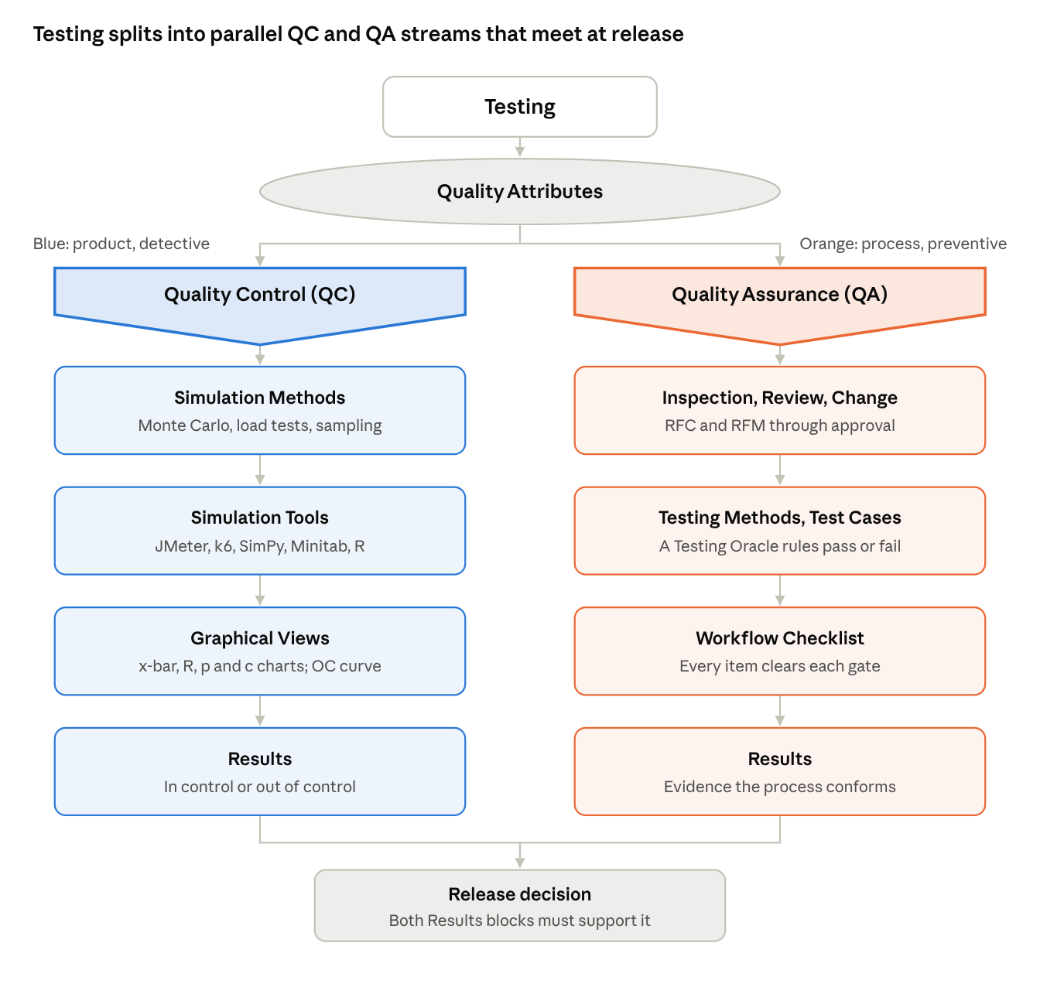
Testing Framework flowchart · redrawn from the source image, with an added release-decision join
Read it top-down: the attributes feed both streams at once, each stream runs four stages, and only agreement between the two Results blocks releases the product.

6.2 SPC dashboard: x̄ and R charts
Build specification
- Layout. Two stacked panels that share one horizontal axis: the x̄ chart on top (about 60% of the height) and the R chart below. Stacking lets the reader see whether a mean spike and a range spike happen on the same day.
- Horizontal axis. Samples in time order (here, 20 business-day dates). Never sort the samples; time order is what reveals trends, jumps and cycles.
- Vertical axes. Top: sample mean in seconds, scaled from 54 to 72 so all limits and points fit. Bottom: sample range in seconds, from 0 to 28.
- Centre lines (solid). x̿ = 63.0 on the x̄ chart and R̄ = 11.85 on the R chart.
- Control limits (dashed). x̄ chart: UCL = 68.7 and LCL = 57.3. R chart: UCL = 23.7 and LCL = 0. Label every line at its right end with its name and value.
- Data series. Points joined by a thin neutral line in time order.
- Out-of-control points. Any point beyond a limit gets a contrasting colour, a larger marker and its value printed beside it. Add a short cause note (here: "Fridays, trainee on duty").
- Optional zone bands. With σx̄ = (UCL − CL)/3 = 5.7/3 = 1.9 s, shade ±1σ and ±2σ bands to apply run rules: seven or more points on one side of the CL signal a shift; six points steadily rising or falling signal a trend. These Western Electric rules extend the textbook's pattern list in Section 10.3.
- Revised panel. Show a second version with the assignable cause removed (Fridays excluded): x̄ chart CL 61.2, UCL 66.2, LCL 56.2; R chart CL 10.3, UCL 20.6, LCL 0.
- Excel recipe. Columns: Date, Mean, Range, CL, UCL, LCL (the last three as constant columns). Insert a line chart with markers, format the limit series as dashed lines, and add an extra series =IF(Mean>UCL, Mean, NA()) with large red markers to flag outliers automatically.
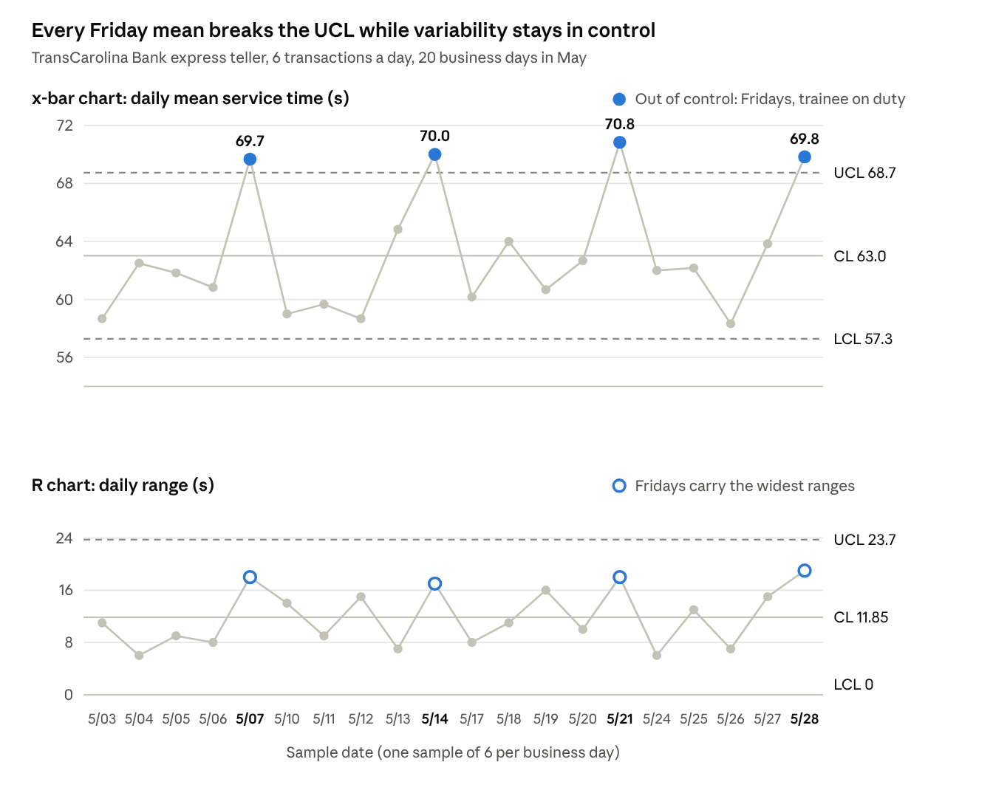
Levin and Rubin Table 10-1 · 20 daily samples of 6 transactions, May; limits computed from the rows
All four Fridays sit above the 68.7 s UCL on the x̄ panel, while every range stays under 23.7 s; the Friday rings at the top of the R panel show the same trainee effect in variability.

6.3 Acceptance sampling OC curve with AQL and LTPD
Build specification
- Axes. Horizontal: actual fraction defective in the incoming lot, p, from 0% to 8% (or 10%). Vertical: probability of accepting the lot, from 0 to 1.0.
- Points. For each p, compute P(accept) = Σ from r = 0 to c of [n! / (r!(n − r)!)] pʳ (1 − p)ⁿ⁻ʳ. In Excel: =BINOM.DIST(c, n, p, TRUE). Use steps of 0.25% or 0.5%; the table in Problem 5.5c gives the key values for n = 100, c = 1.
- Curve. A smooth line through the points. It starts at 1.0 when p = 0 and falls in an S shape as lot quality worsens.
- AQL marker. A vertical dashed line at p = 1%. Mark the point where it meets the curve (P(accept) = 0.736). Draw a bracket from that point up to 1.0 and label it "Producer's risk α = 0.264".
- LTPD marker. A vertical line at p = 2%. Mark the point where it meets the curve (P(accept) = 0.403). Draw a bracket from the axis up to that point and label it "Consumer's risk β = 0.403".
- Annotations. State the plan (n, c, lot size N) in the subtitle and name both risks as Type I and Type II errors.
- Optional comparisons. Overlay the ideal OC curve (a step: 1.0 up to the AQL, 0 beyond it) and a second plan such as n = 250, c = 3. The larger sample gives a steeper curve, which lowers both risks.
- Optional AOQ companion. Plot AOQ = p × P(accept) × (N − n)/N against p. It peaks at the AOQL of about 0.75% near p = 1.6%.
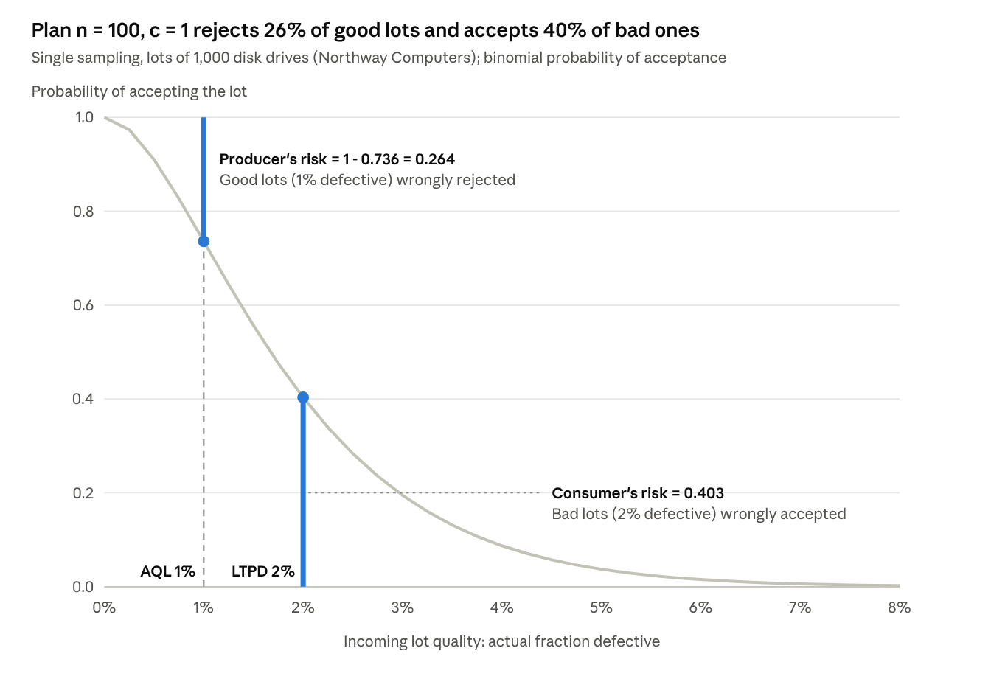
Computed from Equation 5-1 for n = 100, c = 1 at 0.25% steps; textbook Section 10.7 example
The closer the AQL and LTPD lines sit, the steeper the curve must be to separate them; with n = 100 the curve is too shallow, which is why both brackets are long.
Source. Levin, R. I., Rubin, D. S., et al., Statistics for Management (the PDF provided), Chapters 3 to 16, with Chapter 10, "Quality and Quality Control", pp. 465–515. All exercise answers in Sections 4 and 5 were recomputed independently.

